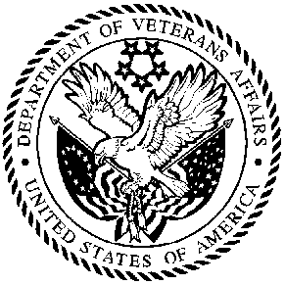
DEPARTMENT OF VETERANS AFFAIRS
HEALTH ELIGIBILITY CENTER
2957 Clairmont Road, Suite 200
Atlanta, Georgia 30329
In Reply Refer To:
Veteran’s Name:
Veteran’s Address:

Dear :

The Department of Veteran Affairs (VA) Health Eligibility Center (HEC) has prepared and published a Veterans Handbook designed to clearly inform Veterans their health care benefits they are uniquely qualified for. This is part of the ongoing commitment to improving our service and communication of health benefits to Veterans eligible for Department of Veteran Affairs health care benefits. Enclosed is a survey for you to provide input and any suggestions for improvement on the Veterans Handbook you recently received. Survey findings will be reported to HEC and the VA.

While I sincerely urge you to complete the survey, should you decide not to participate, it is important for you to know that the survey is completely private and will not affect your current or future benefits in any way.

Please remember, that your answers will be completely private. There is no way your answers will be linked to you. Your help with the survey is very important – HEC needs to know about your experience so that we can improve or make recommended changes to the Handbook based on your feedback. Please take the time to complete and return the survey.

I would like to add how much we appreciate your assistance with this important project. Your participation will help us improve our service to you and many other Veterans. If you have any questions about this request, or need assistance, please call us toll free at 1-800-929-8387, from 8:00 AM until 5:15 PM Eastern time, Monday through Friday.

Respectfully,

Tony Guagliardo
Director

Enclosure

