2010 SDR
Items Added to the Online Surveys (CATI and Web) to Fill in Missing Information

The 2010 SDR contains items in the online modes (the CATI and Web instruments) to fill in missing information for:
- Sex
- Race/Ethnicity
- Date of Birth
- Bachelor’s degree (new in 2008)
- Birthplace (new in 2010)
A set of flags is created prior to the beginning of data collection that signifies which of the items are to be asked for each sample member. Only those items that are missing are asked. The majority of sample members missing these items are new cohort and these sample members are started in the CATI in maximize the chances that they are asked the necessary items.
Screenshots of these questions from the Web instrument, as well as the conditions in which they are asked, are as follows.
ITEM A: SEX
Sex is asked of a respondent in the Web and CATI if sex data is missing for that case and the question has not previously asked and refused.
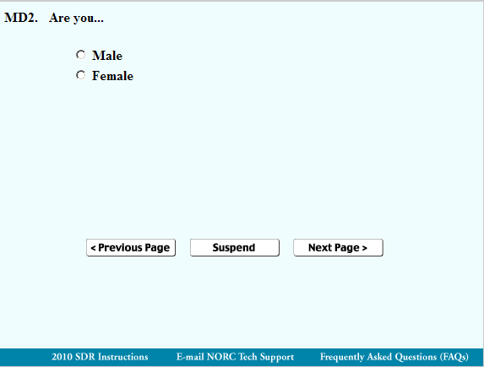
ITEM B: RACE/ETHNICITY
Both race and ethnicity are asked of a respondent in the following scenarios, as long as the panel respondent has not been previously asked to provide data on race or ethnicity and has refused.
- Both race and ethnicity are missing, or
- We have race data, but ethnicity is missing, or
- Race is missing and ethnicity is non-Hispanic.

If race is missing and ethnicity is Hispanic, we do not ask the race/ethnicity questions.

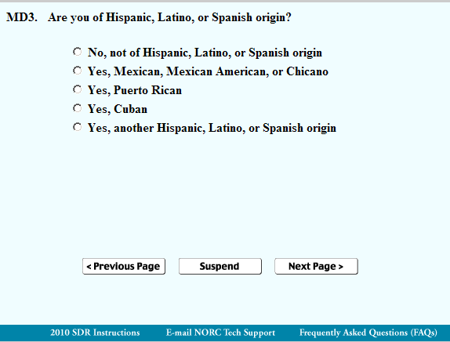
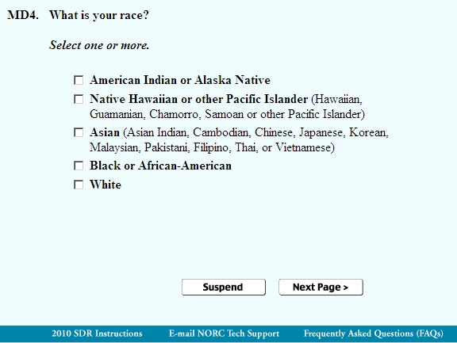
If respondent selects “American Indian or Alaska Native,” the following screen appears:
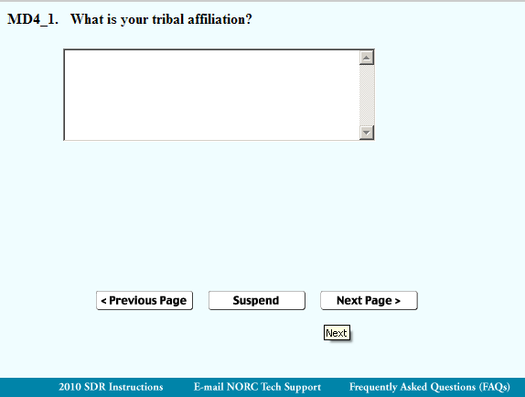

ITEM C: DATE OF BIRTH
Date of Birth is asked if any data are missing (i.e. day, month, or year) and the question has not previously asked and refused by the respondent.
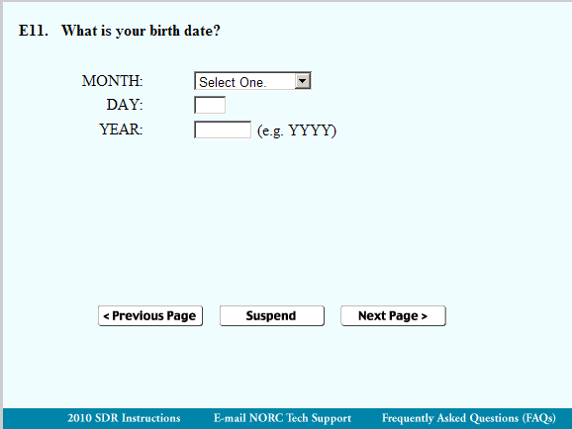
If respondent does not answer this question (leaves blank), the following screen appears:
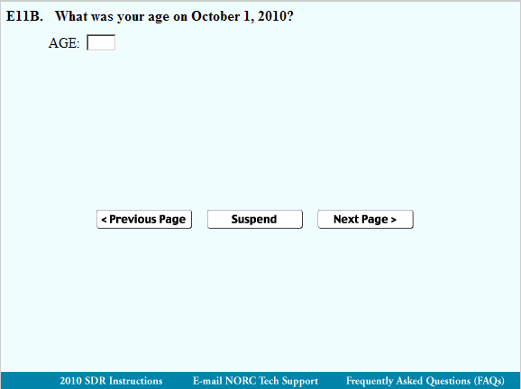

ITEM D: BACHELOR’S DEGREE
Bachelor’s degree information is asked of a respondent if all Bachelor's degree variables are missing from the SDR frame (i.e. the Doctorate Records File) for that case and if the question has not previously been asked on the SDR and refused by the respondent. If there is information in the Doctorate Records File that indicates that a bachelor’s degree was not required for the respondent’s educational program, then the bachelor’s degree questions are not asked.
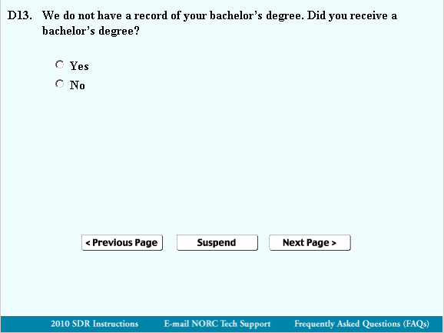
If respondent answers Yes, the following screens appear:
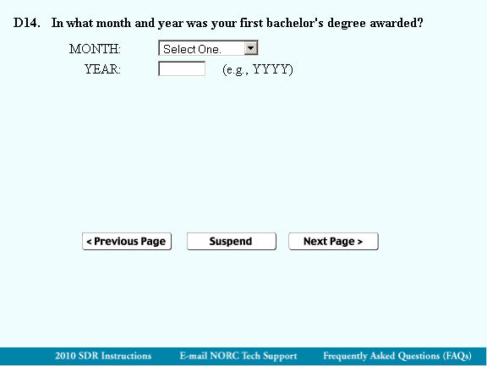
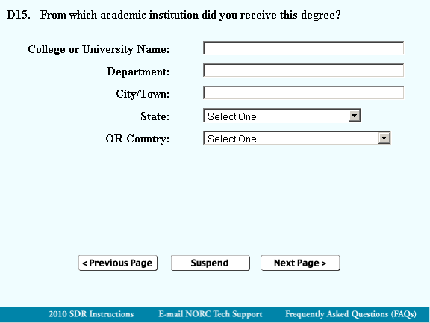
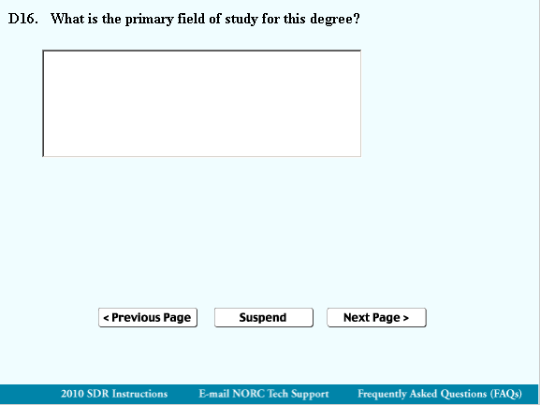
ITEM E: BIRTHPLACE
Birthplace is requested of a respondent if it is missing from the Doctorate Records File frame for that case or if it is coded to a generic U.S. (“096”) or not-US (“555”) code.
