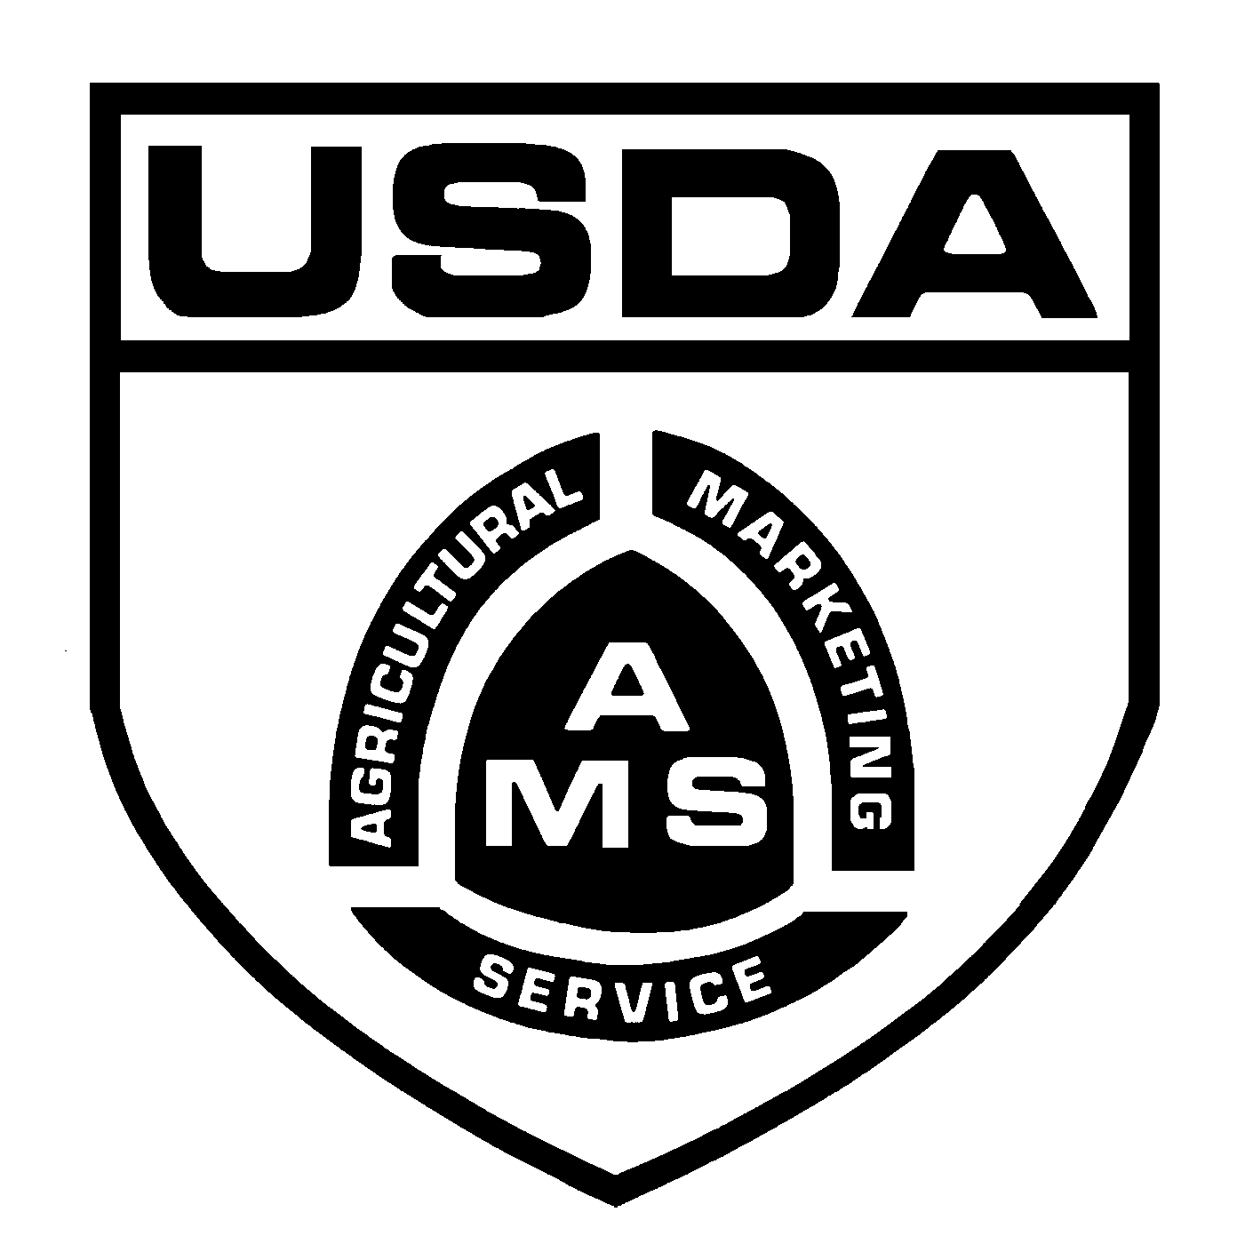
UNITED STATES DEPARTMENT OF AGRICULTURE
AGRICULTURAL MARKETING SERVICE
COTTON AND TOBACCO PROGRAMS, MARKET NEWS BRANCH
3275 APPLING ROAD
MEMPHIS, TENNESSEE 38133
Telephone: 901-384-3016

RECORD OF COTTON ON HAND IN MILLS

FORM APPROVED – OMB NO. 0581-0009
Name and Mailing Address of Mill
“This report is required by law (7 U.S.C. 471-473) and information is held confidential (7 U.S.C. 472). Information is collected in order to publish timely information of color, staple lengths and leaf or stocks of cotton. Failure to comply will result in a misdemeanor and may result in a fine of not less than $300 or more than $1000.”

This report is required by law (7 U.S.C. 471-476) to show all cotton on hand in mills as of 12:01 A.M., August 1.
Complete and return to the address shown. Do not include cotton purchased on call and held by seller.

Report the following:
- All cotton in storge and in transit if in the United States or on a coastwise steamer.
- All staple lengths in thirty-seconds of an inch.
- Leaf in the following terms: 1, 2, 3, 4, 5, 6 and 7.
- American Pima in grades: 1, 2, 3, 4, 5, 6 and 7.
- Foreign growth cotton, including Puerto Rican, by country in which grown.
- American Upland in accordance with the Official Cotton Standards of the United States in the following color codes:

COLOR CODE COLOR CODE
Good Middling 11 Good Middling Spotted 13
Strict Middling 21 Strict Middling Spotted 23
Middling 31 Middling Spotted 33
Strict Low Middling 41 Strict Low Middling Spotted 43
Low Middling 51 Low Middling Spotted 53
Strict Good Ordinary 61 Strict Good Ordinary Spotted 63
Good Ordinary 71 Strict Middling Tinged 24
Good Middling Light Spotted 12 Middling Tinged 34
Strict Middling Light Spotted 22 Strict Low Middling Tinged 44
Middling Light Spotted 32 Low Middling Tinged 54
Strict Low Middling Light Spotted 42 Strict Middling Yellow Stained 25
Low Middling Light Spotted 52 Middling Yellow Stained 35
Strict Good Ordinary Light Spotted 62 Below Grade 81-85

Report as of 12:01 A.M., August 1, 2005.

Name and location of mill (if different from shown in address above) _____________________________________

____________________________________________________________________________________________

I certify that, to the best of my knowledge and belief, this is a true and correct report of the number of bales of cotton (exclusive of linters, waste, and baled loose) on hand on the date shown and shows the location of the listed on the reverse.

Signature_______________________________________ Title__________________________________________________

MAKE YOUR REPORT ON THE REVERSE SIDE

EXAMPLES OF ENTRIES TO RECORD COTTON ON HAND:

Examples of specific lots:

200 bales of Upland, Middling white color, 1 inch, Leaf 3, mill warehouse;
300 bales of Upland, Strict Middling Spotted color, 1-1/32 inches, Leaf 5, in transit;
73 bales of American Pima, Grade 2, 1-1/2 inches, SE Compress and Warehouse, Savannah, GA;
50 bales of Egyptian Giza 7, 1-1/4 inches, mill warehouse.

The above lots should be recorded as illustrated below:

NO. OF  BALES | GROWTH | COLOR CODE  OR AP GRADE | STAPLE  LENGTH | LEAF  CODE | LOCATION OF COTTON
200 | U | 31 | 1 | 3 | Mill warehouse
300 | U | 23 | 1-1/32 | 5 | In transit
73 | A P | 2 | 1-1/2 |  | SE Compress and Warehouse,  Savannah, GA
50 | Egyptian | Giza 7 | 1-1/4 |  | Mill warehouse

COTTON ON HAND IN MILLS AS OF 12:01 A.M., AUGUST 1, 2005.

NO. OF  BALES | GROWTH | COLOR CODE  OR AP GRADE | STAPLE  LENGTH | LEAF  CODE | LOCATION OF COTTON
According to the Paperwork Reduction Act of 1995, an agency may not conduct or sponsor, and a person is not required to respond to a collection of information unless it displays a valid OMB control number. The valid OMB control number for this information collection is 0581-0009. The time required to complete this information collection is estimated to average 30 minutes/hours per response, including the time for reviewing instructions, searching existing data sources, gathering and maintaining the data needed, and completing and reviewing the collection of information.

The U.S. Department of Agriculture (USDA) prohibits discrimination in all its programs and activities on the basis of race, color, national origin, age, disability, and where applicable, sex, marital status, familial status, parental status, religion, sexual orientation, genetic information, political beliefs, reprisal, or because all or part of an individual’s income is derived from any public assistance program (Not all prohibited bases apply to all programs.) Persons with disabilities who require alternative means for communication of program information (Braille, large print, audiotape, etc.) should contact USDA’s TARGET Center at (202) 720-2600 (voice and TDD). To file a complaint of discrimination, write to USDA, Director, Office of Civil Rights, 1400 Independence Avenue, S.W., Washington, D.C. 20250-9410, or call (800) 795-3272 (voice) or (202) 720-6382 (TDD). USDA is an equal opportunity provider and employer.

