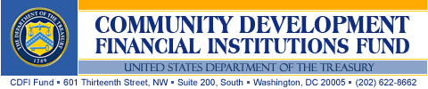

FY 2010 Capital Magnet Fund
Application Instructions

OMB Number: 1559-0036
CDFI Fund No. 0003

Paperwork Reduction Act Notice
This submission requirements package is provided to Applicants for awards under the Capital Magnet Fund. Applicants are not required to respond to this collection of information unless it displays a currently valid OMB control number. The estimated average burden associated with this collection of information is 50 hours per respondent, depending on individual circumstances. Comments concerning the accuracy of this burden estimate and suggestions for reducing this burden should be directed to the Department of the Treasury, Community Development Financial Institutions Fund, 601 Thirteenth Street, N.W., Suite 200-South, Washington, DC 20005.

All materials are available on the CDFI Fund Website: www.cdfifund.gov.

Catalog of Federal Domestic Assistance Number: 21.011

FY 2010 Capital Magnet Fund
Application Instructions

Table of Contents

Introduction and Instructions
CDFI Fund: Mission and Programs 1
Overview of the Capital Magnet Fund 1
Application Eligibility 2
Application Submission Requirements 3
Application Material Checklist 4
Application Deadlines 4
Application Form 5
Contacting the CDFI Fund 6
Additional Information to be Found in the NOFA, Proposed Regulations, and Application Q&A 6

Part I: Applicant Information and Eligibility Questionnaire
Applicant Information and Eligibility Questions 7

Part II: Capital Magnet Fund Proposal
Executive Summary 12
Business Strategy 13
Leveraging Strategy 15
Community Impact 19
Organizational Capacity 23
Application Tables 26

Part III: Forms and Certifications
Forms and Certification Questions 33
Environmental Review Form 35
Assurances and Certifications 36
501(c)(4) Questionnaire 40
Introduction And Instructions

NOTE: Capitalized terms (other than titles) are defined in the Notice of Funds Availability (NOFA) for the FY 2010 Capital Magnet Fund (CMF) funding round and the Proposed Regulations. Certain terms used throughout the Application have meanings unique to the CMF. Applicants should make sure that they are familiar with these meanings by consulting the NOFA and the Proposed Regulations.

CDFI Fund: Mission and Programs
The mission of the Community Development Financial Institutions (CDFI) Fund is to expand the capacity of financial institutions to serve populations and communities lacking adequate access to financial products and financial services. The CDFI Fund achieves its mission by directly investing in and supporting CDFIs, Community Development Entities (CDEs), and other financial institutions through the following programs and initiatives:
- CDFI Financial Assistance and Technical Assistance
- Bank Enterprise Award (BEA)
- New Markets Tax Credit (NMTC)
- Native Initiatives
- Financial Education and Counseling (FEC) Pilot
- Capital Magnet Fund (CMF)
Information on the CDFI Fund’s programs can be found on the CDFI Fund’s website at www.cdfifund.gov. From the home page, click on “What We Do” then “Information for Applicants.” Click on the link for the various programs of interest.

Overview of the Capital Magnet Fund
Through the CMF, the CDFI Fund provides competitively awarded grants to CDFIs and qualified nonprofit housing organizations to finance Affordable Housing Activities and related Economic Development Activities or Community Service Facilities. CMF Awards are reasonably expected to result in eligible Affordable Housing Activities and related Economic Development Activities or Community Service Facilities, whose aggregate project costs total at least 10 times the CMF award amount. CMF awards may be used for the following purposes:
- To provide Loan Loss Reserves;
- To capitalize a Revolving Loan Fund;
- To capitalize an Affordable Housing Fund;
- To capitalize a fund to support Economic Development Activities or Community Service Facilities;
- For Risk-Sharing Loans;
- For Loan Guarantees; and
- To support administrative expenses pertaining to the above activities, but only to the extent that no more than 5 percent of the CMF award may be used for this purpose.
Requirements relating to the process for applying for CMF awards, the eligible use of award dollars, and Awardee compliance are further outlined in the CMF FY 2010 Notice of Funding Availability (NOFA) and these Application materials. These documents are available at the CDFI Fund’s website at http://www.cdfifund.gov.

Applicant Eligibility
At the time that an entity submits its Application, it must be a duly organized and validly existing legal entity under the laws of the jurisdiction (including a Tribal jurisdiction) in which it is incorporated or otherwise established. Further, in order to be deemed eligible to apply for a CMF award, an organization must either: (1) be currently certified as a CDFI by the CDFI Fund; (2) have an application for CDFI certification pending with the CDFI Fund, provided such application was submitted on or before April 1, 2010; or (3) be a Nonprofit Organization having as one of its principal purposes the Development or management of Affordable Housing.

All Applicants (regardless of entity type) must demonstrate that they have operated as an ongoing concern for a period of at least three years prior to the Application deadline.

In order to be deemed to be an eligible Nonprofit Organization, the organization must be able to demonstrate that:

- It has been designated as a non-profit or not-for-profit entity under the laws of the organization’s State of formation;
- It is exempt from Federal income taxation pursuant to the Internal Revenue Code of 1986;
- Its incorporating documents, mission statements or other board-approved documents evidence that the organization is involved in the Development or management of Affordable Housing; and
- At least 33 percent of its resources (i.e., budget or staffing) are dedicated to the Development or management of Affordable Housing.

The CDFI Fund reserves the right to collect additional information from the Applicant in order to verify that it has satisfied these requirements.

NOTE: The Applicant entity must meet the eligibility requirements on its own behalf. While it may, for example, look to the activities of subsidiary entities that it Controls, it may not rely upon the track record of any other Affiliated entities, including its parent company.

Please refer to the FY 2010 Capital Magnet Fund NOFA and Proposed Rule for additional information regarding Application eligibility factors described above.

Application Submission Requirements
This is the Application Instructions document for the FY 2010 Round of the CMF and is the primary guide for the Application. DO NOT SUBMIT THIS DOCUMENT. A complete 2010 CMF Application submission consists of the:
- Application Form (available from the myCDFI Fund account)
- SF-424 (note that Applicants must have a DUNS number for this form)
- Documentation of EIN
- Audited financial statements (most recent year)

In order to download the Application Form and submit the Form and all attachments, Applicants must register User and Organization accounts in myCDFI Fund, the CDFI Fund’s Internet-based interface. As the myCDFI Fund account is the CDFI Fund’s primary means of communication with Applicants and Awardees, organizations must make sure that they update the contact information and previous CDFI Fund awards history in their myCDFI Fund accounts before the Application deadline. In addition, Applicants should make sure that any affiliate information (including previous awards history) is current and correct. For more information on myCDFI Fund accounts, please see the “Frequently Asked Questions” link posted at https://www.cdfifund.gov/myCDFI/Help/Help.asp.

NOTE: myCDFI Fund is the primary vehicle through which the CDFI Fund communicates with its constituent Awardees and Applicants. It allows users to update contact information, including address and e-mails as staff changes occur. Data submitted through myCDFI Fund does not automatically create a myCDFI Fund account for Applicants. Applicants must establish a personal and organization account by clicking on the link that reads “Log onto myCDFI Fund” that can be found on the CDFI Fund’s homepage, www.cdfifund.gov. All Application decisions are communicated through e-mails established in the myCDFI Fund accounts. Because an Applicant will be notified via e-mail, it is essential that the e-mail addresses identified in the SF-424 and Application Form are the same as the ones provided in the myCDFI Fund account. Otherwise, the award notification e-mail may not be received.
If an Applicant’s e-mail system has a spam blocker function, please ensure that the CDFI Fund’s e-mail addresses (cdfihelp@cdfi.treas.gov, ccme@cdfi.treas.gov) are listed as acceptable sources.

TIP: Do not wait until the last minute to obtain a DUNS or EIN documentation. The CDFI Fund strongly advises Applicants to allow sufficient time to obtain the necessary numbers or documentation. Information on obtaining a DUNS number may be obtained by visiting the grants.gov website.

Application Material Checklist

Table 1 – Application Material Checklist
Application Component | Prepare In…
Application Form  (includes Proposal and Certifications) | PDF Form
Standard Form (SF) 424 | MS Word  (then print, sign, and scan)
Documentation of EIN | PDF
Audited Financial Statements  (most recent year) | PDF or MS Word

The Applicant is required to complete and submit, through its myCDFI Fund account, all documents listed above by 5:00 p.m. EDT on April 15, 2010. Application materials submitted to the CDFI Fund in any form or fashion other than through the process described above are ineligible for consideration. The CDFI Fund will only consider information contained in documents listed in Table 1 – Application Material Checklist in its review of an Application. It will not consider attachments that have not been specifically requested (such as organizational strategic plans, marketing plans, or letters of support).

Application Deadlines

Table 2 - FY 2010 CMF Deadlines
(All 5:00 p.m. EDT deadlines)
Applicant Type | Document | Deadline | Last Date to Contact CDFI Fund Staff
Certified CDFIs | CDFI Certification Material Events Form | April 1, 2010 | March 30, 2010
Entities Applying for CDFI Certification | CDFI Certification Application | April 1, 2010 | March 30, 2010
All Applicants | CMF Application | April 15, 2010 | April 13, 2010

TIP: The CDFI Fund encourages Applicants to submit their Applications before the last date to contact CDFI Fund staff, so that if there are any technical problems they can be addressed. CDFI Fund staff will not be able to assist with any problems encountered after 5:00 p.m. EDT on April 13, 2010.

Application Form

The Application Form is a fillable PDF form made up of the following components:

Application Sections
Part I: Applicant Information and Eligibility Questionnaire
Part II: Capital Magnet Fund Proposal
Executive Summary
Business Strategy
Leveraging Strategy
Community Impact
Organizational Capacity
Part III: Forms and Certifications

The Applicant must use the Application Form to respond to all questions. The Application Form is a fillable Adobe PDF form that will be available in the Applications section of the Applicant's myCDFI Fund account. All tables required to complement and supplement the narrative are detailed within each section of the Capital Magnet Fund Proposal. Please allow plenty of time to complete these tables and make sure they are all completed accurately and appropriately. Applicants are encouraged to pay close attention each section’s instructions, questions, as well as all tips.

An Applicant will be able to submit the Application Form even if certain responses are blank or incomplete. However, the lack of information may impact the way that reviewers score the Application. If the CDFI Fund determines that there is insufficient information in the Application Form to evaluate the Application, it may not forward the Application for review. No Applicant will be provided an opportunity to supplement the Application Form.

Each question has stated character limitations, ranging from 1,000 characters (approximately one paragraph) to 10,000 characters (2 pages). The Application Form will not permit Applicants to submit responses longer than the specified character limitation contained in the question.

Contacting the CDFI Fund
The CDFI Fund will respond to questions between the hours of 9:00 a.m. and 5:00 p.m. EDT, through April 13, 2010. The CDFI Fund will not respond to phone calls or e-mail inquiries received after 5:00 p.m. EDT on said date, until after the funding Application deadline. NOTE: These are not toll-free numbers.

Table 2 – CDFI Fund Contact List
Main Office: | (202) 622-8662  (202) 622-7754 (fax) | www.cdfifund.gov | General inquiries; phone numbers for individual CDFI Fund staff; access to myCDFI Fund and program webpage.
Program Support: | (202) 622-6355  Option 9 | cdfihelp@cdfi.treas.gov | CMF Application questions, how to complete tables, certification.
Compliance and Monitoring Support | (202) 622-6330  (202) 622-7754 (fax) | ccme@cdfi.treas.gov | Status of compliance with other CDFI Fund awards including outstanding reports.
IT Support | (202) 622-2455 | ithelpdesk@cdfi.treas.gov | Registering and creating accounts on myCDFI Fund.
Legal Support | If you have any questions or matters that you believe require response by the CDFI Fund’s Office of Legal Counsel, please refer to the document titled “How to Request a Legal Review, “found on the CDFI Fund’s web site at www.cdfifund.gov.

Additional Information to be Found in the NOFA, Proposed Regulations, and FY 2010 Application Q&A

Please be aware that the FY 2010 Capital Magnet Fund NOFA, Proposed Regulations, and Application Q&A contain additional information not contained in this Application. The CDFI Fund strongly encourages all potential Applicants to thoroughly review these documents, which are available at the Capital Magnet Fund page of our website http://www.cdfifund.gov before beginning an Application.
part I: APPLICANT information and eligibility questionnaire
- Organization Information:
a. Organization Name: ____________________________

Mailing Address:
b. Street 1: ____________________________
c. Street 2: ____________________________
d. City: ____________________________
e. State: ____________________________
f. Zip Code (nine-digits): ____________________________

NOTE: Please ensure that this is an address that can receive overnight deliveries (i.e. not a P.O. Box)

g. Applicant Employer Identification Number (EIN): ____________________________
h. Applicant DUNS Number: ____________________________
i. Applicant’s date of incorporation or formation (month/year): _________

NOTE: As specified in the FY 2010 CMF NOFA, only Applicants that have been in operation for at least three years prior to the Application deadline are eligible to apply for funding. In order to be deemed eligible to apply for a CMF award in the FY 2010 round, the Applicant must have been in existence as a legal entity since at least April 15, 2007.

j. Applicant’s fiscal year end (month): ______
k. Applicant’s total assets as of the date of this Application: $_________
- Authorized Representative Information:
a. First Name: ____________________________
b. Last Name: ____________________________
c. Title: ____________________________
d. Email: ____________________________
e. Phone: ____________________________
f. Fax: ____________________________

Mailing Address:
g. Street 1: ____________________________
h. Street 2: ____________________________
i. City: ____________________________
j. State: ____________________________
k. Zip Code (nine-digits): ____________________________
- Contact Person Information (if different from Authorized Representative):
a. First Name: ____________________________
b. Last Name: ____________________________
c. Title: ____________________________
d. Email: ____________________________
e. Phone: ____________________________
f. Fax: ____________________________

Mailing Address:
g. Street 1: ____________________________
h. Street 2: ____________________________
i. City: ____________________________
j. State: ____________________________
k. Zip Code (nine-digits): ____________________________

- Complete an Applicant Profile (1,000 character limit) which will be made public in the event the Applicant is selected to receive an award. Be sure to include the Applicant’s name, the year the organization was established, the proposed products and services offered, and the target geographies served. Please follow the sample template below:

SAMPLE PROFILE TEMPLATE: Affordable Housing Fund (AHF) is a certified CDFI established in 1973. AHF provides loans to affordable housing developers in Washington, DC. It will use its 2010 CMF award to capitalize a loan fund which supports construction loans for mixed-income, multi-family housing projects located in areas of high housing need. AHF will ensure that at least 75% of the units developed with the CMF award are targeted to low-income persons, and that at least 40% are targeted towards very-low income households. AHF will also use 20% of its award dollars to help finance child-care centers on-site at its affordable housing developments.
- Applicant Eligibility Criterion
- Type of Organization (check all that apply):

___ Certified CDFI  ___ Nonprofit Organization  ___ For-Profit Organization  ___ Public Housing Authority (PHA)  ___ State Housing Finance Agency (HFA)  ___ HUD-certified Community Housing Development Organization (CHDO)  ___ USDA Section 523 Grant Recipient (Current Awardee) | ___ Government-Controlled Entity  ___ Faith-Based Institution  ___ Minority-Owned or Controlled  ___ Tribal Entity  ___ Credit Union  ___ Thrift or Bank  ___ Bank Holding Company

NOTE: As specified in the FY 2010 CMF NOFA, an Applicant must be certified as a CDFI; have an application for CDFI certification pending with the CDFI Fund; or else meet the criteria of an eligible Nonprofit Organization. In order to be deemed an eligible Nonprofit Organization, an entity will be required to demonstrate that: (i) it has been designated as a non-profit or not-for-profit entity under the laws of the organization’s State of formation; (ii) its is exempt from Federal income taxation pursuant to the Internal Revenue Code of 1986; (iii) it has articles of incorporation, mission statements or other board-approved documents demonstrating that it undertakes, as one of its principal purposes, the Development or management of Affordable Housing; and (iv) at least 33 percent of its resources (either staffing or budget) is dedicated to the Development or management of Affordable Housing. The CDFI Fund reserves the right to collect additional information (e.g., articles of incorporation; charter information; audited financial statements; agency documentation) to verify that the Applicant is properly classified as satisfying the necessary requirements.
- Does the Applicant have any Affiliates that are applying for a FY 2010 CMF award?
(check one): ___ Yes ___ No

NOTE: The answer to Question #5(b) must be “No.” An Applicant and its Affiliates may collectively submit only one Application under this CMF round. If separate Applications are received from multiple Affiliated entities, the CDFI Fund reserves the right to reject all such Applications. For purposes of this requirement, in addition to assessing whether Applicants are Affiliates or Subsidiaries, the CDFI Fund will consider whether Applicants constitute a common enterprise. A common enterprise may exist: (i) where the activities described in Applications submitted by separate entities are, or will be, operated and/or managed such that, in fact or effect, they may be viewed as a single entity; (ii) where the Applications submitted by separate entities contain significant narrative, textual or other similarities; or (iii) where the strategies and/or activities described in Applications submitted by separate entities are so closely related, in fact or effect, they may be viewed as substantially identical Applications. In such cases, the CDFI Fund reserves the right to reject all Applications received from such entities, to select a single Application as the only one that will be considered for an award, and/or, in the event that an Application is selected to receive an award, to deem certain activities ineligible.
- Identify the type of service area that the Applicant will serve with this award:
National service area
Multi-state service area
Statewide (or territory-wide) service area
Local service area (e.g., neighborhoods, cities, a county or contiguous counties, or metropolitan areas) within a state or territory
NOTE: An Applicant serving a metropolitan area that crosses multiple states (e.g., the Los Angeles or Philadelphia metropolitan areas) should check “Multi-state service area.”

- Identify the particular geographical areas that the Applicant will serve with this award. An Applicant that is serving a national service area must identify the seven states with the largest amount of projected activities:

State(s):
County(ies):

- Requested Award Amount and Anticipated Activities:
- Total dollar amount of award requested in this Application: $ ______________
NOTE: Applicants are encouraged to request an amount for which they believe can be used to finance activities with total costs at least 10 times greater than the award amount; and which they believe can be committed within two years of an award and fully expended (and projects placed in service) within five years of the Assistance Agreement. The maximum amount an Applicant can request under the FY 2010 funding round is $12 million. However, the CDFI Fund reserves the right to make awards smaller than this amount. In Question #15, the Applicant will be permitted the opportunity to describe the minimum award amount that it would accept, in the event that the CDFI Fund were to award less than the full amount.

- Please estimate the percentage of the CMF award dollars (including leveraged funds) that will be directed towards each of the following types of activities (numbers should add up to 100%):

i) ____ Single Family Housing (new construction)
ii) ____ Single Family Housing (rehabilitation)
iii) ____ Single Family Housing (mortgage finance)
iv) ____ Multifamily Housing (new construction)
v) ____ Multifamily Housing (rehabilitation)
vi) ____ Multifamily Housing (preservation)
vii) ____ Economic Development Activities or Community Service Facilities
viii) ____ Other (please identify): _______________________

- Please estimate the percentage of CMF award dollars (including leveraged funds) that will be used for each of the following types of financing (numbers should add up to 100%):

i) ____ Pre-Development
ii) ____ Acquisition and Site Development
iii) ____ Construction
iv) ____ Bridge Loans or similar
v) ____ Permanent Finance (1st Lien)
vi) ____ Permanent Finance (2st Lien or similar)
vii) ____ Refinance
viii) ____ Loan Guarantee/Credit Enhancement
ix) ____ Secondary Market Purchase
x) ____ Other (please identify): _______________________

- Please estimate the percentage of CMF award dollars (including leveraged funds) that will be used for each of the following eligible uses (numbers should add up to 100%):

i) ____ To provide Loan Loss Reserves
ii) ____ To capitalize a Revolving Loan Fund
iii) ____ To capitalize an Affordable Housing Fund
iv) ____ For Risk Sharing Loans
v) ____ For Loan Guarantees
vi) ____To capitalize a fund to support Economic Development Activities or Community Service Facilities
vii) ____For Operations

- Estimate the number of hours required to complete the entire Application package:
________ hours

NOTE: For the purpose of estimating Application completion hours, Applicants should focus only on the amount of time it took to complete the questions asked in the Application materials. Other activities that are carried out in the normal course of business and are only indirectly related to the completion of this Application (e.g., developing a business strategy or marketing plan; etc.) should not be included in this estimation.

part II:
Capital magnet fund proposal

[Executive Summary]

This section will not be scored.

Narrative

- Executive Summary (5,000 character limit): Summarize the key elements of the CMF Proposal, including:
- The amount of the CMF award request;
- The strategy for leveraging the CMF award and the amount of Eligible Project Costs that the Applicant anticipates that it will be able to finance with the award;
- Proposed uses of the CMF award;
- Primary markets or populations that will be served;
- Key products and services that will be offered;
- Proposed Service Area; and
- Anticipated outcomes.

[Business Strategy]
25 points
The CDFI Fund will evaluate the Applicant’s business strategy for its ability to achieve CMF goals. An Applicant will generally be scored more favorably to the extent to which it: proposes activities that are consistent with the Applicant’s track record; proposes to utilize the CMF award to provide products better than those on the market; and illustrates a viable and high-quality pipeline of potential activities.

Tables
- Table A: Activities
- Table B: Production

Narrative

- Proposed Activities (10,000 character limit): Describe what the Applicant will finance with a CMF award and the funds it will raise. Specifically:
- Describe the types of Affordable Housing Activities, Economic Development Activities or Community Service Facilities in which the Applicant intends to engage (e.g., multifamily construction or rehabilitation; single family mortgage financing; single family acquisition and rehabilitation; development of child care facilities; etc.).
- Describe the financing tools that the Applicant intends to use (e.g., a Revolving Loan Fund; an Affordable Housing Fund or a fund for Economic Development Activities or Community Service Facilities; Loan Loss Reserves; Risk-Sharing Loans; Loan Guarantees), and when the proposed financing will be provided (e.g., pre-development; construction; take-out financing; permanent financing; re-financing of an existing loan; etc.).
- Describe the specific debt or equity products that will be offered by the Applicant, including: the dollar range, rates and terms of these offerings; and the extent to which the Applicant will use its CMF award to offer better products than would otherwise be available (e.g., more favorable interest rates; flexible underwriting criteria, nontraditional forms of collateral, low down payment requirements, closing cost assistance, etc.).

TIP: No more than 30% of the CMF award may be used in support of Economic Development Activities or Community Service Facilities. In addition, costs attributable to units of housing for families whose annual income exceeds 120% of area median income cannot be financed by the CMF award or counted toward Eligible Project Costs.

Complete Table A: Activities: See pages 27-28.

Complete Table B: Production: See page 29.

- Track Record (5,000 character limit): Describe the Applicant’s track record of financing each type of activity it intends to pursue with its CMF award, including the communities and populations that it has traditionally served and the impacts that it has achieved.

- Pipeline of Activities (10,000 character limit): Provide a narrative description of the Applicant’s proposed activities, including:
- The information or data used to develop the activity projections (e.g., historical levels of activity; letters of interest from borrowers; current referrals);
- The number and dollar amount of transactions that have already been identified, for which underwriting is completed or underway;
- Of those underway, please describe a sample of transactions (up to three) that can reasonably be expected to close within 24 months. Provide the amount of CMF financing needed and total activity or project costs. Provide the status of the activity, including the status of total financing;
- The Applicant’s strategy for identifying potential borrowers, investees or activities, including the extent to which the Applicant has utilized or will be utilizing community alliances or strategic partners (including banks, credit unions, CDFIs, local governmental or tribal agencies, etc.) to identify activities; and
- If the Applicant is proposing a significant increase in activities over what it has historically provided, be sure to describe why this increase is anticipated to occur (e.g., a larger number of activities will be financed; larger investments will be made into a similar number of activities; etc.).

[leveraging strategy]
25 points
The CDFI Fund will evaluate the Applicant’s ability to leverage CMF award funding. The Applicant will generally be scored more favorably to the extent to which it: commits to financing activities with Eligible Project Costs significantly higher than the dollar amount of the CMF award; utilizes strategies for leveraging funds at the investment level (pre-investment stage and reinvestments), as opposed to solely at the project level; can demonstrate its ability and proposes to utilize the CMF award to raise private capital; and provides financing that represents a significant proportion of the total costs of each activity or otherwise plays a critical role in overall financing.

Tables
- None

Narrative

TIP: For compliance monitoring purposes, the CDFI Fund will be evaluating the size of the CMF award as compared with the Eligible Project Costs (which includes the CMF award amount and the resulting Leveraged Costs). For example, if an Applicant requests an award of $5 million and commits to financing Eligible Project Costs totaling at least $75 million, then it will have committed to a 15 times leveraging multiplier.
Each Awardee that uses CMF funding to support Affordable Housing Activities shall ensure that:
(1) 100% of Eligible Project Costs are attributable to housing units that meet the CMF affordability qualifications for families whose annual income does not exceed 120% of area median family income.
(2) Greater than 50% of Eligible Project Costs are attributable to housing units that meet CMF affordability qualifications for Extremely Low-, Very Low-, and Low-Income Families.
(3) No funds used for Awardee Operations are reported as Leveraged Costs; and
(4) At least 20% of all units (regardless of their affordability status or source of funding) in any multi-family rental project funded in part or in whole with CMF funding must meet CMF affordability qualifications for Extremely Low-, Very Low-, or Low-Income families.

- Leveraging Chart: Quantify the Applicant’s model for using a CMF award to achieve leverage in its activities.
In the space provided below, indicate the total amount of capital that the Applicant anticipates it will be able to secure under each type of leveraging strategy, expressed in terms of total dollars.
The pre-investment stage includes all funds raised prior to investment in specific transactions, and includes the CMF award (minus any Operations costs).
Reinvestments include funds that are revolved after the original investment and invested in eligible activities that are completed within 5 years of the Assistance Agreement. The amount is not inclusive of any funds counted toward the Pre-Investment Stage. If the Applicant does not anticipate revolving funds, the amount should be zero.
The project level includes total Eligible Project Costs for all projected activities. This amount is what is used to calculate the total leveraging projection.

Strategy | Amount | Multiplier
a. Pre-investment stage | $________________ | Auto-calculated
b. Reinvestments | $________________ | Auto-calculated
c. Investment level subtotal | Auto-calculated | Auto-calculated
d. Project level (cost) | $________________ | Auto-calculated
e. Total leveraging projection |  | Auto-calculated

Indicate the minimum combined leveraging multiplier that the Applicant will commit to achieving if it receives a CMF award.

f. Minimum leveraging commitment | $________________ | Auto-calculated

TIPS: It is extremely important that the Applicant consult the CMF Application Q&A document regarding the meaning of and calculation for each strategy.
In general, the higher the leverage amount the Applicant commits to achieve, the higher the Applicant will likely be scored. However, the number itself will not be the sole determining factor. The CDFI Fund will also consider the extent to which there is a mix of leveraging strategies. For example, an Applicant that provides all of its leveraging at the project level, it will not be scored as favorably as an Applicant which achieves leveraging at the investment level (pre-investment stage and reinvestments) as well as the project level.
The Applicant will be required to satisfy the minimum threshold indicated in (f) above as part of its Assistance Agreement with the CDFI Fund.

- Leveraging Narrative (10,000 character limit): Describe the methodology and status for achieving the leveraging approach described above. Indicate the nature (private or public) of the leveraged sources and amounts of the identified, projected, or committed capital. Discuss whether other sources of capital have been identified, are projected, or are committed. Be sure to address the following means of achieving leverage:
- For the pre-investment stage, indicate how the CMF award will be used to attract third-party capital; the total amount of funds that are expected to be leveraged from the CMF award; the current status of the Applicant’s efforts to secure the leveraged funds (i.e. in-hand, committed, speculative), including the names of those third-party investors or sources (if not confidential); the timeline for raising the third-party capital; and the Applicant’s prior relevant experience in raising funds in this manner.
- For reinvestments, indicate the Applicant’s strategy for re-investing the CMF award; the timeline for such reinvestments; and the Applicant’s prior experience in reinvesting funds in this manner.
- For the project level, indicate the minimum and maximum size of investments the Applicant will make in a single project or activity (both in terms of total dollars and as a percentage of total projected Eligible Project Costs); the anticipated average size of investments across the Applicant’s total portfolio of activities (both in terms of total dollars and as a percentage of total projected Eligible Project Costs); the status of other funding sources; and the Applicant’s prior relevant experience in leveraging funds in this manner.

- Need for award (5,000 character limit): Describe why a CMF award is needed for the proposed Activities.
- Explain why the proposed projects or activities could not be undertaken without a CMF award.
- Describe efforts that the Applicant has undertaken, or will undertake, to attract private sector capital in support of its activities – either at the pre-investment stage, or at the project level.

TIP: Applicants that can demonstrate their ability to generate leveraged investments through private capital, as opposed to solely or predominantly through other government supported contributions, will score more favorably.

- Minimum Award Amount:
- Is there an absolute minimum amount below which the Applicant would be unwilling to accept a CMF award?
_____Yes _____No
- If yes, provide the amount $_______
- If yes, describe how this amount was determined (2,000 character limit). Be sure to address why the Applicant could not administer a smaller award.
TIP: The answers to Question #15 will not affect the scoring of the Application. At the conclusion of the Fund’s review process, if the Applicant is recommended to receive less than the minimum amount identified in Question #15(b), the Fund will not provide a CMF award to the Applicant. An Applicant with a high minimum award request will need to demonstrate that it can raise and deploy the capital requested in a timely manner; that it will likely achieve its proposed impacts; and that it could not successfully implement its business strategy without this minimum award amount.

- Minimum Investment Commitment:
  - Is the Applicant willing to commit that the CMF award funding will constitute, at a minimum, 5% of the total costs of each CMF activity?
_____Yes _____No
  - If no, explain how the Applicant’s contribution to the activities it finances will play a significant role in the activity (2,000 character limit).

TIP: The purpose of this question is to determine whether Applicants will provide financing that represents a significant proportion of the total costs of each activity or otherwise plays a critical role in project financing.
Applicants that check “Yes” above will be required to satisfy this obligation as part of its Assistance Agreement with the CDFI Fund.

[Community impact]
25 points
The CDFI Fund will review the extent to which the Applicant’s strategy will have positive community development and economic impacts. The Applicant will generally be scored more favorably to the extent to which it: commits to reaching targeted areas and populations; works to reduce concentrations of poverty and coordinates its activities with local plans; and achieves community benefits through clear strategies that are consistent with its track record.

Tables
- None

Narrative
- Communities Served (10,000 character limit): Describe the persons and communities that the Applicant intends to serve, as well as its track record of providing Affordable Housing or Economic Development Activities to those persons and communities. Discuss the nature and extent of Affordable Housing need among those persons and communities. Address the extent to which the Applicant will focus on; (i) Low-Income Communities; (ii) communities of high housing needs; or (iii) Low-Income, Very Low-Income, or Extremely Low-Income Families.

TIP: High housing need means census tracts that have a score of at least 18 (out of 20) on the vacancy index or foreclosure index in HUD’s Neighborhood Stabilization Data. For more information on high housing need, see the FY 2010 CMF Application Q&A document.

- Housing Need: If selected for a CMF award, indicate the percentage of total housing financing that the Applicant will commit to finance units of Affordable Housing which are:
- ____% Located in communities of high housing need
b. ____% Available and affordable to Low-Income Families (51-80% AMI)
c. ____% Available and affordable to Very Low-Income Families (31-50% AMI)
d. ____% Available and affordable to Extremely Low-Income Families (less than 30% AMI)
Note: Subparts (b), (c), and (d) are mutually exclusive; they cannot add up to more than 100%.

TIP: The Applicant will be required to satisfy these obligations as part of its Assistance Agreement with the CDFI Fund. Note that greater than 50% of the total Eligible Project Costs must be attributable to housing units that meet the CMF affordability qualifications for Low-Income, Very Low-Income, or Extremely Low-Income Families. Generally, an Applicant will score better to the extent that it commits to serving Extremely Low-Income Families or High Housing Need areas. It need not commit to both to receive the highest consideration. For example, an organization that proposes to provide mortgage financing in areas of High Housing Need could score as well as an organization that proposes to serve Extremely Low-Income families.

- Housing Outcomes (5,000 character limit): Describe how the Applicant will work to: (i) ensure that Affordable Housing funded by CMF awards exists in mixed-income developments or communities; (ii) reduce geographic concentrations of poverty; and (iii) ensure that any residents dislocated from housing as a result of the Applicant’s activities are provided with alternative housing solutions.

- Activities Coordinated With Local Plans (5,000 character limit):
- Describe how the Applicant will ensure that its activities are part of a Concerted Strategy.

- Concerted Strategy Commitment: Will the Applicant commit that all multi-family Affordable Housing Activities, Economic Development Activities and/or Community Service Facilities financed with the CMF award will be certified by a government agency, HOME participating jurisdiction or other relevant entity as being part of a Concerted Strategy?
_____Yes _____No
_____Not Applicable (Applicant will only be financing single-family housing).

TIP: The Applicant will be required to satisfy this obligation as part of its Assistance Agreement with the CDFI Fund.

- Additional Community Impacts:
- Check all additional community impacts the Applicant intends to achieve (check all that apply):
1. ____ | Utilize housing activities to stabilize neighborhoods by targeting foreclosed or vacant homes
2. ____ | Require project or activity sponsors to support living wage jobs or prevailing wage rates
3. ____ | Provide economic opportunities for Extremely Low-, Very Low- or Low-Income residents in connection with jobs or activities in their neighborhood
4. ____ | Require project or activity sponsors to use minority or women-owned contractors or subcontractors
5. ____ | Support transit-oriented development or other smart-growth principals
6. ____ | Adhere to principals of sustainable environmental design and development, such as those established through LEED certification
7. ____ | Support Economic Development Activities or Community Service Facilities that provide valuable goods or services to residents of Low-Income Communities
8. ____ | Other (explain below)

- For each item checked above, describe the Applicant’s strategy for, and its prior experience in, achieving the proposed outcomes (3,000 character limit).

- Economic Development Activities and Community Service Facilities (5,000 character limit): To the extent the Applicant intends to use any of its CMF award to finance Economic Development Activities or Community Service Facilities, describe: (i) the types of activities that will be financed; (ii) how these activities will be coordinated with Affordable Housing activities; (iii) how these activities implement a Concerted Strategy to stabilize or revitalize a Low-Income Area or Underserved Rural Area; (iv) the amount of CMF financing and role that the CMF award will play in the overall facility or activity financing; and (v) the extent to which these activities will result in valuable goods or services to be made available to residents of the Affordable Housing or other Low-Income Community residents.

- Non-Metropolitan Areas:
Indicate the minimum and maximum percentage of investments that the Applicant is willing to commit to deploy in Non-Metropolitan Areas:
- ____% minimum investment in Non-Metropolitan Areas
- ____% maximum investment in Non-Metropolitan Areas
- If the responses to Question #23 (a) or (b) are greater than zero percent, briefly describe the Applicant’s track record of serving Non-Metropolitan Areas (2,000 character limit). Be sure to indicate, both in real dollars and as a percentage of the Applicant’s overall activities, the amount of loans, investments or related activities the Applicant has undertaken in Non-Metropolitan Areas.

TIP: The answers to Question #23 will not affect the scoring of the Application. The CDFI Fund will use the information from Question#23 to help ensure that at least 20 percent of the total CMF award funding is invested in Non-Metropolitan Areas.
Applicants are therefore required to provide two target estimates: the minimum percentage of dollars that it would feel comfortable committing to invest in Non-Metropolitan Areas (i.e., minimum commitment); and the maximum percentage that the Applicant is willing to commit to providing to Non-Metropolitan Areas (i.e., maximum commitment). At the discretion of the CDFI Fund, the Applicant may be required to deploy a percentage of its award at or above the minimum indicated, but not more than the maximum percentage indicated; and such requirement shall become a condition of its Assistance Agreement with the CDFI Fund.

Estimate the percentage of activities (by dollar amount of financing provided) that will be directed to each of the following markets:
- ____% Major urban areas (counties in metropolitan area with a population equal to or greater than 1 million, including both central city and surrounding suburbs)
- ____% Minor urban areas (counties in metropolitan area with a population less than 1 million, including both central city and surrounding suburbs)
- ____% Non-Metropolitan Counties

[Organizational CAPACITY]
25 points
The CDFI Fund will evaluate the Applicant’s capacity to achieve the objectives set forth in its CMF Proposal. The Applicant will generally be scored more favorably to the extent to which it: demonstrates that its staff, Board members and other personnel have the requisite skills and experience to administer the CMF award and maintain compliance with its Assistance Agreement; involves Low-Income persons or Low-Income community representatives in its decision-making process; demonstrates an ability to deploy CMF award dollars quickly; and demonstrates a strong portfolio and stable financial position.

Tables
- Table C: Key Personnel
- Table D: Loan Portfolio Quality
- Table E: Financial Data

Narrative
Complete Table C: Key Personnel: Fill out the Table for up to five persons (from the management team, the governing board, staff, consultants, or contractors) who are integral to implementation of the Applicant’s proposal. See page 30.

- Management Team and Key Staff (5,000 character limit): Describe the capacity, skills, and experience of the Applicant’s management team and key staff.
- Describe what roles the key personnel will play in support of your CMF award activities and their time commitment (e.g., hours per week) with respect to carrying out these activities.
- For any vacancies or new positions, describe the status of filling the position(s) and the strategy for doing so, as well as the expected date of filling the position(s).

- Governing Board or Advisory Board (5,000 character limit): Describe the role of the governing board or any advisory boards in advising the Applicant’s strategy, identifying and approving investments, and/or overseeing the Applicant’s loan and/or investment portfolio; including the extent to which individuals representing Low-Income communities or Low-Income persons are involved in these activities.

- Previous Awards:
- Previous Awards Chart (if applicable): Complete the table below for all Federal government awards that the Applicant and/or any Affiliates have received over the past three years.
Name of award | Awarding agency | Award $ amount | Award date | Control number (if applicable)

- Previous Awards Narrative (if applicable)(4,000 character limit):
- Describe the extent to which the Applicant has been successful in administering these awards, including monitoring for housing affordability requirements, and how this will likely translate into success in administering a CMF award. If the Applicant failed to meet a performance measure or financial requirement with respect to any such award, describe what caused the failure and whether issues leading to the failure have been addressed or resolved.
- Discuss any other experience that the Applicant has in administering awards from other entities (e.g., state or local governments, foundations), particularly large monetary awards with substantial compliance requirements.

- Timelines (5,000 character limit): Discuss the timelines for committing funding from the CMF award and how these are feasible given the Applicant’s track record and capacity. Include major milestones and key dates on which the timelines are contingent, keeping in mind that CMF awards must be Committed for use within 2 years and the projects or facilities placed in service within 5 years from the date of execution of an Assistance Agreement with the CDFI Fund.

Complete Table D: Loan Portfolio Quality: See page 31.

- Loan Portfolio (3,000 character limit): Discuss the quality of the Applicant’s loan portfolio, referring to Table D. Explain any weaknesses, especially those related to delinquencies or net loan loss ratios and discuss how the Applicant is trying to improve in those areas.

Complete Table E: Financial Data: See page 32.

- Financial Health (3,000 character limit):
Have any of the Applicant’s completed audits within the past three years (or, if shorter, for the period from inception) indicated any of the following:
- Negative net income (or negative change in net assets)? _____Yes _____No
- An opinion other than qualified? _____Yes _____No
- A going-concern paragraph? _____Yes _____No
- Repeated findings of reportable conditions? _____Yes _____No
- Material weaknesses in internal control? _____Yes _____No
- If yes to any of the above, indicate the fiscal years of the occurrence and describe the circumstances and corrective action taken.
- Financial Health Narrative (3,000 character limit):
- Has the Applicant ever filed for bankruptcy or otherwise defaulted on financial obligations to a third party? If yes, please explain the circumstances, indicate the fiscal year in which they occurred, and describe the corrective action being taken.
- Acknowledge any other areas of significant weakness in the Applicant’s financial health and viability capacity and discuss how the Applicant is trying to improve in those areas.

NOTE: The CDFI Fund reserves the right to contact other governmental organizations to review an Applicant’s award status, and reserves the right to obtain additional audited financial statements from an Applicant to review its financial condition, prior to making an award determination. Failure on the part of the Applicant to acknowledge issues related to the financial health of the organization in Question #29 above or elsewhere in the application could result in the Application being dismissed in a subsequent stage of review, or in termination of an award.

[Application Tables]

Business Strategy
- Table A: Activities
- Table B: Production

Management Capacity
- Table C: Key Personnel
- Table D: Loan Portfolio Quality
- Table E: Financial Data

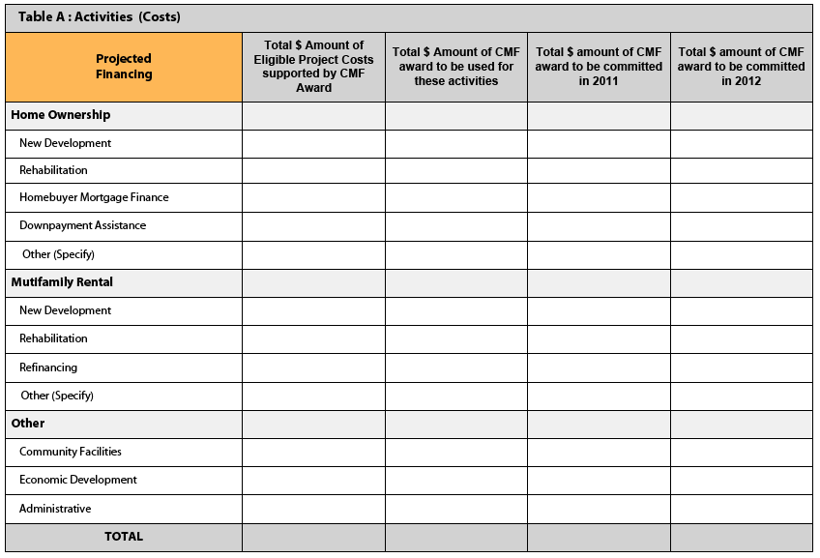

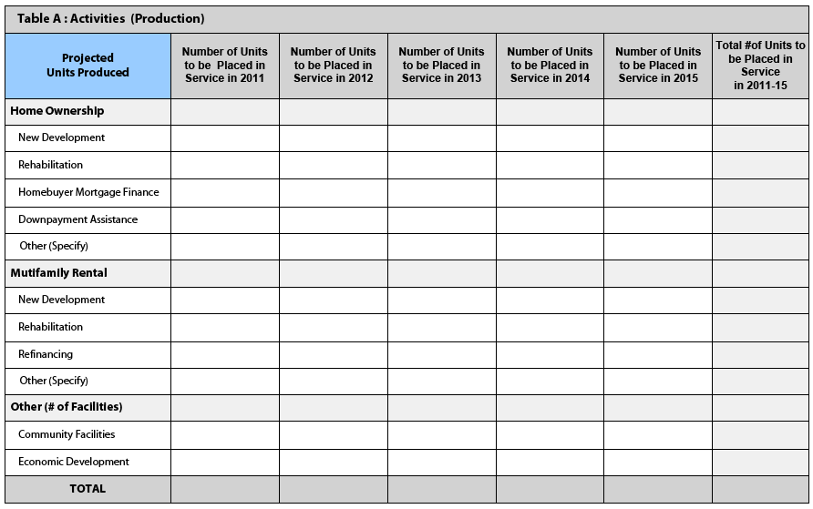

NOTE: All data reported should be based on the placed in service date. Costs reported should be the total development costs inclusive of financing provided by others.

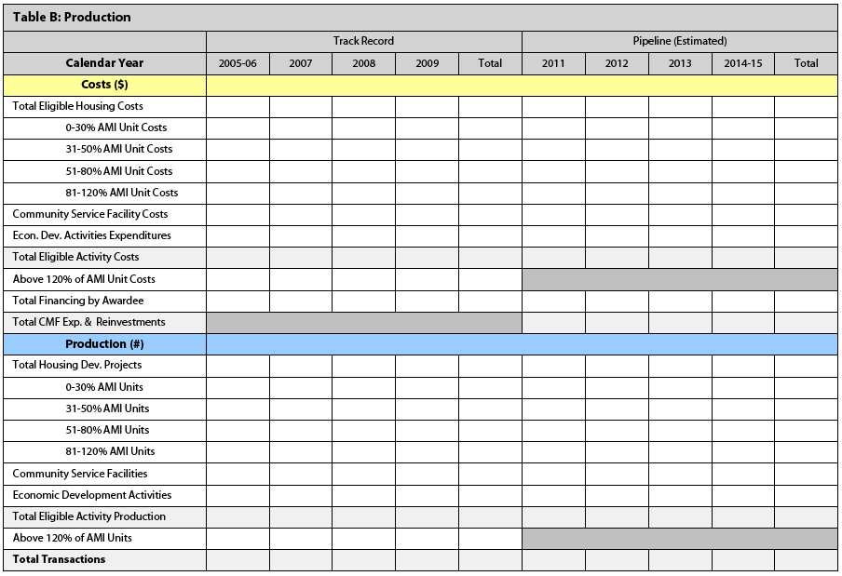

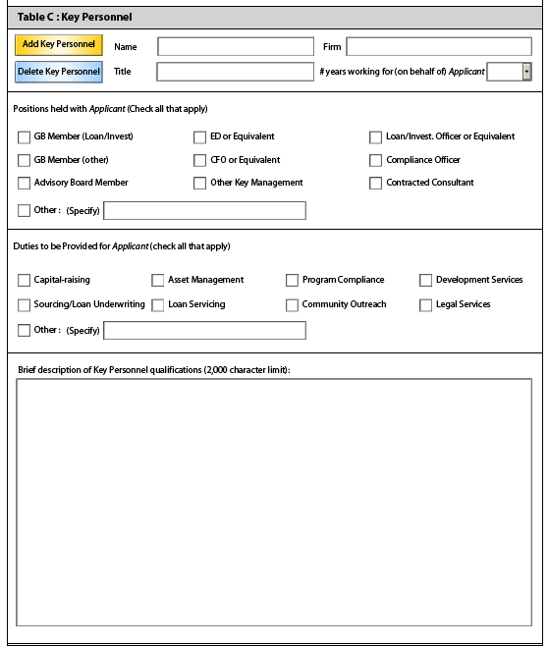
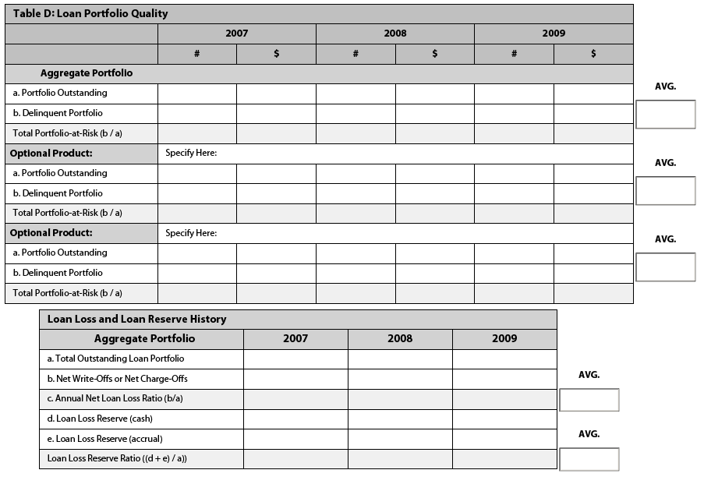
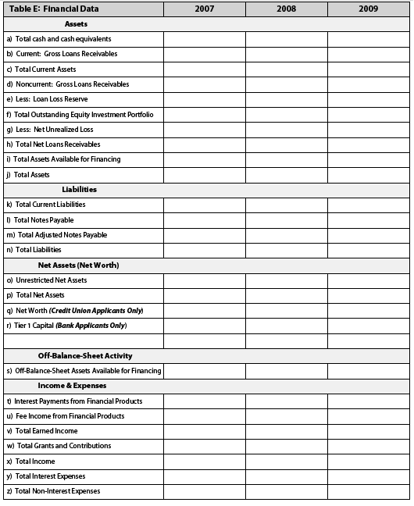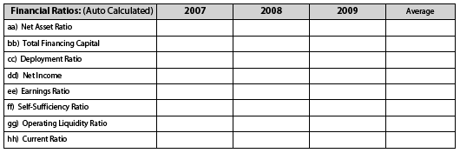

Part III: forms and Certifications

- Environmental Certification Form:
- By checking the box to the right, the Applicant certifies that it will comply with the CDFI Fund’s environmental review requirements as set forth in 12 CFR Part 1815, including those highlighted in the Notification section of the Environmental Review Form.
- Did the Applicant answer “Yes” to any of the questions in the Environmental Review Form?
_____Yes _____No
- If yes to Question #30(b), provide a detailed description of each action affirmatively identified in the Environmental Review Form, clearly identifying the category in which the action falls (4,000 character limit).

- Assurances and Certifications Form:
- Can the Applicant certify that it will comply with all of the Assurances and Certifications listed in the Application Instructions if an award is made? (Note: Certain assurances and certifications may not be applicable to the Applicant).
_____Yes _____No
- If no to Question #31(a), identify the particular Assurance or Certification that cannot be complied with or attested to and describe in detail the particular facts and circumstances behind it. The CDFI Fund will review each case to determine whether the Applicant is eligible to receive CMF funding (4,000 character limit).

- 501(c)(4) Questionnaire:
- Is the Applicant a 501(c)(4)?
_____Yes _____No
If yes to Question #32(a):
- By checking the box to the right, the Applicant certifies that the answers to the 501(c)(4) Questionnaire and the written explanations in Question #32(d), if any, are true, accurate, and complete to the best of the Applicant's information, knowledge, and belief and that, since January 1, 1996, the Applicant has not engaged in Lobbying Activities as defined in Section 3 (7) of the Lobbying Disclosure Act of 1995, P.L. 104-65, as amended.
- Did the Applicant answer “Yes” to any of the questions in the 501(c)(4) Questionnaire?
_____Yes _____No
- If yes to Question #32(c), describe in detail the facts and circumstances, subject matter, date(s), names and titles of all individuals and their employers and their organizations (4,000 character limit).

Environmental Review Form
Applicant Name:
The CDFI Fund’s environmental review requirements are set forth in 12 CFR Part 1815. The Applicant should review such regulations carefully before completing this section. In order to assure compliance with those regulations and other requirements related to the environment, the Applicant shall provide the following information:
 | YES | NO
- Are there any actions proposed in the Application that do not constitute a “categorical exclusion” as defined in 12 CFR 1815.110?
If YES, would any of these actions normally require an environmental impact statement (see 12 CFR 1815.109)?
- Are there any activities proposed in the Application that involve:
- Historical or archeological sites listed on the National Register of Historic Places or that may be eligible for such listing?
- Wilderness areas designated or proposed under the Wilderness Act?
- Wild or scenic rivers proposed or listed under the Wild and Scenic Rivers Act?
- Critical habitats of endangered or threatened species?
- Natural landmarks listed on the National Registry of Natural Landmarks?
- Coastal barrier resource systems?
- Coastal Zone Management Areas?
- Sole Source Aquifer Recharge Areas designated by EPA?
- Wetlands?
- Flood plains?
- Prime and unique farmland?
- Properties listed or under consideration for listing on the Environmental Protection Agency’s List of Violating Facilities?
**If YES to any of the above questions, attach a detailed description of each action, clearly identifying the category in which the action falls.
NOTIFICATION
As stated in 12 CFR 1815.105, if the CDFI Fund determines that the Application proposes actions which require an environmental assessment or an environmental impact statement, any approval and funding of the Application will be contingent upon:
- The Applicant supplying to the CDFI Fund all information necessary for the CDFI Fund to perform or have performed any required environmental review;
- The Applicant not using any CDFI Fund award funds to perform any of the proposed actions in the Application requiring an environmental review until approval is received from the CDFI Fund; and
- The outcome of the required environmental review.
In addition, as stated in 12 CFR 1815.106, if the CDFI Fund determines that an Application, or any part thereof, is not sufficiently definite to perform a meaningful environmental review prior to approval of the Application, final approval and funding of the Application shall require supplemental environmental review prior to the taking of any action directly using CDFI Fund award funding for any action that is not a categorical exclusion.

Assurances and Certifications

Signing the certification on the SF 424 certifies that the Applicant will comply with the Assurances and Certifications listed below if an Award is made. Certain of these Assurances and Certifications may not be applicable to the Applicant. An Applicant may not modify any of the Assurances and Certifications

A. Standard Form 424B: Assurances -- Non-Construction Programs
As the duly authorized representative of the Applicant, I certify that the Applicant:
- Has the legal authority to apply for Federal assistance, and the institutional, managerial and financial capability (including funds sufficient to pay the non-Federal share of project costs) to ensure proper planning, management and completion of the project described in this Application.
- Will give the awarding agency, the Comptroller General of the United States, and if appropriate, the State, through any authorized representative, access to and the right to examine all records, books, papers, or documents related to the award; and will establish a proper accounting system in accordance with generally accepted accounting standards or agency directives.
- Will establish safeguards to prohibit employees from using their positions for a purpose that constitutes or presents the appearance of personal or organizational conflict of interest, or personal gain.
- Will initiate and complete the work (activities in Application) within the applicable time frame after receipt of approval of the awarding agency.
- Will comply with the Intergovernmental Personnel Act of 1970 (42 U.S.C. 4728-4763) relating to prescribed standards for merit systems for programs funded under one of the nineteen statutes or regulations specifies in Appendix A of OPM’s Standards for a Merit System of Personnel Administration (5 CFR 900, Subpart F).
- Will comply with all Federal statutes relating to nondiscrimination. These include but are not limited to: (a) Title VI of the Civil Rights Act of 1964 (P.L.88-352) which prohibits discrimination on the basis of race, color or national origin; (b) Title IX of the Education Amendments of 1972, as amended (20 U.S.C.1681-1683, 1685-1686), which prohibits discrimination on the basis of sex; (c) Section 504 of the Rehabilitation Act of 1973, as amended (29 U.S.C.794), which prohibits discrimination on the basis of handicaps; (d) the Age Discrimination Act of 1975, as amended (42 U.S.C.6101-6107), which prohibits discrimination on the basis of age; (e) the Drug Abuse Office and Treatment Act of 1972 (P.L. 92-255), as amended, relating to nondiscrimination on the basis of drug abuse; (f) the Comprehensive Alcohol Abuse and Alcoholism Prevention, Treatment and Rehabilitation Act of 1970 (P.L.91-616), as amended, relating to nondiscrimination on the basis of alcohol abuse or alcoholism; (g) Sections 523 and 527 of the Public Health Service Act of 1912 (42 U.S.C. 290 dd-3 and 290 ee-3), as amended, relating to confidentiality of alcohol and drug abuse patient records; (h) Title VIII of the Civil Rights Act of 1968 (42 U.S.C.3601 et seq.), as amended, relating to nondiscrimination in the sale, rental or financing of housing; (i) any other nondiscrimination provisions in the specific statute(s) under which Application for Federal assistance is being made; and (j) the requirements of any other nondiscrimination statutes which may apply to the Application.
- Will comply, or has already complied, with the requirements of Titles II and III of the Uniform Relocation Assistance and Real Property Acquisition Policies Act of 1970 (P.L. 91-646) which provide for fair and equitable treatment of persons displaced or whose property is acquired as a result of Federal or federally assisted programs. These requirements apply to all interests in real property acquired for project purposes regardless of Federal participation in purchases.
- Will comply with the provisions of the Hatch Act (5 U.S.C.1501-1508 & 7324-7328) which limit the political activities of employees whose principal employment activities are funded in whole or in part with Federal funds.
- Will comply, as applicable, with the provisions of the Davis-Bacon Act (40 U.S.C. 276a to 276a-7), the Copeland Act (40 U.S.C. 276c and 18 U.S.C. 874), and the Contract Work Hours and Safety Standards Act (40 U.S.C. 327-333), regarding labor standards for federally assisted construction subagreements.
- Will comply, if applicable, with flood insurance purchase requirements of Section 102(a) of the Flood Disaster Protection Act of 1973 (P.L. 93-234) which requires recipients in a special flood hazard area to participate in the program and to purchase flood insurance if the total cost of insurable construction and acquisition is $10,000 or more.
- Will comply with environmental standards which may be prescribed pursuant to the following: (a) institution of environmental quality control measures under the National Environmental Policy Act of 1969 (P.L.91-190) and Executive Order 11514; (b) notification of violating facilities pursuant to EO 11738; (c) protection of wetlands pursuant to EO 11990; (d) evaluation of flood hazards in floodplains in accordance with EO 11988; (e) assurance of project consistency with the approved State management program developed under the Coastal Zone Management Act of 1972 (16 U.S.C. 1451et seq.); (f) conformity of Federal actions to State Implementation Plans under Section 176(c) of the Clear Air Act of 1955, as amended (42 U.S.C. 7401 et seq.); (g) protection of underground sources of drinking water under the Safe Drinking Water Act of 1974, as amended, (P.L.93-523); and (h) protection of endangered species under the Endangered Species Act of 1973, as amended, (P.L.93-205).
- Will comply with the Wild and Scenic Rivers Act of 1968 (16 U.S.C. 1271 et seq.) related to protecting components or potential components of the national wild and scenic rivers system.
- Will assist the awarding agency in assuring compliance with Section 106 of the National Historic Preservation Act of 1966, as amended (16 U.S.C. 470), EO 11593 (identification and protection of historic properties), and the Archaeological and Historic Preservation Act of 1974 (16 U.S.C. 469a-1 et seq.).
- Will comply with P.L. 93-348 regarding the protection of human subjects involved in research, development, and related activities supported by this award of assistance.
- Will comply with the Laboratory Animal Welfare Act of 1966 (P.L. 89-544, as amended, 7 U.S.C. 2131 et seq.) pertaining to the care, handling, and treatment of warm blooded animals held for research, teaching, or other activities supported by this award of assistance.
- Will comply with the Lead-Based Paint Poisoning Prevention Act (42 U.S.C. 4801 et seq.) which prohibits the use of lead based paint in construction or rehabilitation of residence structures.
- Will cause to be performed the required financial and compliance audits in accordance with the Single Audit Act of 1984.
- Will comply with all applicable requirements of all other Federal laws, executive orders, regulations and policies governing this program.

B. Additional Certifications
In addition to the assurances and certifications provided by the Applicant pursuant to OMB Standard Form 424B, the Applicant hereby assures and certifies that:
- It is duly organized and validly existing under the laws of the jurisdiction in which it was incorporated or otherwise established, and is (or within 30 days will be) authorized to do business in any jurisdiction in which it proposes to undertake activities specified in this Application;
- Its Board of Directors (or similar governing body) has by proper resolution or similar action authorized the filing of this Application, including all understandings and assurances contained herein, and directed and authorized the person identified as the authorized representative of the Applicant to act in connection with this Application and to provide such additional information as may be required;
- It will comply with all applicable requirements of the Community Development Banking and Financial Institutions Act of 1994 (the Act) [12 U.S.C. 4701 et seq.], regulations implementing the Act and all other applicable Department of the Treasury regulations and implementing procedures (and any regulations or procedures which are later promulgated to supplement or replace them);
- It will comply, as applicable and appropriate, with the requirements of OMB Circulars (e.g., A-110 and A-133) and any regulations and circulars which are later promulgated to supplement or replace them, including standards for fund control and accountability;
- It has not knowingly and willfully made or used a document or writing containing any false, fictitious or fraudulent statement or entry as part of this Application or any related document, correspondence or communication. (The Applicant and its authorized representative should be aware that, under 18 U.S.C. 1001, whoever knowingly and willfully makes or uses such document or writing shall be fined or imprisoned for not more than five years, or both); and
- The information in this Application, and in these assurances and certifications in support of the Application, is true and correct to the best of the Applicant’s knowledge and belief and the filing of this Application has been duly authorized.

C. Certification Regarding Debarment, Suspension, and Other Responsibility Matters -- Primary Covered Transactions: Instructions for Certification
- By signing and submitting this Application, the prospective primary participant (the Applicant) is providing the certification set out below.
- The inability of a person to provide the certification required below will not necessarily result in the denial of participation in this covered transaction. The prospective Applicant shall submit an explanation of why it cannot provide the certification set out below. The certification or explanation will be considered in connection with the Fund’s determination whether to enter into this transaction (approval and funding of the Application). However, failure of the Applicant to furnish a certification or an explanation shall disqualify such person from participation in this transaction.
- This certification is a material representation of fact upon which reliance is placed when the Fund determines to enter into this transaction. If it is later determined that the Applicant knowingly rendered an erroneous certification, in addition to other remedies available to the Federal Government, the Fund may terminate this transaction for cause or default.
- The Applicant shall provide immediate written notice to the Fund if at any time the Applicant learns that its certification was erroneous when submitted or has become erroneous by reason of changed circumstances.
- The terms “covered transactions,” “debarred,” “suspended,” “ineligible,” “lower tier covered transaction,” “participant,” “person,” “primary covered transaction,” “principal,” “proposal”, and “voluntarily excluded,” as used in this clause (certification), have the meanings set out in the Definitions and Coverage sections of the rules implementing Executive Order 12549. You may contact the Fund for assistance in obtaining a copy of those regulations (31 CFR part 19).
- The Applicant agrees by submitting this Application that, should the proposed covered transaction be entered into, it shall not knowingly enter into any lower tier covered transaction with a person who is debarred, suspended, declared ineligible, or voluntarily excluded from participation in this covered transaction, unless authorized by the Fund.
- The Applicant further agrees by submitting this Application that it will include the clause titled “Certification Regarding Debarment, Suspension, Ineligibility and Voluntary Exclusion-Lower Tier Covered Transaction,” to be provided by the Fund, without modification, in all lower tier covered transactions and in all solicitations for lower tier covered transactions (see 31 CFR part 19, Appendix B).
- A participant in a covered transaction may rely upon a certification of a prospective participant in a lower tier covered transaction that it is not debarred, suspended, ineligible, or voluntarily excluded from the covered transaction, unless it knows that the certification is erroneous. A participant may decide the method and frequency by which it determines the eligibility of its principals. Each participant may, but is not required to, check the Nonprocurement List.
- Nothing contained in the foregoing shall be construed to require establishment of a system of records in order to render in good faith the certification required by this clause. The knowledge and information of a participant is not required to exceed that which is normally possessed by a prudent person in the ordinary course of business dealings.
- Except for transactions authorized under paragraph 6 of these instructions, if a participant in a covered transaction knowingly enters into a lower tier covered transaction with a person who is suspended, debarred, ineligible, or voluntarily excluded from participation in this transaction, in addition to other remedies available to the Federal Government, the Fund may terminate this transaction for cause or default.

D. Certification Regarding Debarment, Suspension, and Other Responsibility Matters -- Primary Covered Transactions
- The prospective primary participant (the Applicant) certifies to the best of its knowledge and belief, that it and its principals:
- are not presently debarred, suspended, proposed for debarment, declared ineligible, or voluntarily excluded from covered transactions by any Federal department or agency;
- have not within a three-year period preceding this Application been convicted of or had a civil judgment rendered against them for commission of fraud or a criminal offense in connection with obtaining, attempting to obtain, or performing a public (Federal, State or local) transaction or contract under a public transaction; violation of Federal or State antitrust statutes or commission of embezzlement, theft, forgery, bribery, falsification or destruction of records, making false statements, or receiving stolen property;
- are not presently indicted for or otherwise criminally or civilly charged by a governmental entity (Federal, State or local) with commission of any of the offenses enumerated in paragraph (1)(b) of this certification; and
- Have not within a three-year period preceding this Application had one or more public transactions (Federal, State or local) terminated for cause or default.
- Where the Applicant is unable to certify to any of the statements in this certification, such Applicant shall attach an explanation to this proposal.

E. Certification Regarding Drug-Free Workplace Requirements
- The Applicant certifies that it will provide a drug-free workplace by:
- publishing a statement notifying employees that the unlawful manufacture, distribution, dispensing, possession, or use of a controlled substance is prohibited in the Applicant’s workplace and specifying the actions that will be taken against employee for violations of such prohibition;
- establishing a drug-free awareness program to inform employees about:
(i) the dangers of drug abuse in the workplace;
(ii) the Applicant’s policy of maintaining a drug-free workplace;
(iii) any available drug counseling, rehabilitation, and employee assistance program;
(iv) the penalties that may be imposed upon employees for drug abuse violations occurring in the workplace
- making it a requirement that each employee to be engaged in the performance of the award be given a copy of the statement required by subparagraph (a);
- notifying the employee in the statement required by subparagraph (a) that, as a condition of employment in such grant, the employee will:
(i) abide by the terms of the statement; and
(ii) notify the employer of any criminal drug use statute conviction for a violation occurring in the workplace no later than five calendar days after such conviction;
- notifying the granting agency in writing, within ten calendar days after receiving notice of a conviction under subparagraph (d) (ii) from an employee or otherwise receiving actual notice of such conviction;
- taking one of the following actions, within 30 days of receiving notice under subparagraph (d)(ii), with respect to any employee who is so convicted:
(i) taking appropriate personnel action against such an employee, up to and including termination, consistent with the requirements of the Rehabilitation Act of 1973, as amended; or
(ii) requiring such employee to participate satisfactorily in a drug abuse assistance or rehabilitation program approved for such purposes by a Federal, State, or local health, law enforcement, or other appropriate agency; and
- making a good faith effort to continue to maintain a drug-free workplace through implementation of subparagraphs (a), (b), (c), (d), (e), and (f).
- The Applicant may insert in the space provided below the site(s) for the performance of work (activities carried out by the Applicant) to be done in connection with the award (Place of Performance (Street Address, City, County, State and zip Code)): Not Applicable

F. Certification Regarding Lobbying
- The Applicant certifies, to the best of its knowledge and belief, that:
(a) No Federal appropriated funds have been paid or will be paid, by or on behalf of the Applicant, to any person for influencing or attempting to influence an officer or employee of any agency, a Member of Congress, an officer or employee of Congress, or an employee of a Member of Congress in connection with the awarding of any Federal contract, the making of any Federal grant, the making of any Federal loan, the entering into of any cooperative agreement, and the extension, continuation, renewal, amendment, or modification of any Federal contract, grant, loan, or cooperative agreement;
(b) If any funds other than Federal appropriated funds have been paid or will be paid to any person for influencing or attempting to influence an officer or employee of any agency, a Member of Congress, an officer or employee of Congress, or an employee of a Member of Congress in connection with this Application, the undersigned shall complete and submit Standard Form LLL, “Disclosure Form to Report Lobbying, “ in accordance with its instructions; and
(c) The Applicant shall require that the language of this certification be included in the award documents for all sub-awards of all tiers (including subcontracts, subgrants, and contracts under grants, loans, and cooperative agreements) and that all subrecipients shall certify and disclose accordingly.
- This certification is a material representation of fact upon which reliance is placed when this transaction is made or entered into. Submission of this certification is a prerequisite for making or entering into this transaction imposed by section 1352, title 31, U.S. Code. Any person who fails to file the required certification shall be subject to a civil penalty of not less than $10,000 and not more than $100,000 for each such failure.

501(C)(4) Questionnaire
This questionnaire is necessary for the CDFI Fund to determine whether an Applicant with a 501(c)(4) designation from the IRS is eligible to receive an award from the Fund (see 2 U.S.C. 1601 et al). Please read all definitions before responding to the questions and continue to refer to such definitions in responding to this questionnaire. If the answer to any question is yes, please describe in detail the facts and circumstances, subject matter, date(s), names and titles of all individuals and their employers and their organizations on a separate sheet(s) of paper. The CDFI Fund reserves the right to seek follow-up responses from an Applicant. Failure to complete this questionnaire and, if applicable, respond timely to follow-up questions, will delay the Fund’s processing of the Application, and may result in the disqualification of the Application from further consideration. After submitting responses to this questionnaire, the Applicant is under a continuing obligation to: (1) supplement its responses upon a change in circumstances; and (2) revise or modify its responses within 10 business days of having actual or constructive knowledge that the responses previously submitted and certified are no longer complete, accurate, or true. You may call the CDFI Fund’s Office of Legal Counsel at (202) 622-8662 if you have any questions about this form.
Scope: The scope of this questionnaire is limited to activities on or after January 1, 1996.

Questions
- Has any officer, employee, director, partner, proprietor, or board member contacted¹ a Covered Executive Branch Official² with regard to the formulation, modification, or adoption of Federal legislation (including legislative proposals) | ❑ Yes   No
- Has any officer, employee, director, partner, proprietor, or board member contacted a Covered Executive Branch Official with regard to the formulation, modification, or adoption of a Federal rule, regulation, Executive Order, or any other program, policy, or position of the United States Government? | ❑ Yes   No
- Has any officer, employee, director, partner, proprietor, or Board member contacted a Covered Executive Branch Official with regard to the administration or execution of a Federal program or policy (including the negotiation, award, or administration or a Federal contract, grant, loan, permit, or license)? | ❑ Yes   No
- Has any officer, employee, director, partner, proprietor, or Board member contacted a Covered Executive Branch Official with regard to the nomination or confirmation of a person for a position subject to confirmation by the United States Senate? | ❑ Yes   No
- Has any officer, employee, director, partner, proprietor, or Board member engaged in efforts supporting and coordinating the contact by others of a Covered Executive Branch Official including preparation and planning activities, research and other background work that was intended, at the time performed, for a purpose described in Questions 1-4? | ❑ Yes   No
- Has any officer, employee, director, partner, proprietor, or Board member contacted a Covered Executive Branch Official with regard to the formulation, modification, or adoption of Federal legislation (including legislative proposals)? | ❑ Yes   No
- Has any officer, employee, director, partner, proprietor, or Board member contacted a Covered Executive Branch Official with regard to the formulation, modification, or adoption of a Federal rule, regulation, Executive Order, or any other program, policy, or position of the United States Government? | ❑ Yes   No
- Has any officer employee, director, partner, proprietor, or Board member contacted a Covered Executive Branch Official with regard to the administration or execution of a Federal program or policy (including the negotiation, award, or administration of a Federal contract, grant, loan, permit, or license)? | ❑ Yes   No
- Has any officer, employee, director, partner, proprietor, or Board member contacted a Covered Executive Branch Official with regard to the nomination or confirmation of a person for a position subject to confirmation by the United States Senate? | ❑ Yes   No
- Has any officer, employee, director, partner, proprietor, or Board member engaged in efforts supporting and coordinating the contact by others of a Covered Legislative Branch Official³ including preparation and planning activities, research and other background work that was intended, at the time performed, for a purpose described in Questions 6-9? | ❑ Yes   No

Signature
Signing the certification on SF 424 certifies that the answers to the 501(c)(4) Questionnaire and the written explanations attached thereto are true, accurate, and complete to the best of its information, knowledge, and belief and that, since January 1, 1996, the Applicant has not engaged in Lobbying Activities as defined in Section 3 (7) of the Lobbying Disclosure Act of 1995, P.L. 104-65, as amended.
“Contacted” means any oral or written communication including an electronic communication.
² “Covered executive branch official” means: (a) the President; (b) the Vice President; (c) any officer or employee, or any other individual functioning in the capacity of such an officer or employee, in the Executive Office of the President; (d) any officer or employee serving in an Executive Level I-V position, a “Schedule C” position, or any official in a Senior Executive Service position; (e) any member of the uniformed services serving at grade 0-7 or above; or (f) any officer or employee serving in a position of a confidential, policy-determining, policy-making, or policy-advocating character.

3 “Covered legislative branch official” means: (a) a member of Congress; (b) an elected officer of either House of Congress; and (c) any employee of the House or Senate, including employees of Members, committees, leadership and working groups or caucuses organized to provide legislative services or other assistance to Members of Congress.

