

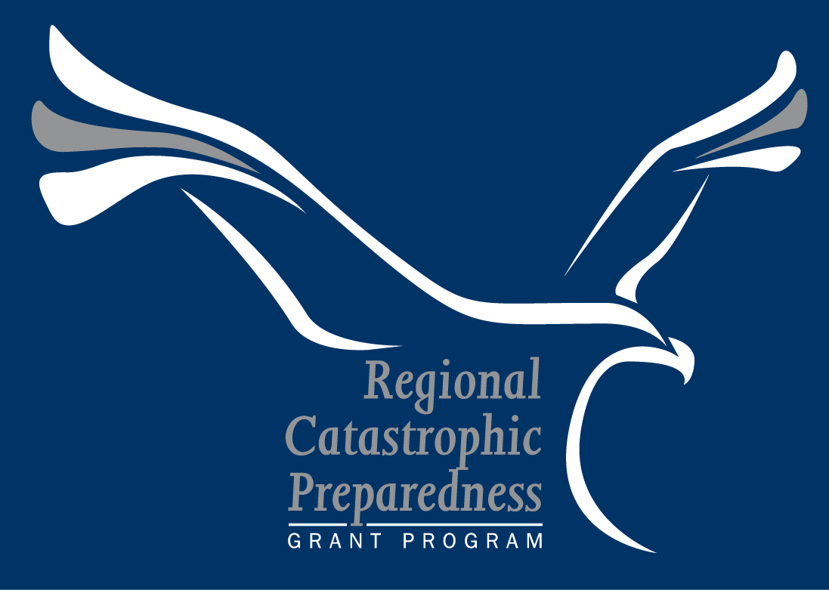

Regional Catastrophic Preparedness
Grant Program (RCPGP)

Investment Justification Template
FY 2009

FEMA Form Number: 089-19
OMB Control Number: 1660-XXXX
Expiration Date: XX-XX-XXXX
Paperwork Burden Disclosure Notice
Public reporting burden for this form is estimated to average 120 hours per response. The burden estimate includes the time for reviewing instructions, searching existing data sources, gathering and maintaining the data needed, and completing and submitting the form. You are not required to respond to this collection of information unless it displays a valid OMB control number. Send comments regarding the accuracy of the burden estimate and any suggestions for reducing the burden to: Information Collections Management, Department of Homeland Security, Federal Emergency Management Agency, 500 C Street, SW, Washington, DC 20472, Paperwork Reduction Project (1660-NEW) NOTE: Do not send your completed form to this address.

RCPGP Background
The Regional Catastrophic Preparedness Grant Program (RCPGP) is intended to enhance regional catastrophic preparedness and continuity of operations efforts, with the aim of strengthening the Nation against risks associated with catastrophic events. The RCPGP centers on the highest risk Urban Areas and surrounding regions, where its impact will have the most significant effect on our collective security and resilience. Each site eligible for participation in the RCPGP, designated as the RCPGP site, includes a collection of jurisdictions that must work collaboratively to fulfill the program requirements.

The RCPGP initiative is provided in response to the direction by Congress to develop “all-hazard regional catastrophic event plans and preparedness” for UASI Urban Areas and participating governments. The goal of this program is to allow Urban Areas to determine how to improve their security and resilience through a process best described as “Fix, Build, and Resource” – that is, fix shortcomings in existing plans; build regional planning processes and planning communities; and, link operational needs identified in plans to resource allocation, including homeland security grant programs.

Document Title: Investment Justification Template

Purpose and Audience
This MS Word document contains the instructions and template for the RCPGP Investment Justification. All RCPGP Investment Justifications for FY 2009 must be developed using this template. Each of the eleven pre-designated urban areas within an RCPGP site may submit a maximum of one Investment Justification for the FY 2009 grant cycle.

To be considered for award, the RCPGP Investment Justification must be accompanied by all grant materials specified in the Overview section and submitted by the primary SAA via grants.gov by 11:59 PM EDT on March 20, 2009. Documents must be submitted as a single Grant Application package under Catalog of Federal Domestic Assistance (CFDA) number 97.111.

Content
Key topics covered in this document include:
- Overview
  - Submission Requirements
  - Further Assistance
- Instructions for Completing an Investment Justification
  - Section I: Overview
  - Section II: Background
  - Section III: Project Details and Project Management
- Investment Justification Template
Overview
Each of the eleven pre-designated high risk, high consequence urban areas within one of the ten RCPGP sites must submit a Grant Application package to DHS on or before March 20, 2009 to apply for and receive RCPGP funds. The Regional Catastrophic Planning Team (RCPT) is responsible for the development of the RCPGP Grant Application package, while the SAA is responsible for submission. The SAA may submit a maximum of one Investment Justification package per pre-designated urban area for the FY 2009 grant cycle.

This document provides instructions and a template for the Investment Justification. All Investment Justifications must be developed using this template. A complete Grant Application package includes an Investment Justification, a detailed project plan, all standard federal grant application forms, an RCPT membership list, and an RCPT Charter. DHS uses the Grant Application package to make grant award decisions and inform programmatic decisions.

Submission Requirements
The program title listed in the Catalog of Federal Domestic Assistance (CFDA) is “Regional Catastrophic Preparedness Grant Program.” The CFDA number is 97.111. Once Central Contractor Registration (CCR) is confirmed, submit completed Investment Justifications along with all other required documents to DHS via grants.gov by 11:59 PM EDT on March 20, 2009. The primary SAA, as designated by the RCPT, is the only entity eligible to submit the documents.

To be considered complete, the Grant Application package must include all of the following required documents, uploaded to grants.gov as separate Adobe .pdf or MS Word files:
Investment Justification (developed using this template)
Detailed Project Plan (for each project submitted)²
RCPT Membership List²
RCPT Charter²
Standard Form 424, Application for Federal Assistance
Standard Form 424A, Budget Information
Standard Form 424B, Assurances
Standard Form LLL, Disclosure of Lobbying Activities

Prior to submission, save the documents as separate Adobe .pdf or MS Word files (version 2003 or earlier) using the following naming convention: RCPGP Document Title_Site Name.doc

Further Assistance
For additional guidance, please contact the Centralized Scheduling and Information Desk (CSID) at askcsid@dhs.gov or 1-800-368-6498 or e-mail RCPGP@dhs.gov. Additional information on RCPGP is also available at http://www.fema.gov/government/grant/rcp/index.shtm.
Instructions for Completing an Investment Justification
This section provides detailed guidance for completing the RCPGP Investment Justification. Details regarding the other required documents (i.e., detailed project plan, standard forms, RCPT Membership List, and RCPT Charter) can be found in Section IV.B of the FY 2009 RCPGP Guidance and Application Kit.

The Investment Justification consists of three primary sections, listed below. Completion instructions for each section can be found in the following sections.
- Section I: Overview
- Section II: Background
- Section III: Project Details and Project Management

Section I: Overview
The Overview section provides FEMA NPD HQ with general information related to the RCPGP site and a summary of the projects proposed in the Investment Justification. This section is structured like a form, with specific questions and designated areas for response. Detailed instructions for this section have been inserted into the template.

Section II: Background
The Background section provides FEMA NPD HQ with an update on the RCPGP site’s RCPT and current regional planning effort. This section is structured like a form, with specific questions and designated areas for response. Detailed instructions for this section have been inserted into the template.

Section III: Project Details and Project Management
The Project Details and Project Management section provides FEMA NPD HQ with a detailed description of each proposed project. This section is free-form, allowing the RCPT maximum flexibility in the presentation of the proposed project(s). This section should be split into two sub-sections for each proposed project: Project Details Section and Project Management Section. Each sub-section must include all information specified below, but the format and length of the response is at the discretion of the RCPT.

Project Details

- Project Name
Create and provide a unique title for the proposed project.

- Project Number
In the event that multiple projects are proposed in the Investment Justification, assign a project number and identify the project as “Project X of Y.” For example, if the Investment Justification includes two projects, indicate the project number in the following format: Project 1 of 2.

- Estimated Project Cost
Include an estimated cost breakdown for the proposed project. Allowable costs include planning, personnel, and management and administration. More information on allowable costs is included in Appendix A of the FY 2009 RCPGP Guidance and Application Kit. All management and administration expenses must be justified in this section. Please refer to section IV.E. in the FY 2009 Guidance and Application Kit for further information on management and administration costs.
The sum of estimated project costs for all proposed projects must equal the amount specified for the site in Section II of the FY 2009 RCPGP Guidance and Application Kit.

- Cost Share Requirement
Describe how the 25 percent cost share requirement of non-federal funds (cash or “in-kind”) will be met. Investment Justifications may spread the 25 percent cost share requirement unevenly across projects. Please refer to section III.B. of the FY 2009 Guidance and Application Kit for further information regarding the required cost share.

- Start Date & End Date
Indicate the start and end date of the proposed project. Projects must start and end within the grant’s 24 month period of performance.

- Project Scope Statement
Provide a scope statement for each proposed project. Scope statements must meet the following criteria:
  - Briefly state the project’s objective(s) in terms of desired outcomes and final products
  - Describe all of the work required, and only the work required, to complete the project successfully
A strong scope statement should be precise and use action verbs (e.g., develop, deliver, select). Applicants may supplement the project scope statement with a work breakdown structure if they choose. The scope statement and work breakdown structure will become the basis for measuring project success.

- Explain how Specified Requirements will be Fulfilled
Provide an overview of each catastrophic planning project that will be implemented using RCPGP funds. At a minimum, each overview must specify the expected outcomes and accomplishments of the project and detail how the proposed projects fulfill the following requirements, citing specific examples where possible.
  - Address the following RCPGP FY 2009 priorities:
    - Ensure the integration of planning and synchronization of plans through the use of national planning systems and tools
    - Share best practices in support of a robust national planning community
    - Implement citizen and community preparedness campaigns with a focus on educating citizens about catastrophic events and the necessary steps for preparedness
    - Plan for the pre-positioning of needed commodities and equipment
    - Implement the principles and processes identified in CPG-101 for the development of plans consistent with the Integrated Planning System.
    - Address shortcomings in existing plans and processes
  - Focus on at least one of the three RCPGP objectives (Fix, Build, Resource)
  - Build on FY 2008 RCPGP funded projects to ensure successful coordination and implementation of the plans developed
  - Improve the RCPGP site’s catastrophic incident preparedness for all threats and hazards when combined with existing efforts
  - Correct shortcomings identified in reports on catastrophic planning (e.g., Hurricane Katrina After Action Reporting or the 2006 Nationwide Plan Review, the FY 2007 FEMA-led Gap Analysis, or Congressional requirements)
  - Demonstrate consistency with available national planning guidance and the goals, objectives, and targets identified in relevant State/Urban Area Homeland Security Strategies and the State Preparedness Report(s)
  - Explain how selected target capabilities will be addressed

- Coordination with Applicable Entities
Describe how the activities will be coordinated with all relevant State, local, regional, and Tribal authorities. In addition, include coordination between private sector representatives, critical infrastructure owners and operators, and Citizen Corps Council representatives.

Project Management

- Key Milestones
Provide a list of the project’s high-level, key milestones, including start and end dates. At a minimum, the key milestones must include all project and program deliverables. Additional milestones and details will be provided in the Detailed Project Plan (see Section IV.B of the Guidance and Application Kit for additional information).

- Project Leadership Team and Key Resources
Describe, at a high-level, the roles and responsibilities of the management team, governance structures, and subject matter expertise required to manage the project. If the management team is the same as in other projects, the response should explain why this is appropriate.
Also, include a high-level description of the roles and responsibilities of all key resources outside of the project leadership team. For example, key resources may be emergency management subject matter experts, representatives of public utilities, or technical resources that are critical for the success of the project. All resources that are essential for the success of the project should be included.

- Risk Identification and Risk Management
Identify and describe project-related risks that threaten the effective implementation of each project in terms of cost, schedule, or quality. Common examples of project risks include:
  - Scope creep (i.e., unplanned expansion in the size of the project)
  - Delayed decisions (i.e., a key decision-maker is unavailable or slow to respond)
  - Resource imbalances (i.e., too few resources cause slips in schedule, too many increase overhead)
  - Coordination of many stakeholders with varied interests (i.e., it can be difficult to schedule large meetings if everyone is not invested in the outcome)
  - Underestimation of project costs
  - Reliance on a small number of vendors without cost controls
  - Inability to secure key resources for project management team or other subject matter experts

For each risk identified, include the following:
  - The probability of occurrence. At a minimum, the Investment Justification should indicate the probability as high, medium, or low for each risk identified.
  - The level of impact on the project’s success, should the risk occur. The level of impact should describe, at a high level, the projected impact to the success of the project (i.e., a high impact risk might significantly change the project plan; a low impact risk might decrease the ability to complete a milestone on time).

In addition, describe the risk management strategy to handle each identified risk. Each risk can be managed with the following four strategies; select the strategy that is most capable of managing the identified risk.
  - Accept: In the event the risk occurs, the project leadership team may choose to accept the impact of the risk. Before selecting this strategy, ensure the primary impacts of the risk are clearly understood (i.e., delays of related deliverables or projects). Acceptance is an appropriate strategy when risks are small and the impact of all other strategies outweighs that of retaining the risk.
  - Avoid: To prevent the risk from occurring the project leadership team may choose to avoid the impact by changing plans. For example, the deliverable or necessary task that causes the risk may be removed from the project plan. Avoidance may appear to be beneficial, but consider the loss of potential gain, by removing the deliverable or task.
  - Mitigate: Creating a mitigation strategy involves taking immediate steps to reduce the impact of the identified risk. Identify what extra steps can be taken to mitigate the impact of the identified risk and describe each briefly.
  - Transfer: Transferring risk involves sending the risk to a third party. In some cases, certain groups will be better equipped to handle a given risk or be able to accept the impact. For example, fire representatives are better equipped to handle the risk of fire and are a logical choice for the transfer of the identified risk.

To ensure that all appropriate information is captured regarding project risks, it is recommended that the Investment Justification include a table or chart to outline each risk identified, assess the probability and impact, and identify a risk management strategy. An example chart is included below.

Risk Identification and Risk Management Chart for Project [#]: [Project Name]
Risk Number | Project Risk | Probability of Occurrence | Impact | Risk Management Strategy
1 | Delayed Decisions | High | High | Mitigate: RCPT will establish protocol for project- related decision-making (e.g., project manager approval for low-impact decisions and RCPT approval for high-impact decisions only, in order to decrease bureaucracy).
2 | Not Enough Resources to Complete Projects | Medium | High | Transfer: SAA will develop options for expedited hiring and procurement in the event that more resources are needed to complete project(s).

Section I: Overview
Purpose: Provide basic information on the applicant, geography, and projects.
State Name (Of the Primary SAA): |  |  |  |  | RCPGP Site Name:
UASI Urban Area:
Geographical Area:
Discuss any proposed changes to the pre-defined geographical area, as defined in the FY 2009 Guidance and Application Kit. Instructions on making changes to the site’s footprint are included in Section IV.B of the FY 2009 Guidance and Application Kit.
 | << Insert Text Here >>

Section I: Overview (Continued)
Project Focus:
Provide an overview of each project associated with this Investment Justification. The project overviews should include the project title and a short description of the type of project and its expected accomplishments, including a description of how it will build upon projects funded in FY 2008. Specific project details, including key milestones and risks, should be included in Section III: Project Details and Project Management.
<< Insert Text Here >>

Section II: Background
Purpose: Describe which regional partners will be included in implementing the projects outlined in this Investment Justification and the site’s current regional planning effort.
Regional Catastrophic Planning Team (RCPT) Overview:
Provide an overview of any changes to the RCPT from the FY 2008 grant application. This includes any changes to the RCPT structure, including number of members, agencies and jurisdictions represented, and voting rights. Specific details should be provided in the RCPT Membership List and Charter.
<< Insert Text Here >>

Section II: Background (Continued)
Current Regional Planning Effort:
Provide an overview of the site’s current regional planning effort, including key gaps. This section should include details regarding the FY 2008 funded projects and how the proposed FY 2009 projects build upon those started in FY 2008.
<< Insert Text Here >>

Section III: Project Details and Project Management
Purpose: This section is free-form and should provide detailed information regarding each proposed project that will be implemented using RCPGP funds.
Section Structure:
For each project proposed, provide a Project Details and Project Management section. At a minimum, this section should cover the following topics. Additional details can be found in the Instructions section of this document, as noted in parentheses below.
Project Details  - Include Project Name (p. iii)  - Include Project Number (p. iii)  - Provide Estimated Project Cost (p. iii)  - Specify Start and End Date (p. iv)  - Provide Cost Share Requirement Details (p.iv)  - Include Project Scope Statement (p. iv)  - Explain how Specified Requirements will be Fulfilled (p. iv)  - Describe how the Project will be Coordinated with Applicable Entities (p. v) | Project Management  - List Project’s High-Level, Key Milestones (p. v)  - Provide an Overview of the Project’s Leadership Team and Key Resources (p. v)  - Describe Project-Related Risks, Including:  - Probability of Occurrence (p. v)  - Level of Impact (should the risk occur) (p. v)  - Risk Management Strategy (p. vi)

Section III.C and Section IV of the FY 2009 RCPGP Guidance and Application Kit provide additional information on the primary SAA and submission of the grant application.
CPG-101 – Producing Emergency Plans: A Guide for All-Hazard Operations Planning for State, Territorial, Local, and Tribal Governments (Interim), http://www.fema.gov/about/divisions/cpg.shtm
Each individual project does not need to focus on all three objectives; however, the projects collectively must address all three objectives and their deliverables, with a priority focus on the Fix objective.
Section III.C of the FY 2009 RCPGP Guidance and Application Kit provides a list of entities required for coordination.

