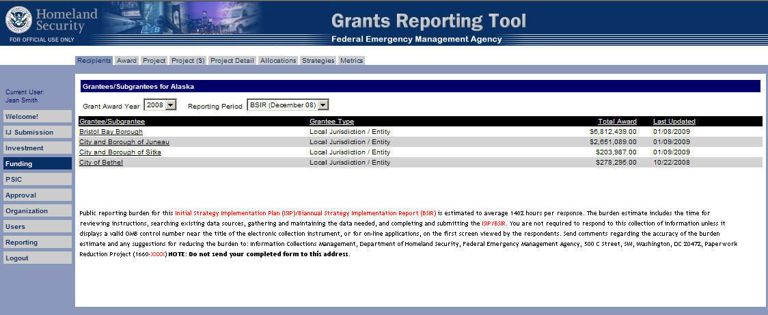
ISIP Submission Funding Module – Recipients Tab – First Screen
(The public reporting burden notice at the bottom of this page will be placed into the system once this data collection effort has been approved by OMB)
Funding Module – Award Tab – Second Screen
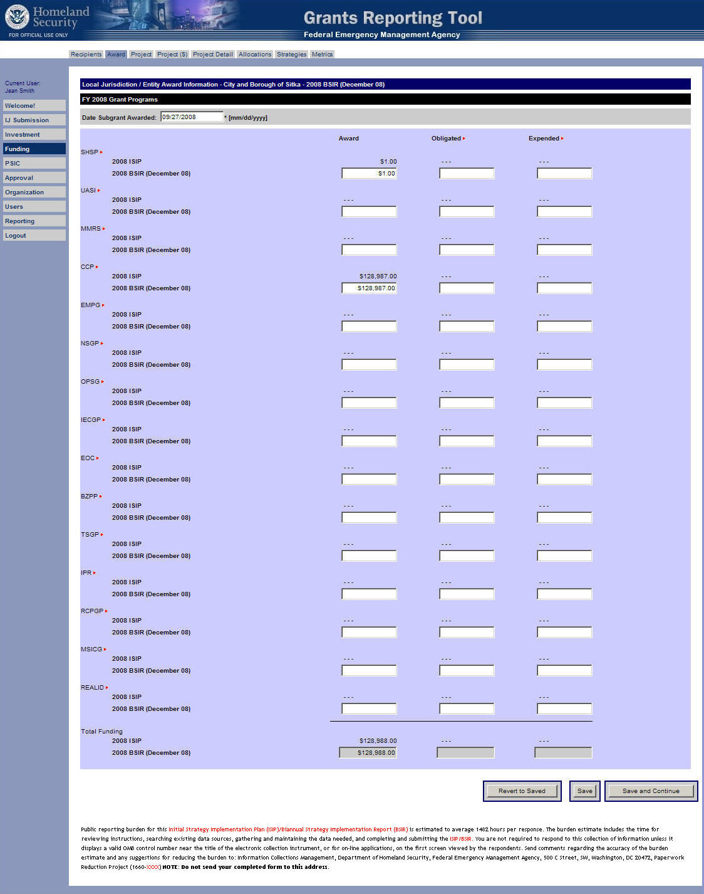
(The public reporting burden notice at the bottom of this page will be placed into the system once this data collection effort has been approved by OMB)

Approval Module – Organization Approval Tab – Eleventh Screen
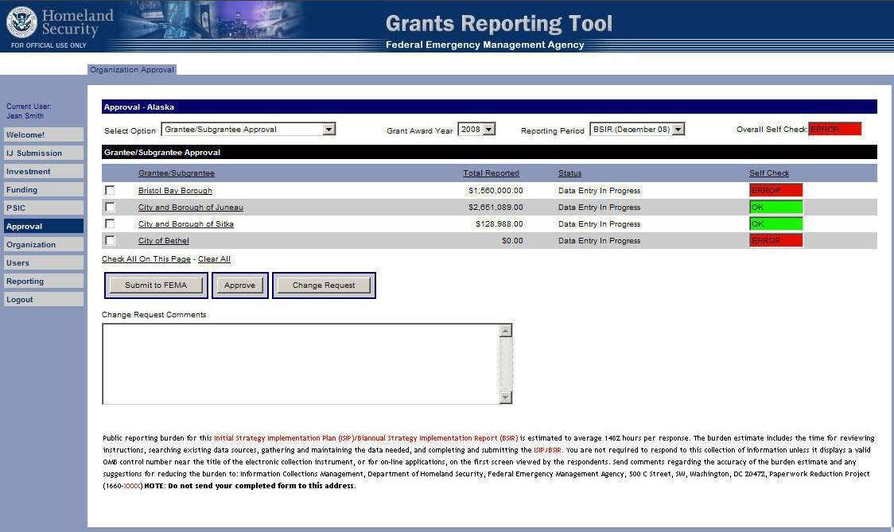
(The public reporting burden notice at the bottom of this page will be placed into the system once this data collection effort has been approved by OMB)

