OMB No. XXXX-XXXX: Approval Expires XX/XX/XXXX



National Household Education Survey

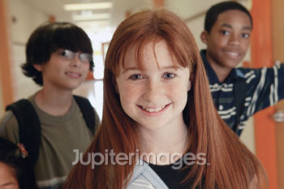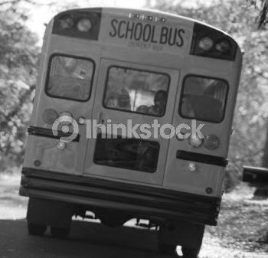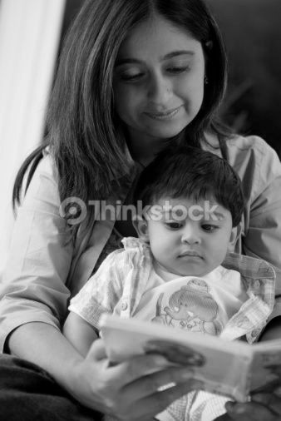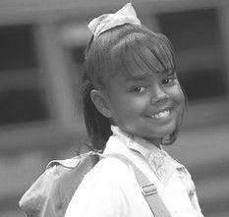

|  |
| --- |
| The National Center for Education Statistics is authorized to conduct this survey under Section 9543, 20 US Code. Your participation is voluntary. Your answers may be used only for statistical purposes and may not be disclosed, or used, in identifiable form for any other purpose except as required by law (Section 9573, 20 US Code). The information you provide will be combined with information from other participants to produce statistical summaries and reports. |



**National Household Education Survey**

**Start Here**

► *This survey should be filled out by an adult household member living at this address.*

► *Please use a blue or black pen if available.*

**► These first questions are about this household’s sources of information and reading materials.**

**1.** **Where do people in this household look for information about current events?**

*Mark* [X] *all that apply.*

* Television
* Radio
* Newspapers
* Magazines
* Internet
* Some other source

**2.** **Are there 10 or more books in your home right now?**

* Yes
* No

**3. Are there a variety of magazines and other reading materials in your home?**

* Yes
* No

**4. In a typical week,** **how many hours do you spend reading a book, magazine, or newspaper?**

|__|__| hours per week

**► Next, we’re interested in courses or training that any adult in this household may have taken in the past 12 months.**

**5. In the past 12 months, has any adult in this household taken any courses or training to find a new job?**

* Yes
* No

**6. In the past 12 months, has any adult in this household taken any courses or training for a current job?**

* Yes
* No

**7. In the past 12 months, has any adult in this household taken courses or training on the following topics?**

|  |  |  |  |
| --- | --- | --- | --- |
|  |  | Yes  ▼ | No  ▼ |
| a. | Computer skills | □ | □ |
| b. | Stress management | □ | □ |
| c. | Health or fitness | □ | □ |
| d. | Foreign language | □ | □ |
| e. | English as a second language | □ | □ |
| f. | Hobbies | □ | □ |
| g. | Some other topic | □ | □ |

**8. In the past 12 months, has any adult in this household taken any classes that are part of a program leading toward…**

|  |  |  |  |
| --- | --- | --- | --- |
|  |  | Yes  ▼ | No  ▼ |
| a. | A college or university degree? | □ | □ |
| b. | A vocational or technical school diploma or certificate? | □ | □ |

**9. A professional certification or license shows the person is qualified to perform a specific job and includes Licensed Realtor, Certified Medical Assistant, Certified Construction Manager, a Project Management Professional (PMP) certification or an Information Technology (IT) certification.**

**Does any adult in this household have a professional certification or state or industry license?**

* Yes
* No

**10. Some people enroll in a college, university, community college or trade school to earn a certificate rather than a degree. Does any adult in this household have an educational certificate?**

* Yes
* No

**► These next questions are about your opinions on schools nationally and in your community.**

**11. Overall, do you think the nation’s public schools are teaching students the skills they will need to be competitive in the workplace?**

* Yes
* No

**12. How would you rate the quality of public schools nationally?**

* Excellent
* Good
* Fair
* Poor
* Very poor

**13.** **How would you rate the quality of your community’s public schools?**

* Excellent
* Good
* Fair
* Poor
* Very poor

**14. Do you agree or disagree with the following statements about schools in your community?**

|  |  |  |  |  |
| --- | --- | --- | --- | --- |
|  |  | Agree  ▼ | Disagree  ▼ | Don’t know  ▼ |
| a. | They are safe places during the school day | □ | □ | □ |
| b. | They are safe places during the evening | □ | □ | □ |
| c. | They maintain good discipline among students | □ | □ | □ |
| d. | They maintain good relationships with the community | □ | □ | □ |

**► These next questions are about the community participation of adults in this household.**

**15. Does any adult in this household participate regularly in a community service activity, such as, volunteering, coaching a sports team, or working with a church or neighborhood association?**

* No ***GO TO question 17.***
* Yes

**16. In a typical week,** **how many hours total does any adult member of this household spend on community service activities?**

|__|__| hours

**17. In the past 12 months, has any adult in this household attended a meeting on local, town, or school affairs?**

* Yes
* No

**► These next questions are about your home/residence.**

**18. How many years have you lived at this address?**

*Write ‘0’ if less than 1 year.*

|__|__| years at this address

**19.** **Is this house…**

*Mark* [X] *ONE only.*

* Owned or being bought by someone in this household,
* Rented by someone in this household, or
* Occupied by some other arrangement?

**20.** **How many computers are in this household that can access the internet?**

|__|__| number of computers

**21. Is there at least one phone inside your home that is currently working and is not a cell phone?**

* Yes
* No

**22. Do you have a working cell phone?**

* Yes
* No

**23. Of all the telephone calls that you receive are…**

* all or almost all calls received on cell phones,
* some received on cell phones and some on regular phones, or
* all or almost all calls received on regular phones?

**24. What is the best phone number to reach you if we have more education questions about someone in your household?**

(__|__|__) |__|__|__| – |__|__|__|__|

**► Think about everyone who lives in this household. Then answer the following questions for all the female and male household members.**

**25.** **How many females live in this household?**

|__|__| number of females

**26.** **How many males live in this household?**

|__|__| number of males

**27.** **Of everyone in this household, how many are age 20 or younger?**

*Do not include those living in college housing.*

|__|__| number age 20 or younger

**► If anyone age 20 or younger usually lives in this household, then fill in the rest of this survey. If no one in this household is age 20 or younger, return this survey in the postage-paid envelope that came with the survey.**

**YOUTH / CHILD 1**

**► Start with the youngest youth or child who is age 20 or younger**.

**1. How old is this child in years?**

* Mark for babies less than 1 year old

|__|__| age in years

**2. What is this child’s sex?**

* Male
* Female

**3.** **Is this child currently in …**

*Mark* [X] *ONE only.*

* Public or private school, or preschool,
* Homeschool instead of school for some or all classes, or
* Not in school? **GO TO A AT BOTTOM.**

**4.** **What is this child’s current grade or equivalent?**

* Preschool
* Kindergarten

|__|__| write grade 1 through 12

* College or vocational school
* None of these

**A.** **Continue with youth or child 2. If no one else age 20 or younger lives here return this form in the postage-paid envelope provided.**

**YOUTH / CHILD 2**

**► Continue with the next youngest youth or child who is age 20 or younger**.

**1. How old is this child in years?**

* Mark for babies less than 1 year old

|__|__| age in years

**2. What is this child’s sex?**

* Male
* Female

**3.** **Is this child currently in …**

*Mark* [X] *ONE only.*

* Public or private school, or preschool,
* Homeschool instead of school for some or all classes, or
* Not in school? **GO TO A AT BOTTOM.**

**4.** **What is this child’s current grade or equivalent?**

* Preschool
* Kindergarten

|__|__| write grade 1 through 12

* College or vocational school
* None of these

**A.** **Continue with youth or child 3. If no one else age 20 or younger lives here return this form in the postage-paid envelope provided.**

**► Youth/child 3 through 6 continue on the next pages.**

**YOUTH / CHILD 3**

**1. How old is this child in years?**

* Mark for babies less than 1 year old

|__|__| age in years

**2. What is this child’s sex?**

* Male
* Female

**3.** **Is this child currently in …**

*Mark* [X] *ONE only.*

* Public or private school, or preschool,
* Homeschool instead of school for some or all classes, or
* Not in school? **GO TO A AT BOTTOM.**

**4.** **What is this child’s current grade or equivalent?**

* Preschool
* Kindergarten

|__|__| write grade 1 through 12

* College or vocational school
* None of these

**A.** **Continue with youth or child 4. If no one else age 20 or younger lives here return this form in the postage-paid envelope provided.**

**YOUTH / CHILD 4**

**1. How old is this child in years?**

* Mark for babies less than 1 year old

|__|__| age in years

**2. What is this child’s sex?**

* Male
* Female

**3.** **Is this child currently in …**

*Mark* [X] *ONE only.*

* Public or private school, or preschool,
* Homeschool instead of public or private school for some or all classes, or
* Not in school? **GO TO A AT BOTTOM.**

**4.** **What is this child’s current grade or equivalent?**

* Preschool
* Kindergarten

|__|__| write grade 1 through 12

* College or vocational school
* None of these

**A.** **Continue with youth or child 5. If no one else age 20 or younger lives here return this form in the postage-paid envelope provided.**

**YOUTH / CHILD 5**

**1. How old is this child in years?**

* Mark for babies less than 1 year old

|__|__| age in years

**2. What is this child’s sex?**

* Male
* Female

**3.** **Is this child currently in …**

*Mark* [X] *ONE only.*

* Public or private school, or preschool,
* Homeschool instead of school for some or all classes, or
* Not in school? **GO TO A AT BOTTOM.**

**4.** **What is this child’s current grade or equivalent?**

* Preschool
* Kindergarten

|__|__| write grade 1 through 12

* College or vocational school
* None of these

**A.** **Continue with youth or child 6. If no one else age 20 or younger lives here return this form in the postage-paid envelope provided.**

**YOUTH / CHILD 6**

**1. How old is this child in years?**

* Mark for babies less than 1 year old

|__|__| age in years

**2. What is this child’s sex?**

* Male
* Female

**3.** **Is this child currently in …**

*Mark* [X] *ONE only.*

* Public or private school, or preschool,
* Homeschool instead of school for some or all classes, or
* Not in school? **GO TO A AT BOTTOM.**

**4.** **What is this child’s current grade or equivalent?**

* Preschool
* Kindergarten

|__|__| write grade 1 through 12

* College or vocational school
* None of these

**A.** **Thank you. Please return this form in the postage-paid envelope provided or mail it to:**

**National Household Education Survey**

**Westat**

**1600 Research Blvd. Room RC B16**

**Rockville, MD 20850-9973**

**Toll-free number for questions: 1-888-880-3033**

**Commonly Asked Questions**

**Q: How did you get my address?**

A: Your address was randomly selected from among all of the home addresses in the nation. It was selected using scientific sampling methods to represent other households in the U.S.

**Q: If there are no children or anyone currently in school in my household, should I respond?**

A: Yes, you should respond to this survey. Once you return the questionnaire, the study will be able to see if anyone in your household is eligible for the next and final survey. If no one is eligible, you will not receive another survey.

**Q: Why don’t you ask more questions about education in this questionnaire?**

A: The purpose of this questionnaire is to find out if anyone in your household is eligible for the next stage of the survey. If so, we will send a second questionnaire that will ask about educational experiences of a member of your household.

**Q: Why should I take part in this study? Do I have to do this?**

A: You represent thousands of other households like yours, and you cannot be replaced. Your answers and opinions are very important to the success of this study. You may choose not to answer any or all questions in this survey. In order for the survey to be representative it is important that you complete and return this questionnaire.

**Q: How will the information I provide be used?**

A: Your responses will be combined with those of others to produce statistical summaries and reports. Your individual data will not be reported. Your answers may be used only for statistical purposes and may not be disclosed, or used, in identifiable form for any other purpose except as required by law (Section 9573, 20 US Code).

**Q: How much time will it take?**

A: On average, it should take 8 minutes for you to respond, including the time for reviewing instructions, and completing and reviewing the collection of information.

**Q: Who is sponsoring the study? Is this study conducted by the Federal Government?**

A: The National Center for Education Statistics, within the Department of Education, is authorized to conduct this study (Section 9543, 20 US Code). Westat has been contracted to conduct this study. This study has been approved by the Office of Management and Budget, the office that reviews all federally sponsored surveys. The approval number assigned to this study is XXXX-XXXX. You may send any comments about this survey, including its length, to the Federal Government. Write to: Andrew Zukerberg, National Center for Education Statistics, U.S. Department of Education, 1990 K Street NW, Room 9036, Washington, DC 20006-5650. You may send e-mail to NHES@westat.com.

**Q: Who is Westat?**

A: Westat is a research company located in Rockville, Maryland. Westat is conducting this survey under contract to the U.S. Department of Education. If you have any questions about the study contact Westat toll-free at 1-888-880-3033.