Department of Energy Utility Billing Data Collection of Building Retrofits

Department of Energy (DOE) aims to collect information from utilities about energy consumption in buildings retrofitted with DOE Recovery Act funds via the Weatherization Assistance Program, State Energy Program, and Energy Efficiency and Conservation Block Grant Program. This document outlines the purpose, process and purposed forms for collecting this energy consumption information.

Purpose: DOE will use energy consumption data to calculate the benefits of Recovery Act programs and to better understand energy savings attributable to these programs. The monthly utility bill data on pre- and post-retrofitting energy consumption from buildings improved with Recovery Act money will be used to analyze the cost effectiveness of different energy efficiency measures, to define the magnitude of energy and cost savings achieved by these Recovery Act programs and to gain lessons learned from the Recovery Act funded projects to improve and promote energy efficiency in the future.

Process:
Grantees, sub-grantees and other recipients of Recovery Act funding (“Recipients”) will sign the approved waiver form “Authorization to Obtain Energy Use Information” (Appendix 1). This form will be distributed, to the extent possible, when work begins on building retrofits by DOE Project Officers responsible for individual grantees. DOE or its contractors will then collect and consolidate the information from the signed recipient waiver forms. DOE or its contractors will provide utilities with the information from recipients in the data form outlined in Appendix 2. Utilities will then provide read dates and consumption information of recipients.

All of the information obtained from this survey and from utilities will be protected and remain confidential. The data will be analyzed in such a way that the information provided cannot be associated back to a specific grantee, sub-grantee, housing unit, or client that a grantee served.

APPENDIX 1: Recovery Act Recipient Authorization Waiver Form

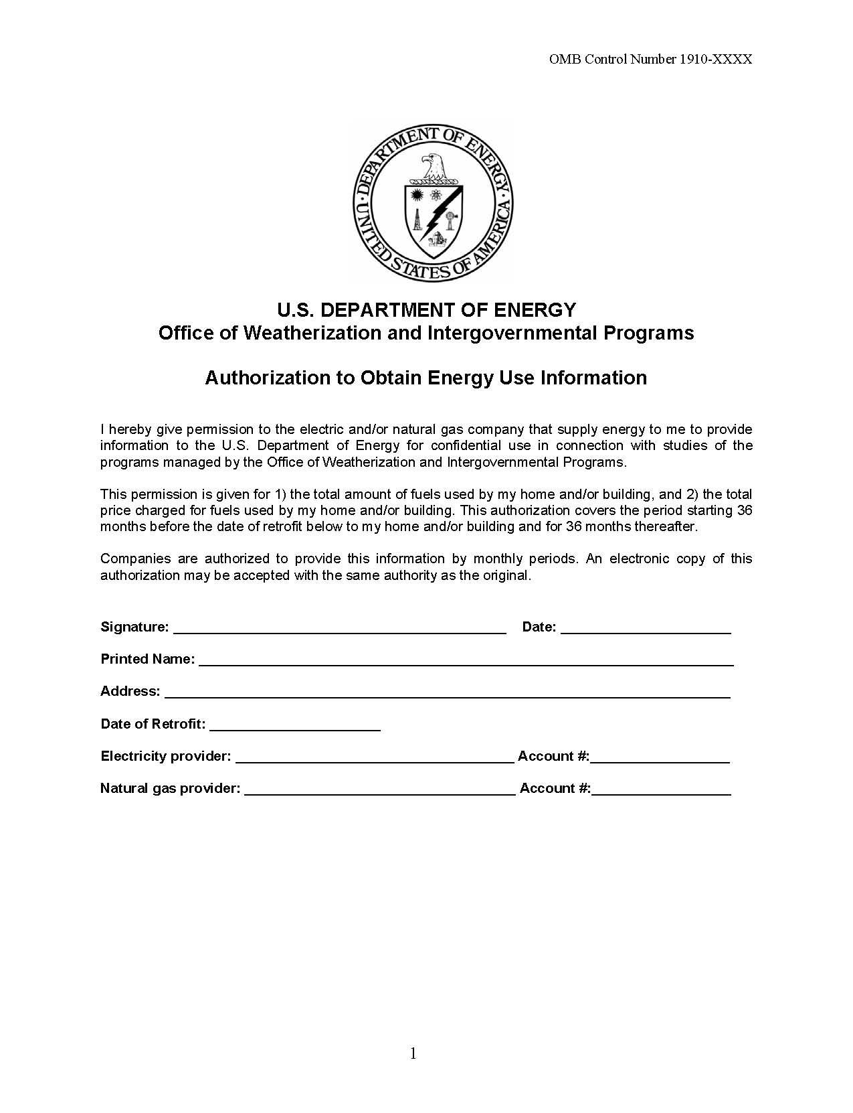

APPENDIX 2: Data Form for Utilities

Section 1: Customer information
We would like to collect electricity and natural gas billing data on facilities retrofitted through Recovery Act funds. A list of your customers receiving retrofits will be provided and new customers appended as necessary. DOE holds waiver forms signed by each Recipient receiving Recovery Act funds authorizing the disclosure of utility billing data both pre-retrofit and post-retrofit that can provided upon request. DOE is requesting the provision of monthly utility billing data for the 36 month period prior to and 36 month period following the date of retrofit indicated.

Account number |  | Utility | Previous read date |  | Current read date | Type of read (1) | Consumption | Units (2) | Rate schedule | Service Active (3) | Date of Retrofit
1234 56789 |  | ABC Utility | 10/6/2010 |  | 11/4/2010 | Actual | 3.0 | Therms | R | 1 | 10/11/2010
(1): Indicate whether reading was either actual or estimated
(2): Use the following units: KWH for electricity, Therms for natural gas
 |  |  |  | (3): Yes = 1, Otherwise = 0

Section 2: Requested information
DOE requests that utility billing data be provided in the format specified above for the data highlighted in yellow. This information will be requested as needed but no more than yearly.

Public Reporting Burden
Public reporting burden by utilities for this collection of information is estimated to average ten minutes per account number, including the time for reviewing instructions, searching existing data sources, gathering and maintaining the data needed, and completing and reviewing the collection of information. Send comments regarding this burden estimate or any other aspect of this collection of information, including suggestions for reducing this burden, to Office of the Chief Information Officer, Records Management Division, IM-11, Paperwork Reduction Project (1910-XXXX), U.S. Department of Energy, 1000 Independence Ave SW, Washington, DC, 20585-1290; and to the Office of Management and Budget (OMB), OIRA, Paperwork Reduction Project (1910-XXXX), Washington, DC 20503.

