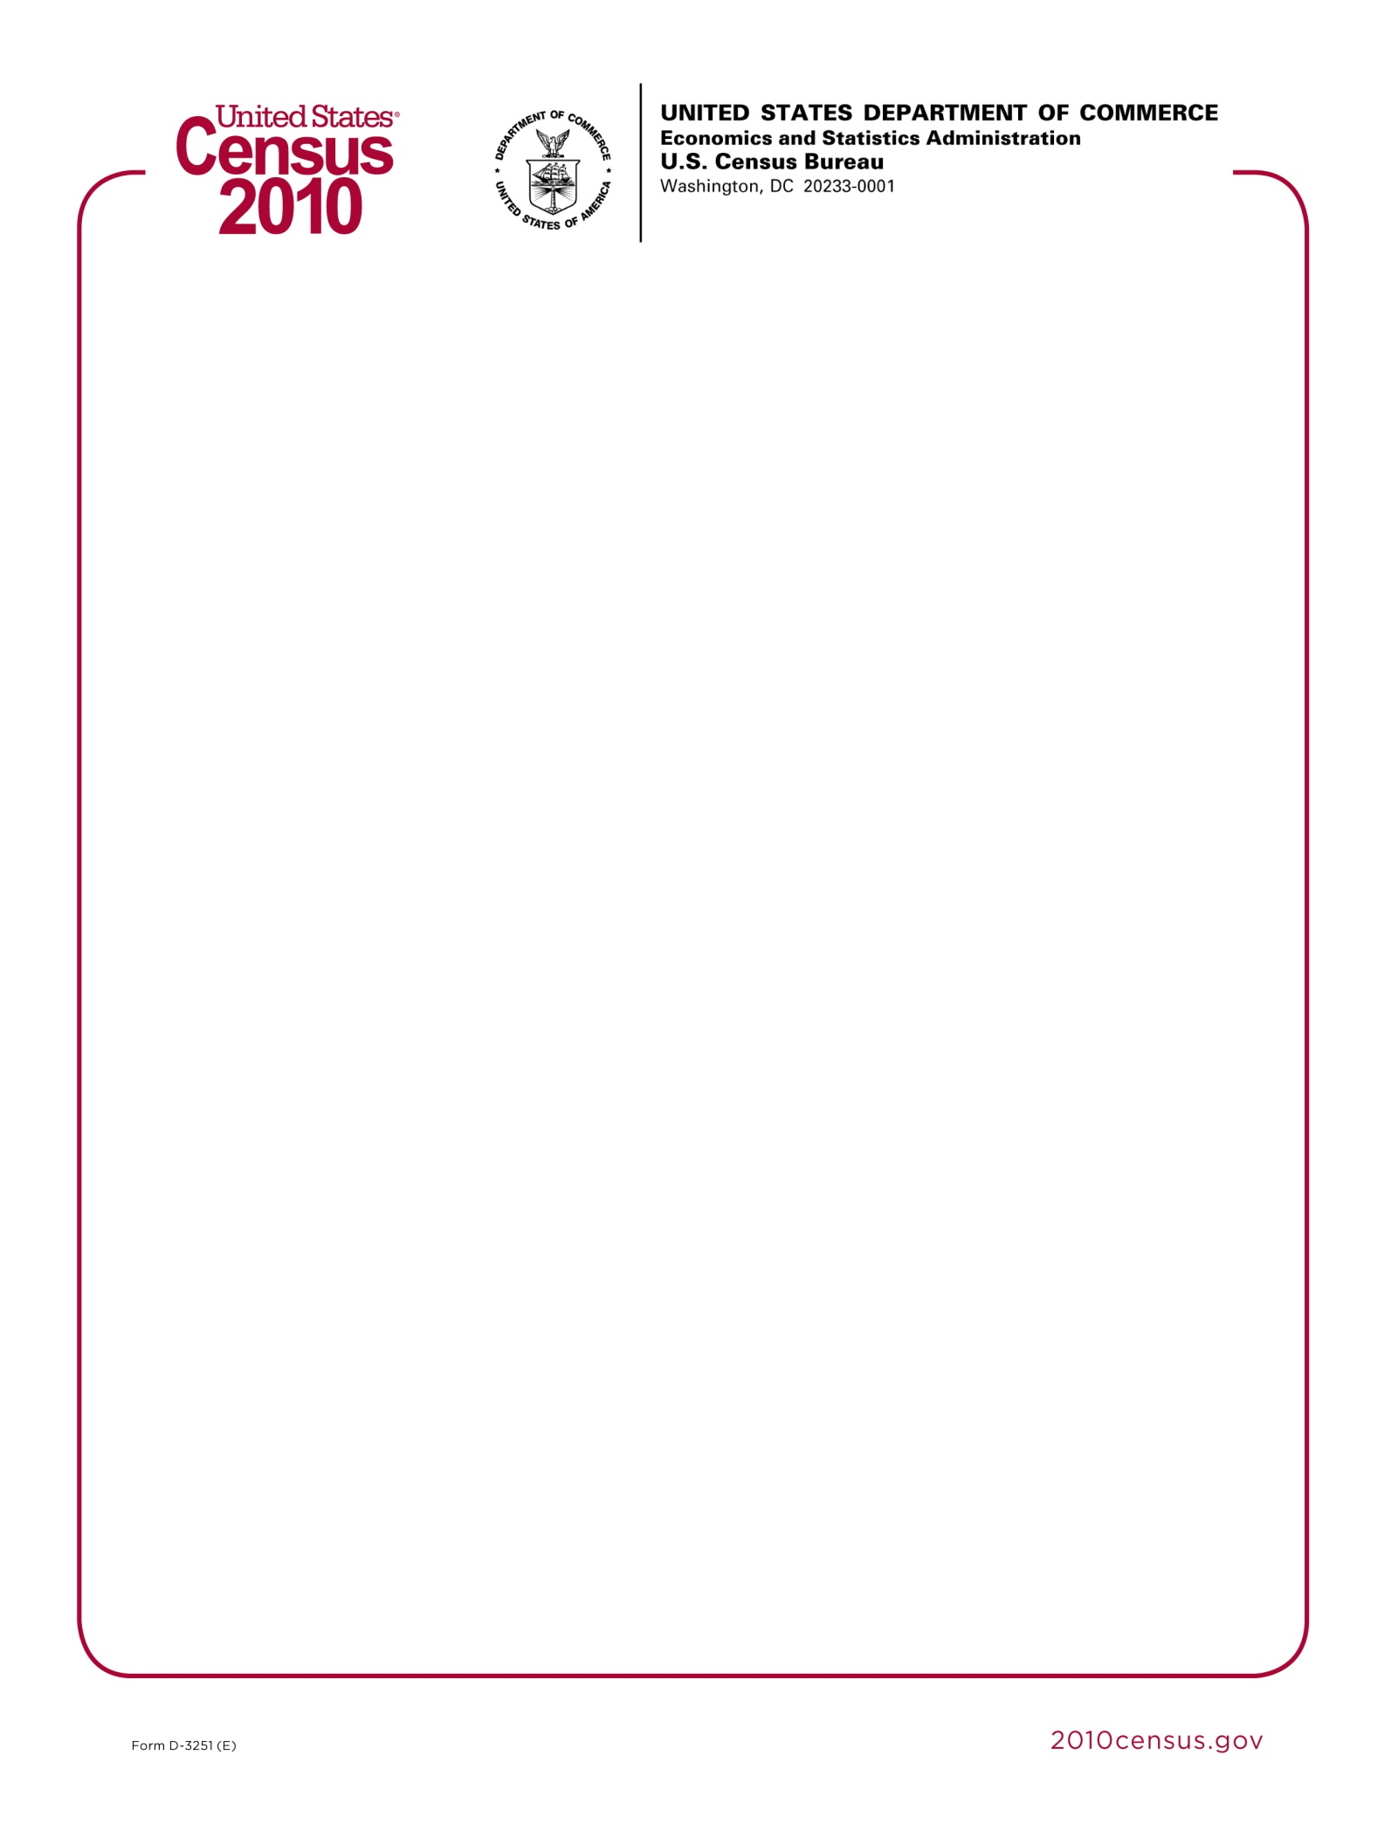

**<<DATE>>**

Dear **<<CONTACT NAME>>**,

A few days ago, you should have received a request for your participation in our 2010 Census Partner Survey. We are conducting this survey to help assess our service to you during the 2010 partnership program and find ways to improve for the 2020 Census. We look forward to receiving your feedback and comments on this program.

If you haven’t already done so, please take this time to complete the online survey at <https://questionweb.com/49335>. If you are unable to access the online survey, please call us toll-free at 1-888-369-3617 from 9:00AM-9:00PM eastern time for assistance in completing this survey.

Your responses and comments will help to improve the partnership program for the 2020 Census.

Sincerely,

Robert M. Groves

Director