**PARENT BROCHUREStudent Focus Groups about the Safe Dates Program**

**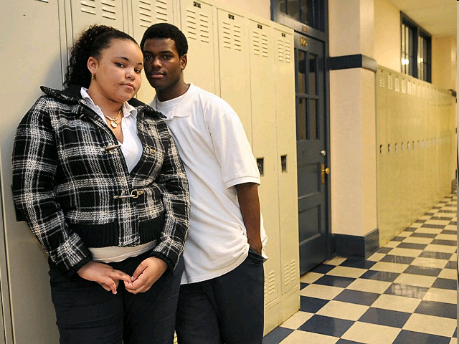**

To Learn More

If parents have any questions, they can contact Olivia Ashley toll-free at (800) 334-8571 ext. 2-6427 or by email at osilber@rti.org.

MCj04122720000[1]

February 2010

**. . . . . . . . . . . . . . . . .**

Please visit our website at:

https://safedates.rti.org/

*Sponsored By:*





*Evaluation Team:*

RTI_gray_1inPC

**RTI International**

Durham, NC

**University of North Carolina**

Chapel Hill, NC

*Student Focus Groups About the Safe Dates Program*

**. . . . . . . . . . . . . . . . .**

******

|  |
| --- |
| **About the Project**  This study about youth violence is funded by the Centers for Disease Control and Prevention (CDC). It will help CDC and schools better understand whether the Safe Dates program to prevent adolescent dating violence should be adapted to meet the needs of urban schools. The study is being conducted for the CDC by RTI International, a nationally recognized organization that has many years of experience conducting research in schools.  Your school was chosen because of its urban location and because it delivered the Safe Dates program last year. Your teen was selected because he or she received the Safe Dates program last year in school and because we value your teen’s opinion.  our school is one of several schools across the country asked to be in this study. Your school was selected because of its demographic and geographic characteristics because we want to include a variety of different schools across the nation. |

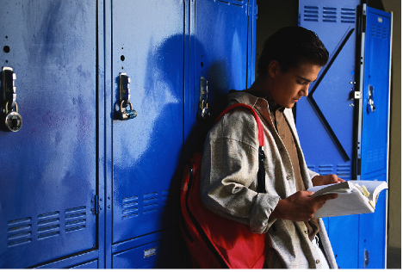

**How Can You Help?**

If your teen was selected, we hope you agree to let him or her participate in the study.

_Pic15

We would like to learn about things like students’ opinions about the Safe Dates program and how the program may need to be changed for delivery in urban schools. Students do not have to have begun dating or experienced violence to participate in the study.



We would like to find out this information through focus groups with students. Please complete and return the contact information form and return it by [DATE]. RTI will contact you to share more information and ask for your consent for your teen to participate. We will also ask your teen for permission to participate.

All the information we collect about your teen’s opinions is very important to us and will be kept private. The information we collect will be identified by an identification number, and we will NEVER use students’ names. The opinions students give during the focus group sessions will not be shared with anyone outside of the study team. Our study team has lots of experience with teens. You can be sure that the people who will talk with your teen are experienced and well-trained.

The decision to take part in the study is entirely up to you and your teen.

If you agree for your teen to participate in the study, RTI will give your teen a $25 gift card as a token of appreciation. Your teen will make an important contribution to the only study in the nation about the Safe Dates program in urban areas. This study will show whether the program needs to be modified for urban teens.

About 40 students at your school will be a part of this exciting effort. We hope your teen will help us!

_Pic17