Attachment A.

Protocol for Children and Adolescent Physical Activity and Fitness Feasibility Study (ages 3-15)

National Health and Nutrition Examination Survey (NHANES)
Children and Adolescent Physical Activity and Fitness Feasibility Study

OMB no. 0920-0237
Expires: 11/30/2012

Assurance of confidentiality – All information which would permit identification of an
individual, a practice, or an establishment will be held confidential, will be used for
statistical purposes only by NCHS staff, contractors, and agents only when required and with necessary controls, and will not be disclosed or released to other persons without the consent of the individual or establishment in accordance with section 308(d) of the Public Health Service Act (42 USC 242m) and the Confidential Information Protection and Statistical Efficiency Act (PL-107-347).

Public reporting burden of this collection of information is estimated to average 90 minute per response, including the time for screening for eligibility, reviewing instructions, searching existing data sources, gathering and maintaining the data needed, and completing and reviewing the collection of information. An agency may not conduct or sponsor, and a person is not required to respond to a collection of information unless it displays a currently valid OMB control number. Send comments regarding this burden estimate or any other aspect of this collection of information, including suggestions for reducing this burden to CDC/ATSDR Reports Clearance Officer; 1600 Clifton Road, MS D-74, Atlanta, GA 30333. ATTN: PRA (0920-0237).

Physical Activity and Fitness Test in Children and Adolescents Feasibility Study Protocol:

Eligibility: Children and adolescents age 3 through 15 years who are not participants in NHANES will be eligible for the feasibility study. Study participants will be selected from within screened households from which no member was eligible for NHANES.

Informed Consent: Parents or guardians will be presented with a Health Measurements List containing the measurements and tests included in the feasibility study. The parents or children ages 3-15 years will provide documented consent for the study after reading the Health Measurements List and participants 12-15 years will give documented assent. The health measurement list and consent forms are provided at the end of this document.

Exclusion Criteria: Individuals ineligible for the study will be identified at the household by the interviewers based on the screening question: “Has a doctor ever said that <SP> should limit or restrict his/her physical activity?”

Study Design: The feasibility study will take place during examinations at an NHANES location. However, a trailer designed for use in Community NHANES will serve as the examination center for the feasibility study. The physical activity and fitness tests to be included in the feasibility study have been selected by DHANES staff with the input of experts in the fields of physical activity and kinesiology. The study will include a measurement of physical activity using an accelerometer, as well as three tests of aerobic capacity, a test for lower body muscle strength, a test of muscular endurance, and a set of tests for fine and gross motor skills. The tests are age dependent.

Report of Findings:
Height, weight, BMI and aerobic capacity will be reported to participants.

Health Measurements List:

Health Measurements List

Below is a list of measurements your child will receive.
Your child will only have the measurement if his or her age falls within the ages shown in parenthesis.

Health Measurements

Your child’s height and weight will be weighed (all) ♦

Your child will wear a physical activity monitor for 7 days (3-5). A prepaid envelope will be provided for mailing the monitor back to our headquarters.

Your child will walk on a treadmill (6-11) ♦

Your child will perform a running test (8-15) ♦

Your child will perform the plank exercise (3-15)

Your child will perform the modified pull-up exercise (6-15)

Your child will have a test of lower body muscle strength (6-15) ♦

Your child’s coordination and balance will be measured (3-5) ♦

Your child will receive the results of health measures shown with a black diamond (♦).

Informational Flyer:

Informational Flyer

U.S. Department of Health and Human Services • Centers for Disease Control and Prevention
National Center for Health Statistics

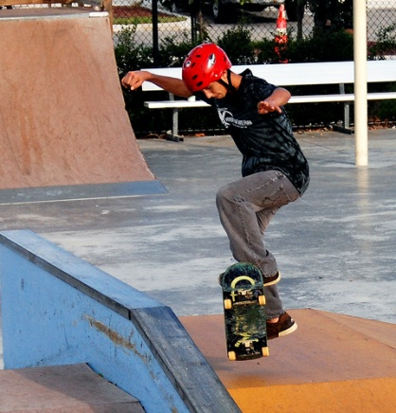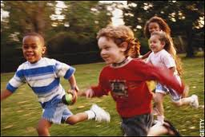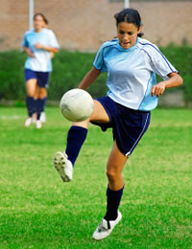

Physical Activity in Children and Youth

Why is physical activity important?
Physical activity is an essential component of a healthy lifestyle. The human body was designed for activity, and by exercising regularly children and adolescents will look and feel better!

In combination with healthy eating, physical activity can help:

- Reduce the risk of heart disease, stroke, cancer and diabetes
- Build strong muscles and bones
- Maintain a healthy weight and improve posture
- Improve mental well-being and increase self-esteem.
It is important that children and adolescents develop exercise and fitness skills that help them maintain good health and well-being in childhood as well as when they are adults. Yet physical inactivity and obesity are increasing in the United States and may threaten the health and well-being of young people.
Who are we?
The National Health and Nutrition Examination Survey (NHANES) is a program of studies designed to assess the health and nutritional status of adults and children in the United States. NHANES is a major program of the National Center for Health Statistics (NCHS). NCHS is part of the Centers for Disease Control and Prevention (CDC) and has the responsibility for producing vital and health statistics for the Nation.

What we want to do
NHANES is conducting a study on ways to measure physical activity and fitness levels in children and adolescents. Participation will help us improve the physical activity measures for children in the National Health and Nutrition Examination Survey. We will take their height and weight and ask them to perform activities such as walking on a treadmill, exercises, and wearing an activity monitor that records body movement during everyday activities. Participation is voluntary.

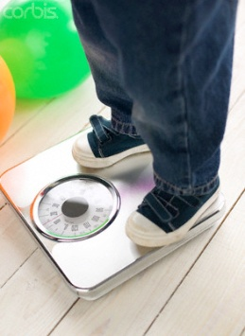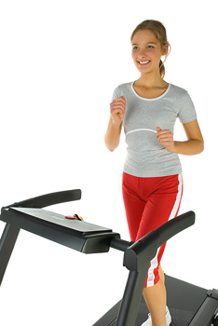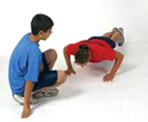

We protect you. All details and information shared with us remain private and we ensure that confidentiality is maintained at all times.

For more information call Dr. Kathryn Porter of the U.S. Public Health Service: 1-800-452-6115 or visit our website: http://www.cdc.gov/nchs/nhanes.htm.

Informed Consent:

NATIONAL HEALTH AND NUTRITION EXAMINATION SURVEY (NHANES)
Children’s Physical Activity Feasibility Study

CONSENT FORM

Please read the following information.
If you agree to participate, sign your name at the bottom

The Centers for Disease Control (CDC) is asking you to participate in a study on ways to measure physical activity and fitness levels in children and adolescents. It is important that children and adolescents develop exercise and fitness skills that help them maintain good health and well-being in childhood as well as when they are adults. Your participation will help improve the physical activity measures for children in the National Health and Nutrition Examination Survey. We will take your height and weight and ask you to perform activities such as walking on a treadmill, exercises, and wearing an activity monitor that records body movement during everyday activities. You may feel tired or sore after the study.

This will take about 1.5 hours of your time and you will be paid $20.00 for your time and effort. An additional $30 will be given to your parent on the day of your exam. Checks for an additional $40 will be mailed to the parents of participants who return the physical activity monitor to the data collection contractor.

You may also choose to end your participation in the study at any time. There is no penalty for withdrawing from the study. All data collected will be kept strictly confidential and will be used only in NHANES planning. By law, the information you provide cannot be used for any other purpose without your permission.

If you have any questions, feel free to speak to any member of the staff. You may also contact Dr. Kathryn Porter of the U.S. Public Health Service at 1-800-452-6115.

I HAVE READ THE INFORMATION PRESENTED ABOVE AND CONSENT TO PARTICIPATE IN THE EXAMINATION.

__________________________________________
Print first, middle, last name of volunteer

__________________________________________________________
Signature of volunteer (7-15 years of age) Date

___________________________________________________________
Signature of parent/guardian Date

