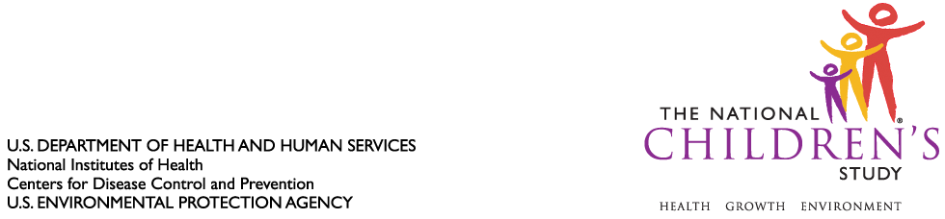

DATE: October 1, 2010

TO: Dr. Margo Schwab

Office of Information and Regulatory Affairs

Office of Management and Budget

FROM: Dr. Jennifer Park

THROUGH: Dr. Steven Hirschfeld

SUBJECT: Request for Non-Substantive Change to National Children’s Study, Vanguard (Pilot) Study (OMB Control #0925-0593, Expiration July 13, 2013)

CC: Dr. Sarah Glavin, Ms. Jamelle Banks, Ms. Mikia Currie

We request non-substantive change to the National Children’s Study Vanguard (Pilot) Study protocol approved as revised by the Office of Information and Regulatory Affairs on July 23, 2010.

1. We ask that minimal visit instruments approved for use in the Alternate Recruitment Substudy (locations=30) also be approved for implementation in the initial Vanguard Study (locations=7).This alignment will assist in the evaluation of study visit measures over the course of the Vanguard Study while minimizing data collection until evaluation of study visit measures is completed. A list of these instruments appears in Table 1, below.

2. We also ask that instruments approved for use in the Alternate Recruitment Substudy be administered in alternate modes. Mode evaluation would assist in the development of efficient and less burdensome data collection for the Vanguard Study and Main Study. With an anticipated recruitment of 2,500 to 3,000 participants, each with multiple encounters, we believe we will have sufficient sample size to examine mode effects statistically. A list of these instruments and proposed modes appears in Table 2, below.

In separate requests, we will ask for OIRA approval of the revised Women’s Informed Consent Form and new study instruments, which largely borrow from instruments previously approved by OIRA.

