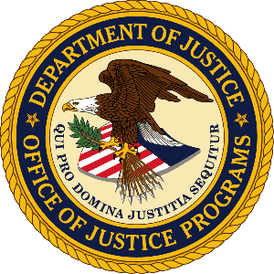

U.S. Department of Justice

Office of Justice Programs

Bureau of Justice Statistics

Washington, D.C. 20531
ATTACHMENT 3 - Survey Cover Letter

MEMORANDUM

Date: [Date]

To: Directors, State Criminal Record Repositories

From: James P. Lynch, Director

Subject: Survey of Criminal History Information Systems

I am writing to seek your assistance in providing information to the Bureau of Justice Statistics (BJS), U.S. Department of Justice, on the status of state-held criminal records. Approximately every two years, since 1989, The Survey of State Criminal History Information Systems, has captured a snapshot of the continuing growth, ongoing improvements, and practices associated with the initiation and updating of state criminal records. As in previous years, your response to this survey is voluntary.

As in the past, survey responses will be compiled by SEARCH, The National Consortium for Justice Information and Statistics. A copy of the 2010 survey questionnaire is attached. A password-protected section of the SEARCH Web site is available for those states that wish to provide their survey responses online. Responses should reflect conditions as of December 31, 2010. Those wishing to utilize the online response option to fill out the survey can visit http://www.search.org/surveys/repository/ and use the password [password] to gain access. The online survey allows each section to be completed independently by the appropriate staff person. Respondents using the online survey tool to enter 2010 data can view previously submitted 2008 data for comparison purposes.

Statistical data presented in past surveys has supported and provided insight to both State and Federal legislative efforts that involve the use of criminal history records. Prominent among these is the Brady Handgun Violence Prevention Act, which mandated the development of the National Instant Criminal Background Check System. Further, the survey provides trend data demonstrating the correlation between continuing federal funding incentives such as the Bureau of Justice Statistics administered National Criminal History Improvement Program and documented results.

Your past cooperation and assistance with this effort has provided a wealth of useful data for law- and policymakers, researchers, justice practitioners and others who depend on survey data to craft responsible laws, policies and procedures, and to prepare informative reports and other educational materials. For your information the published 2008 survey is available at http://bjs.ojp.usdoj.gov/index.cfm?ty=pbdetail&iid=1755.

Your contributions to the Web-enabled Survey of State Criminal History Information Systems make it a useful resource to users both within and outside of the criminal justice community.

Please contact Dennis DeBacco at 916-392-2550 X-325 (email: Dennis@search.org) if you have any questions or comments about the survey, or if you need more information. Thank you in advance for your assistance and cooperation with this important effort.

