**STATE ALUMNI REGISTRATION**

This document details the registration information requested from all State Alumni users, including: alumni, hosts, U.S. Department of State employees and guests.

Two versions will be available for registrants – those that have java scripting enabled and those who do not.

For those that do not have java scripting enabled, the user will have to click “**Next**” to go to the next screen. If java scripting is enabled, the user will be able to see everything on the same page.

***Page One- For All Account Types***

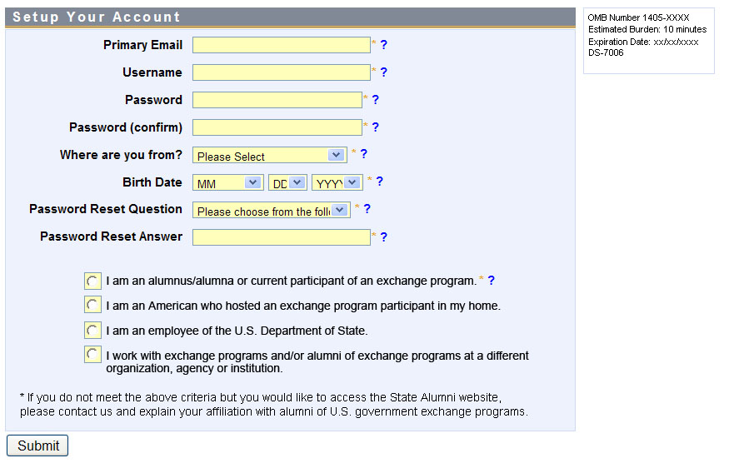

NOTE: The box on the top right will appear for all users as they determine what account they are signing up for.

**ALUMNI VIEW** (without Java Scripting)

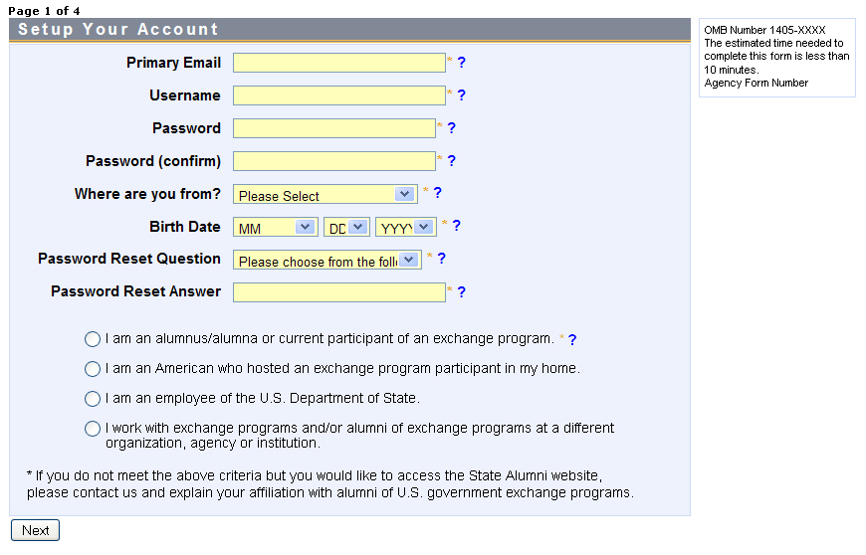

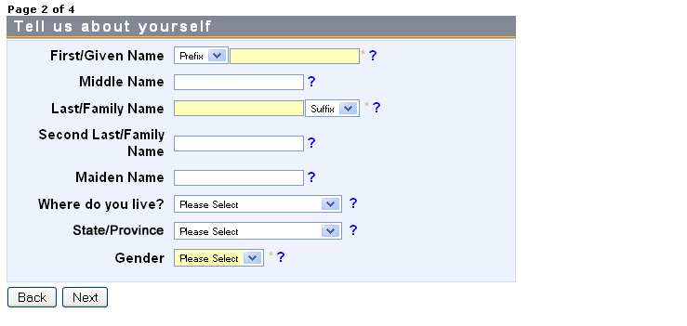

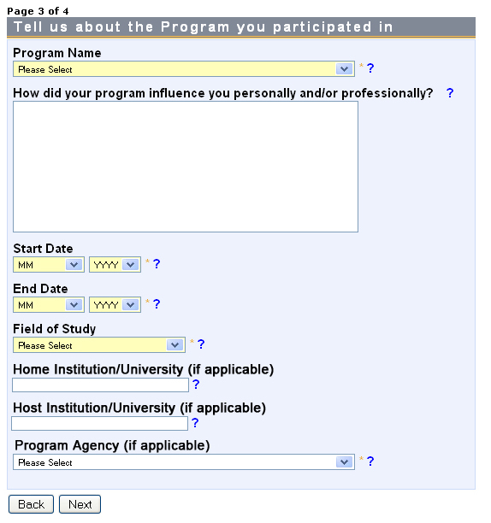

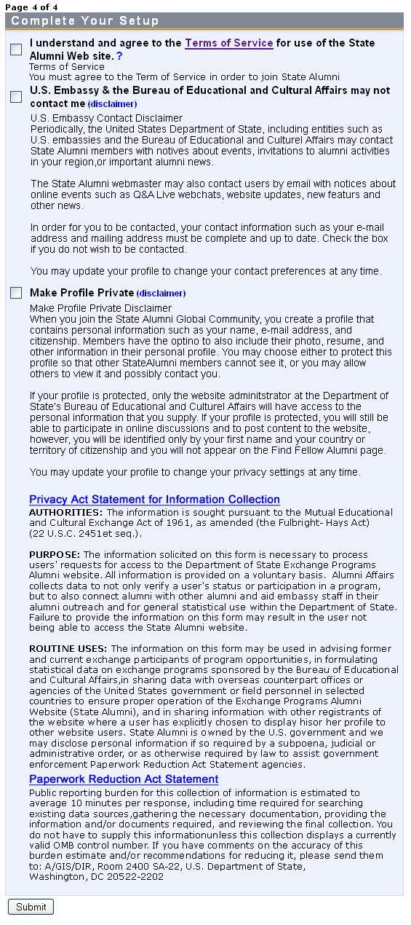

**ALUMNI VIEW** (with Java Scripting enabled)

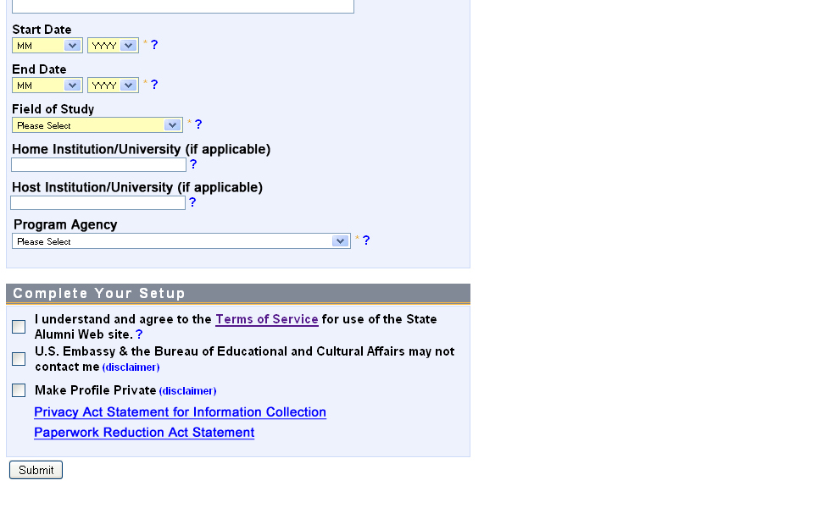

***NOTE:***   
When java scripting is enabled, the “Complete Your Setup” box will appear without the full text displayed.

When a registrant scrolls over the words “Privacy Act Statement for Information Collection” and “Paperwork Reduction Act Statement,” the text to the left and on the next page will appear.

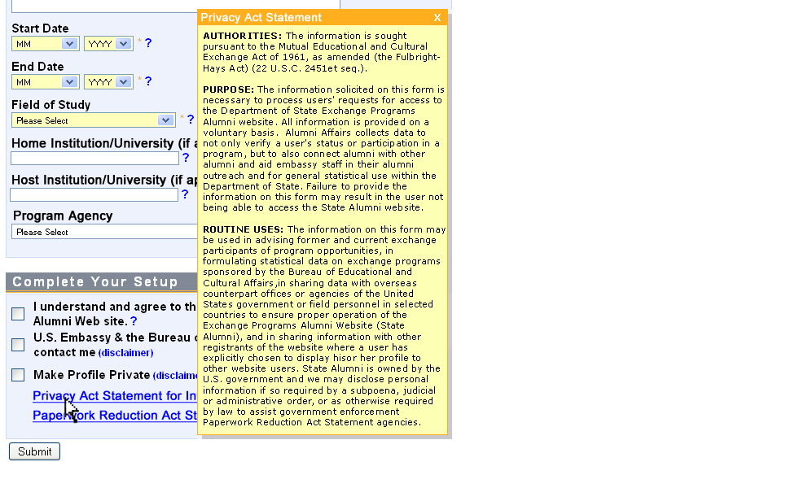

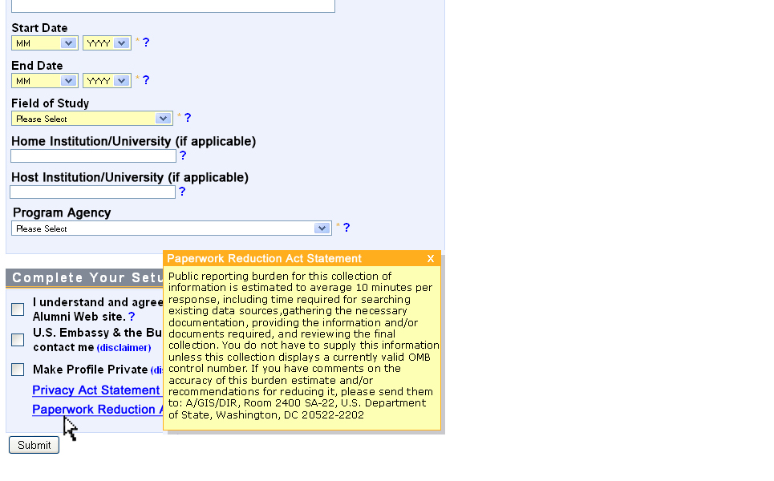

***View for Fulbright Alumni ONLY*** *(Java Scripting Enabled)*  
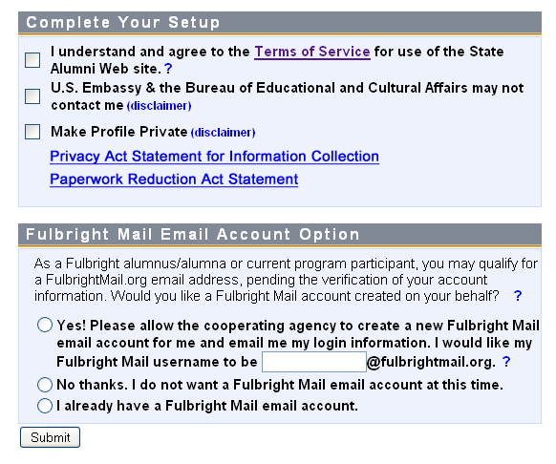

***View for Fulbright Alumni ONLY*** *(Java Scripting NOT Enabled)****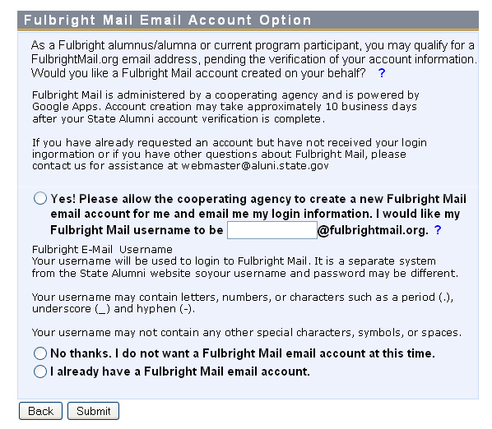***

***View for Sensitive Countries*** *(Near East Region, Afghanistan and Pakistan)*

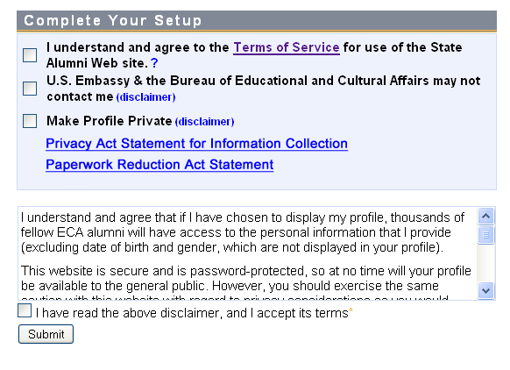

~~~~~~~~~~~~~~~~~~~~~~~~~~~~~~~~~~~~~~~~~~~~~~~  
The full text of the disclaimer reads:

I understand and agree that if I have chosen to display my profile, thousands of fellow ECA alumni will have access to the personal information that I provide (excluding date of birth and gender, which are not displayed in your profile).

This website is secure and is password-protected, so at no time will your profile be available to the general public. However, you should exercise the same caution with this website with regard to privacy considerations as you would with any other. Please keep in mind that if you allow website members to view your profile, thousands of fellow alumni could potentially gain access to the personal information you supply here (excluding date of birth and gender). This website assumes that you would prefer to protect your profile. If instead you choose to display your profile so that other alumni can network with you and so that you can participate in discussion forums and online events with guest speakers, please indicate below. If at any time in the future you change your mind, you can choose to protect or display your profile through the website's "Update Your Profile" section.

### Profile status restriction

Users who are from sensitive countries (currently all of NEA, Afghanistan and Pakistan) and who are under the age of 21 are not permitted to set their profile status to “public.” By default, their status is set to private. They may still opt to be contacted (by DOS employees and through the site’s mass messaging system) but they may not display their profile publicly.

Content submitted by users with private profiles is attributed to them by their first name and country only.   
~~~~~~~~~~~~~~~~~~~~~~~~~~~~~~~~~~~~~~~~~~~~~~~~

**GUEST VIEW***(With Java Scripting Enabled)*

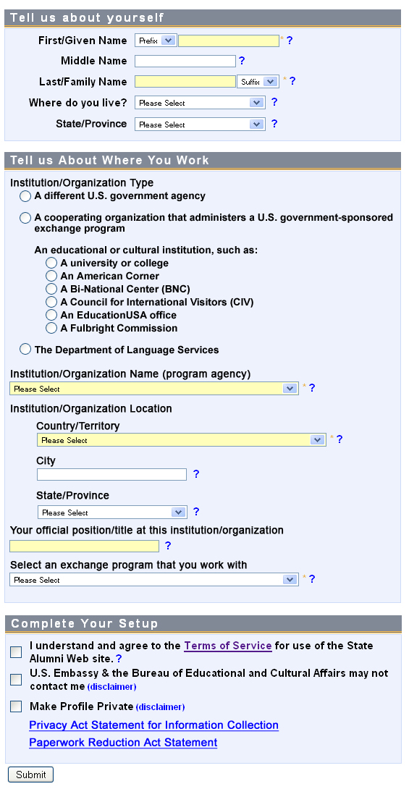

***NOTE:***   
As shown above in the alumni account view, the boxes will display the text for “Privacy Act Statement for Information Collection” and “Paperwork Reduction Act Statement” when a user scrolls over any part of the text.

If they do not have java scripting enabled, the full text will appear (as shown above in the alumni example.)

**HOST VIEW**   
(Hosts are U.S. Citizens who hosted a participant in their home)

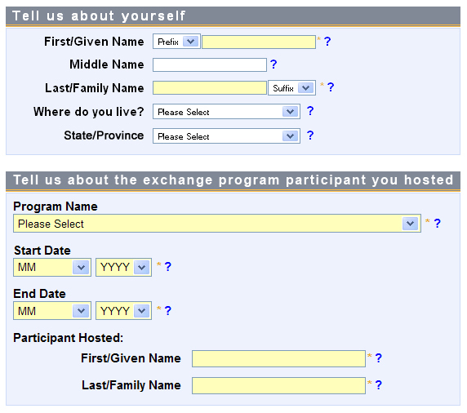



***NOTE:***   
As shown above in the alumni account view, the boxes will display the text for “Privacy Act Statement for Information Collection” and “Paperwork Reduction Act Statement” when a user scrolls over any part of the text.

If they do not have java scripting enabled, the full text will appear (as shown above in the alumni example.)