
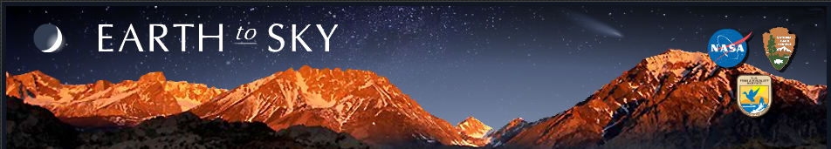


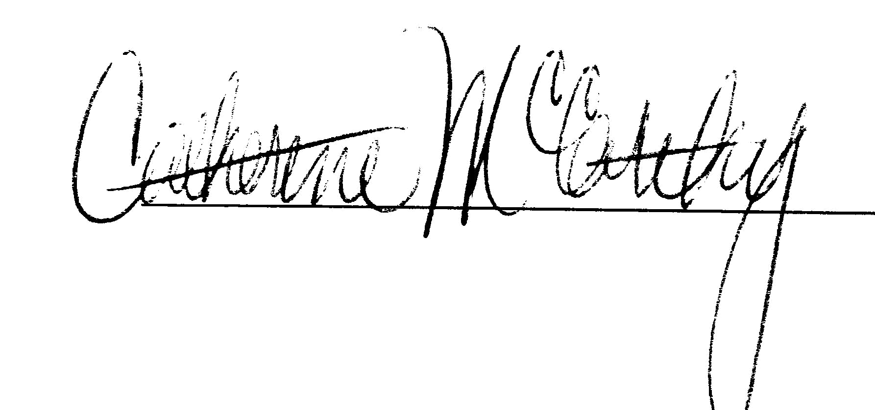

San Antonio, Texas
Catherine McCarthy
Associates
David Smaldone
Assistant Professor
Theresa Coble
Associate Professor
Dear Visitor,

The Earth to Sky partnership seeks to provide park and refuge visitors with an up-to-date understanding of climate change science. The Earth to Sky partnership is a joint effort between the National Aeronautic and Space Administration, the National Park Service and the U.S. Fish and Wildlife Service.

Thank you for completing this survey. We estimate this survey will require approximately 15 minutes of your time. The purpose of this survey is to assess important aspects of your onsite experience. The survey will help project leaders understand audience needs and perspectives, ensuring enhanced relevancy and program effectiveness.

Sincerely,
Section 1—Your Site Visit
- How long have you already been at the site during this trip? ______ hours OR ______ days
2. Which of the following did you participate in or use on this trip? (Check all that apply.)
- □ A ranger or educator-led talk.
- □ A ranger or educator-led walk.
- □ A ranger or educator-led evening (or campfire) program.
- □ Exhibits at the museum or visitor center.
- □ Brochures or written material distributed by the site. Please describe: ______________
- □ Wayside exhibits located at pullouts, along trails or at trailheads.
- □ A Junior Ranger Program (by myself or with children in my group).
- □ One or more park or refuge podcasts that were viewed online.
- □ A film or multi-media program that was viewed onsite.
- □ I visited the site’s webpage.
- □ I spoke informally with an employee or volunteer.
- □ Other ___________________________________________________________
- a. Please indicate on a scale of 1-5 the extent to which the following factors influenced your decision to visit this site. (Circle the number of your choice.)
 | Did Not Influence |  |  |  | Strongly Influenced
- I saw the roadside sign and decided at that moment to stop by. | 1 | 2 | 3 | 4 | 5
- I came because my spouse/friend/relative wanted to come. | 1 | 2 | 3 | 4 | 5
- I am bringing friends or relatives who are visiting. | 1 | 2 | 3 | 4 | 5
- I was looking for something fun to do with members of my group. | 1 | 2 | 3 | 4 | 5
- I came as part of a trip or vacation. | 1 | 2 | 3 | 4 | 5
- I have an interest in outdoor recreation. | 1 | 2 | 3 | 4 | 5
- I have an interest in history. | 1 | 2 | 3 | 4 | 5
- I have an interest in nature. | 1 | 2 | 3 | 4 | 5
- I have an interest in educational programs. | 1 | 2 | 3 | 4 | 5
- I like visiting national parks, wildlife refuges and similar sites. | 1 | 2 | 3 | 4 | 5
- Other: ___________________________ | 1 | 2 | 3 | 4 | 5
- b.______Which is the most important reason for you to visit this park or wildlife area?
(Write the number from the question 3a list.)

Section 2—Your Onsite Experience

- a. During the climate change program or media you just experienced, indicate the extent to which you: (Circle the number of your choice.)
 | Not at All |  |  |  | A Lot
Learned something new about climate change. | 1 | 2 | 3 | 4 | 5
Understood something better about climate change. | 1 | 2 | 3 | 4 | 5
Thought about climate change differently. | 1 | 2 | 3 | 4 | 5
Formed an intellectual connection to the meanings and significance of climate change. | 1 | 2 | 3 | 4 | 5

➲ b. Please describe the thoughts you had during or after this climate change program or media product.
*Did any information catch you by surprise?
*Did a personal experience come to mind during the program?
*Did you share any thoughts with your group members afterwards?

- a. During the climate change program or media product you just experienced, did the program or media: (Circle the number of your choice.)
 | Not at All |  |  |  | A Lot
Touch you in some way? | 1 | 2 | 3 | 4 | 5
Stir up any feelings? | 1 | 2 | 3 | 4 | 5
Reach you at a personal level? | 1 | 2 | 3 | 4 | 5
Trigger an emotional connection to the meanings and significance of climate change? | 1 | 2 | 3 | 4 | 5
➲ b. Please describe the feelings you had during or after this climate change program or media.
*Did any of the content cause sadness, joy, amazement or any other feeling?
*Did the program remind you of a previous experience?
*Did you share any feelings with your group members afterward?

- a. Did the climate change program or media product you just experienced: (Circle the number of your choice.)
 | Not at All |  |  |  | A Lot
Develop important concepts? | 1 | 2 | 3 | 4 | 5
Provide a balanced presentation of differing viewpoints? | 1 | 2 | 3 | 4 | 5
Build skills to assess environmental issues? | 1 | 2 | 3 | 4 | 5
Provide you with opportunities to move from awareness to action? | 1 | 2 | 3 | 4 | 5
➲ b. As a result of this program or media product, please describe how you might think or act
differently.

Section 3 -- Your Views about Climate Change and Global Warming

Recently climate change, sometimes referred to as global warming, has been getting attention in the news. Global warming refers to the idea that the world’s average temperature has been increasing over the past 150 years, may be increasing more in the future, and that the world’s climate may change as a result.

7. What do you think? Do you think that global warming is happening?
Yes…
…and I’m extremely sure.
…and I’m very sure.
…and I’m somewhat sure.
…but I’m not at all sure.
No…
…and I’m extremely sure
…and I’m very sure
…and I’m somewhat sure
…but I’m not at all sure

…I don’t know
8. Assuming global warming is happening, do you think it is …
 Caused mostly by human activities.
 Caused mostly by natural changes in the environment.
 Caused by both natural changes in the environment and human activities.
 None of the above because global warming isn’t happening.

9. How worried are you about global warming?
 Very worried.
 Somewhat worried.
 Not very worried.
 Not at all worried.

10. How much do you think global warming will harm you personally?
- A great deal.
- A moderate amount.
- Not at all.
- Don’t know.
11. When do you think global warming will start to harm people in the United States?
- They are being harmed now.
- In 10 years.
- In 25 years.
- In 50 years.
- In 100 years.
- Never.
12. How much do you think global warming will harm future generations of people?
- A great deal.
- A moderate amount.
- Not at all.
- Don’t know.
13. How much had you thought about global warming before today?
- A great deal.
- A moderate amount.
- Not at all.
- Don’t know.
14. How important is the issue of global warming to you personally?
- Extremely important
- Very important
- Somewhat important
- Not too important
- Not at all important
15. Do you agree or disagree with the following statement: “I could easily change my mind about global warming.”
 Strongly agree
 Somewhat agree
 Somewhat disagree
 Strongly disagree

16. How many of your friends share your views on global warming?
 None
 A few
 Some
 Most
 All
17. Which of the following statements comes closest to your view?
 Global warming isn’t happening.
 Humans can’t reduce global warming, even if it is happening.
 Humans could reduce global warming, but people aren’t willing to change their behavior, so we’re not going to reduce global warming.
 Humans could reduce global warming, but it’s unclear at this point whether we will do what’s needed.
 Humans can reduce global warming, and we are going to do so successfully.

18. Do you think citizens themselves should be doing more or less to address global warming?
 Much more.
 More.
 Currently doing the right amount.
 Less.
 Much less.
- Don’t know.
19. Do you think global warming should be a low, medium, high, or very high priority for the President and Congress? (Topic Area 6 – Individual Perceptions of their Park Experiences)
- Low
- Medium
- High
- Very high

20. People disagree whether the United States should reduce greenhouse gas emissions on its own, or make reductions only if other countries do too. Which of the following statements comes closest to your own point of view?
The United States should reduce its greenhouse gas emissions…
 Regardless of what other countries do
 Only if other industrialized countries (such as England, Germany and Japan) reduce their emissions
 The US should not reduce its emissions
 Don’t know

21. How much do you trust or distrust the following as a source of information about global warming? (Please place a check in the appropriate box)

 | Strongly distrust | Somewhat distrust | Somewhat trust | Strongly trust
- Family & friends
- Environmental organizations
- Corporations or businesses
- Religious leaders
- Scientists in general
- NASA scientists
- Park rangers or refuge educators
- Mainstream news media

List source you trust most: ______________

Why do you trust this source most?: __________________________________________________

_______________________________________________________________________________

_______________________________________________________________________________

List source you distrust most: ______________

Why do you distrust this source most?: _______________________________________________

_______________________________________________________________________________

_______________________________________________________________________________

22. Over the past 12 months, how many times have you done these things? (Please put a check in the appropriate box)

 | Never | Once | A few times  (2-3) | Several times (4-5) | Many times | Don’t Know

Written letters, emailed, or phoned government officials to urge them to take action to reduce global warming.
Attended a community meeting or rally about global warming.

Volunteered with or donated money to an organization working to reduce global warming.

Purchased carbon offsets.

Bought green products.

Told my friends about what I’ve learned.

Actively pursued more knowledge about climate change.

Rewarded companies that are taking steps to reduce global warming by buying their products.

Punished companies that are opposing steps to reduce global warming by NOT buying their products.

23. Over the next 12 months, would you like to do each of the following… (Please put a check in the appropriate box)
 | Less frequently | About the same as now | More frequently

Write letters, email, or phone government officials to urge them to take action to reduce global warming.
Attend a community meeting or rally about global warming.

Volunteer with or donated money to an organization working to reduce global warming.

Purchase carbon offsets.

Buy green products.

Tell my friends about what I’ve learned.

Actively pursue more knowledge about climate change.

Reward companies that are taking steps to reduce global warming by buying their products.

Punish companies that are opposing steps to reduce global warming by NOT buying their products.

24. Which comes closer to your own view:
 Most scientists think global warming is happening.
 Most scientists think global warming is not happening.
 There is a lot of disagreement among scientists about whether or not global warming is happening.
 Don't know enough to say.

25. Personally, how well informed do you feel you are about … (Please put a check in the appropriate box)
 | Not at all informed | Not very well informed | Fairly well informed | Very well informed
The different causes of global warming
The different consequences of global warming
Ways in which we can reduce global warming

Section 4—Demographics

- What is your gender? (Please check.)
□ Male
□ Female

- What is your age? (Check one.)
□ under 18 | □ 45 – 54
□ 18 - 24 | □ 55 – 64
□ 25 – 34 | □ 65 – 74
□ 35 - 44 | □ 75 and over

- What is the highest grade of school or year of college that you completed? (Check one.)
□ Less than high school
□ High school graduate or GED
□ Some college or associate degree
□ Four year college degree
□ Masters, doctoral, or professional degree

- Are you Hispanic or Latino?
□ No
□ Yes
- What is your race? (Check one or more.)
□ American Indian or Alaska Native
□ Asian
□ Black or African American
    - Native Hawaiian or other Pacific Islander
□ White
- Which category best describes your total household income in 2010 before taxes?
(Check one.)
□ Less than $14,999 | □ $75,000 to $99,999
□ $15,000 to $24,999 | □ $100,000 to $149,999
□ $25,000 to $34,999 | □ $150,000 to $199,999
□ $35,000 to $49,999 | □ Over $200,000
□ $50,000 to $74,999

- Are you a permanent resident or citizen of the U.S.?
□ No ― What is your country of origin? ______________________________
□ Yes ― What is your zip code and state of residence?
Zip Code _____________________________
State _______________________________

- a. Which of the following best describes your personal group you are traveling with? (Check one.)
    - Myself alone
□ Myself with family (including spouse/partner and/or other family members/relatives)
□ Myself with family and friends
□ Myself with friends
□ Other (Please specify) _______________________________________________
  - b. Are there any children under age 18 in your group?
□ No
□ Yes ― How many children are in each of these age categories?
______ Number of children under 5 years old.
______ Number of children age 5-12
______ Number of children age 13-17
- Do you consider yourself a:
□ Republican
□ Democrat
□ Independent

Thank you for your time!

Privacy Act and Paperwork Reduction Act statement:
16 U.S.C. 1a-7 authorizes collection of this information. This information will be used by park managers to better serve the public. Response to this request is voluntary and anonymous. No action may be taken against you for refusing to supply the information requested. Permanent data will be anonymous. An agency may not conduct or sponsor, and a person is not required to respond to, a collection of information unless it displays a currently valid OMB control number.
Burden estimate statement: Public reporting for this form is estimated to average 15 minutes per response. Please direct comments regarding the burden estimate or any other aspect of this form to [insert contact info].

Please record any additional comments below.

