March XX, 2011

Executive
Night Vision Company
Address

Dear Executive:

The Bureau of Industry and Security’s (BIS), Office of Technology Evaluation, in coordination with a number of federal agencies, is conducting a technology survey and assessment of the night vision focal plane array, sensor and camera sectors. There is concern that U.S. night vision production and products, which are used in critical weapons and intelligence systems, may be adversely impacted by U.S. Government regulations that push foreign customers to foreign suppliers and U.S. companies to transfer technology and production overseas, which negatively affects U.S. national and economic security. The results of the survey and assessment will assist BIS in recommending regulatory actions that support a viable U.S. defense industrial base.

Your company has been identified as a manufacturer of night vision products and related services. To begin, download the Excel formatted night vision sector survey and corresponding instructions at:
http://www.bis.doc.gov/nightvisionsurvey/index.htm
For internal data collection purposes, a PDF version of the survey can also be downloaded at this website. BIS will only accept Excel survey submissions.

If your company has more than one U.S. facility or division supporting the night vision sector and finds it easier to submit individual business unit-level survey responses, please notify BIS. If not, BIS will expect one consolidated Excel survey response from your company.

Information furnished to BIS is business confidential and will not be published or disclosed, other than in aggregate form. Such information is also protected from disclosure from Freedom of Information Act (FOIA) requests. Also note that your company is required by federal law under 50 U.S.C. App Sec 2155 to complete the survey within 30 days of receipt of this letter.

If you have any questions regarding the survey, e-mail NightVisionSector@bis.doc.gov or contact BIS staffers: Teresa Telesco at 202-482-4959, Katharine Huang at 202-482-1271, or Meaghan Archer at 202-482-7980.

Please contact me at 202-482-4060 if you have any questions regarding the overall Night Vision Sector assessment.

Thank you for your participation.

Sincerely,

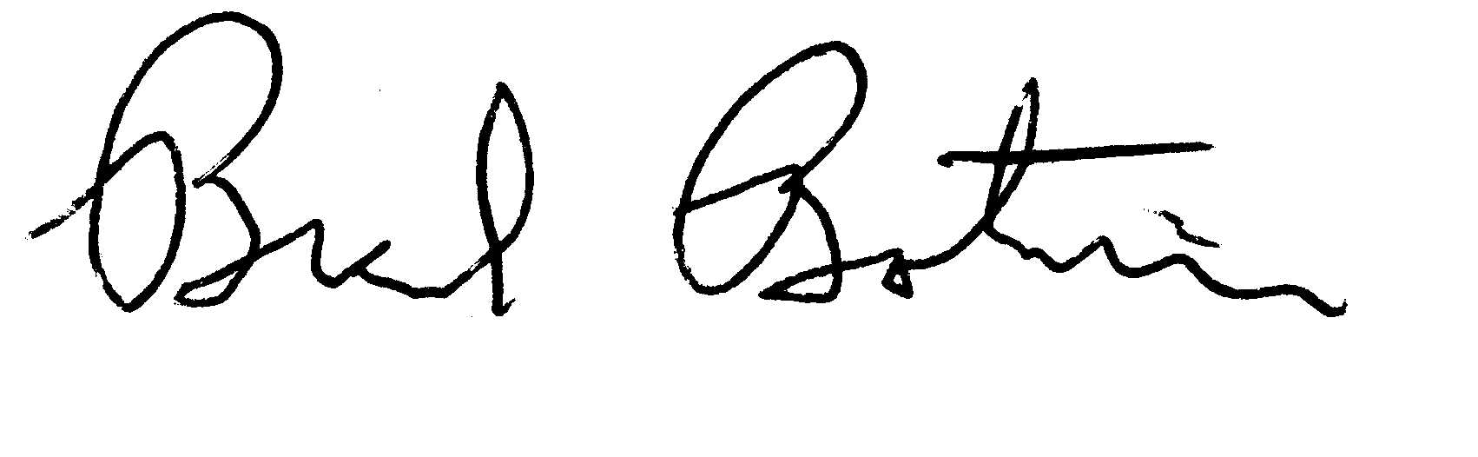
Brad Botwin
Director, Industrial Studies
Office of Technology Evaluation

