Memo

Institutional Review Board
Federal Wide Assurance:
FWA00009066

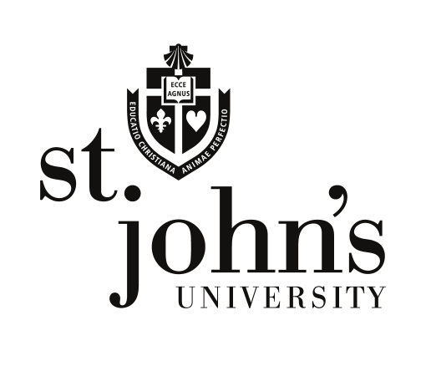

Dr. Jeffery Olson
Chair, Institutional Review Board
Tel 718-990-5705
olsonj@stjohns.edu

Dr. Marie Nitopi
IRB Coordinator
Tel 718-990-1440
nitopim@stjohns.edu

Date:

To:

October 29, 2010

Dr. Scyatta Wallace

CC:

Protocol # 0409-114

Protocol: Promoting HIV testing among Low Income Heterosexual Young adult Black Men Brothers Encouraged to Access Testing Services

Please be advised that your human subjects amendment application has been reviewed and approved by the Institutional Review Board (IRB). You are free to begin your project with these new revisions.

As a reminder, STJ-IRB approval of research projects is valid for one year only from the original date of approval. Beyond this period, a new proposal must be submitted.

If you have any questions, please do not hesitate to call me or Marie Nitopi, IRB Coordinator at 718-990-1440.

Best wishes for successful pursuit of this research.

**It is imperative that you keep this on file where it can easily be accessed. You will need to provide copies of this document when involved in further correspondence with the IRB. The IRB will provide you with an additional copy of this document only in the case of an emergency.**

