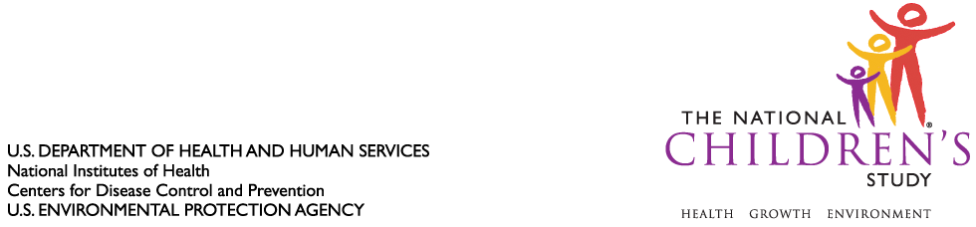

DATE: October 22, 2010

TO: Dr. Margo Schwab
Office of Management and Budget
Office of Information and Regulatory Affairs

FROM: Dr. Jennifer Park

THROUGH: Dr. Steven Hirschfeld

SUBJECT: Request for Non-Substantive Change to National Children’s Study, Vanguard (Pilot) Study (OMB Control #0925-0593, Expiration July 13, 2013) – Revision to Informed Consent Materials and Approval of 12-Month Visit Instrumentation

CC: Dr. Sarah Glavin, Ms. Jamelle Banks, Ms. Mikia Currie

We request non-substantive change to the National Children’s Study Vanguard (Pilot) Study protocol approved as revised by the Office of Information and Regulatory Affairs (OIRA) on July 23, 2010.

- We ask that the National Children’s Study revised women’s informed consent materials be approved for implementation in the Vanguard (Pilot) Study protocol across all 37 Vanguard Centers. These consent materials, approved by OIRA on July 23, 2010, were revised to address stipulations of the NICHD IRB. These revisions were made
- to address feedback stipulated to the National Children’s Study by the NICHD IRB and the Office of Information and Regulatory Affairs;
- to clearly articulate to potential study participants the changing nature of the NCS Vanguard Study, and to explain that Study activities may change over the course of the Vanguard Study;
- to combine the respective consent forms and corresponding consent signature pages into one cohesive document; and,
- to convert the previously approved consent materials to plain language (8th grade reading level) to address concerns related to literacy impairments of potential study participants.

The Pregnant Women’s Informed Consent Form and the Non-Pregnant Women’s Informed Consent Form, approved by NICHD on August 31, 2010, have been attached to this memorandum for your consideration.

- We also request non-substantive change to instruments associated with the 12-Month Visit of the National Children’s Study for implementation in the Vanguard (Pilot) Study protocol among the seven Initial Vanguard Study Centers. The 12-Month Visit instruments were approved in concept by OIRA on September 22, 2008; they are now minimized in length, and therefore represent a reduction of anticipated burden to Study participants. Please see attached the Interview Script, Self-Administered Questionnaire (SAQ), and Visit Information Sheet for the 12-Month Visit for your consideration.

- Under separate cover, we will request approval of non-substantive change of the 3-, 6-, and 9-month instruments approved by OIRA on September 22, 2008 for use in the seven Initial Vanguard Study locations. These instruments have been reduced in length and therefore do not represent an estimated increase in burden.

- As a separate action, we will request substantive change to the NCS Vanguard (Pilot) Study to administer the (3-, 6-, 9-, and) 12-month instruments among the thirty Recruitment Substudy locations. This burden was not previously submitted for approval to OIRA when the Recruitment Substudy was approved as a substantive change on July 23, 2010.

Attachments (5):

1. Pregnant Women’s Informed Consent Form, approved by NICHD IRB 8/31/10
2. Non-Pregnant Women’s Informed Consent Form, approved by NICHD IRB 8/31/10
3. 12 Month Mother Interview
4. 12 Month Mother SAQ
5. 12 Month Visit Information Sheet

