Framingham Heart Study – Exam Appointment Scheduling, Reminder and Instruction Forms

______________________________________

Public reporting burden for this collection of information is estimated to average 6-10 minutes per response, including the time for reviewing instructions,searching existing data sources, gathering and maintaining the data needed, and completing and reviewing the collection of information. An agency may not conduct or sponsor, and a person is not required to respond to, a collection of information unless it displays a currently valid OMB control number. Send comments regarding this burden estimate or any other aspect of this collection of information, including suggestions for reducing this burden, to:

**NIH,** **Project Clearance Branch, 6705 Rockledge Drive, MSC 7974, Bethesda, MD 20892-7974, ATTN: PRA (0925-0216)**.

Do not return the completed form to this address.

Dear___________________________:

We thank you for participating in the Framingham Heart Study. Your clinic appointment is scheduled for ___________**at _____________.**

The Framingham Heart Study’s address is 73 Mt.Wayte Avenue, in the **Perini Building**. The Framingham Heart Study offices are **located in the wing at the Franklin Street side** of the Building. **There is reserved parking for participants behind the Franklin Street wing.** Please see the enclosed map. The building is handicap accessible.

**You should bring slippers** and if you choose, bring your own robe. In order to perform certain tests, we ask that you **NOT** eat after 8:00 P.M. the previous evening. You may have **water**, **decaffeinated black coffee or tea (no creamer, milk or sugar) that evening and again in the morning** before your appointment. A urine sample will be collected when you arrive.

**Please do not wear jewelry because of the Bone Density Scan.**

Please **take any prescription medications**, as you normally would.

Using the enclosed **MEDICATION BAG,** please bring all prescription and nonprescription medications **you currently take or have taken in the past month in their original containers.**

**ON THE BACK OF THIS SHEET,** please list information regarding hospitalizations and major illnesses you have experienced since your last exam or health history with the Framingham Heart Study*.*

**PLEASE BRING THIS LETTER WITH YOU TO THE CLINIC.** If you need help completing this form, Clinic staff can assist you at the time of your appointment.

If you have any questions, please call Maureen Valentino, Project Coordinator at

(**508) 935-3417** locally and for long distance at **(800) -536-4143**

Sincerely yours,

Daniel Levy, MD

Director

Framingham Heart Study

**OVER →**

**FHS REPORT GOES TO:**

**Doctor’s Name Doctor’s Address & Phone #**

__________________________ _______________________________________

__________________________ _______________________________________

__________________________ _______________________________________

**Hospitalizations, Emergency Room Visits, or Day Surgery Since Your Last Clinic Visit**

**Date Reason Hospital Name & Address Doctor’s Name**

_____ _______________ ________________________ ____________________

_____ _______________ ________________________ ____________________

_____ _______________ ________________________ ____________________

_____ _______________ ________________________ ____________________

# Doctor Office Visits:

**Date Reason Doctor’s Name**

_____ ________________________________ _____________________________

_____ ________________________________ _____________________________

_____ ________________________________ _____________________________

_____ ________________________________ _____________________________

_____ ________________________________ _____________________________

_____ ________________________________ _____________________________

**OMB NO=0925-0216 03-08-2010**

**FRAMINGHAM HEART STUDY**

**(Perini Headquarters)**

**72 MT. WAYTE AVENUE**

**FAMINGHAM, MA**

**01702**

**Fax# 508-872-6586**

**TO: JFK TAXI Attention: Tim/Candy Fax# 508-651-0422**

**Office# 508-653-4500**

RIDE REQUEST:

Ride Date______________

Name_______________________________________________

Pick Up At:__________________________________________

Phone # ___________________________________________

Going To:_____________________________________________

FHS Appt Time:_________ JFK Pick Up Time______

**RETURN TRIP**

Pick Up At:___________________________________________

Going To: _____________________________________________

Phone # _____________________________________

FHS Pick Up Time________

Ordered By:__________________ Phone#__________

Reminder Post Card **OMB NO=0925-0216 03-08-2010**

The first Exam Cycle for the third generation of the Framingham Heart Study is coming to an end.  Attendance at Exam I is necessary to ensure your enrollment in the Framingham Heart Study.

If you are interested in being a part of the Study and have not yet made an appointment, please do so AS SOON AS POSSIBLE.

Thank you in advance for participating in the Framingham Heart Study.

Appointments/Information:

Maureen Valentino                                                                             Daniel Levy, M.D.

(508) 935-3417                                                                                               Director

(800) 536-4143                                                                                               Framingham Heart

DIRECTIONS OMB NO=0925-0216 03-08-2010

South of Framingham

Merge onto I-95 N. Take the I-495 N exit- exit number 6B- towards WORCESTER. Merge onto I-495 N. Take the I-90 exit- exit number 22- towards MASS. PIKE/BOSTON/ALBANY N.Y.. Keep RIGHT at the fork in the ramp. Merge onto I-90 E (Portions toll). Follow directions from Mass Pike Eastbound.

Mass Pike Eastbound, Exit 12 or Route 9 Eastbound

Route 9 East to the “Edgell Rd, Main St, Framingham” exit. Turn right at the end of ramp to Main Street/Union Ave. Take the 2nd right onto Franklin Street. Follow Franklin St for ½ mile (past the blinking light). Take a left into the Heart Study (Perini) parking lot. Go to the far left of the parking lot, behind the building to the Heart Study parking spaces.

North of Framingham

Merge onto I-95 S. Stay straight to go onto I-295 S. Take I-95 S (Portions toll). Take the I-90/MASS. PIKE exit - exit number 25. Keep RIGHT at the fork in the ramp. Merge onto I-90 W (Portions toll). Follow directions from Mass Pike Westbound.

Mass Pike Westbound, Exit 13

After tollbooth, bear right towards Framingham, Route 30 West. Proceed on Route 30 straight until the end. Turn right onto Route 9 West. Follow Route 9 West to the “30 West, Framingham, Southboro” exit. At the end of the ramp (at the traffic light, not before!) go left onto Main Street. Go through 1 quick traffic light and take the 2nd right onto Franklin Street. Follow Franklin St for ½ mile (past the blinking light). Take a left into the Heart Study (Perini) parking lot. Go to the far left of the parking lot, behind the building to the Heart Study parking spaces.

Route 9 Westbound

Follow Route 9 West to the “30 West, Framingham, Southboro” exit. At the end of the ramp (at the traffic light, not before!) go left onto Main Street. Go right onto Franklin Street. Follow Franklin St for ½ mile (past the blinking light). Take a left into the Heart Study (Perini) parking lot. Go to the far left of the parking lot, behind the building to the Heart Study parking spaces.

**Please see attached map.**

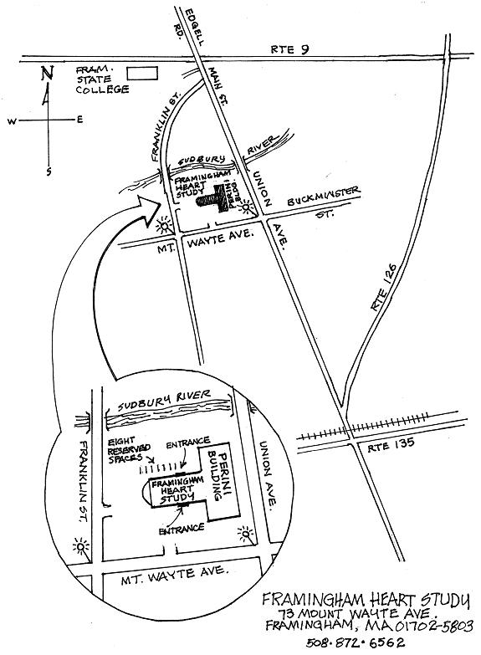

HOTEL LIST **OMB NO=0925-0216 03-08-2010**

Best Western

130 Worcester Road (Route 9), Framingham, MA 01702

(opposite Walmart, attached to Chili’s), 508-872-8811

Courtyard-Marriott

342 Speen St., Natick, MA 01760 (has a pool)

(opposite Home Depot), 508-655-6100 (front desk)

866-239-3145 (Natick reservations)

800-321-2211 (reservations)

Crowne Plaza

1360 Worcester Road (Route 9), Natick, MA 01760

508-653-8800 (front desk), 800-2-CROWNE (reservations)

Econolodge

1186 Worcester Road (Route 9), Framingham, MA 01701

508-879-1510 (front desk), 800-446-6900 (reservations)

Hampton Inn

319 Speen St., Natick, MA 01760

508-653-5000 (front desk), 800-426-7866 (reservations)

Motel 6

1668 Worcester Road (Route 9), Framingham, MA 01701

508-620-0500 (desk), 800-466-8356 (reservations)

Red Roof Inn

650 Cochituate Road (Route 30), Framingham, MA 01701

508-872-4499 (desk), 800-843-7663 (reservations)

Red Roof Inn

367 Turnpike Road, Southboro, MA 01772

508-481-3904

Travelodge

1350 Worcester Road (Route 9), Natick, MA 01701

508-655-2222 (desk), 800-578-7878 (reservations)

Sheraton Tara Hotel

1657 Worcester Road, Framingham, MA 01701

508-879-7200 (desk), 800-325-3535 (reservations)

Logan Express Bus Service – 800-235-6426 (800-23-LOGAN)

**OMB NO=0925-0216 03-08-2010**

Date

*Name*

*Address*

Dear *NAME:*

The faculty and staff of the Framingham Heart Study would like to extend to you our condolences. We have learned of the death of *NAME* and are very sorry for your loss.

Because *NAME* was a participant of the Framingham Heart Study, we also want to express great appreciation on behalf of the Study and our nation. People everywhere have a chance for better health thanks to *HIS/HER* dedication as a volunteer and the knowledge that is being gained from the Studz over the years. Please share our message of sympathy with other family members and friends.

Sincerely,

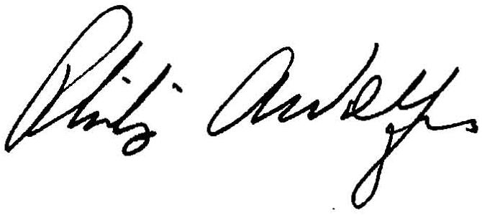

Daniel Levy, M.D. Phillip Wolf, M.D.

Director, Principal Investigator,

Framingham Heart Study Framingham Heart Study

**OMB NO=0925-0216 03-08-2010**

**Instructions for Completing the Food**

# Frequency Questionnaire

THANK YOU for participating in this research study. An important part of this study is the Food Frequency Questionnaire, designed to measure your dietary pattern over the past year. Remember, the information we get from the study is only as good as the information you give us. Accuracy is essential!

**When completing the questionnaire we are asking that you:**

1. Please use a No. 2 pencil, and make sure the circles are completely darkened.

2) Please do not leave any questions blank. If the section does not apply to you, please fill in the **“never”** section.

1. Please do not separate, staple or rip the booklet.

4) Please do not leave any stray marks. Make sure all erasures are complete.