Attachment C: List of Grants
Patient Safety Grants - Results (Page 1 of 4)

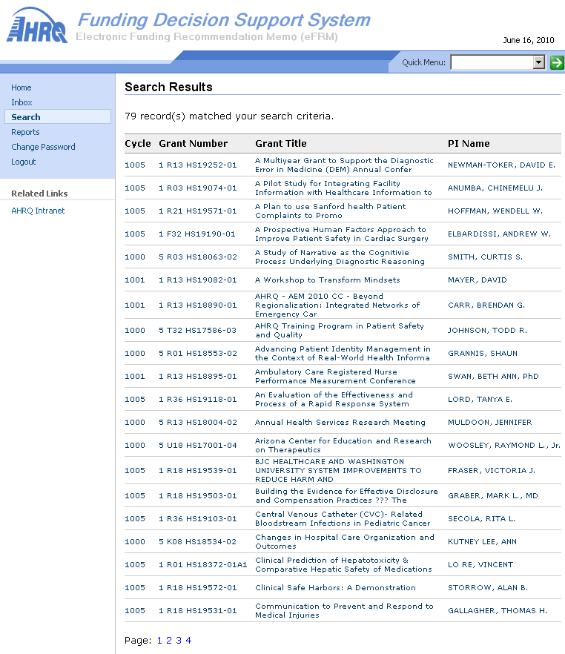

Patient Safety Grants - Results (Page 2 of 4)

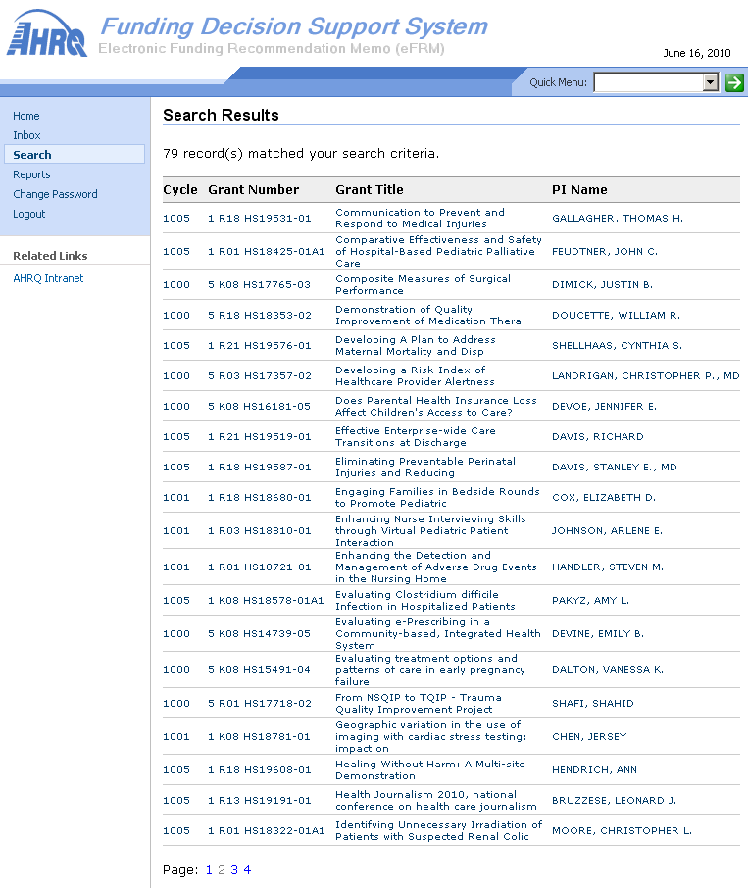
Patient Safety Grants - Results (Page 3 of 4)

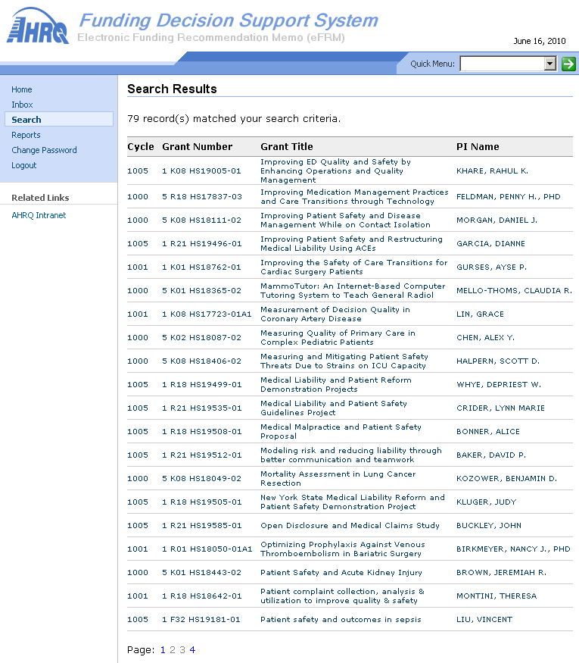
Patient Safety Grants - Results (Page 4 of 4)

