Logging in to GRS
All users access the GRS system through a secure interface which requires a user id and password entered through the GRS Login screen as shown in Figure 1-1. The screen also contains links to general information about system updates and instructions for obtaining user id’s and passwords.
When status reports are due AHRQ notifies Principle Investigators (PI) and Vendors via email. The e-mail instructs users on how to access the system:
- Click the link within the e-mail or copy and paste the link into the browser’s URL address bar to display the GRS Login screen.
- Enter a User id and Password to authenticate to the system and display the inbox containing a list of Grants for which the PI is responsible.
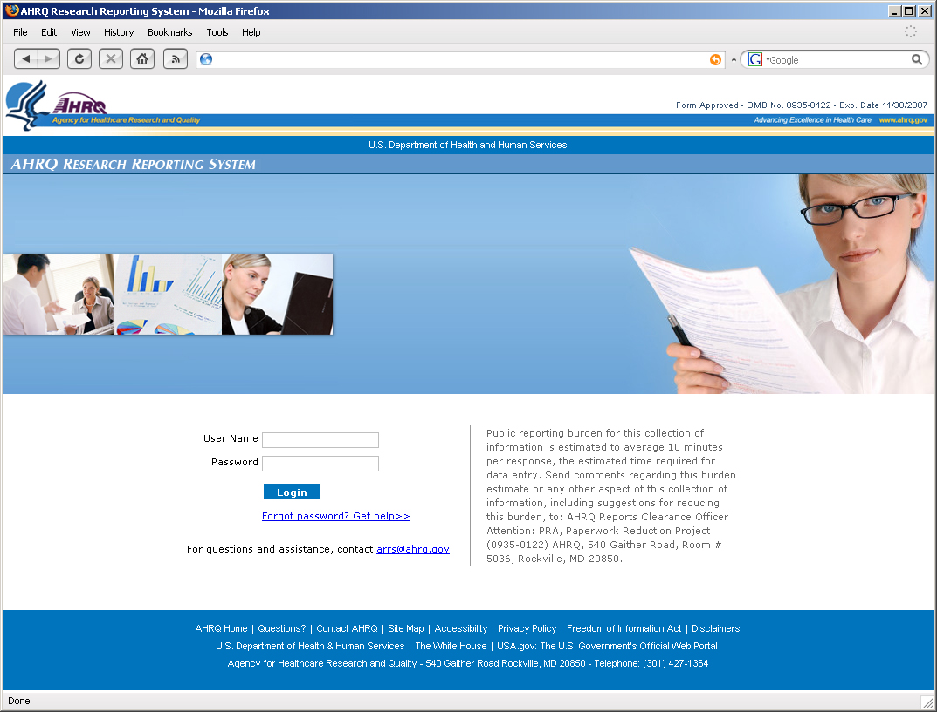
Figure 1-1 Login Page

Accessing the Inbox
The first page displays the PI inbox. The Inbox contains only grants for which the PI or is responsible. The Inbox contains the following information for each Grant:
- ID Number – Displays the unique number for each Grant for which the PI is responsible.
- AHRQ Officer – Identifies the name of the Project Officer responsible for a specific Grant.
- Project Title – Identifies Title of the Grant or Project.
- Start Date – Displays the project start date of the Grant or Project.
- End Date – Displays the project end date of the Grant or Project.
- Manage – Allows the PI to drill down records to complete reports for a specific Grant. If the report is editable, a View/Edit link appears in the Manage column. If the report is not editable a View link appears in the Manage column for a specific record.
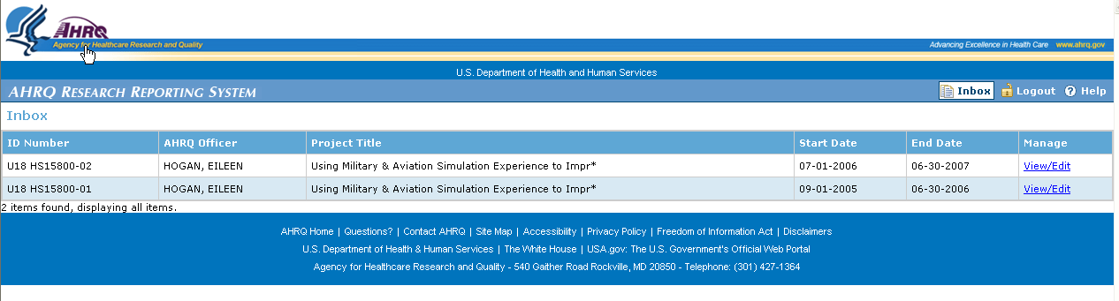
Figure 2-2: Inbox
- Select the View/Edit link adjacent to the Grant or Project for which the report will be completed.
- The system displays a detailed inbox.
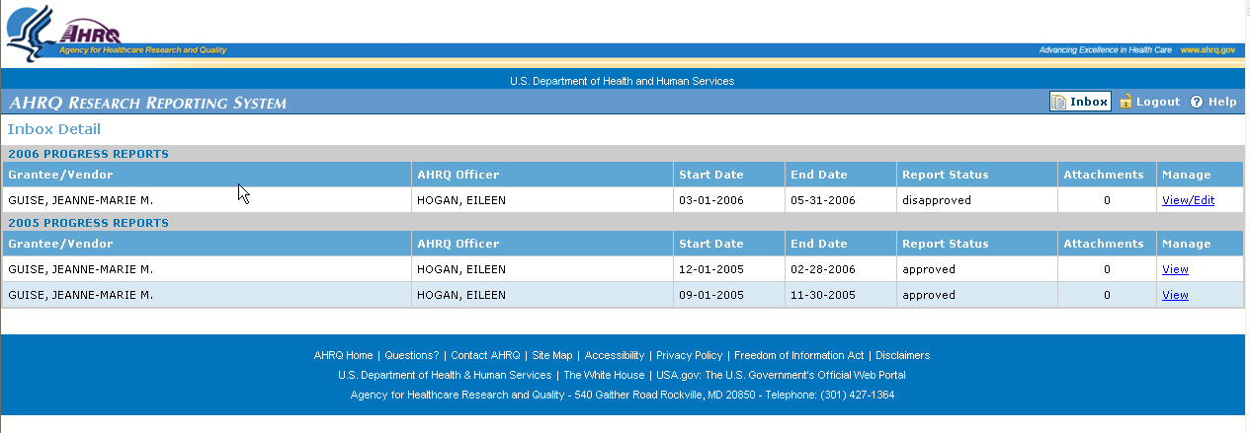
Figure 2-3: Detailed Inbox
The Detailed Inbox page uses a hierarchical format. The page displays reports grouped by year and reporting period. The Detailed Inbox contains the following columns:
- Grantee\Vendor- Identifies the name of the PI who is responsible for completing the status report.
- AHRQ Officer – Identifies the name of the AHRQ Project Officer who is responsible for the Grant or project and to whom the status report is submitted.
- Start Date – Displays the Start Date for specific reporting period.
- End Date – Displays the End Date for a specific reporting period.
- Report Status – Displays the status of a specific progress report.
- Attachments – Indicates the number of attachments a specific report has enclosed.
- Manage - Allows the user to drill down records to complete reports for a specific Grant or Project. If the report is editable View/Edit link appears in the Manage column. If the report is read only a View link appears in the Manage column for a specific record.

A status for each report is provided allowing the user to see in which state each report is. The report states are defined below:

Pending– Report is not completed (submitted). The report is editable in this state.
Submitted– Report is completed. The status report is read only in this state.
Expired– Report is expired if the PI has not submitted the report within 30 days of receipt of the initial e-mail notification.
Approved- Report is reviewed and approved by PO. The status report is read only in this state.
Disapproved– Report is reviewed and disapproved by the PO. The report is editable by the PI so the necessary revisions can be made.

Completing and Submitting a Status Report
Figure 3-1 illustrates the first page of the status report. Follow the steps below to update and complete the status report:
- From the Inbox, select the pending status report for the quarter for which the report is being completed.
- The system displays the report. If available, the report is populated with data from the previous quarter.
- Access the different pages of the report by clicking the tabs at the top of the screen.
- Click the Save button. The save function writes the data to the database. A saved report can be selected and updated at anytime by the user. Save the report frequently to ensure work is not lost due to unexpected interruptions.
- Click the Submit button at the top right hand side of the form to submit the completed report to the PO. The submit function performs 3 actions:
  - Saves the report to the database.
  - Sends a notification to the PO that the report has been completed.
  - Protects the Report and makes it READ ONLY.

Note: Once a report is changed to READ ONLY, the Project Officer must resubmit the report back to the PI to allow further update by the PI.

Project Page
The Project Page displays contact information for the Principle Investigator or Vendor and point of contact information for the AHRQ Project Officer. The page is read only. Modifications and changes to the data on this page need to be communicated to the Project Officer.
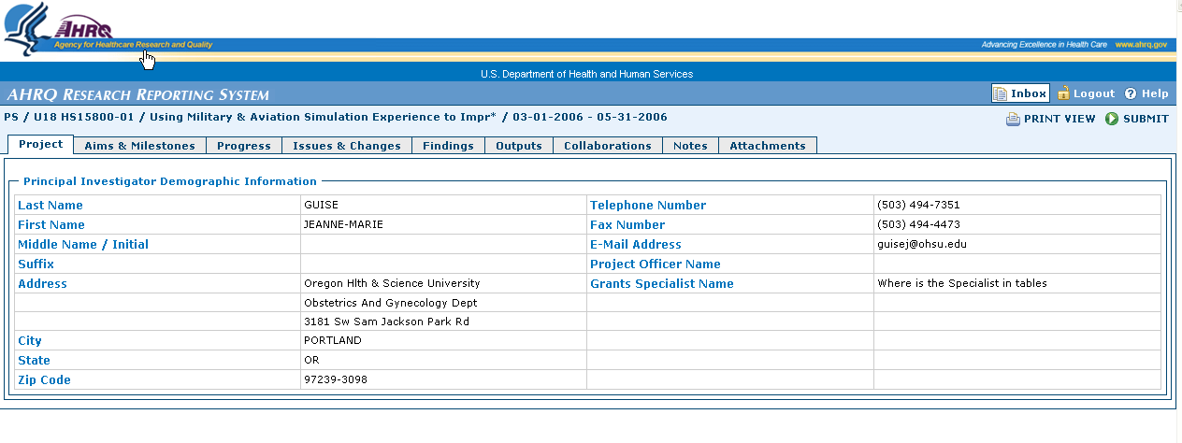
Figure 3-4: Project Page

Aims and Milestones Page
Project Goals are displayed in the Aims and Milestone page. Enter each project Aim or Milestone to be achieved beginning with its title. The title is a mandatory field. The page displays previous quarter data if available. Select the Expand button to see previous text for each aim/milestone.
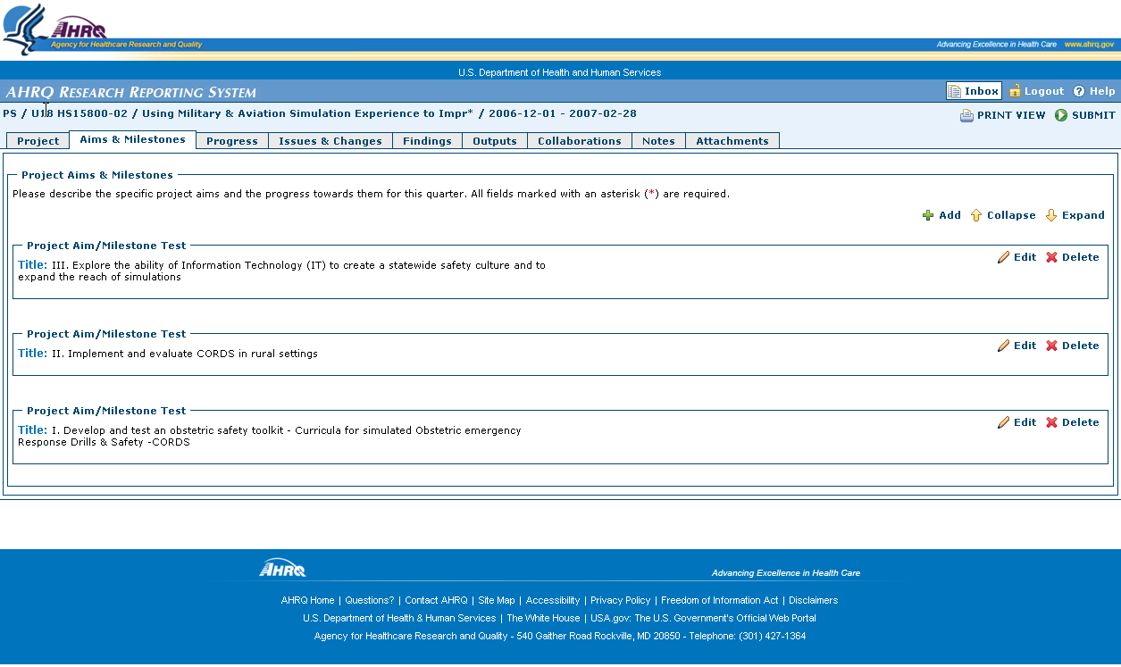
Expand Button
Figure 3-5: Expanding Page Sections

To UPDATE an existing aim\milestone:
- Locate the Aim\Milestone to update.
- Select the Edit button to the right of the title field.
- The aim\milestone text box expands and is editable.
- Edit\update the text.
- Select the Save Button to save the newly entered text.
Edit button
Figure 3-6: Updating Aims & Milestones

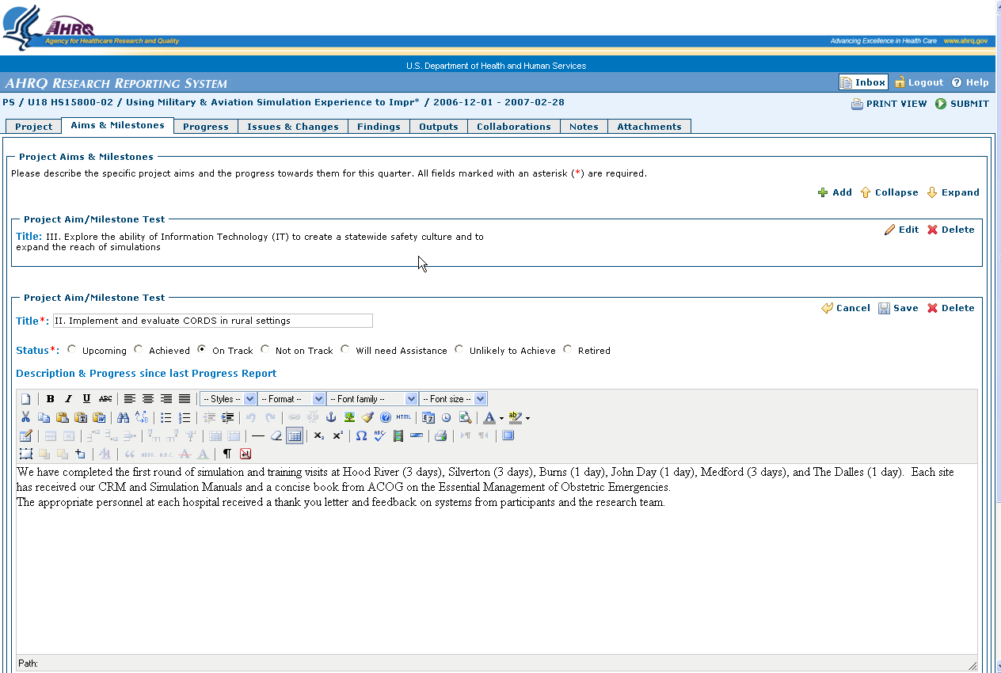
Save button

Figure 3-7: Saving Aims & Milestones
To ADD a new Aim\Milestone:
- Select the Add button on the upper-right side of the Aims & Milestones page.
- A new empty record is displayed.
- The text box expands for data entry.

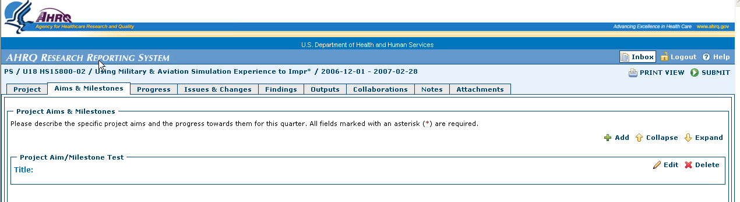
Figure 3-8: Adding Aims & Milestones

- Enter a title for the new record. (mandatory field)
- Enter the Status of the Aim\Milestone. (mandatory field)
- Enter the text.
- Select the Save button to save the newly entered data.
- Repeat steps 1-7 for each new aim\milestone.
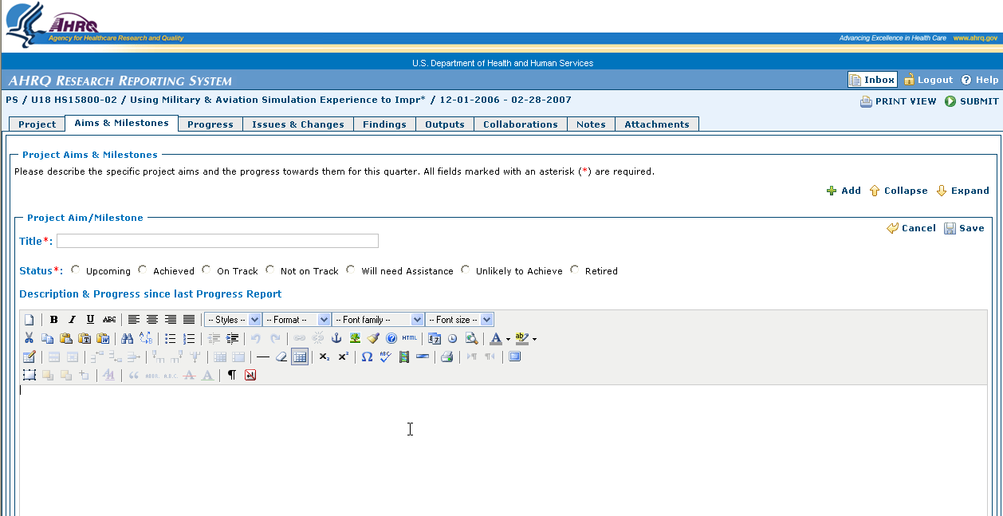
Required Field

Required Field

Figure 3-9: Required Fields for Aims and Milestones

To Delete an Aim\Milestone
- Find the Aim\Milestone to be deleted.
- Select the Delete button located on in the upper right hand side of the text box of the Aim\Milestone.
- The system displays a warning message.
- Select OK to delete the Aim\Milestone.

Progress Page
The Progress page displays a set of radio buttons to indicate overall project progress and project spending. Both sections of the page are mandatory. A status for each category must be chosen.

Patient Safety Users
- Select the appropriate status for overall progress rating. (mandatory field)
- The system displays active Cancel and Save Buttons.
- Select the appropriate status for project spending to date. (mandatory field)
- Select the Save button to save the choices.

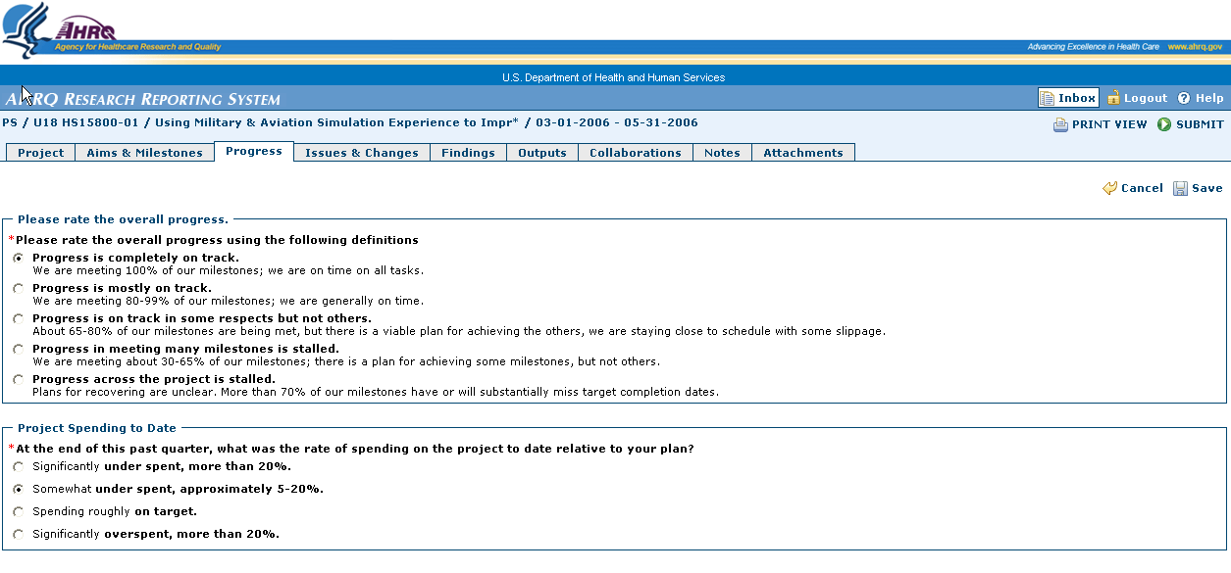
Figure 3-10: Progress Page

HIT and ACTION Users
The progress page displays additional information for HIT PIs and ACTION vendors. The page also contains an Impact section. When fully expanded this section displays three text boxes, one for each impact. The title field is mandatory if impact information is entered.
Data from the previous quarter will display for each impact entered if available. Select the Expand button to view the text entered previously.
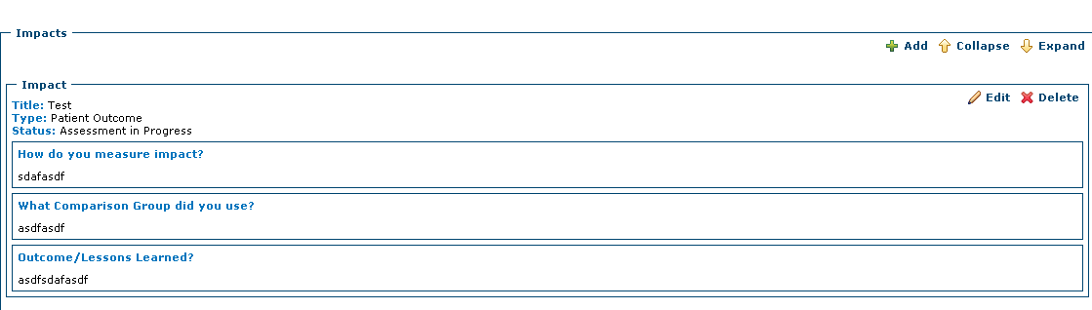
Edit button
Expand button
Figure 3-11: Impact Section

To UPDATE an existing Impact:
- Find the Impact to update.
- Select the Edit button to the right hand side of the title field.
- The Impact section text boxes expand and are editable.
- Edit\update the text.
- Select the Save Button to save the newly entered text.

To ADD a new Impact:
- Select the Add button on the upper right hand side of the page.
- This action displays a new empty record.
Add button
- The text fields expand for data entry.
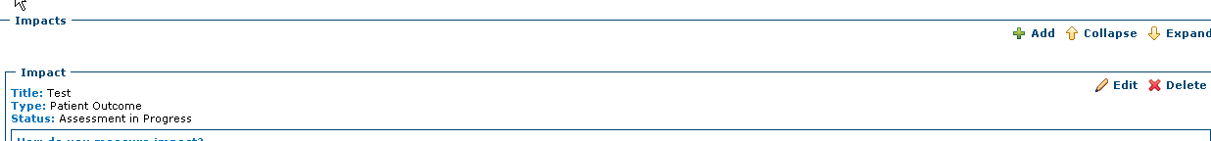
Figure 3-12: Adding and Impact

- Enter the Title of the Impact (mandatory field).
- Enter the text into the sections.
- Select the Save button to save the newly entered data.
- Repeat setps 1 – 6 for each new Impact.
Save button

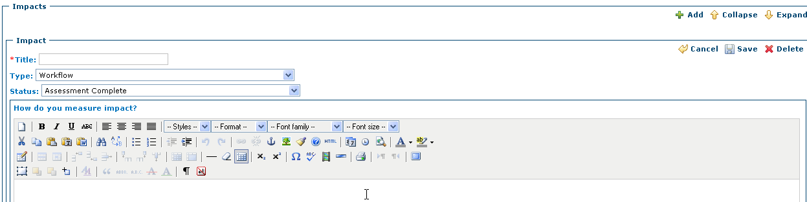
Required field
Figure 3-13: Required Fields for Impact

To Delete an Impact:
- Find the Impact section to be deleted.
- Select the Delete button located on in the upper right hand side of the text box to be deleted.
- The system displays a warning message.
- Select OK to delete the Impact section.

Issues and Changes
The issues and changes page describes additional problems and or changes to the initial project plan or project progress. Although entering text in this page is not required, the type of issue or change field is mandatory if an issue or change is added.
This page displays three text boxes for each Issue/Change when the page is fully expanded. It displays a Description Section, a Reason Section and an Impact Section. There are no dependencies for any of these sections and text is not mandatory for any section.
The page displays the title for each project issue/change entered if data is available from a previous report. Select the Expand button to view the text previously entered for each issue/change.
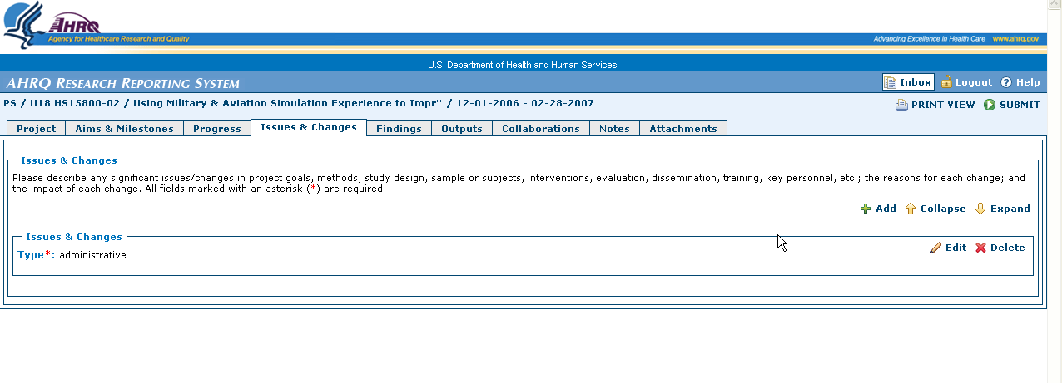
Expand button
Figure 3-14: Expanding Issues & Changes Sections
To UPDATE an existing Issue\Change:
- Find the Issue\Change to update.
- Select the Edit button to the right hand side of the title field.
- The Issue\Change text box expands and is editable.
- Edit\update the text for Description Section, the Reason Section and the Impact Session as necessary.
- Select the Save button located on the right side of the frame to save the data.
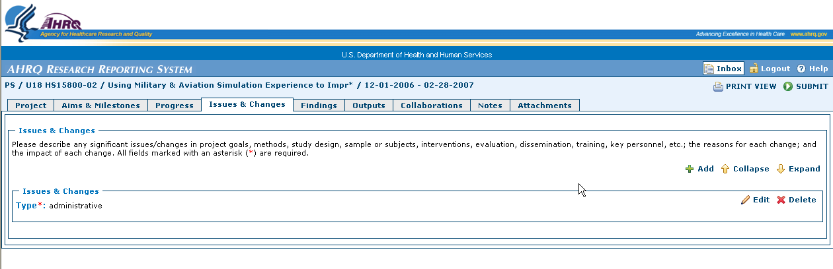
Edit button
Figure 3-15: Updating Issues & Changes
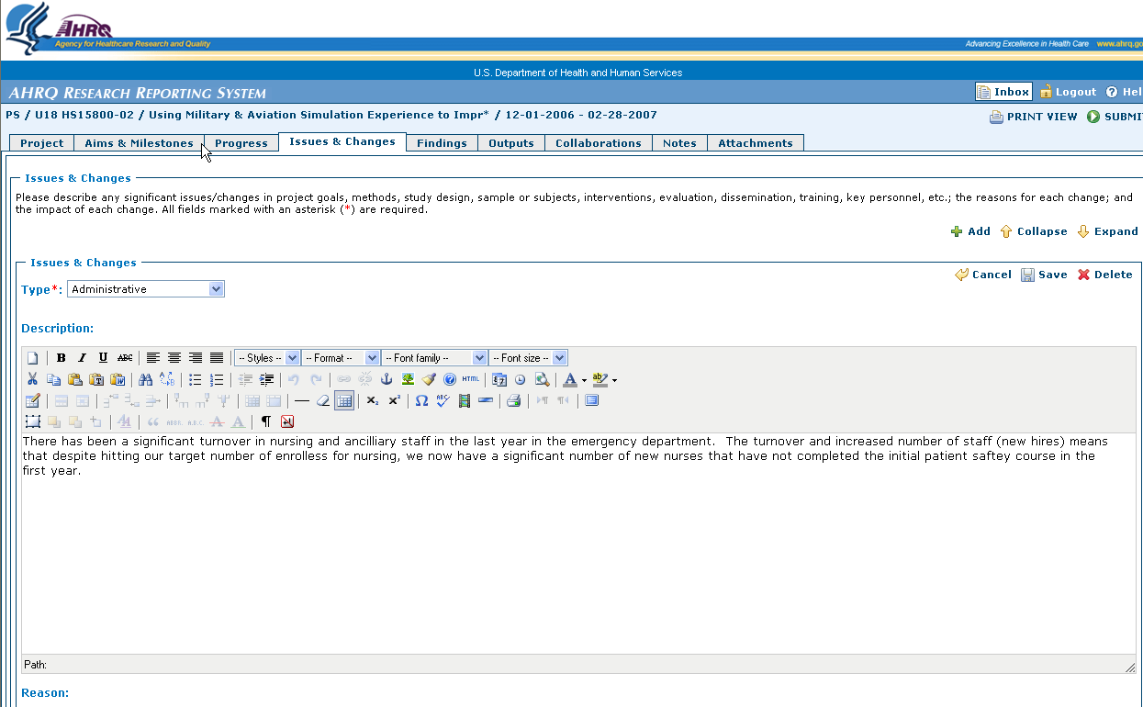
Save button
Figure 3-16: Saving Issues & Changes

To ADD a new Issue/Change
- Select the Add button on the upper right hand side of the page.
- The system displays a new empty record.
- Select the Edit button to right hand side of the page for the newly inserted record.
- The text box expands for data entry.

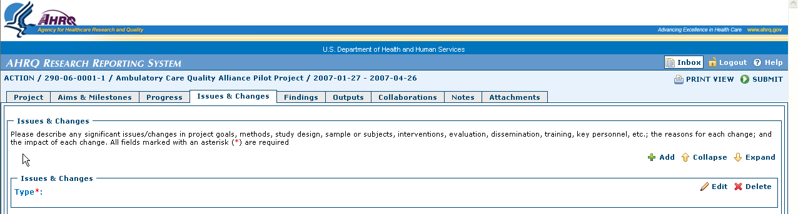
Add button
Figure 3-17: Adding Issues & Changes

- Select an Issue\Change type for the new record. (mandatory field)
- Enter the text in the Description Section, Reason Section and Impact Section as necessary.
- Select the Save button to save the newly entered data.
- Repeat steps 1-7 for each new issue\change.

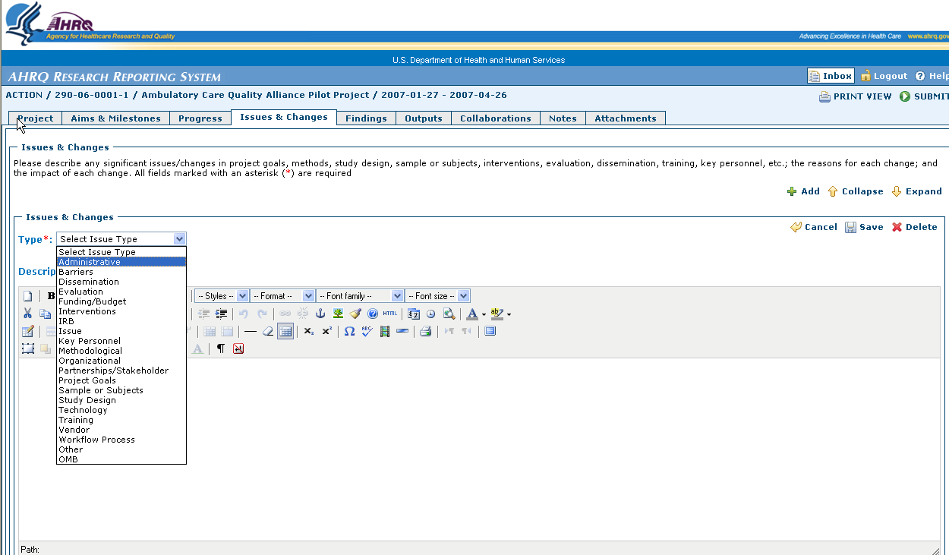
Required Field
Save button
Figure 3-18: Required Fields for Issues & Changes

To Delete an Issue\Change
- Find the Issue\Change to be deleted.
- Select the Delete button located on in the upper right hand side of the text box to be deleted.
- The system displays a warning message.
- Select OK to delete the Issue\Change.

Findings Page
The Findings page details any study outcomes or findings to report to AHRQ. The findings page is unique in that it displays one text field that is editable. To add new findings, the user must modify the existing text box.

To UPDATE Findings
- Select the Edit button in the upper right hand side to open the text box.
- Enter the text.
- Select the Save button to save the data entered.

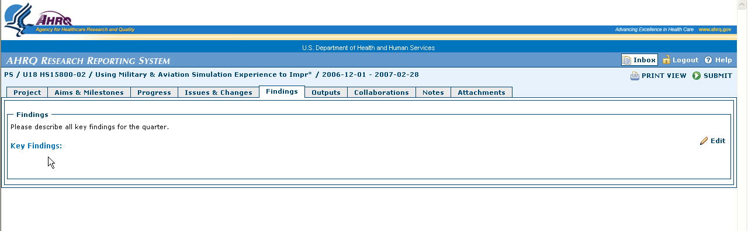
Edit button
Figure 3-19: Updating & Adding Findings
To ADD Findings
- Select the Edit button on the right hand side.
- The Findings text box expands and is editable.
- If the text box contains data, either add new text to the existing data or delete the existing text and enter the new text.
- Select the Save button to save the newly entered data.

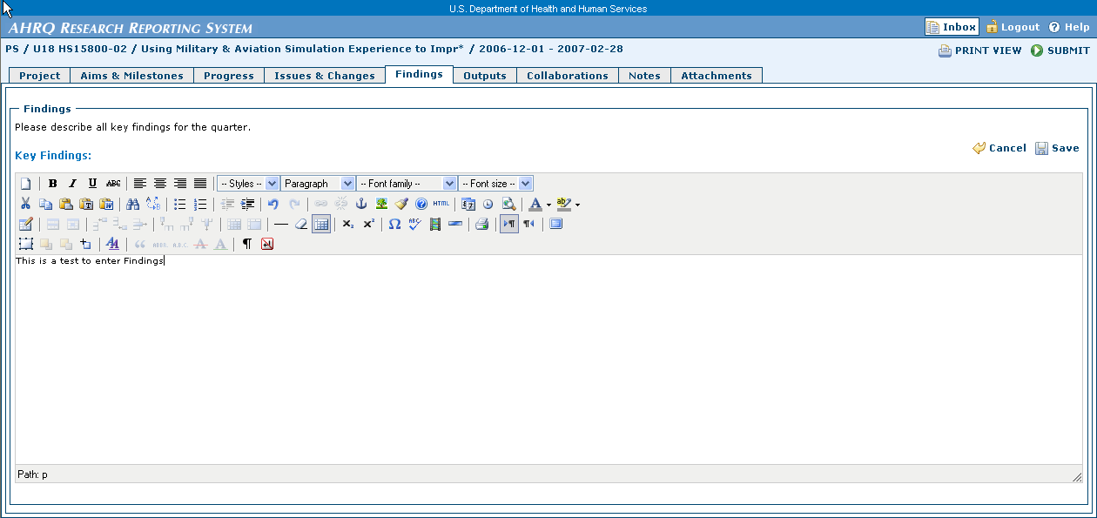
Save button
Figure 3-20: Saving Findings

Outputs Tab
The Outputs page describes any tools, products or deliverables produced since the last report. Although entering text in this page is not required, if text is entered then a type of issue or change must be selected from the drop down box.
This page displays two text boxes for each Output when the page is fully expanded. It displays a Description and Caption Section and an Impact and Dissemination Section. There are no dependencies on either of these sections and text is not mandatory for either section.
If the report contains data from the previous quarter the page will display the title for each project issue/change entered. Select the Expand button to view the text entered for each issue/change.
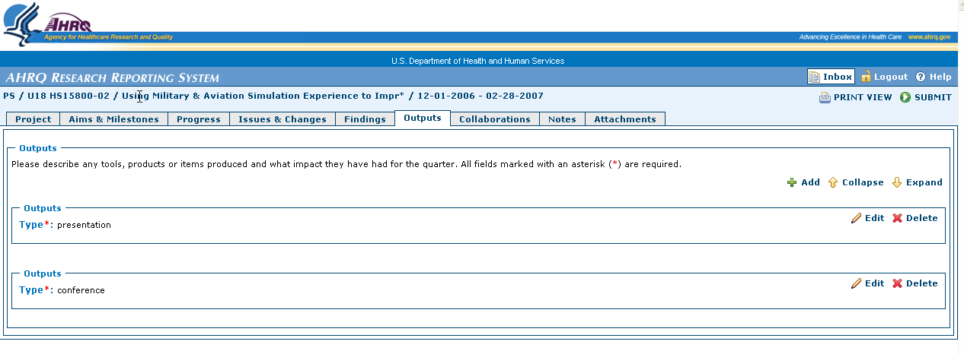
Expand button
Figure 3-21: Expanding Output Sections

To UPDATE an existing OUTPUT:
- Find the existing Output to update.
- Select the Edit button on the right hand side of the title field.
- The Issue\Change text box expands and is editable.
- Edit\update the text for the Description and Caption Section and the Impact and Dissemination Section as necessary.
- Select the Save button located on the right side of the frame to save the entered data.
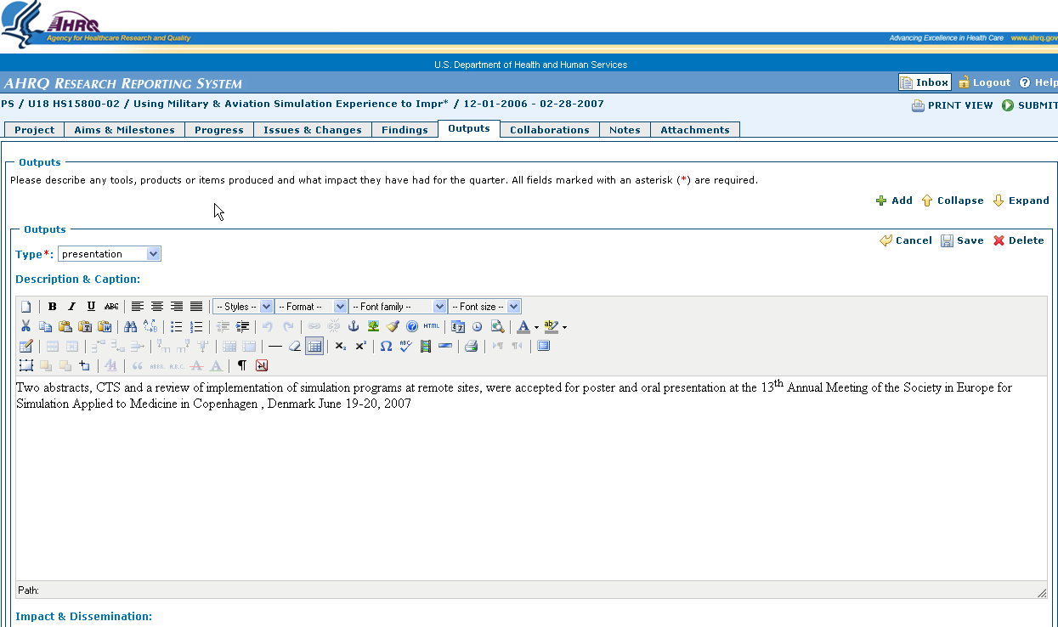
Save button
Figure 3-22: Saving Options

To ADD an Output:
- Select the Add button on the upper right hand side of the page.
- The Outputs text box expands and is editable.
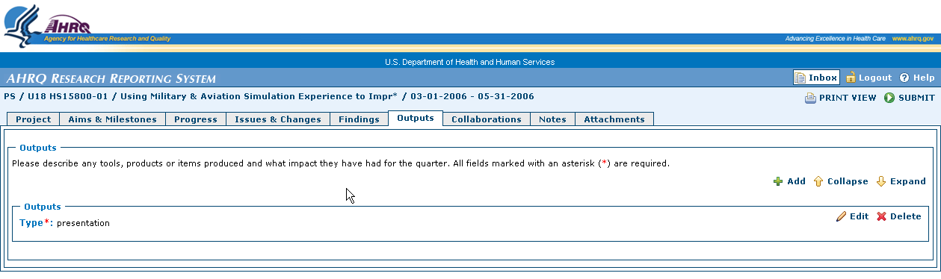
Add button
Figure 3-23: Adding Outputs
- Select an Output type for the new record. (mandatory field)
- Enter the text in the Description and Caption Section and the Impact and Dissemination Section as necessary.
- Select the Save button to save the newly entered data.
- Repeat steps 1-7 for each Output.

To Delete an Output
- Find the output to be deleted.
- Select the Delete button located on in the upper right hand side of the text box to be deleted.
- The system displays a warning message.
- Select OK to delete Output.
Required Field
Figure 3-24: Required Fields for Outputs

Collaborations Page
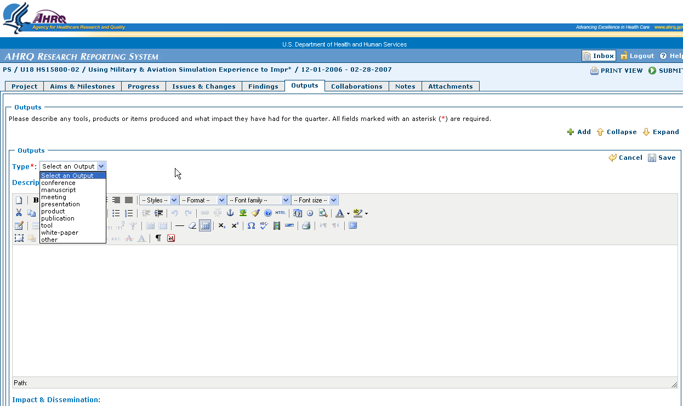

The Collaborations page describes new collaborations or partnerships formed since the last reporting period. This page is not required to be completed.
This page displays two text boxes when the page is fully expanded. It displays a Description section, and a Purpose of Collaboration/Partnership section. There are no dependencies for any of these sections and text is not mandatory for any section.
If the report contains data from the previous quarter the page displays the title for each Collaboration/Partnership previously entered. Select the Expand button to view the text entered for each issue/change.
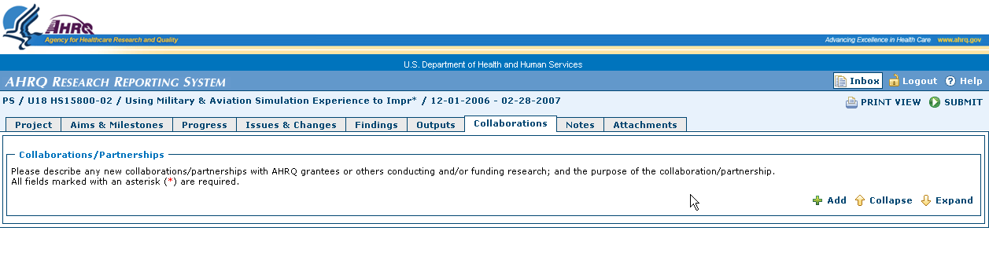
Figure 3-25: Expanding Collaborations

To UPDATE an existing Collaboration/Partnership:
- Find the Collaboration/Partnership to update.
- Select the Edit button on the right hand side of the title field.
- The Collaborations text box expands and is editable.
- Edit\update the text for the description Section and Purpose of Collaboration/Partnership section as necessary.
- Select the Save Button to save the newly entered text.
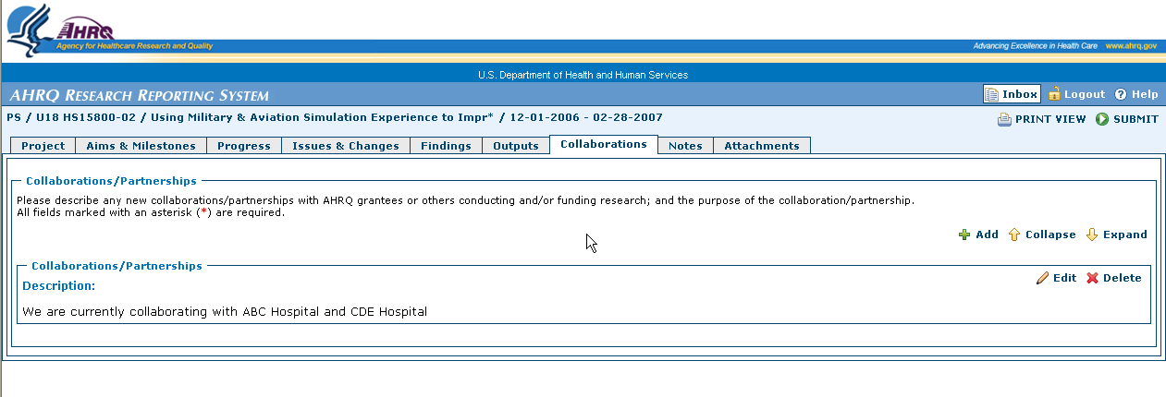
Figure 3-26: Updating Collaborations

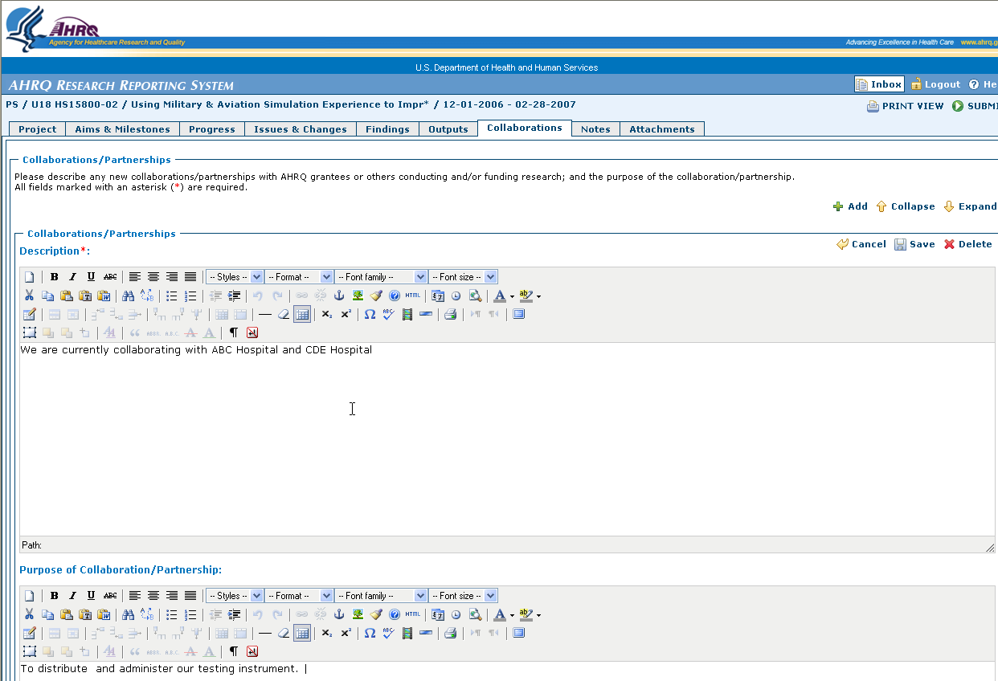
Figure 3-27: Saving Collaborations

To ADD a new Collaboration:
- Select the Add button on the upper right hand side of the page.
- A new Collaborations text box expands and is editable.
- Enter the Description Section and Purpose of Collaboration/Partnership section as necessary.
- Select the Save button to save the newly entered data.
- Repeat steps 1 – 5 for each new collaboration.
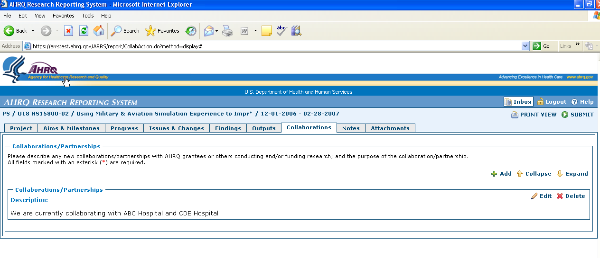
Add button
Figure 3-28: Adding Collaborations

To Delete a Collaboration
- Find the Collaboration to be deleted.
- Select the Delete button located on in the upper right hand side of the text box to be deleted.
- The system displays a warning message.
- Select OK to delete the Collaboration.

Notes Page
The Notes page displays any additional notes or comments not covered in any other sections of the report. The Notes page is unique; it displays only one text field that is editable. To add new notes, the user must modify existing text.
To UPDATE Notes
- Select the Edit button located on the right hand of the Collaborations section to open the text editor.
- Enter the text desired.
- Select the Save button to save the newly entered data.

Edit button
Figure 3-29: Updating & Adding Notes
To ADD Notes
- Select the Edit button located on the right hand side of the Notes section to open the text editor.
- If the text box is empty, enter new text for your Notes.
- If the text box contains data, add either new text to the existing data or delete the existing text and enter the new text.
- Select the Save button to save the newly entered data.

Save button
Figure 3-30: Saving Notes

Attachments Page
The attachments page allows users to attach various files to the status report.
- Text Files designated with a .txt extension
- Microsoft Word files designated with a .doc extension
- Microsoft Excel files designated with an .xls extension
- Microsoft PowerPoint files designated with a .ppt extension
- Image files designated with a .jpg or .bmp extension
- Hypertext MARKUP Language files designated with a .HTML extension
- Adobe portable document format files designated with a .pdf extension
Each report can contain up to 10 files. The maximum size for each file is 5 megabytes.

To ADD Attachments:
- Enter a title for the file being attached. (mandatory field)
- Select the Browse button located to the right of the “File” field. (mandatory field)
- The system displays a “Choose File” window.
- Locate the file to be added to the report.
- Highlight the file and select the Open button in the Choose File window.
- The system displays the file path.
- Select the Add button to add the file as an attachment to the report.
- Repeat Steps 1-7 to continue attaching more files.

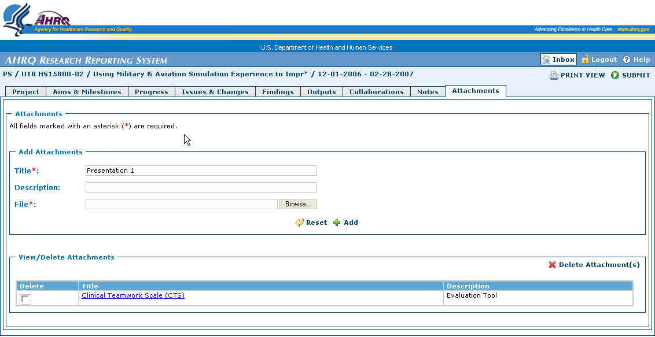
Required Field
Select to choose file
Figure 3-31: Browse Files for Attachment

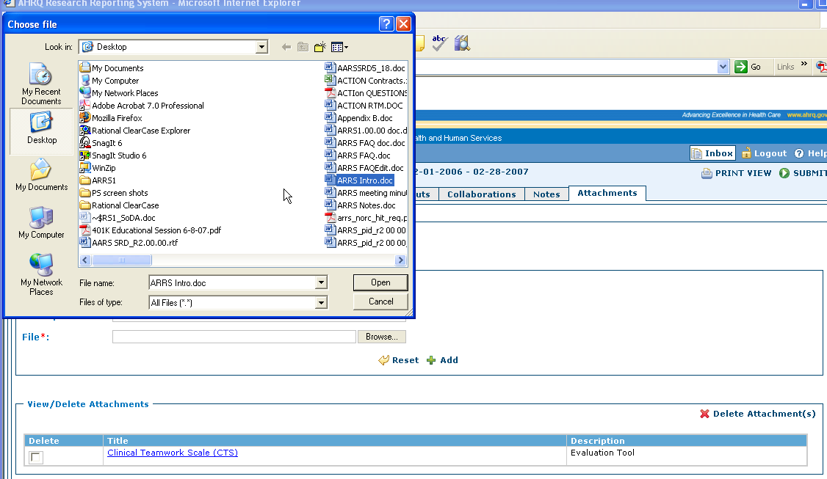
Select to capture file for report
Figure 3-32: Selecting Files for Attachment

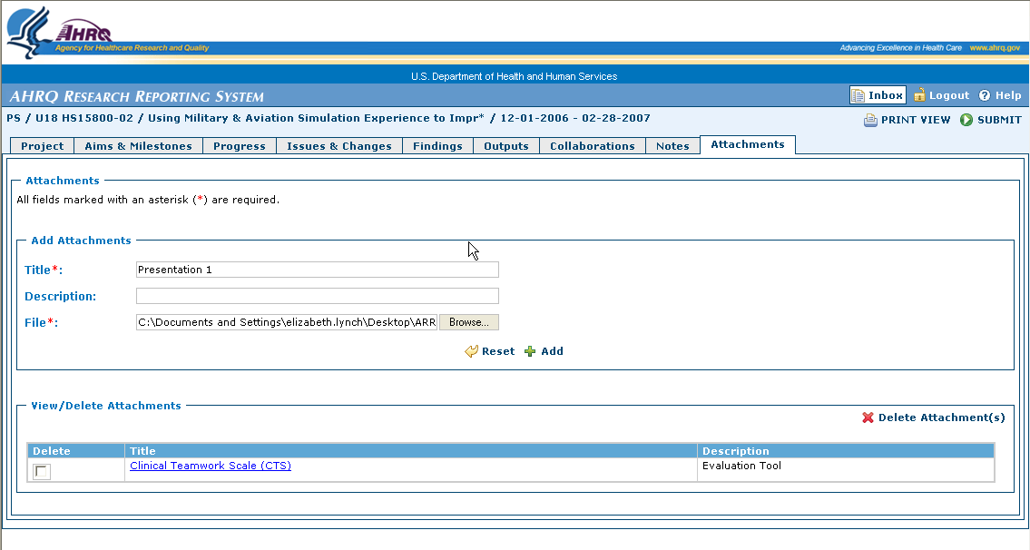
Select to add file to report
Figure 3-33: Adding an Attachment

To Reset Attachments
- Select the Reset button located to the left of the Add button.
- The system clears the Title field and the File field.
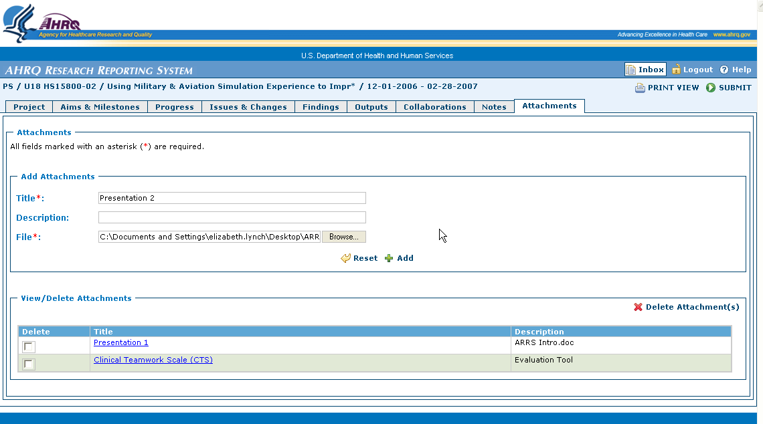
Reset button
Figure 3-34: Resetting Attachments
To Delete and Attachment
- In the Delete column of the View/Delete Attachments Section, select the radio button next to an attachment to mark it for deletion.
- Select the Delete Attachment(s) button located on the right side of the View/Delete Attachments Section.
- The system displays a warning message.
- Select OK to delete the selected attachments.

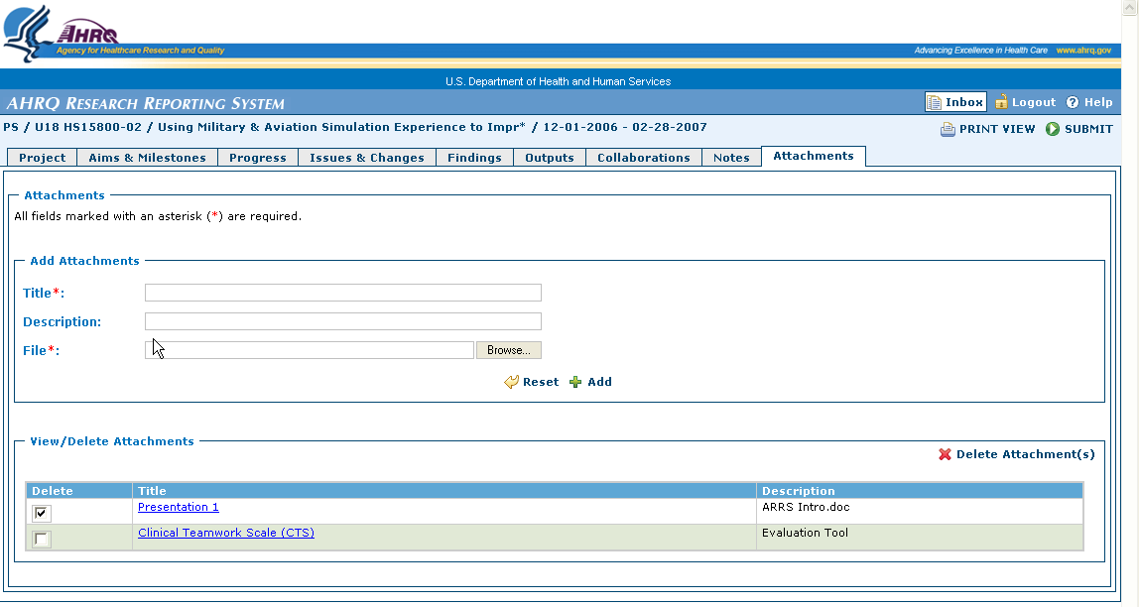
Select to Delete
Delete button
Figure 3-35: Deleting Attachments

Printing a Report
All users are able to print or print preview the status report at anytime. To print the status report:
- Open the application and login.
- The system displays your inbox.
- Select the Grant/Project for which the status report will be viewed.
- The system displays the detailed inbox which contains the actual status reports for a specific Grant/project.
- Select the status report to be printed.
- The system opens the report.
- Select the Print View button located inside the report.
- The system displays a preview of the report.
- Select the Print icon to print the report.
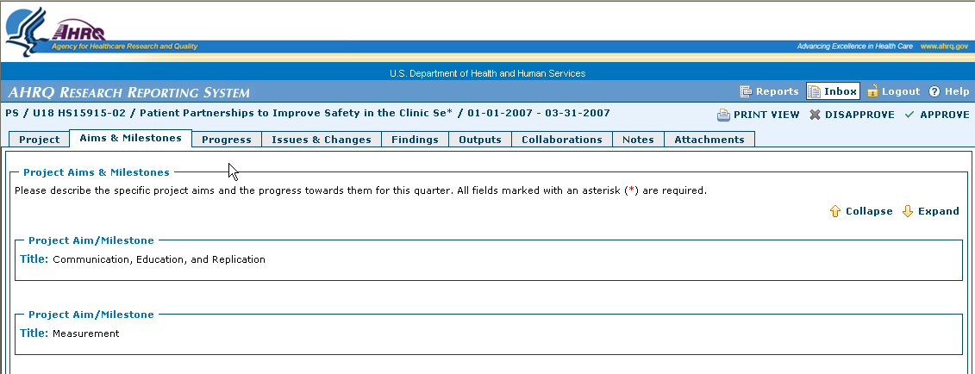
Figure 4-36: Viewing and Printing a Report

