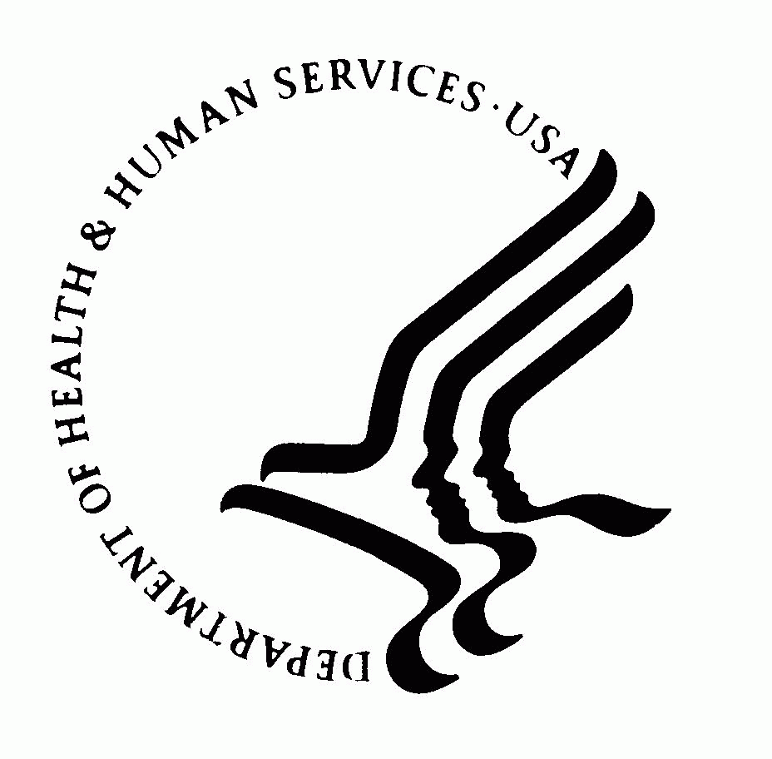 | DEPARTMENT OF HEALTH AND HUMAN SERVICES  Office of the Secretary  Washington DC 20201

MEMORANDUM

TO: Sherette Funn-Coleman, OS Reports Clearance Officer

THROUGH: Deborah Burris

FROM: Rebecca Hindrichs

SUBJECT: Request to Change 0990-0001, Exchange Visitor Waiver Application Process

DATE: October 27, 2010

OGHA requests OMB approve a modification to our Exchange Visitor Waiver Program application process. HHS will require applicants to provide a pdf version on computer disk that is identical to the already mandated and OMB-approved paper submission.

Applicants are institutions (e.g., universities) and normally hire attorneys to represent them. The attorneys prepare the application in electronic format and usually print the application from a scanned pdf file.

This request will have no impact on burden as currently approved and will remain in compliance with the PRA. The electronic version will facilitate quicker distribution, processing, accessing, and filing (pursuant to the Federal Records Act) the application.

Elizabeth Gianturco, OGC, supported this change to our application instructions provided PRA clearance requirements were met.

Please provide us with the Notice of Action upon OMB approval.

Thank you.

