Field Test Panel Maintenance Reminder Email – Sample Members Only

/From: els@rti.org
Subject: Education Longitudinal Study of 2002

Dear <NAME>:
Thank you for your ongoing participation in the Education Longitudinal Study of 2002 (ELS:2002). As you may recall, ELS:2002 is sponsored by the National Center for Education Statistics (NCES) of the U.S. Department of Education. Your voluntary participation, and the participation of other young adults like you, has helped to make ELS:2002 a great success and has provided valuable data about young adults’ experiences in and out of school. One of the most powerful aspects of ELS:2002 is the longitudinal component. Our ability to assess the progress of the study participants over time will help researchers better understand what drives young adults to academic and professional success. Recently, we sent a letter asking you to verify your contact information. If you have already completed this update, we thank you! If you have not yet had an opportunity, this is a friendly reminder to please spend about five minutes to update this information at your earliest convenience. We greatly appreciate your help with this critical effort.
[If selected for treatment group: As a token of our appreciation for your participation, we will mail you a $10 check if you or a parent updates your information by December 10, 2010.]
Please either fill out and return the form that was enclosed with the letter we sent to you or visit the web address below and use the study ID provided to update your contact information. We appreciate your continued support of ELS:2002. If you have any questions or encounter any difficulty, please call RTI toll-free at 1-800-334-8571 ext. 27791 or send an e-mail to els@rti.org.
- Go to https://surveys.nces.ed.gov/els/
- Select “Update Your Contact Information”
- Enter your study ID: <ID fill>
We look forward to hearing from you.
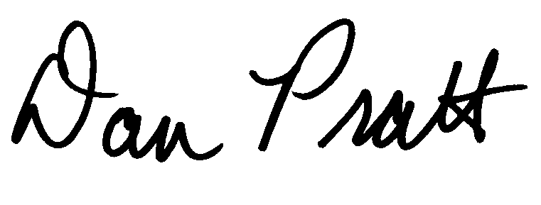

Dan Pratt
ELS:2002 Project Director

Field Test Panel Maintenance Email – Parent only

From: els@rti.org
Subject: Education Longitudinal Study of 2002

Dear <NAME>:
Thank you for your ongoing support of the Education Longitudinal Study of 2002 (ELS:2002). As you may recall, ELS:2002 is sponsored by the National Center for Education Statistics (NCES) of the U.S. Department of Education. The voluntary participation of your young adult has helped to make ELS:2002 a great success and has provided valuable data about young adults’ experiences in and out of school. One of the most powerful aspects of ELS:2002 is the longitudinal component. Our ability to assess the progress of the study participants over time will help researchers better understand what drives young adults through academic and professional experiences. Recently, we sent a letter asking for your help in verifying your young adult’s contact information. If you have already completed this update, we thank you! If you have not yet had an opportunity, this is a friendly reminder to please spend about five minutes to update this information at your earliest convenience. We greatly appreciate your help with this critical effort.
[If selected for treatment group: As a token of our appreciation for their participation, we will mail your young adult a $10 check if you or they confirm or update their information by December 10, 2010.]
Please either fill out and return the form that was enclosed with the letter we sent to you or visit the web address below and use the study ID provided to update your young adult’s contact information. We appreciate your continued support of ELS:2002. If you have any questions or encounter any difficulty, please call RTI toll-free at 1-800-334-8571 ext. 27791 or send an e-mail to els@rti.org.
- Go to https://surveys.nces.ed.gov/els/
- Select “Update Your Contact Information”
- Enter your study ID: <ID fill>
We look forward to hearing from you.

Dan Pratt
ELS:2002 Project Director

Thank You Letter for Sample Members Who Have Updated Their Information

<date>

Dear ELS:2002 Study Participant:

As a token of our appreciation of your assistance with the Education Longitudinal Study of 2002 (ELS:2002), enclosed is a check for you. Your participation, and the participation of other young adults like you, has made ELS:2002 a great success and has provided valuable data about young peoples’ experiences in and out of school.

Thank you for your assistance!

Sincerely,
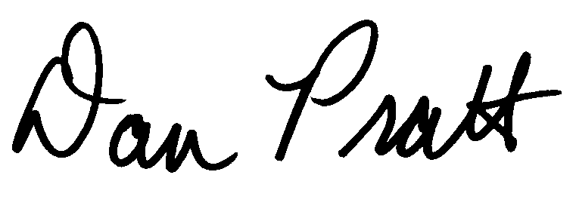
Dan Pratt
ELS:2002 Project Director

