OMB Control # 3245-0352
Expiration Date:


LENDER’S
USER’S
MANUAL

Microloan Program Electronic
Reporting System (MPERS)

U.S. Small Business Administration

March, 2007

The estimated burden for responding to this collection of information is
15 minutes per response including time for reviewing instructions, searching existing data sources, gathering and maintaining the data needed and completing and reviewing the collection of information. You are not required to respond to this collection of information unless it displays a currently valid OMB approval number. The OMB control number for this collection of information is 3245-0352. Comments on the burden estimates should be sent to the U.S. Small Business Administration, Chief, AIB 409 3rd Street, S.W. , Washington, D.C. 20416 and Desk Officer for the Small Business Administration, Office of Management and Budget, New Executive Office Building, Room 10201, Washington, D.C. 20503
Table of Contents

1.1 System Overview 1
1.2 Authorized Use Permission 1
1.3 Points of Contact 2
1.3.1 Information 2
1.3.2 Help Desk 2
1.4 Terms and Abbreviations 3
2.1 System Configuration 1
3.1 Logging On 1
3.1.1 Choose Function Menu 1
3.2 System Menu 2
3.2.1 Lender Portfolio 2
3.2.2 Portfolio Status 2
3.2.3 Help 3
3.2.4 Exit 3
3.3 Changing User ID and Password 3
3.4 Exit System 4
4.1 Lender Functions 1
4.1.1 Lender Detail 1
4.1.2 Add Loan 3
4.1.3 Edit Loan 7
4.1.4 Add Additional Borrower 12
4.1.5 Edit Additional Borrower 14
4.1.6 Loan Search 15
4.1.7 Loan Search Results 17
4.1.8 Borrower Search 17
4.1.9 Borrower Search Results 18
4.1.10 Snapshot Summary 19
4.1.11 Update Portfolio 21
4.1.12 No Change Certification Reason 23
4.1.13 Snapshot Detail 24
4.1.14 Reason for No Change Certification 25
4.1.15 CO/PIF Loans 26
4.2 Special Instructions for Error Correction 27
4.3 Caveats and Exceptions 27

1.0 GENERAL INFORMATION

System Overview
MPERS is a web enabled system accessed with the General Login System (GLS). The menu is dynamically built based on the function that a user’s role may have access to.

This system broadly keeps track of the following information about Microlenders, Microloans and Microborrowers:

- Microlender Information – Lender Name, Address, Phone and Fax Numbers, Program Start Date, and Program End Date.
- Microloan Information – Identifying information about loans that the Microlender makes. This includes Portfolio status information, percent of woman ownership in business, Loan Amount, Interest Rate and Terms, Number of Hours, Organization Type, NAICS Code, Urban/Rural Code, Number of Employees Created and Retained, SBA Loan Number and Lender Loan Number.
- Microborrower Information – Identifying information about borrowers (businesses or people) who receive loans from Microlenders. This includes Tax Id number, Name, Address, Phone and Fax Numbers, Date the Business was formed, Veterans Status, and Ethnicity.

The system will be completely redesigned using Cold Fusion 5.0, accessing a Sybase database.

1.2 Authorized Use Permission

This is a Federal computer system and is the property of the United States Government. It is for authorized use only. Users (authorized or unauthorized) have no explicit or implicit expectation of privacy in anything viewed, created, downloaded, or stored on this system, including e-mail, Internet, and Intranet use. Any or all uses of this system (including all peripheral devices and output media) and all files on this system may be intercepted, monitored, read, captured, recorded, disclosed, copied, audited, and/or inspected by authorized Small Business Administration (SBA) personnel, the Office of Inspector General (OIG), and/or other law enforcement personnel, as well as authorized officials of other agencies, both domestic and foreign. Access or use of this computer by any person, whether authorized or unauthorized, constitutes consent to such interception, monitoring, reading, capturing, recording, disclosure, copying, auditing, and/or inspection at the discretion of authorized SBA personnel, law enforcement personnel (including the OIG), and/or authorized officials of other agencies, both domestic and foreign. Unauthorized use of, or exceeding authorized access to, this system is prohibited and may constitute a violation of 18 U.S.C. § 1030 or other Federal laws and regulations and may result in criminal, civil, and/or administrative action. By using this system, users indicate awareness of, and consent to, these terms and conditions and acknowledge that there is no reasonable expectation of privacy in the access or use of this computer system.

1.3 Points of Contact

1.3.1 Information
Individuals with questions or concerns regarding these instructions should contact the SBA Microenterprise Development Branch at 202-205-6495 or the individual indicated below:

Jan Blackwell-Robinson
Financial Analyst
Microenterprise Development Branch
(202) 205-7134 (voice)
(202) 481-6083 (fax)
Janet.blackwell-robinson@sba.gov

1.3.2 Help Desk

Contact Name | Department/Division | Telephone Number | E-mail address
N/A | Network Integration Branch | 202-205-6400 | hqhelpdesk@sba.gov

1.4 Terms and Abbreviations

GLS - General Login System – Also referred to as SSII; Controls access to MPERS
Location ID - Identifies a physical address of a Partner or Microlender in PIMS; The primary Location ID is often times used in place of the Partner ID as a means of identifying a Partner
Microborrower - Small business concern that receives a Microloan
Microlender - SBA approved intermediary lender working in the Microloan Program
Microlender ID - SBA manually generated intermediary lender identification number utilized in the LAM system
Microloan - Loan under $35,000 made by a Microlender to a small business concern
Microloan Number - Also referred to as the Lender Loan Number; A unique number sometimes assigned by the Microlender used to identify a Microloan within their portfolio
MDB - Microloan Development Branch - Also referred to as the Program Office
MLS – Microloan System
MPERS - Microloan Program Electronic Reporting System
MPPO - Microloan Program Participating Organization
OISS – Office of System Support
Partner ID - Identifies a Partner or Microlender in PIMS
PIMS - Partner Identification Management System
SBA – Small Business Administration
SBA Loan - Loan made by SBA to the Microlender
SBA Loan Number – Number generated by SBA LAM System used to identify an SBA Loan
Sequence Number - Unique number generated by MPERS that identifies microloan to Microborrower.
SSII-Security System II – also referred to as GLS

2.0 SYSTEM SUMMARY

2.1 System Configuration

The application is developed for use with a minimum browser configuration of Netscape 4.7, Microsoft IE 4.0 or greater. You must use High level encryption (128 bit) when configuring your browser. You must enable support for JAVA script. There is no use of client side COOKIES. In general the font type is 10pt. Arial, style sheets are not used. The application is best viewed at an 800x 600 resolution screen to avoid scrolling using a minimum 15" screens.

3.0 GETTING STARTED

3.1 Logging On
Connect to the internet and enter https://eweb.sba.gov/gls/dsp_login.cfm in the URL. You will be presented with the Log-In screen. Enter the User Id and Password provided to you by the Small Business Administration's Security Officer.

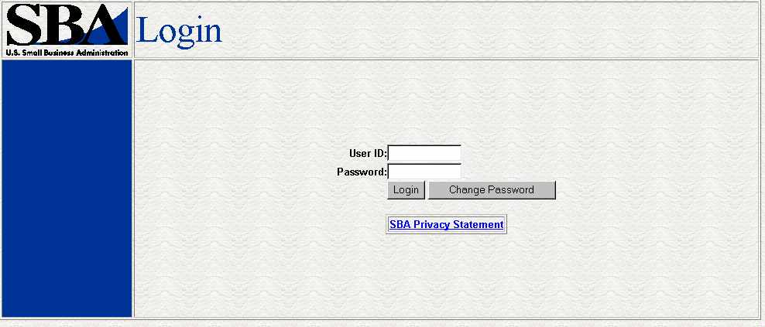

3.1.1 Choose Function Menu

Not all items listed on this sample menu are available to all personnel. The menu will only display those items that you are authorized to use.
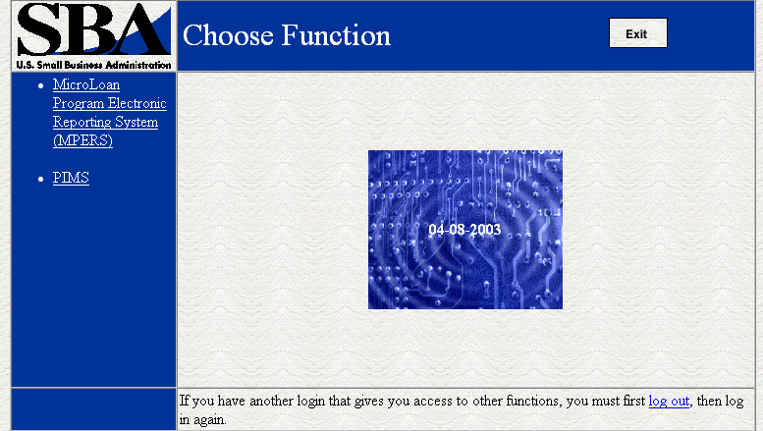

Possible selections include;
- Microloan Program Electronic Reporting System (MPERS) - Allows a user the ability to enter the MPERS System.
- PIMS - This will take you to the Partner Identification and Management System.

System Menu

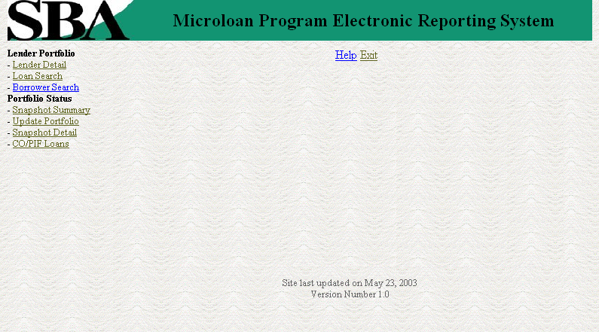

Lender Portfolio
- Lender Detail – Provides detailed information on a lender and displays a list of the lenders loans.
- Loan Search – Allows a user to search for a loan by Lender Loan Number, SBA Loan Number, Loan Sequence Number or by Loan Amount, Closing Date, and Complete or Incomplete status.
- Borrower Search – Allows a user to search for a borrower by EIN/SSN Number, Borrower Name, or Trade Name.

Portfolio Status
- Snapshot Summary – Displays the portfolio summary information for a lender.
- Update Portfolio – Displays the current status information for a lenders portfolio and allows the lender to update the status information.
- Snapshot Detail – Displays a snapshot of a lenders portfolio.
- CO/PIF Loans – Displays the Charged Off and Paid In Full Loans for a lender.

Help
Displays information to help the user with the application in a new window.

Exit
Allows the user to exit the application.

Changing User ID and Password
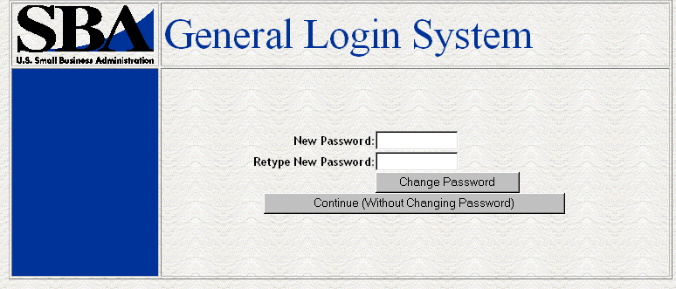
This screen provides the end user the ability to change the password provided to them, by the SBA’s Security Office or to continue on to the application without changing the password.

Exit System
To Exit the system, press the Exit Button. You will be returned to the General Login System.

4.0 USING THE SYSTEM (ONLINE)

Lender Functions

Lender Detail
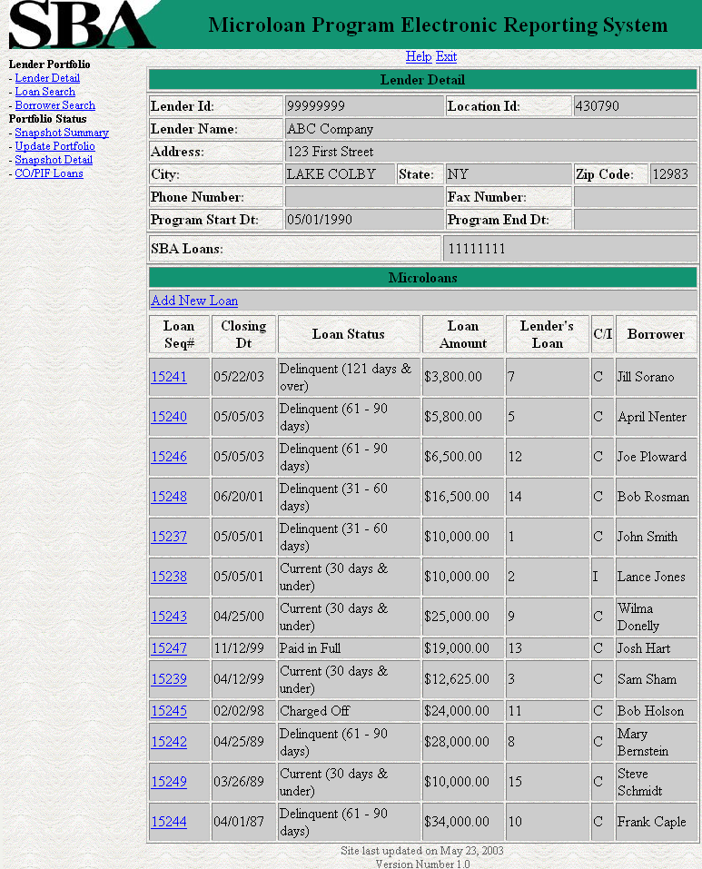

The Lender Detail Page Displays the following information about the lender:
- Lender ID
- Location ID
- Name
- Address
- City
- State
- Zip Code
- Phone Number
- Program Start Date
- Program End Date
- SBA Loans

The user can create a new loan by selecting the Add New Loan link.
The Lender Detail Page displays the following information about all loans for the lender:
- Sequence Number - This is a link that will redirect the user to the Loan Detail Page.
- Closing Date
- Loan Status
- Loan Amount
- Lender's Loan Number
- C/I - For Complete or Incomplete Loan
- Borrower Name

- Add Loan 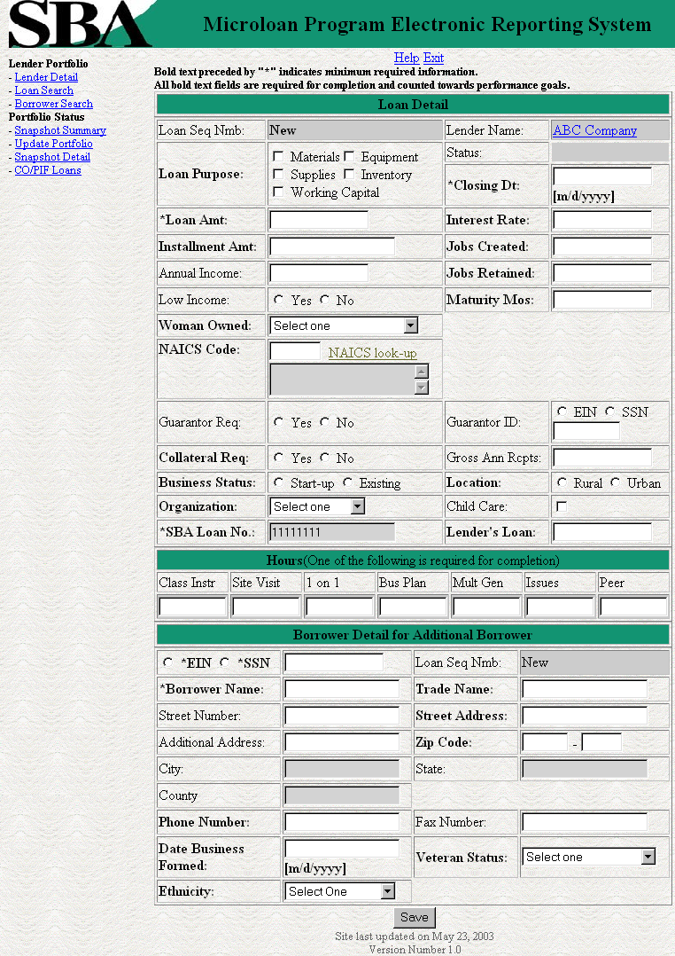
The following fields are available to create a new loan:
- Loan Seq Nmb
- This field is pre-populated with the word “New”, signifying that this is a new loan and does not have a Loan Sequence Number.
- Lender Name
- This field is pre-populated with the name of the lender.
- This is a link that will redirect the user to the Lender Detail Page.
- Loan Purpose
- One or more of the following options can be selected:
- Materials
- Equipment
- Supplies
- Inventory
- Working Capital
- Status - Complete or Incomplete
- Closing Dt
- Loan Amt
- Interest Rate
- Installment Amt
- Jobs Created
- Annual Income
- Jobs Retained
- Low Income
- Maturity Mos
- Woman Owned – One of the following options can be selected:
  - 100% Female Owned
  - 51 - 99% Female Owned
  - 0 - 50% Female Owned
- NAICS Code - The code description will be displayed below the code. The user can select the "NAICS look-up" link for help selecting the NAICS Code.
- SIC - The code description will be displayed below the code. This field will only be displayed if a value has been previously entered for it.
- Guarantor Req
- Guarantor ID - This field will only be displayed if yes has been selected for Guarantor Req.
- Collateral Req
- Gross Ann Rcpts
- Business Status - Start-up or Existing
- Location: Rural or Urban
- Organization - One of the following options can be selected:
  - Proprietorship
  - Partnership
  - Corporation
  - Joint Venture
  - LLC
  - Non-Profit
- Child Care - This can only be selected if "Non-Profit has been selected for Organization.
- SBA Loan No.
- Lender Loan No.
- Hours – The user can enter hours for any of the following options:
- Class Instr
- Site Visit
- 1 on 1
- Bus Plan
- Mult Gen
- Issues
- Peer

The following fields are for the primary borrower to create a new loan:
- SSN/EIN Number
- Loan Seq Nmb
  - This field is pre-populated with the word “New”, signifying that this is a new loan and does not have a Loan Sequence Number.
- Borrower Name
- Trade Name
- Street Number
- Street Address
- Additional Address
- ZIP
- City - This field is automatically populated when the Zip is entered.
- ST - This field is automatically populated when the Zip is entered.
- County - This field is automatically populated when the Zip is entered.
- Phone No
- Fax No
- Date Business Formed
- Veteran Status - One of the following options can be selected:
- Veteran
- Service Disabled Veteran
- Non Veteran
- Ethnicity - One of the following options can be selected:
- Hispanic or Latino
- Non Hispanic or Latino
- Race - One or more of the following options can be selected:
- American Indian or Alaska Native
- Black or African American
- Asian
- Native Hawaiian or other Pacific Islander
- White

Any fields which are bold and preceded by an asterisk are required and must be completed to create the loan.

Any fields which are bold but are not preceded by an asterisk are required for the loan to be complete and counted towards performance goals. If any of these fields have not been filled in, the loan will be saved as an incomplete loan.

The user will have the ability to create a new loan by inputting the appropriate information into the form and selecting the Save button.

Edit Loan

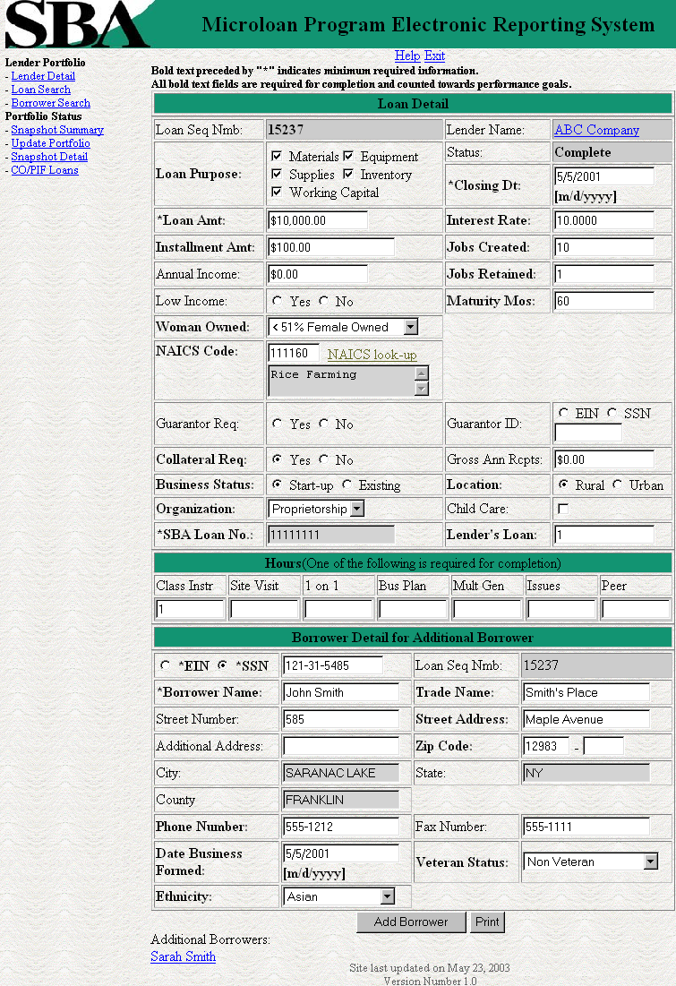
The following fields are available to modify an existing loan if the loan is incomplete:
- Loan Seq Nmb
- This field is pre-populated with the Loan Sequence Number and can not be modified.
- Lender Name
- This field is pre-populated with the name of the lender.
- This is a link that will redirect the user to the Lender Detail Page.
- Loan Purpose
- One or more of the following options can be selected:
- Materials
- Equipment
- Supplies
- Inventory
- Working Capital
- Status - Complete or Incomplete
- Closing Dt
- Loan Amt
- Interest Rate
- Installment Amt
- Jobs Created
- Annual Income
- Jobs Retained
- Low Income
- Maturity Mos
- Woman Owned – One of the following options can be selected:
  - 100% Female Owned
  - 51 - 99% Female Owned
  - 0 - 50% Female Owned
- NAICS Code - The code description will be displayed below the code. The user can select the "NAICS look-up" link for help selecting the NAICS Code.
- SIC - The code description will be displayed below the code. This field will only be displayed if a value has been previously entered for it.
- Guarantor Req
- Guarantor ID - This field will only be displayed if yes has been selected for Guarantor Req.
- Collateral Req
- Gross Ann Rcpts
- Business Status - Start-up or Existing
- Location: Rural or Urban
- Organization - One of the following options can be selected:
  - Proprietorship
  - Partnership
  - Corporation
  - Joint Venture
  - LLC
  - Non-Profit
- Child Care - This can only be selected if "Non-Profit has been selected for Organization.
- SBA Loan No.
- Lender Loan No.
- Hours – The user can enter hours for any of the following options:
- Class Instr
- Site Visit
- 1 on 1
- Bus Plan
- Mult Gen
- Issues
- Peer

The Loan Detail Page Displays the following information about the primary borrower for the loan:
- SSN/EIN Number
- Loan Seq Nmb
  - This field is pre-populated with the Loan Sequence Number and can not be modified.
- Borrower Name
- Trade Name
- Street Number
- Street Address
- Additional Address
- ZIP
- City
- ST
- County
- Phone No
- Fax No
- Date Business Formed
- Veteran Status - One of the following options can be selected:
- Non Veteran
- Service Disabled Veteran
- Veteran
- Ethnicity - One of the following options can be selected:
- Hispanic or Latino
- Non Hispanic or Latino
- Race - One or more of the following options can be selected:

- American Indian or Alaska Native
- Black or African American
- Asian
- Native Hawaiian or other Pacific Islander
- White

If the loan is currently a complete loan, the user will not be able to modify the loan.

If the loan is currently an incomplete loan, any fields which are bold but are not preceded by an asterisk are required for the loan to be complete and counted towards performance goals. If any of these fields have not been filled in, the loan will be saved as an incomplete loan.

The user will have the ability to edit the loan by modifying the appropriate field(s) and selecting the "Save" button if the loan is incomplete.

The user will have the ability to add an additional borrower by selecting the "Additional Borrower" button. This will open the Borrower Detail page.
The user will have the ability to view the loan information in a printable format by selecting the "Print" button. This will be displayed in a new window.
Additional borrowers will also be displayed with a link to the Borrower Detail page.

Add Additional Borrower
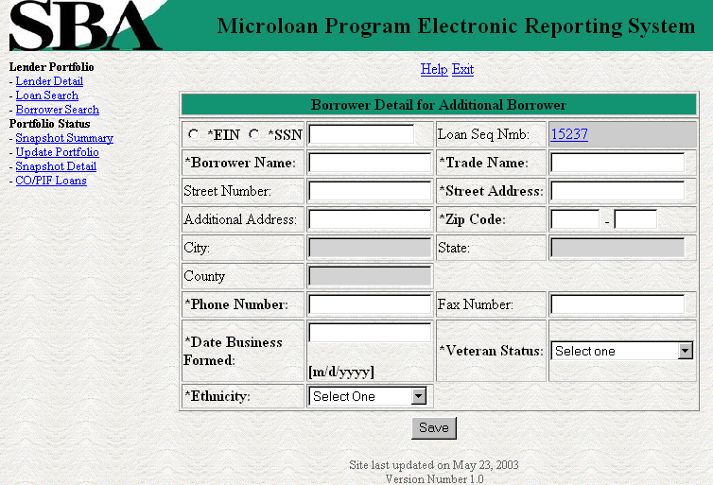

The following fields are available to create an additional borrower:
- SSN/EIN Number
- Loan Seq Nmb
  - This field is pre-populated with the Loan Sequence Number and can not be modified.
  - This is a link that will redirect the user to the Lender Detail Page.
- Borrower Name
- Trade Name
- Street Number
- Street Address
- Additional Address
- ZIP
- City - This field is automatically populated when the Zip is entered.
- ST - This field is automatically populated when the Zip is entered.
- County - This field is automatically populated when the Zip is entered.
- Phone No
- Fax No
- Date Business Formed
- Veteran Status - One of the following options can be selected:
- Non Veteran
- Service Disabled Veteran
- Veteran
- Ethnicity - One of the following options can be selected:
- Hispanic or Latino
- Non Hispanic or Latino
- Race - One or more of the following options can be selected:
- American Indian or Alaska Native
- Black or African American
- Asian
- Native Hawaiian or other Pacific Islander
- White

Any fields which are bold and preceded by an asterisk are required and must be completed to create the additional borrower.

The user will have the ability to create an additional borrower by inputting the appropriate information into the form and selecting the "Save" button.

Edit Additional Borrower
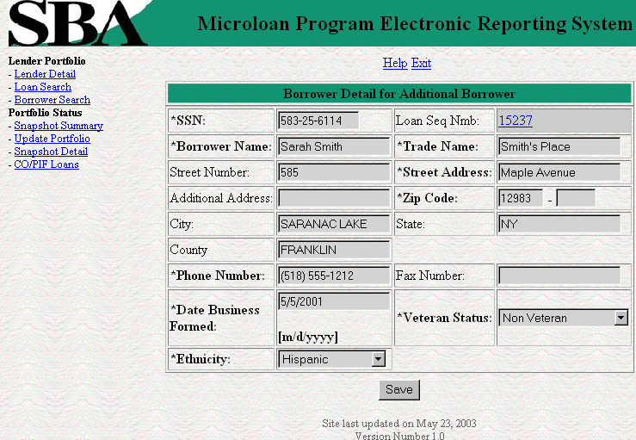
The following fields are fields are display for an additional borrower:
- SSN/EIN Number
- Loan Seq Nmb
  - This field is pre-populated with the Loan Sequence Number and can not be modified.
  - This is a link that will redirect the user to the Lender Detail Page.
- Borrower Name
- Trade Name
- Street Number
- Street Address
- Additional Address
- ZIP
- City - This field is automatically populated when the Zip is entered.
- ST - This field is automatically populated when the Zip is entered.
- County - This field is automatically populated when the Zip is entered.
- Phone No
- Fax No
- Date Business Formed
- Veteran Status - One of the following options can be selected:
- Non Veteran
- Service Disabled Veteran
- Veteran
- Ethnicity - One of the following options can be selected:
- Hispanic or Latino
- Non Hispanic or Latino
- Race - One or more of the following options can be selected:
- American Indian or Alaska Native
- Black or African American
- Asian
- Native Hawaiian or other Pacific Islander
- White

The user will not have the ability to edit the additional borrower.

Loan Search
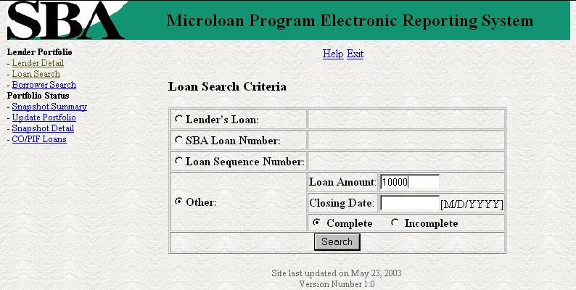

The user can search for a loan by Lender Loan Number, SBA Loan Number, Loan Sequence Number, or Other Options.
- To search by Lender Loan Number:
- Select the radio button for Lender Loan Number
- Enter the Lender Loan Number in the text field provided

- Select the Search button
- To search by SBA Loan Number:
- Select the radio button for SBA Loan Number
- Enter the SBA Loan Number in the text field provided
Select the Search button
- To search by Loan Sequence Number:
- Select the radio button for Loan Sequence Number
- Enter the Loan Sequence Number in the text field provided
- Select the Search button
- To search by other options:
- Select the radio button for Other Options
- Enter the Closing Date and/or Loan Amount in the fields provided
- Select the radio button for Complete" or "Incomplete
- Select the Search button

If no loans match the search criteria the user will be notified and advised to try again.

Loan Search Results
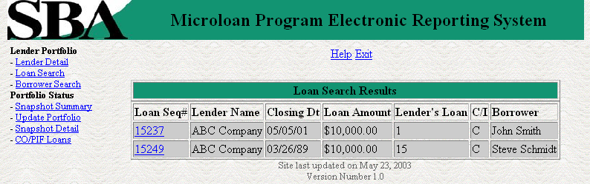

The loans will be listed with the Loan Sequence Number, Lender Name, Closing Date, Loan Amount, Lender’s Loan, C/I (Complete or Incomplete), and Borrower Name being displayed. To view a loan, select the Loan Sequence Number. This will open the Loan Detail page for the selected loan.

Borrower Search
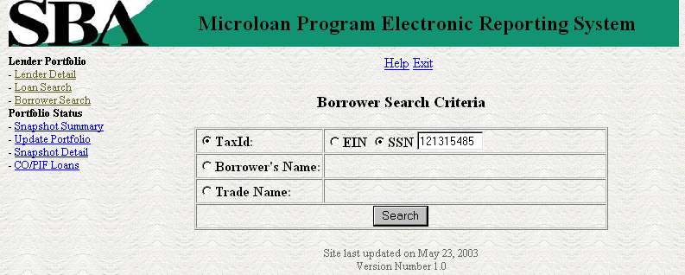

The user can search for a borrower by Tax ID, Borrower Name, or Trade name.
- To search by Tax ID:
- Select the radio button for Tax ID
- Select the radio button for EIN or SSN
- Enter the Tax ID in the text field provided
- Select the Search button
- To search by Borrower Name:
- Select the radio button for Borrower Name
- Enter the Borrower Name in the text field provided
Select the Search button
- To search by Trade name:
- Select the radio button for Trade name
- Enter the Trade name in the text field provided
- Select the Search button

If no borrowers match the search criteria the user will be notified and advised to try again.

Borrower Search Results
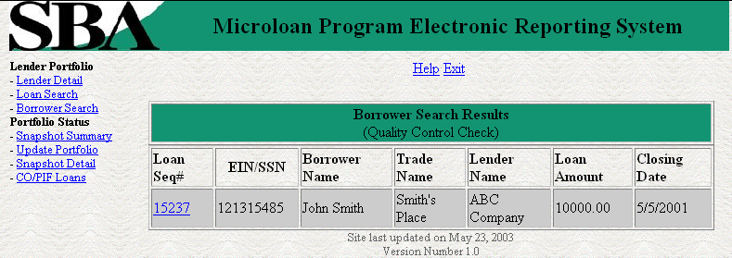

The loans will be listed with the Loan Sequence Number, EIN/SSN Number, Borrower Name, Trade Name, Lender Name, Loan Amount, and Closing Date being displayed. To view a loan, select the Loan Sequence Number. This will open the Loan Detail page for the selected loan.

Snapshot Summary
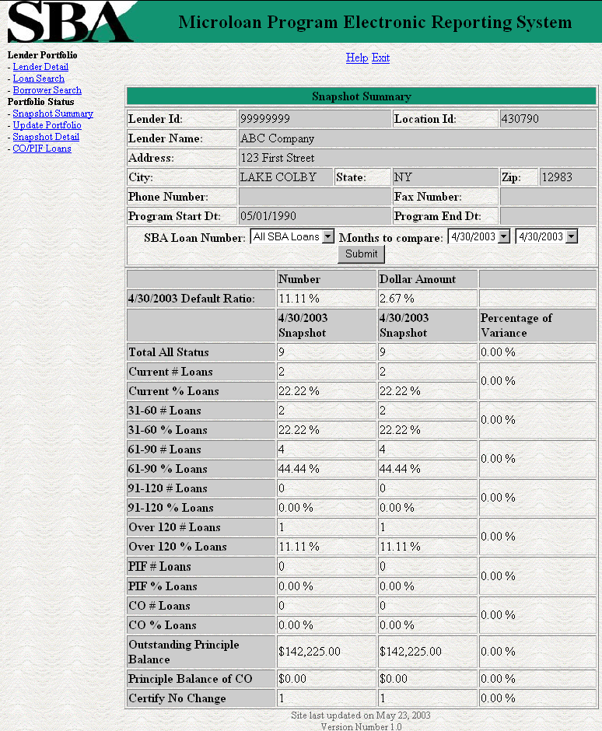

The Snapshot Summary Page displays the following information about the lender:
- Lender ID
- Location ID
- Name
- Address
- City
- State
- Zip Code
- Phone Number
- Program Start Date
- Program End Date

The user will have the ability to select a summary of all loans for a lender or loans for a specific SBA Loan Number and which two dates to compare.
The default ratio percentage for the number of loans and the dollar amount of loans is displayed.
The following information is displayed for each date:
- Total All Status
- Current # Loans
- Current % Loans
- 31-60# Loans
- 31-60% Loans
- 61-90# Loans
- 61-90% Loans
- 91-120# Loans
- 91-120% Loans
- Over 120# Loans
- Over 120% Loans
- PIF# Loans
- PIF% Loans
- CO# Loans
- CO% Loans
- Outstanding Principal Balance
- Principal Balance of CO
- Certify No Change
The user will have the ability to select from all available snapshot dates to compare two snapshots.

Update Portfolio
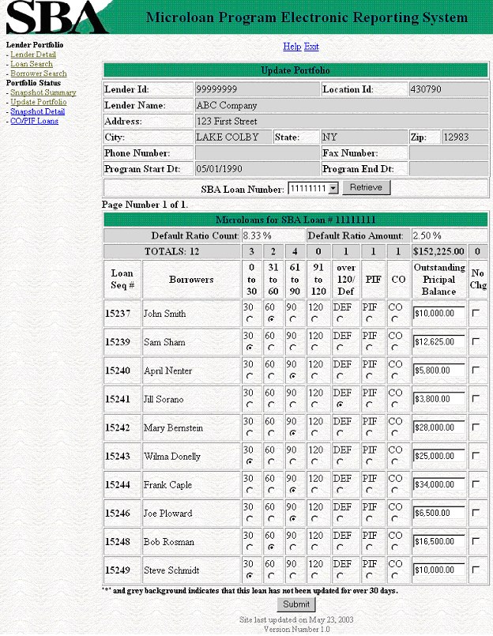

The Snapshot Summary Page displays the following information about the lender:
- Lender ID
- Location ID
- Name
- Address
- City
- State
- Zip Code
- Phone Number
- Program Start Date
- Program End Date

The user will have the ability to select an SBA Loan Number to display all current loans.
Once the user chooses an SBA Loan Number and selects the "Retrieve" button, the following information will be displayed about all microloans for that SBA Loan Number which have not been paid in full or charged off prior to the last snapshot:
- Loan Seq#
- Borrowers
- Loan Status - these will be a series of radio buttons with the following options:
- 0 - 30
- 31 - 60
- 61 - 90
- 91 - 120
- Over 120/Def
- PIF
- CO
- Outstanding Principal Balance
- No Chg

Any loan which has not been updated in the last 30 days will be displayed with an asterisk preceding the Loan Sequence Number and the row background color will be grey.
The user will have the ability to update the loan status, loan outstanding balance, or no change indicator and then submit the changes

No Change Certification Reason
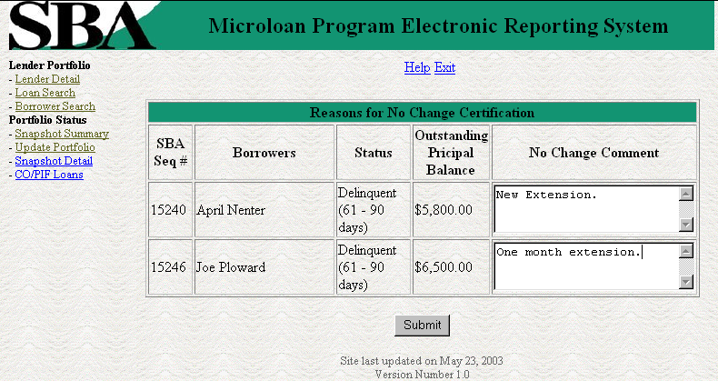

After submitting the changes, if the no change indicator has been selected for one or more of the loans, a new screen will be displayed for the user to insert or update a reason for all loans selected "certify no change". Once the user is finished he/she must select the submit button to update the loans.

Snapshot Detail
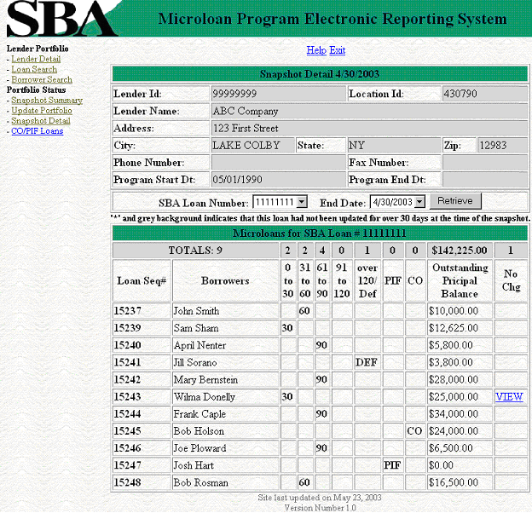

The Snapshot Detail Page displays the following information about the lender:
- Lender ID
- Location ID
- Name
- Address
- City
- State
- Zip Code
- Phone Number
- Program Start Date
- Program End Date

The user will have the ability to select an SBA Loan Number and a date to display all loans for that snapshot.
Once the user chooses an SBA Loan Number and selects the "Retrieve" button, the following information will be displayed about all microloans for the selected snapshot of the SBA Loan Number:
- Loan Seq#
- Borrowers
- Loan Status
  - 0 - 30
  - 31 - 60
  - 61 - 90
  - 91 - 120
  - Over 120/Def
  - PIF
  - CO
- Outstanding Principal Balance
- No Chg

If any loans had been certified No Change, the user will have the ability to select on a link to display the reason for the certification.

Reason for No Change Certification
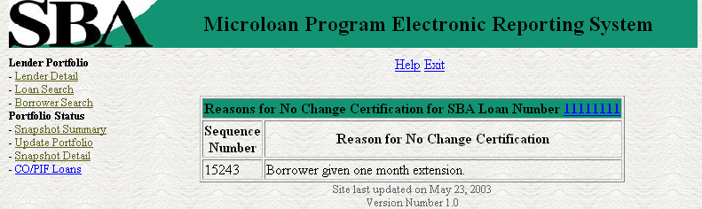

Displays the reason for the No Change Certification.

CO/PIF Loans
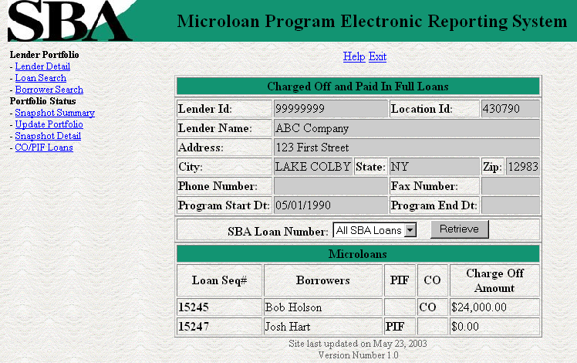

The Charged Off/Paid In Full Page displays the following information about the lender:
- Lender ID
- Location ID
- Name
- Address
- City
- State
- Zip Code
- Phone Number
- Program Start Date
- Program End Date

The user will have the ability to select an SBA Loan Number or to view Charged Off and Paid in Full Loans for the lenders total portfolio.
The following information will be displayed:
- Loan Seq#
- Borrowers
- Loan Status
  - PIF
  - CO
- Charge Off Amount

Special Instructions for Error Correction

Pressing the Save button will cause the data on the screen to be validated. If there is an error, a message box will be displayed, with information on the cause of the error. Correct the invalid data and press the Save button again.

Caveats and Exceptions

There are no caveats or exceptions

