Gonococcal Isolate Surveillance Project
OMB 0920-0307
Robert Kirkcaldy, Project Officer
Attachment 4
Screen shots of web-based application

Screenshot of Form 1 Main Menu:

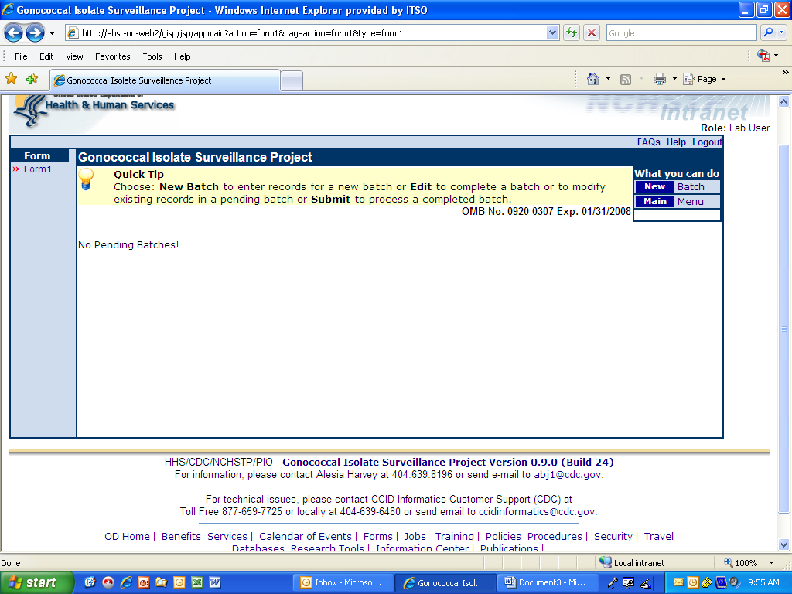
Screenshot of Form 1 data entry:

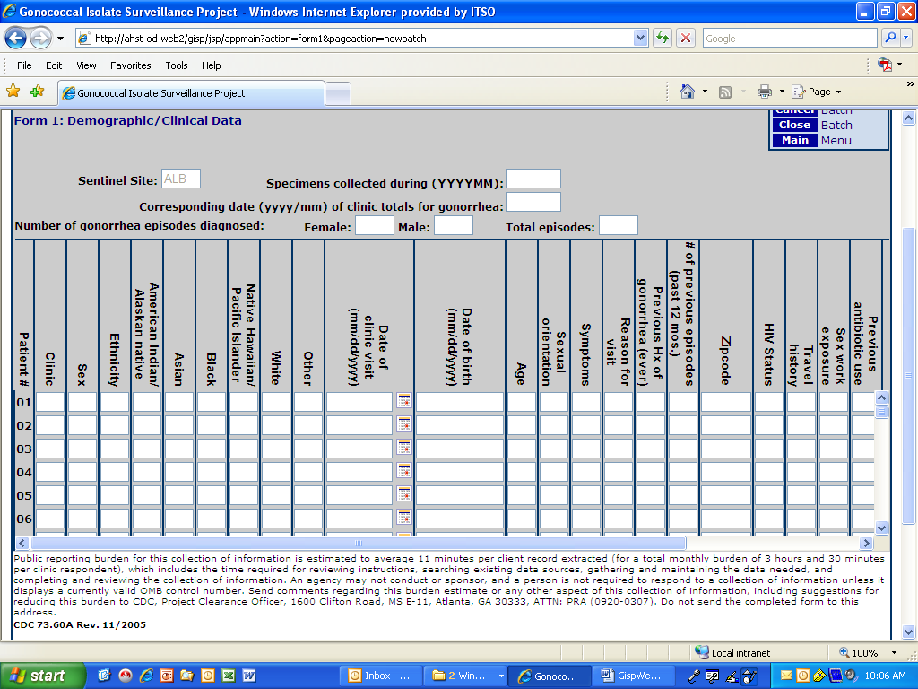
Screenshot of Form 2 and Form 3 Welcome Page:

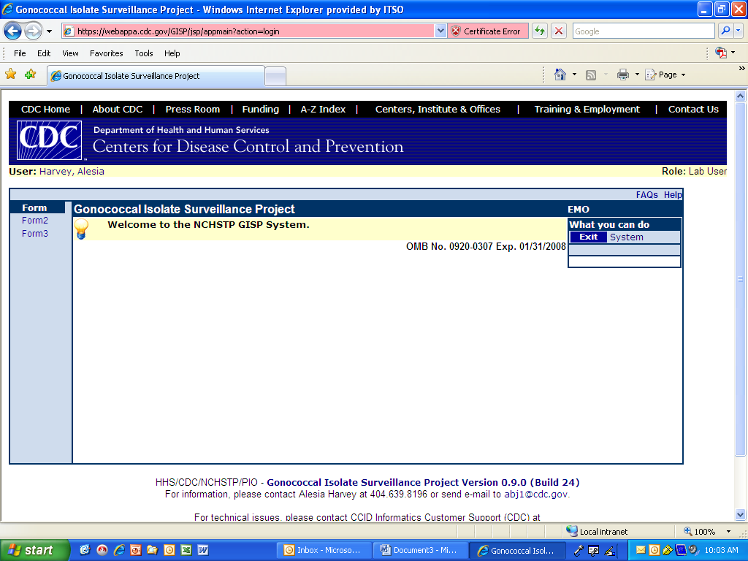
Screenshot of Form 2 Main Menu:

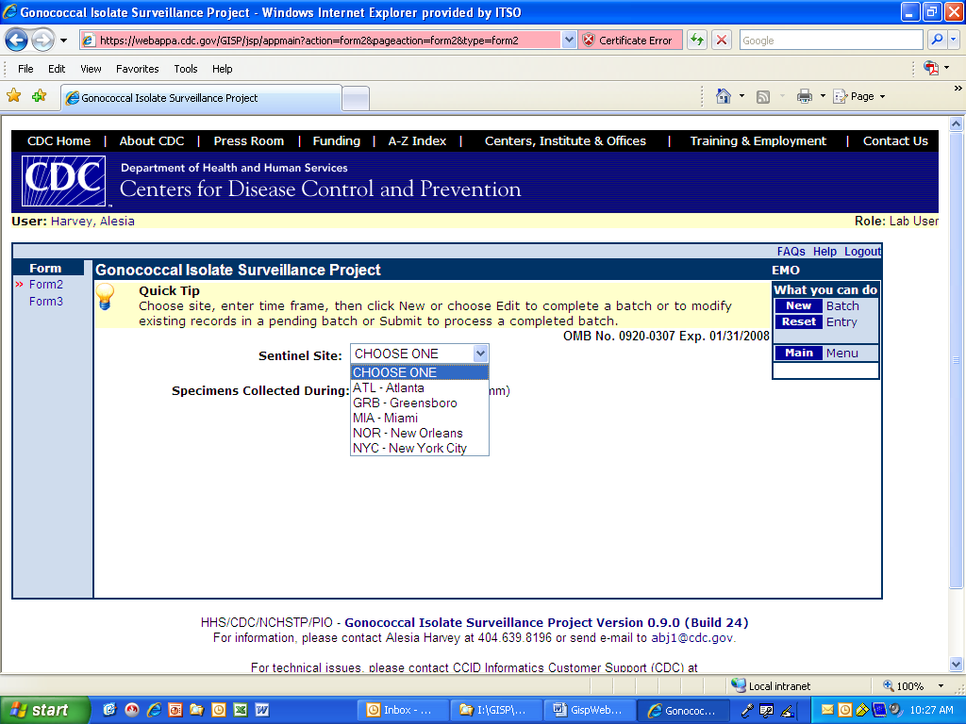
Screenshot of Form 2 data entry:

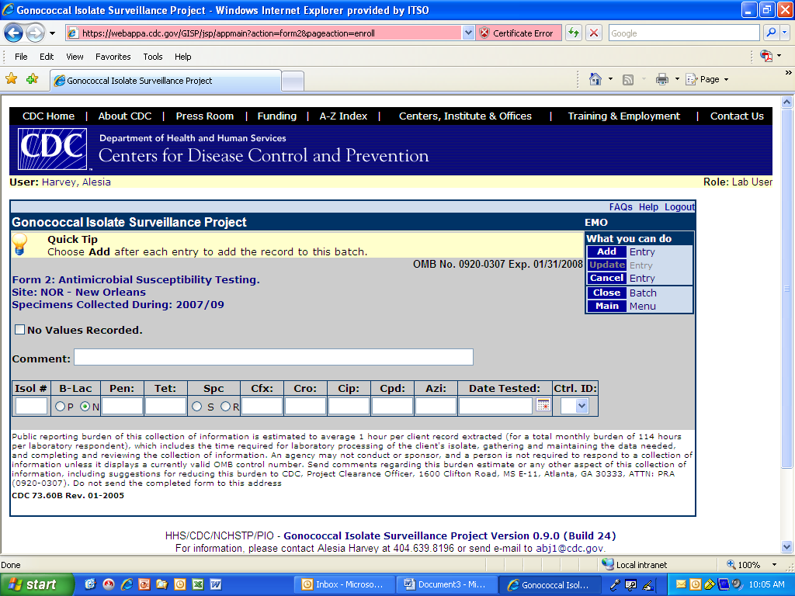
Screenshot of Form 3 Main Menu:

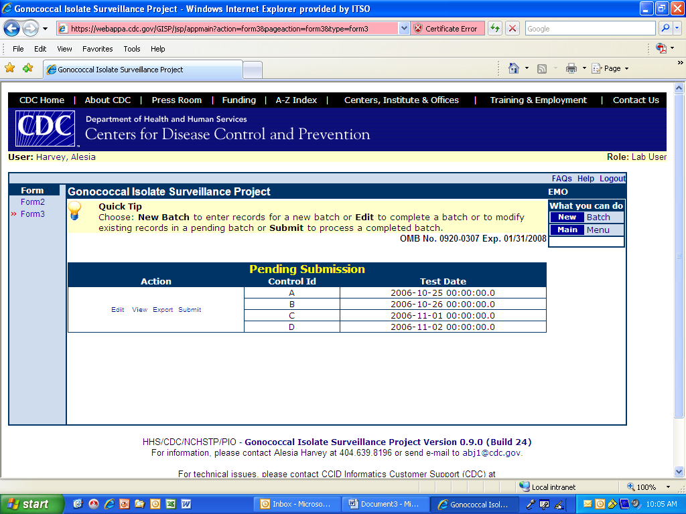
Screenshot of Form 3 data entry:

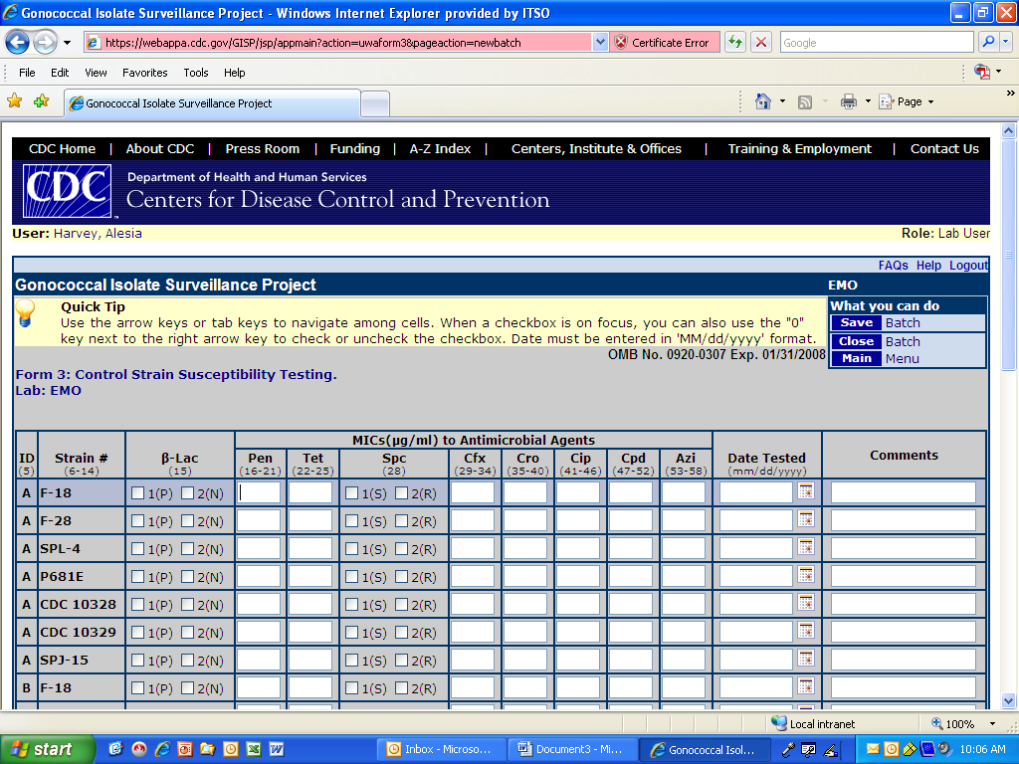
Screenshot of Form 3 data entry (cont’d):

