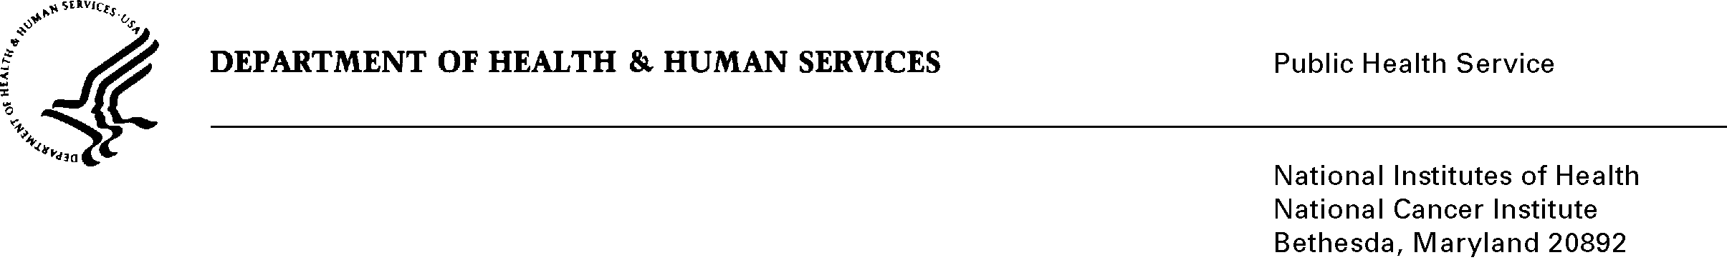

Date: May 6, 2010

TO: Office of Management and Budget (OMB)

Through: Seleda Perryman, DHHS Report Clearance Officer
Mikia Currie, NIH Program Analyst, OPERA
Vivian Horovitch-Kelley, NCI OMB Project Clearance Liaison, OMA

FROM: Steve Friedman,
National Cancer Institute/NIH

SUBJECT: NIH NCI Central Institutional Review Board (CIRB) Initiative (NCI)

This is a request for OMB to approve the Existing Collection in Use without an OMB number, “NIH NCI Central Institutional Review Board (CIRB) Initiative (NCI)” for 3 years. The CIRB was developed to reduce the administrative burden on local Institutional Review Boards (IRBs) and medical researchers while protecting human research participants in cancer clinical trials. The CIRB initiative uses various information collection tools the multiple sets of respondents it interacts with. The CIRB initiative is composed of an adult board and a pediatric board. Both boards are composed of public members who represent a broad range of oncology scientific and nonscientific disciplines including oncology physicians, nurses, patient representatives, pharmacists, ethicists and attorneys.

The CIRB utilizes various information collection tools to support its activities. This includes forms requiring completion by a site conducting clinical trials eligible for review by the CIRB as well as forms requiring completion by CIRB board members. A summary of such forms include CIRB membership information forms which requests profile information on board members, non-disclosure agreements, direct deposit forms, and 16 forms used based on the type of review and reviewer role a board member may participate on. The CIRB also requests that anyone who contacts the CIRB helpdesk to complete a survey.

Due to the role that the CIRB plays in the protection of human participants by providing institutional review of cancer clinical trials, there is a need to provide emergency clearance so CTEP’s mission of improving the way cancer is treated can continue without disruption.

