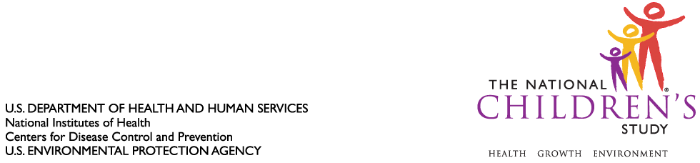

DATE: November 30, 2010

TO: Dr. Margo Schwab
Office of Management and Budget
Office of Information and Regulatory Affairs

FROM: Dr. Jennifer Park

THROUGH: Dr. Steven Hirschfeld

SUBJECT: Request for Non-Substantive Change to National Children’s Study, Vanguard (Pilot) Study (OMB Control #0925-0593, Expiration July 13, 2013) – Revision to 6-Month Visit Instrumentation

CC: Dr. Sarah Glavin, Ms. Jamelle Banks, Ms. Mikia Currie

We request non-substantive change to the National Children’s Study Vanguard (Pilot) Study protocol approved as revised by the Office of Information and Regulatory Affairs (OIRA) on July 23, 2010.

We request non-substantive change to instruments associated with the 6-Month Visit of the National Children’s Study for implementation in the Vanguard (Pilot) Study protocol among the seven Initial Vanguard Study Centers. The 6-Month Visit instruments were approved in concept by OIRA on September 22, 2008; they are now minimized in length, and therefore represent a reduction of anticipated burden to Study participants. Please see attached the Interview Script, Self-Administered Questionnaire (SAQ), and Visit Information Sheet for the 6-Month Visit for your consideration.

Attachments (3):

1. Visit Information Sheet (Minimal Visit Revision)
2. 6 Month Mother Interview (Minimal Visit Revision)
3. 6 Month Mother SAQ (Minimal Visit Revision)

