Attachment 4-2A: Burden Statement for ACT-24
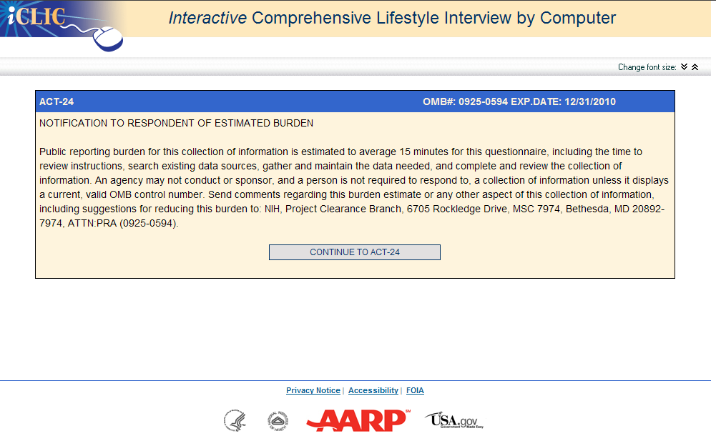

Attachment 4-2B: The ACT-24- Activities Completed by Time in 24 Hours Instrument

http://act24demo.westat.com

