Attachment 4-1A: Burden Statement for ASA24
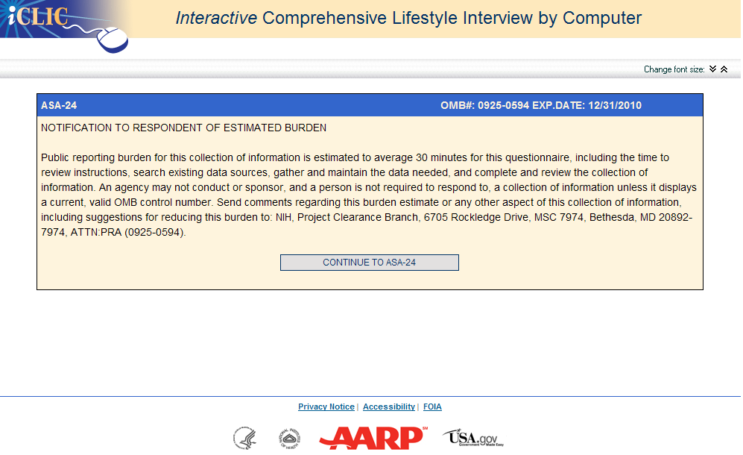

Attachment 4-1B: The ASA24 -- Automated Self-Administered 24-Hour Dietary Recall Instrument
https://asa24.westat.com
