**Attachment 4-3A: Burden Statement for LHQ**

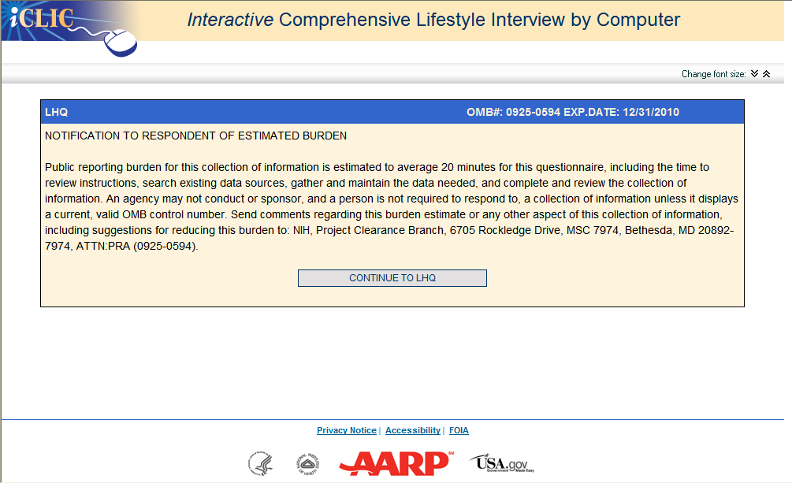

**Attachment 4-3B: Screenshot of the LHQ**

