Attachment 4-4A: Burden Statement for DHQ

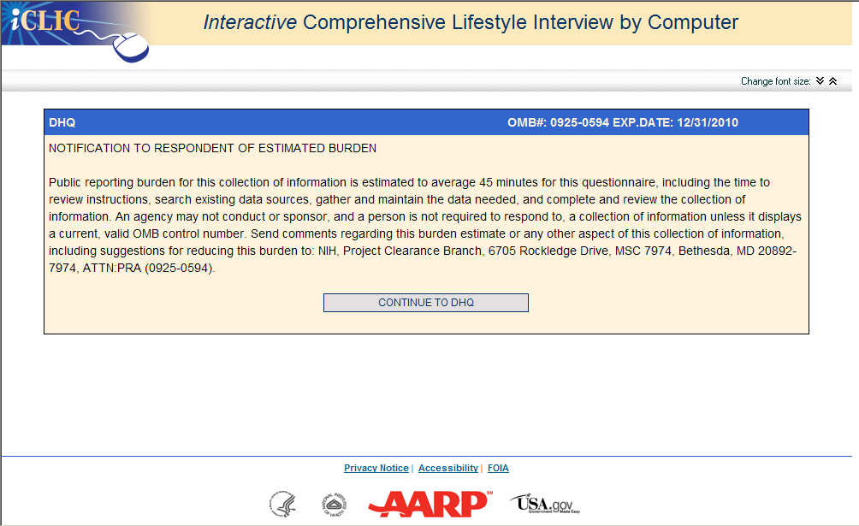

Attachment 4-4B: Screenshot for DHQ
http://riskfactor.cancer.gov/DHQ/
