Attachment 6: Pre-Enrollment, Screenshot 1
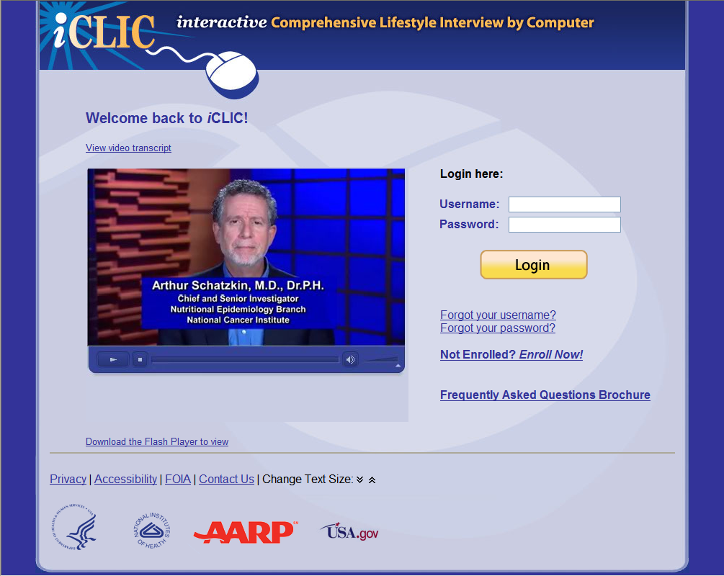

Attachment 6: Pre-Enrollment, Screenshot 2
