Attachment 7: Enrollment, Screenshot 1
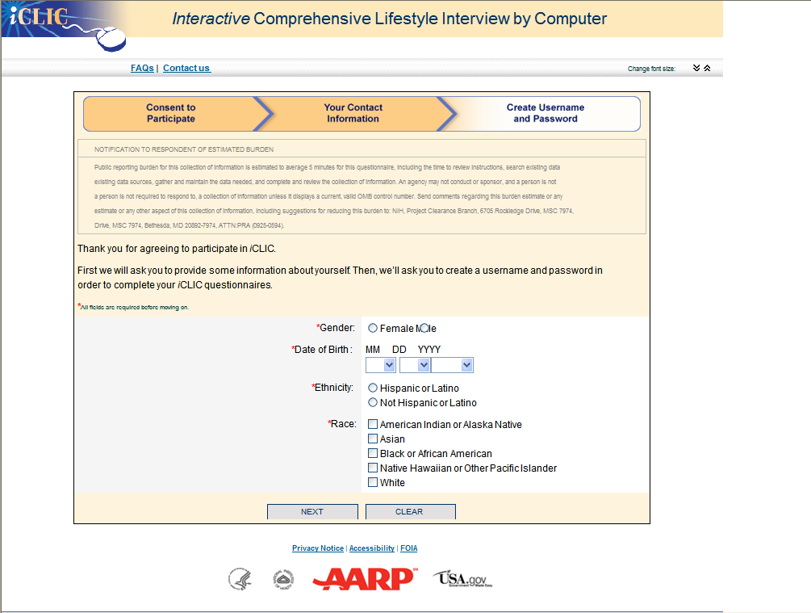

Attachment 7: Enrollment, Screenshot 2
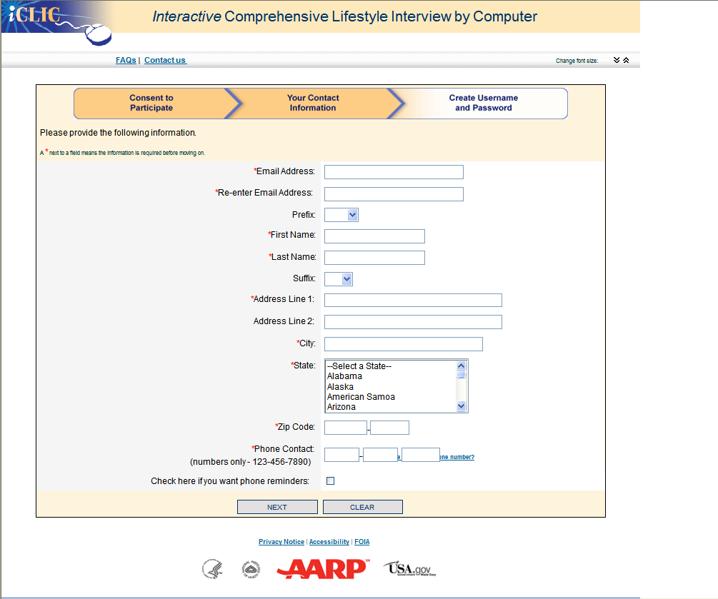

Attachment 7: Enrollment, Screenshot 3

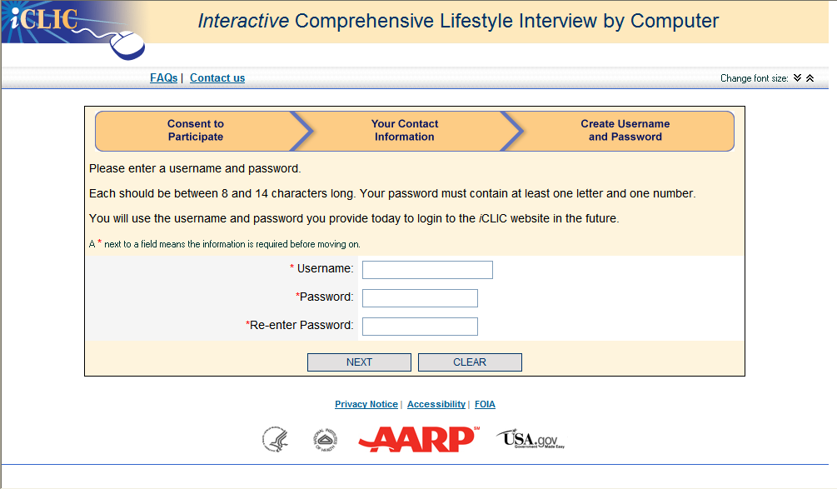

Attachment 7: Enrollment, Screenshot 4
