I. General Instructions
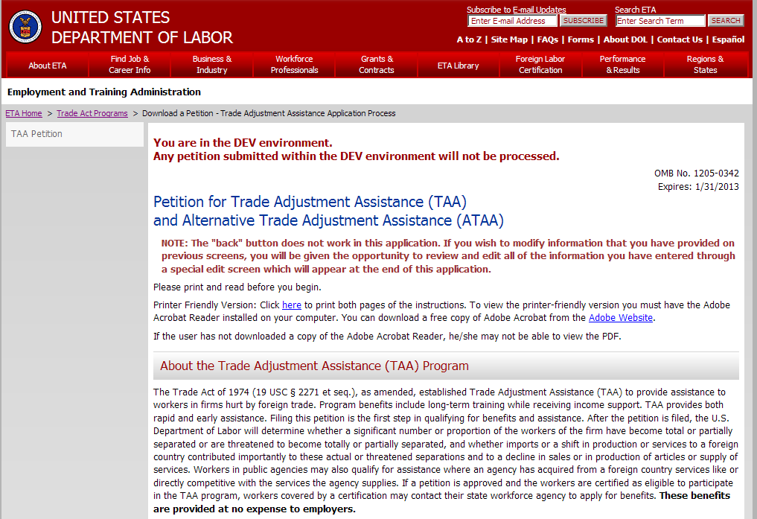
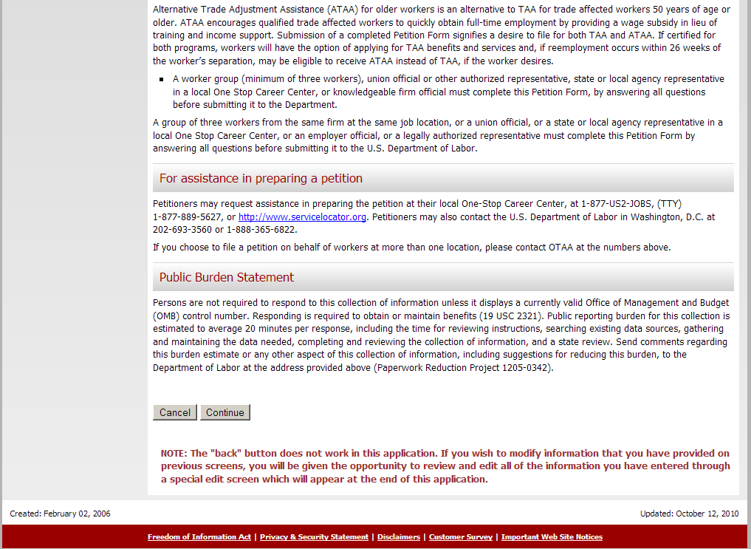
Addition of ATAA in Title throughout Petition form
Addition of a paragraph about the ATAA Program
III. Section 2. Workers’ Firm Information
All reference to public agency and service providers removed.

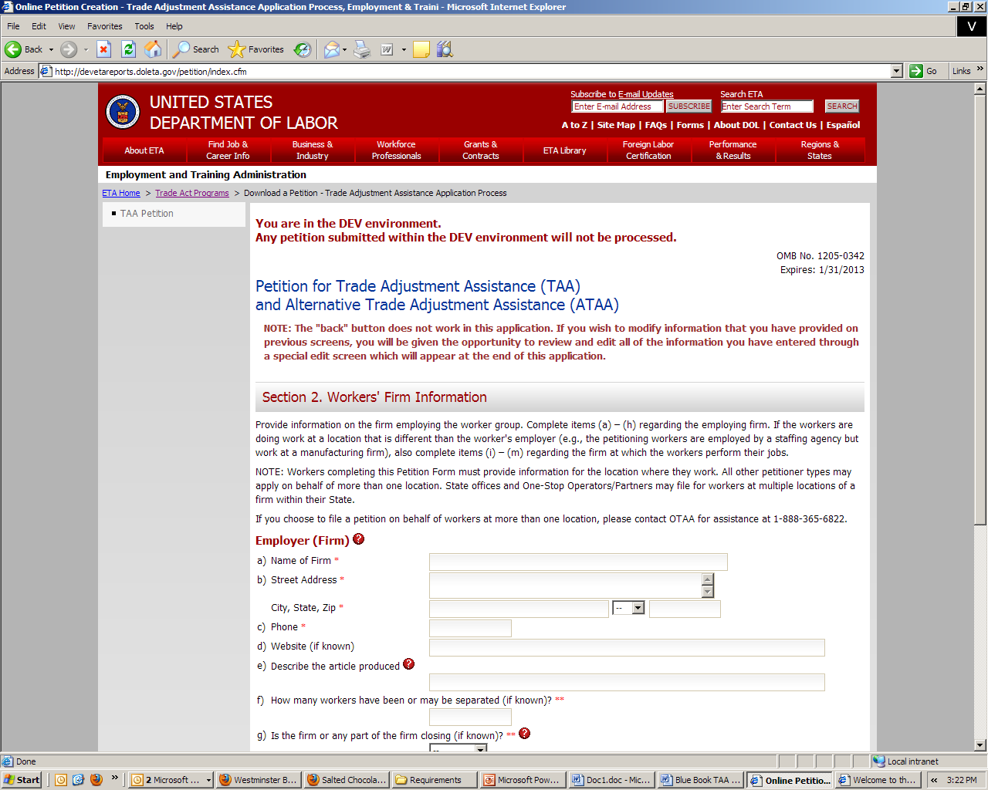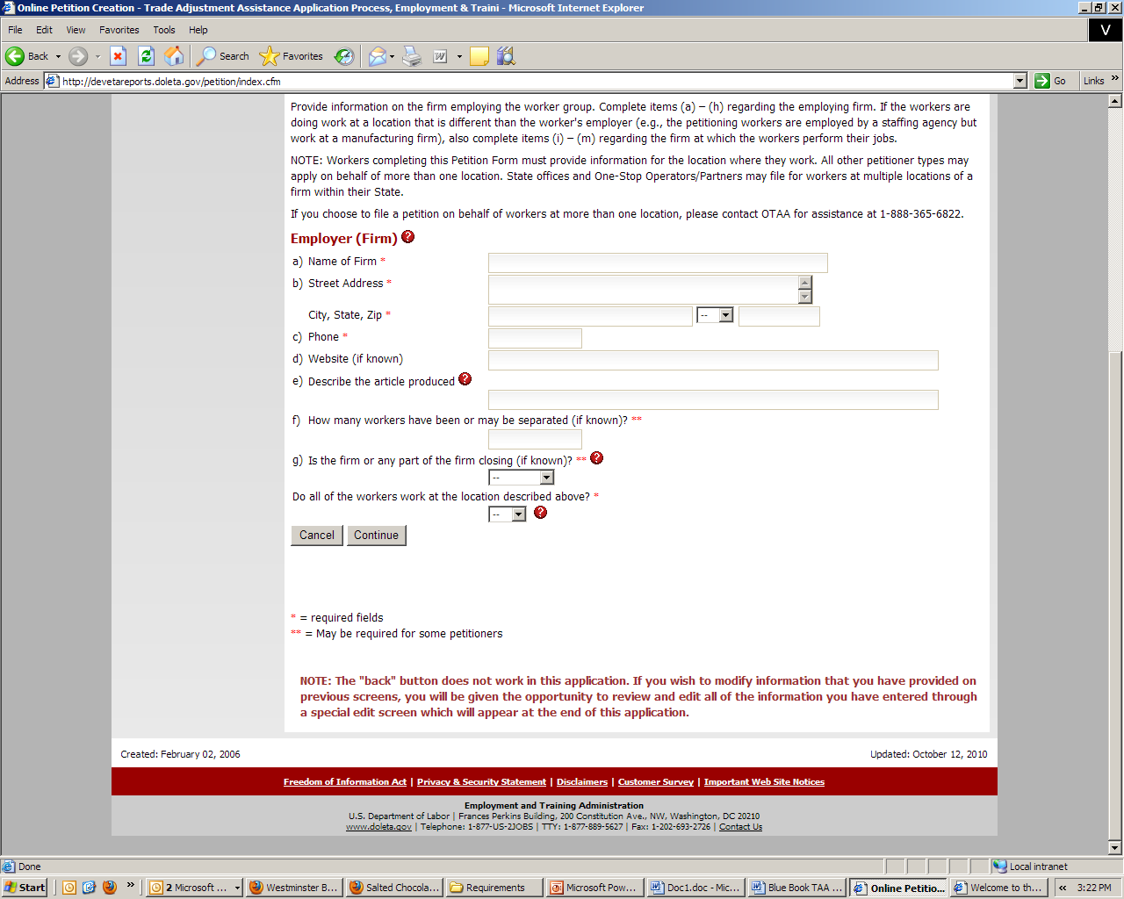
Deletion of “or Public Agency”
Deletion of “or service supplied”
III. Section 3. Firm/Public Agency Information
Examples of services related trade effects removed.
Deletion of two examples: “services are being outsourced to a foreign country” and “increased imports of services”
