TEACH
Instruments for Collection

- Form

- URL: https://www.teach.gov/node/add/job-listing
- Screenshot:
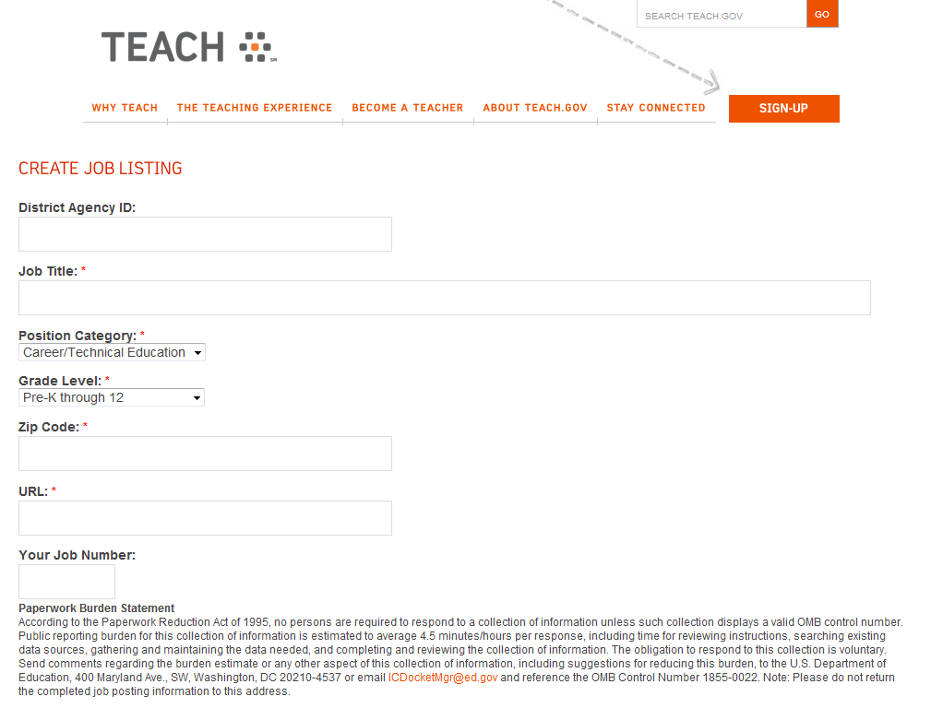

- CSV File

- URL: https://www.teach.gov/node/add/csv
- Screenshot:
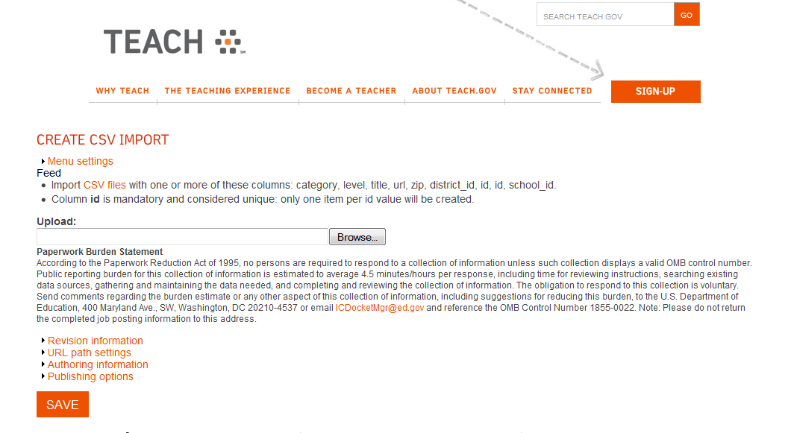

- XML Feed

- URL: https://www.teach.gov/node/add/feed
- Screenshot:
