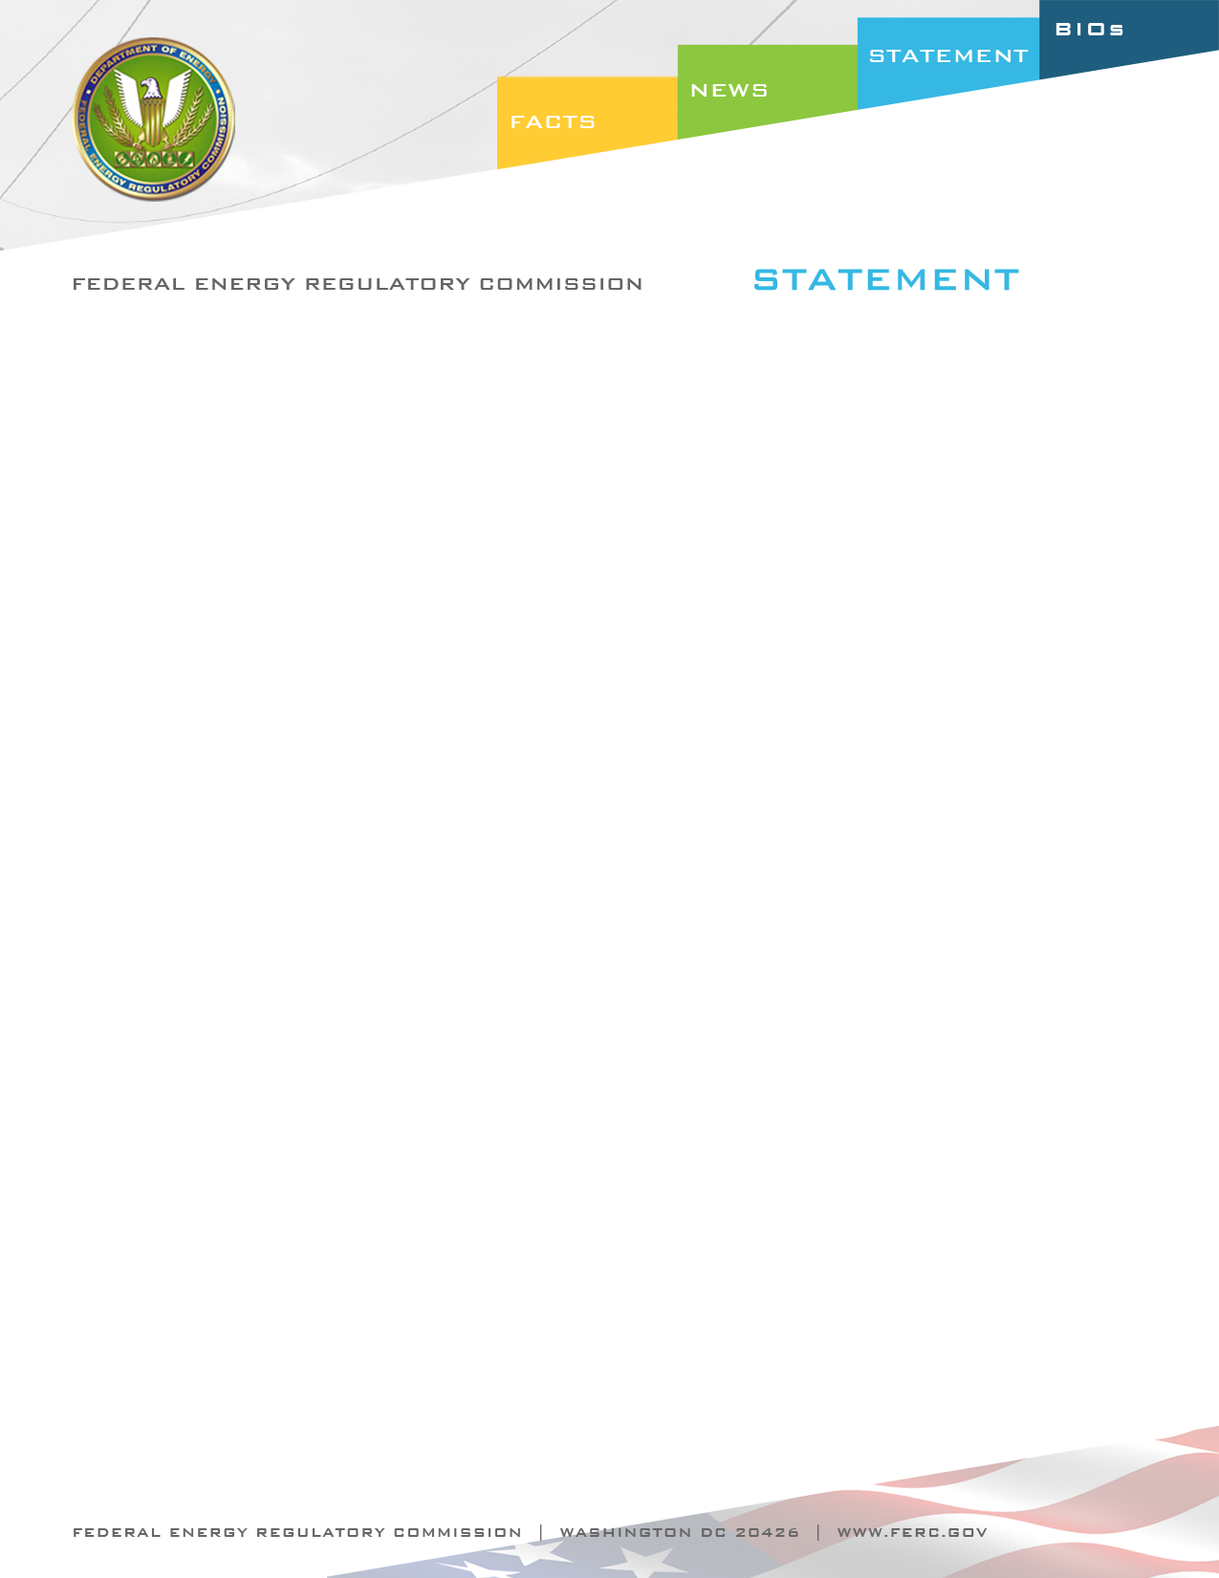

Docket Nos. RM10-13-000
Item No. E-3

October 21, 2010
Commissioner Philip D. Moeller

Statement of Commissioner Philip D. Moeller on
Credit Reform in Organized Wholesale Electric Markets

“Not unlike banking and Wall Street exchanges, the organized wholesale electric markets require strong but sensible credit practices to manage risk and protect the interest of all participants. Today’s final rule moves us in that direction by requiring the RTOs and ISOs to include in their tariffs clear and reasonable measures to balance market liquidity with corresponding risk. These measures include the elimination of unsecured credit in the financial transmission rights markets, caps on the level of unsecured credit issued to each market participant, and a time limit on posting additional collateral when required by the RTO or ISO.

While today’s changes will not entirely eliminate market-wide risk, they will go a long way towards limiting that risk. And while some may argue that the credit reform practices contained in the final rule will result in some participants incurring additional costs, on balance I strongly believe that these new regulations will benefit the overall financial health of the markets and its participants.”

