Screen shot of information collection form. Full content, as accessed by using the scroll bar shown on screen, is provided on following two pages.

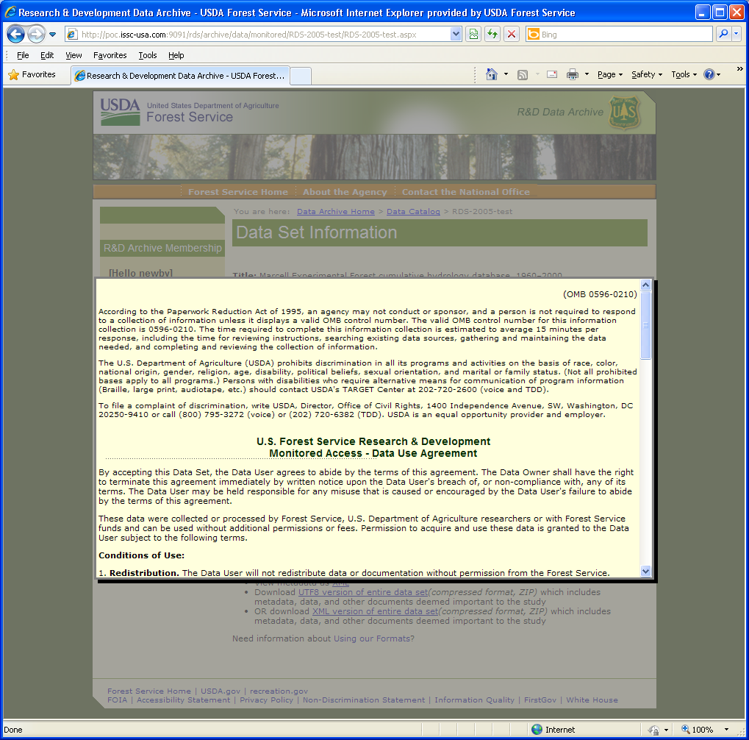
(OMB 0596-0210)
Expires XX/XXXX

According to the Paperwork Reduction Act of 1995, an agency may not conduct or sponsor, and a person is not required to respond to a collection of information unless it displays a valid OMB control number. The valid OMB control number for this information collection is 0596-0210. The time required to complete this information collection is estimated to average 15 minutes per response, including the time for reviewing instructions, searching existing data sources, gathering and maintaining the data needed, and completing and reviewing the collection of information.
The U.S. Department of Agriculture (USDA) prohibits discrimination in all its programs and activities on the basis of race, color, national origin, gender, religion, age, disability, political beliefs, sexual orientation, and marital or family status. (Not all prohibited bases apply to all programs.) Persons with disabilities who require alternative means for communication of program information (Braille, large print, audiotape, etc.) should contact USDA's TARGET Center at 202-720-2600 (voice and TDD).
To file a complaint of discrimination, write USDA, Director, Office of Civil Rights, 1400 Independence Avenue, SW, Washington, DC 20250-9410 or call (800) 795-3272 (voice) or (202) 720-6382 (TDD). USDA is an equal opportunity provider and employer.

U.S. Forest Service Research & Development
Monitored Access - Data Use Agreement
By accepting this Data Set, the Data User agrees to abide by the terms of this agreement. The Data Owner shall have the right to terminate this agreement immediately by written notice upon the Data User's breach of, or non-compliance with, any of its terms. The Data User may be held responsible for any misuse that is caused or encouraged by the Data User's failure to abide by the terms of this agreement.
These data were collected or processed by Forest Service, U.S. Department of Agriculture researchers or with Forest Service funds and can be used without additional permissions or fees. Permission to acquire and use these data is granted to the Data User subject to the following terms.
Conditions of Use:
1. Redistribution. The Data User will not redistribute data or documentation without permission from the Forest Service.
2. Citation. It is routine professional ethics to acknowledge the work of other scientists. Thus, the Data User will properly cite the Data Set in any publications or in the metadata of any derived data products that were produced using the Data Set. Citation should take the following general form: Data Set Creator, Year of Data Publication, Title of Dataset, Publisher, Dataset identifier. For example:
- Verry, Elon S.; Elling, Arthur E. 2005. Marcell Experimental Forest cumulative hydrology database, 1960–2000. Saint Paul, MN: U.S. Department of Agriculture, Forest Service, North Central Research Station. doi:10.2737/RDS.2005.0001
3. Notification. The Data User will notify the designated Data Set Contact (see data documentation) when any derivative work or publication based on or derived from the data and documentation is distributed. This notification will include a citation for the derived work. The citation will be incorporated into the metadata for the data set.
Forest Service scientists are evaluated, in part, on the utility of their research. Your compliance with this notification requirement is important to proper evaluation of the Forest Service's research contributions.
4. Membership. The Data User will provide the following information:
Member Affiliation:
U.S. Federal Government | U.S. State Government
Higher Education | Elementary/Secondary
Public | Non-Profit
Business
Member Country of Origin:
Member Intended use of data:
The Last Reasons

The information I am about to submit is correct to the best of my knowledge, and I agree to the conditions of distribution for the data set.

Distribution Liability:
The metadata documentation has been reviewed for accuracy and completeness. The data are considered to satisfy the originating Research Station's quality standards relative to the purpose for which the data were collected. However, the Forest Service cannot assure the reliability or suitability of these data for a particular purpose. The act of distribution shall not constitute any such warranty, and no responsibility is assumed by the Forest Service for a user's application of these data or related materials.
The metadata, data, or related materials may be updated without notification. If a Data User believes errors are present in the metadata, data or related materials, please use the information in
(1) Identification Information: Point of Contact,
(2) Metadata Reference: Metadata Contact, or
(3) Distribution Information: Distributor
to notify the Forest Service of the issues.
Additional information is available at http://www.fs.fed.us/qoi.
Definitions:
- Data Set = electronic research data, metadata, and other documentation the author believes would facilitate the understanding of the study.
- Data User = individual to whom access has been granted to this Data Set, including his or her immediate collaboration sphere, which is defined here as the institutions, partners, students and staff with whom the Data User collaborates, and with whom access must be granted, in order to fulfill the Data User’s intended use of the Data Set.
- Data Set Creator = individual or institution that produced the Data Set.
- Data Set Contact = party designated in the accompanying metadata of the Data Set as the primary contact for the Data Set.
- Distributor = individual or institution providing access to the Data Set

