2010 Annual RYAN WHITE HIV/AIDS PROGRAM
SERVICES REPORT (RSR) INSTRUCTION MANUAL
Effective Date: November 1, 2010

Public Burden Statement: An agency may not conduct or sponsor, and a person is not required to respond to, a collection of information unless it displays a currently valid OMB control number. The OMB control number for this project is 0915-0323, and the expiration date is 03/31/2011. Public reporting burden for this collection of information is estimated to average 12 hours per respondent annually, including the time for reviewing instructions, searching existing data sources, gathering and maintaining the data needed, and completing and reviewing the collection of information. Send comments regarding this burden estimate or any other aspect of this collection of information, including suggestions for reducing this burden, to HRSA Reports Clearance Officer, 5600 Fishers Lane, Room 10-33, Rockville, Maryland, 20857.

HIV/AIDS Bureau
Division of Science and Epidemiology
Health Resources and Services Administration
U.S. Department of Health and Human Services
5600 Fishers Lane, Room 7-90
Rockville, MD 20857
What’s New in the Document?

The following changes have been made to the Ryan White HIV/AIDS Program Services Report (RSR) Instruction Manual (Version 2.1). The key changes to the different sections have been highlighted throughout the document.
Content Changes
- Changed document title to 2010 Annual Ryan White HIV/AIDS Program Services Report (RSR) Instruction Manual
- Revised page header content throughout.
- Updated Table of Contents
- Reorganized and updated content in the Introduction:
  - The “About the Ryan White HIV/AIDS Program Services Report” sub-section is now the “What is the RSR?” sub-section.
  - The “RSR Reporting Requirements for Service Providers” is now the “What are the reporting requirements?” sub-section. This sub-section has been moved from beneath the RSR Grantee Report section to the Introduction section.
- Page 1: Revised reference to the legislation.
- Page 9: Revised the definition of Hospice services.
- Page 9 and 10: Revised the definition of Medical Case Management (including treatment adherence) services.
- Page 11: Revised the note under Legal services and revised the definition of permanency planning.
- Page 21: Updated screen shot of the Services List in the RSR Grantee Report section.
- Page 28: Updated screen shot of the Services List in the RSR Provider Report section.
- Pages 31, 33, 54 and 57: Deleted notes that exempted all providers–except providers of outpatient/ambulatory medical services, medical case management services, and non-medical case management services–from submitting client level data for the 2009 reporting period. ALL providers of core and support services are now required to submit client level data.
- Page 34: Revised the note under the System Variables sub-section.
- Page 35: Added System Variable 3, Unique Provider Registration Code.
- Page 35: Changed the System Variable number (from SV3 to SV4) for the Unique Client Identifier data element for consistency with the RSR XML Schema.
- Page 36: Expanded the definition of the response category “Referred or Discharged” under Item 2, the client’s vital enrollment status at the end of the reporting period.
- Updated the Index.

Table of Contents

Introduction 5
What is the RSR? 5
How will the data collected in the RSR be used? 6
Who is the grantee of record? 7
Who is the service provider? 7
What are the reporting requirements? 7
What is the reporting period? 10
Which services are reported in the RSR? 10
1. Administrative and Technical Services 10
2. Core Medical Services 11
3. Support Services 14
4. HIV Counseling and Testing Services 16
How is the RSR submitted to HAB? 16
The Grantee Report 18
Grantee Organization Information 18
How to complete the Grantee Report contract lists 19
How to Update the List of “Providers Funded by Your Grant” 20
How to Update the List of “Providers Funded Through Your Fiscal Intermediaries” 22
The Service Provider Report 23
How to Complete the Service Provider Report Manually 23
Provider Information 24
HIV Counseling and Testing 30
Importing the Client-Level Data XML File 31
How to complete the Service Provider Report via XML file upload 32
The Client Report 33
Reporting Client-Level Data 33
Submitting Client-Level Data to HAB 34
Client-Level Data Fields 34
System Variables 34
Client Demographics 36
Core Services 42
Support Services 43
Clinical Information 45
Appendix A: Required Client-Level Data Elements For RWHAP-Eligible Services 51
Appendix B: RSR Reporting Scenarios 54
RSR Submission Requirements 54
RSR Submission Models 54
Scenario 1: A grantee-provider 54
Scenario 2: A grantee with one provider 55
Scenario 3: A grantee/provider with one provider 56
Scenario 4: A grantee/provider with two providers. 56
Scenario 5: A grantee/provider with two providers exempt from reporting 57
Scenario 6: A grantee that uses an administrative agent to coordinate its Ryan White HIV/AIDS Program 59
Appendix C: Calculating Client Income Percentage of the Federal Poverty Measure Using HHS Federal Poverty Guidelines 61
Glossary 62
Index 69

Introduction

The Ryan White HIV/AIDS Treatment Extension Act of 2009 (Public Law 111-87, October 30, 2009) provides the Federal HIV/AIDS programs in the Public Health Service (PHS) Act under Title XXVI flexibility to respond effectively to the changing epidemic. Its emphasis is on providing life-saving and life-extending services for people living with HIV/AIDS across the country and resources to targeted areas with the greatest need.

All Program “Parts” of the Ryan White HIV/AIDS Program (RWHAP) specify the Health Resources and Services Administration’s (HRSA) responsibilities in the administration of grant funds, the allocation of funds, the evaluation of programs for the population served, and the improvement of the quality of care. Accurate records of the providers receiving RWHAP funding, the services provided, and the clients served continue to be critical to the implementation of the legislation and thus are necessary for HRSA to fulfill its responsibilities.

Previously, the HIV/AIDS Bureau (HAB) required that all RWHAP-funded grantees and their contracted service providers report aggregate data annually using the Ryan White HIV/AIDS Program Annual Data Report (RDR).

------------------------------------------------------------------------------------------------------------------------------
NOTE: HAB expects all grantees and providers to submit a 2010 Ryan White HIV/AIDS Program Annual Data Report (RDR) during the transition to client-level reporting. For additional information about the RDR, visit: http://hab.hrsa.gov/rdr/.
------------------------------------------------------------------------------------------------------------------------------

However, aggregate data are limited in two ways:

- Aggregate data lack client identifiers and, by definition, cannot be merged and unduplicated across service providers within a given geographic area. As a result, grantees—and ultimately HAB—cannot obtain accurate counts of the number of individuals the RWHAP serves.
- Aggregate data cannot be analyzed in the detail required to assess quality of care, or to sufficiently account for the use of RWHAP funds.

To address these deficiencies, RWHAP grantees and service providers began using a new data reporting system in 2009, the Ryan White HIV/AIDS Program Services Report (RSR),

What is the RSR?

The RSR is a client-level data reporting system that provides data on the characteristics of the funded grantees, their service providers, and the clients served with program funds. The Ryan White HIV/AIDS Program Services Report (RSR) includes three components: the Grantee Report, the Service Provider Report, and the Client Report.

- The Grantee Report is a collection of basic information about the grantee organization and the service provider contracts that it funded during the reporting period. It is completed by all RWHAP-funded grantees, including Parts A, B, C and D (including the Adolescent Initiative).
- The Service Provider Report is a collection of basic information about both the service provider agency and the services it delivered under each of its RWHAP contracts. It is completed by all RWHAP service providers. See the “Who is the service provider?” and the “RSR Reporting Requirements for Service Providers” sections of this manual for more information about service providers required to submit a Service Provider Report.
- The Client Report (client-level data) is a collection of one record each for the RWHAP clients served. Each record includes the client’s encrypted unique identifier and basic demographic data. A client’s record also may include HIV clinical information and data about the HIV-care medical and support services received at the service provider. This report is completed by all service providers that deliver and/or pay for direct client services with RWHAP funds.

------------------------------------------------------------------------------------------------------------------------------
NOTE: While identifiable health information is being disclosed to HRSA, this is authorized under the HIPAA Privacy Rule for public health purposes. HAB has taken every measure possible, including the implementation and use of an encrypted Unique Client Identifier, to limit data collection to only that “information reasonably necessary to accomplish the purpose” of the Ryan White HIV/AIDS Program Services Report.
------------------------------------------------------------------------------------------------------------------------------

How will the data collected in the RSR be used?

The data you submit will be used to:
- Monitor the outcomes achieved on behalf of HIV/AIDS clients and their affected families receiving care and treatment through RWHAP grantees and/or providers;
- Address the disproportionate impact of HIV in communities of color by assessing organizational capacity and service utilization in minority communities;
- Monitor the use of RWHAP funds for appropriately addressing the HIV/AIDS epidemic in the United States; and
- Address the needs and concerns of Congress and the Department of Health and Human Services (HHS) Secretary concerning the HIV/AIDS epidemic and the RWHAP.

------------------------------------------------------------------------------------------------------------------------------
NOTE: HAB will continue to use the data collected with the RDR to report to Congress and the HHS Secretary as well as to monitor program performance until the RDR is retired. HAB anticipates that 2010 will be the final year to submit the RDR.
------------------------------------------------------------------------------------------------------------------------------

HAB also understands how important the data reported can be to each RWHAP as it assesses its clients’ service needs and establishes practical outcome measures for its programs. Therefore, HAB will continue to provide each RWHAP grantee with a validated copy of all data submitted by the grantee and its funded service organizations. HAB views these data as the “property” of the grantee, and thus will not share the data with other grantees without the permission of the reporting grantee.

Who is the grantee of record?

The grantee of record (also referred to as the “grantee”) is the official RWHAP grantee that receives Federal funding directly from HRSA. This agency may be the same as the provider agency or may be the agency that contracts with other agencies to provide RWHAP services.

Who is the service provider?

The service provider (also referred to as the “provider”) is the agency that provides direct services to:

- Clients and their affected family members and/or
- Grantees of record (e.g., agencies that provide administrative and technical services).

Service providers may be directly funded through one or more Program “Parts,” through subcontract(s) with one or more grantees, or through subcontract(s) with a grantee’s fiscal intermediary (an administrative agent of the grantee). For more information about service provider reporting requirements, see the Grantee Report section “RSR Reporting Requirements for Service Providers.”

What are the reporting requirements?

The rules and requirements that govern the administration of HHS grants are set forth in the regulations found in Title 45, Code of Federal Regulations (CFR), Part 74 – Uniform Administrative Requirements for Awards and Subawards to Institutions of Higher Education, Hospitals, Other Nonprofit organizations, and commercial organizations; and Part 92 – Uniform Administrative Requirements for Grants and Cooperative Agreements to State, Local, and Tribal Governments. These regulations explicitly state that grantees have a responsibility to monitor all recipients of their Federal grant program funds to ensure agencies are using them in accordance with program requirements:

- Title 45 CFR 92.40, monitoring and reporting program performance; monitoring by grantees:
Grantees are responsible for managing the day-to-day operations of grant and subgrant supported activities. Grantees must monitor grant and subgrant supported activities to assure compliance with applicable Federal requirements and that performance goals are being achieved. Grantee monitoring must cover each program, function, or activity.

- Title 45 CFR 74.51, monitoring and reporting program performance:
Recipients are responsible for managing and monitoring each project, program, subaward, function or activity supported by the award. Recipients shall monitor subawards to ensure that subrecipients have met the audit requirements as set forth in §74.26.

The Federal regulations go on to affirm that grantees are required to maintain, as set forth in 45 CFR Sec. 74.47:

“a system for contract administration…to ensure contractor conformance with the terms, conditions and specifications of the contract and to ensure adequate and timely followup of all purchases.” And, grantees “shall evaluate contractor performance and document, as appropriate, whether contractors have met the terms, conditions and specifications of the contract.”

Likewise, HRSA, HHS, and Congress hold HAB responsible for monitoring and reporting the program performance of its recipients, Ryan White Program grantees, and its subrecipients, Ryan White Program service providers. Accordingly, HAB has established the following reporting requirements for recipients of RWHAP funds.

1. A service provider that also is a grantee (also referred to as a “grantee-provider”) must complete the Web-based Provider Report and submit client-level data, if applicable. (NOTE: Agencies that only provide Administrative and Technical Services, Outreach services to anonymous individuals, and/or HIV Counseling and Testing services are exempt from submitting client-level data.)

2. A service organization that has a contract with a RWHAP grantee is considered a first-line provider. A first-line provider must complete the Web-based Provider Report and submit client-level data, if applicable.


3. A service organization that enters into a contract with a first-line provider is considered a second-line provider. A second-line provider must complete the Web-based Provider Report and submit client-level data, if applicable.

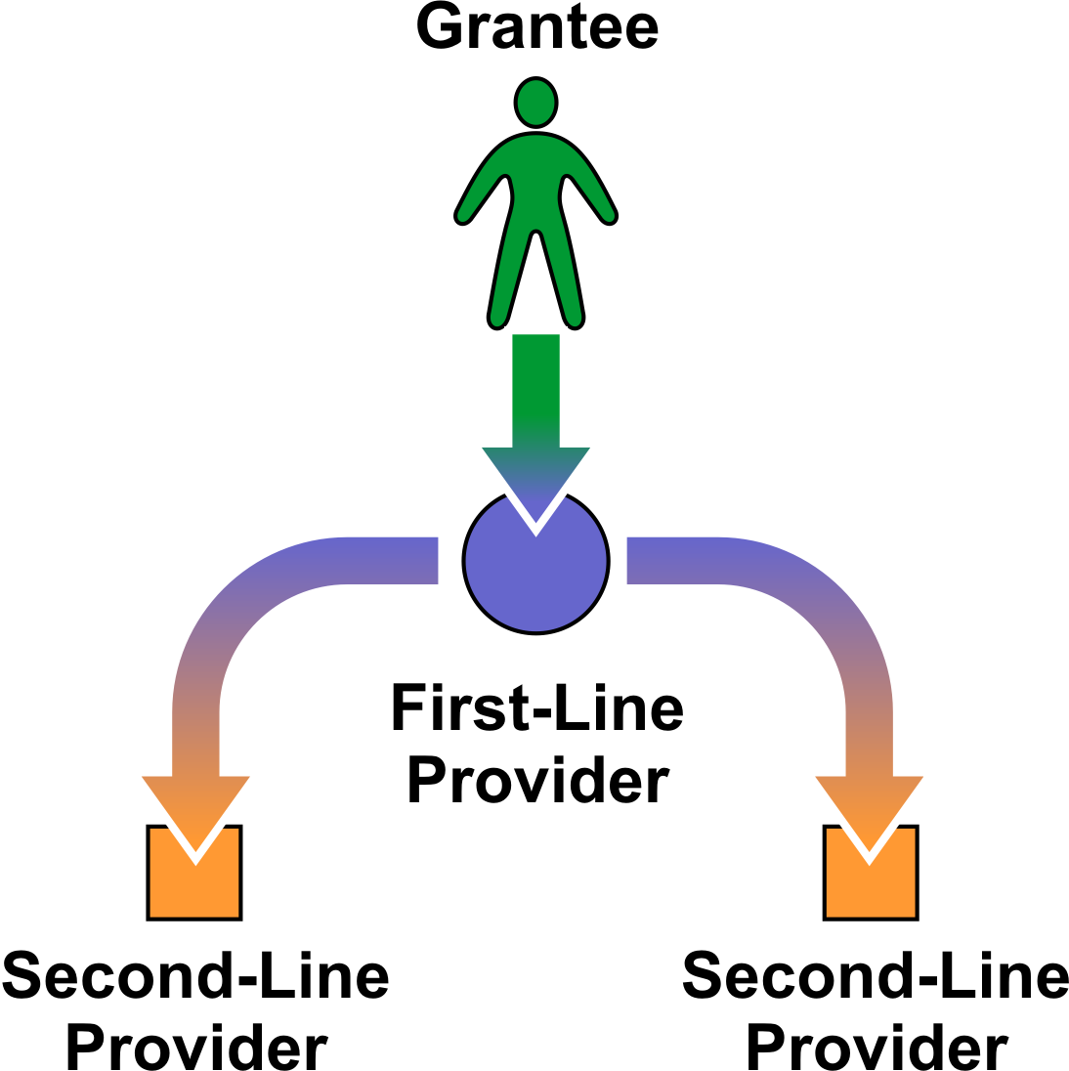

4. If a service organization is a multilevel provider (a second-line provider to one grantee and a first-line provider to another), it must complete a single Provider Report and submit client-level data, if applicable, that includes client data from ALL program Parts under which the provider is funded.

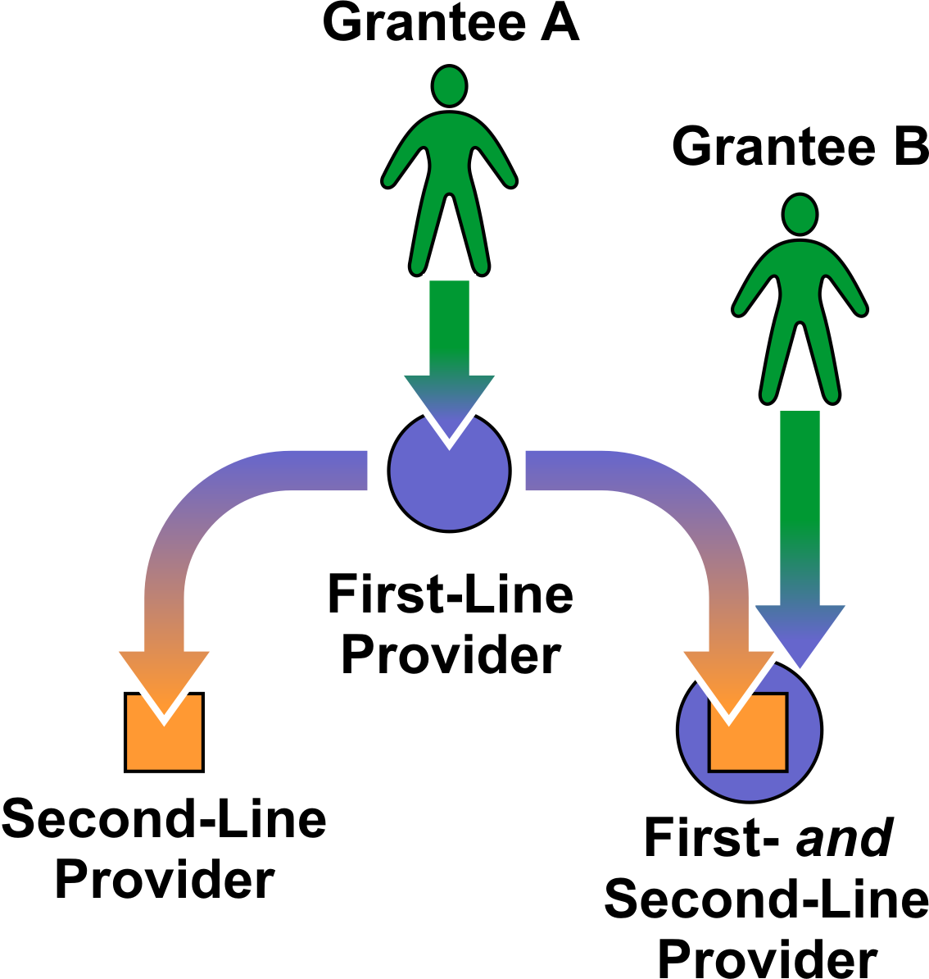

5. A service organization may be exempt from completing its own Provider Report and submitting client-level data, at the grantee’s discretion, if any of the following apply to it:

- It submits only vouchers or invoices for payment (e.g., a taxicab company that provides transportation services only);
- It does not see clients on a regular and sustained basis (e.g., on an emergency basis only);
- It offers services to clients on a “fee-for-service” basis;
- It received less than $10,000 in RWHAP funding during the reporting period;
- It sees a small number (1–25 patients) of Ryan White Program clients;
- It no longer is funded by your agency; and/or
- It no longer is in business.

In the event a grantee exempts a first-line provider from submitting a Service Provider Report, the grantee should submit a Service Provider Report and client-level data in its, the grantee’s, own name that includes the data from the fist-line provider. In the event a grantee exempts a second-line provider from submitting a Service Provider Report, the grantee should either (1) submit a Service Provider Report and client-level data in its, the grantee’s, own name that includes the data from the second-line provider or (2) instruct the first-line provider to submit a Service Provider Report and Client Report in its, the first-line provider’s, own name that includes the data from the second-line provider.

------------------------------------------------------------------------------------------------------------------------------
NOTES: (1) A grantee-provider may NOT be given an exemption. (2) A multilevel provider may NOT be given an exemption. (3) A multiply-funded provider that is not also a “multilevel” provider MAY be exempt from completing its own Service Provider Report and client-level data IF all of its grantees have granted the provider an exemption. If, however, the provider is required to submit a Service Provider Report by ANY of its grantees, it must complete one Service Provider Report and submit client-level data, if applicable, that includes client data from ALL Program Parts under which the provider is funded. (4) If the provider is no longer funded by your agency and/or has gone out of business, you may report on behalf of the provider OR incorporate the data into the grantee’s (or first-level provider’s) Service Provider Report
------------------------------------------------------------------------------------------------------------------------------

What is the reporting period?

The reporting year is a calendar year. However, Ryan White Program grantees must submit data twice a year as required by HAB. Grantees will submit two RSRs for each reporting (calendar) year:

An interim report for the period January 1 through June 30, 2010 and
An annual report for the period January 1 through December 31, 2010.

-------------------------------------------------------------------------------------------------------------------------------
NOTES: (1) The reporting period is the period of time for which data are submitted to HAB. This should not be confused with clinical performance measurement periods. Though service providers are required to report the applicable data elements with each report submission, they should not perform a clinical activity more frequently than required to meet the generally accepted standards of medical care for HIV-positive patients. (2) Beginning in 2011, Ryan White Program grantees will submit the RSR once each year for the previous calendar year. This report will include information on all clients served and services funded between January 1 and December 31 of the reporting year.
-------------------------------------------------------------------------------------------------------------------------------

Which services are reported in the RSR?

In the Grantee Report, grantees report the services they funded under each service provider contract. Meanwhile, in the Service Provider Report, providers report on the services delivered to clients and/or grantees under each contract (Item 8). Each client record submitted in the Client Report will indicate the core and/or support services the client received (Items 16–45).

The services are divided into four groups:

- Administrative and technical services;
- Core medical services;
- Support services; and
- HIV counseling and testing services.

1. Administrative and Technical Services

Planning or evaluation services are the systematic (orderly) collection of information about the characteristics, activities, and outcomes of services or programs to assess the extent to which objectives have been achieved, to identify needed improvements, and/or to make decisions about future programming.

Administrative or technical support services are the provision of qualitative and responsive “support services” to an organization. These may include human resources, financial management, and administrative services (e.g., property management, warehousing, printing/publications, libraries, claims, medical supplies, and conference/training facilities).

Fiscal intermediary services are the provision of administrative services to the grantee of record by a pass-through organization. These organizations’ responsibilities may include: determine the eligibility of RWHAP recipients, decide how funds are allocated to recipients, award RWHAP funds to recipients, monitor recipients for compliance with RWHAP specific requirements, and complete required reports.

Other fiscal services are the receipt or collection of reimbursements on behalf of health care professionals for services rendered or other related fiduciary services pursuant to health care professional contracts.

Technical assistance services are identifying the need for and the delivery of practical program and technical support to the RWHAP community. These services should help grantees, planning bodies, and affected communities to design, implement, and evaluate RWHAP-supported planning and primary care service delivery systems.

Capacity development services are services to help develop a set of core competencies that in turn help an organization develop effective HIV health care services, including the quality, quantity, and cost-effectiveness of such services. These competencies also sustain the infrastructure and resource base necessary to develop and support these services. Core competencies include: management of program finances; effective HIV service delivery, including quality assurance, personnel management, and board development; resource development, including preparation of grant applications to obtain resources and purchase supplies/equipment; service evaluation; and cultural competency development.

Quality management services comprise a systematic process with identified leadership, accountability, and dedicated resources that uses data and measurable outcomes to determine progress toward relevant, evidence-based benchmarks. Quality management programs should focus on linkages, efficiencies, and provider and client expectations in addressing outcome improvement, and they need to adapt to change. The process is continuous and should fit in the framework of other program quality assurance and quality improvement activities, such as the Joint Commission on the Accreditation of Healthcare Organizations and Medicaid. Data collected as part of this process should be fed back into the quality management process to assure that goals are accomplished and outcomes improved.

Quality management is a continuous process to improve the degree to which a health or social service meets or exceeds established professional standards and user expectations. The purpose of a quality management program is to ensure that (a) services adhere to PHS guidelines and established clinical practice; (b) program improvements include supportive services; (c) supportive services are linked to access and adherence to medical care; and (d) demographic, clinical, and utilization data are used to evaluate and address characteristics of the local epidemic. (For further information on quality management of the RWHAP, refer to the Technical Assistance Manual available at http://hab.hrsa.gov/tools/QM/index.htm.)

2. Core Medical Services

Core medical services are a set of essential, direct health care services provided to persons living with HIV/AIDS and specified in the Ryan White HIV/AIDS Treatment Modernization Act.

Outpatient/ambulatory medical care includes the provision of professional diagnostic and therapeutic services rendered by a physician, physician’s assistant, clinical nurse specialist, nurse practitioner, or other health care professional who is certified in his or her jurisdiction to prescribe antiretroviral (ARV) therapy in an outpatient setting. These settings include clinics, medical offices, and mobile vans where clients generally do not stay overnight. Emergency room services are not considered outpatient settings. Services include diagnostic testing, early intervention and risk assessment, preventive care and screening, practitioner examination, medical history taking, diagnosis and treatment of common physical and mental conditions, prescribing and managing medication therapy, education and counseling on health issues, well-baby care, continuing care and management of chronic conditions, and referral to and provision of specialty care (includes all medical subspecialties). Primary medical care for the treatment of HIV infection includes the provision of care that is consistent with the PHS’s guidelines. Such care must include access to ARV and other drug therapies, including prophylaxis and treatment of opportunistic infections and combination ARV therapies.

------------------------------------------------------------------------------------------------------------------------------
NOTE: Early Intervention Services provided by Ryan White Parts C and D programs are reported under outpatient/ambulatory medical care.
------------------------------------------------------------------------------------------------------------------------------

Local AIDS pharmaceutical assistance (APA, not ADAP) includes local pharmacy assistance programs implemented by Part A or Part B Grantees to provide HIV/AIDS medications to clients. This assistance can be funded with Part A grant funds and/or Part B base award funds. These organizations may or may not provide other services (e.g., primary care or case management) to the clients they serve through an RWHAP contract with their grantee.

Programs are considered APAs if they provide HIV/AIDS medications to clients and meet all of the following criteria:

- Have a client enrollment process;
- Have uniform benefits for all enrolled clients;
- Have a record system for distributed medications; and
- Have a drug distribution system.

Programs are not APAs if they dispense medications in one of the following situations:

- As a result or component of a primary medical visit;
- On an emergency basis (defined as a single occurrence of short duration); or
- By giving vouchers to a client to procure medications.

Local APAs are similar to AIDS Drug Assistance Programs (ADAPs) in that they provide medications for the treatment of HIV disease. However, local APAs are not paid for with Part B funds “earmarked” for ADAP.

Oral health care includes diagnostic, preventive, and therapeutic services provided by a dental health care professional licensed to provide health care in the State or jurisdiction, including general dental practitioners, dental specialists, and dental hygienists, as well as licensed and trained and dental assistants.

Early intervention services for Parts A and B include counseling individuals with respect to HIV/AIDS; testing (including tests to confirm the presence of the disease, to diagnose the extent of immune deficiency, and to provide information on appropriate therapeutic measures); referrals; other clinical and diagnostic services regarding HIV/AIDS; periodic medical evaluations for individuals with HIV/AIDS; and provision of therapeutic measures.

Health insurance premium and cost sharing assistance is the provision of financial assistance for eligible individuals living with HIV to maintain continuity of health insurance or to receive medical benefits under a health insurance program. This includes premium payments, risk pools, co-payments, and deductibles.

Home health care is the provision of services in the home by licensed health care workers, such as nurses, and the administration of intravenous and aerosolized treatment, parenteral feeding, diagnostic testing, and other medical therapies.

Home and community-based health services includes skilled health services furnished to the individual in the individual’s home, based on a written plan of care established by a case management team that includes appropriate health care professionals. Services include: durable medical equipment; home health aide services and personal care services in the home; day treatment or other partial hospitalization services; home intravenous and aerosolized drug therapy (including prescription drugs administered as part of such therapy); routine diagnostics testing administered in the home; and appropriate mental health, developmental, and rehabilitation services.

------------------------------------------------------------------------------------------------------------------------------
NOTE: Inpatient hospital services, nursing homes, and other long-term care facilities are not included as home and community-based health services.
------------------------------------------------------------------------------------------------------------------------------

Hospice services are end-of-life care provided to clients in the terminal stage of an illness. They include room, board, nursing care, counseling, physician services, and palliative therapeutics. Services may be provided in a home or other residential setting, including a non-acute-care section of a hospital that has been designated and staffed to provide hospice care to terminal patients. A physician must certify that a patient is terminal, defined under Medicaid hospice regulations as having a life expectancy of 6 months or less. Counseling services provided in the context of hospice care must be consistent with the definition of mental health counseling. Palliative therapies must be consistent with those covered under respective State Medicaid Programs.

Mental health services are psychological and psychiatric treatment and counseling services for individuals with a diagnosed mental illness. They are conducted in a group or individual setting, and provided by a mental health professional licensed or authorized within the State to render such services. Such professionals typically include psychiatrists, psychologists, and licensed clinical social workers.

Medical nutrition therapy including nutritional supplements is provided by a licensed registered dietitian outside of a primary care visit. The provision of food may be provided pursuant to a physician's recommendation and a nutritional plan developed by a licensed, registered dietician.

Nutritional services and nutritional supplements not provided by a licensed, registered dietician shall be considered a support service. Food not provided pursuant to a physician's recommendation and a nutritional plan developed by a licensed, registered dietician also shall be considered a support service.

Medical case management services (including treatment adherence) are a range of client-centered services that link clients with health care, psychosocial, and other services provided by trained professionals, including both medically credentialed and other health care staff. The coordination and followup of medical treatments are a component of medical case management. These services ensure timely and coordinated access to medically appropriate levels of health and support services and continuity of care through ongoing assessment of the client and other key family members’ needs and personal support systems. Medical case management includes the provision of treatment adherence counseling to ensure readiness for, and adherence to, complex HIV/AIDS treatments. Key activities include: (1) initial assessment of service needs; (2) development of a comprehensive, individualized service plan; (3) coordination of services required to implement the plan; (4) client monitoring to assess the efficacy of the plan; and (5) periodic reevaluation and adaptation of the care plan, at least every six months, as necessary over the life of the client. It includes client-specific advocacy and review of utilization of services. This includes all types of case management, including face-to-face, telephone, and any other forms of communication.

Substance abuse services (outpatient) are medical or other treatment and/or counseling to address substance abuse problems (i.e., alcohol and/or legal and illegal drugs) in an outpatient setting by a physician or under the supervision of a physician, or by other qualified personnel.

3. Support Services

Support services are a set of services needed to achieve medical outcomes that affect the HIV-related clinical status of a person living with HIV/AIDS.

Case management services (non-medical) include advice and assistance in obtaining medical, social, community, legal, financial, and other needed services. Non-medical case management does not involve coordination and followup of medical treatments.

Child care services are care for the children of HIV-positive clients, while the clients are attending medical or other appointments or RWHAP-related meetings, groups, or training. These do not include child care while the client is at work.

Pediatric developmental assessment and early intervention services are professional early interventions by physicians, developmental psychologists, educators, and others in the psychosocial and intellectual development of infants and children. They involve the assessment of an infant or a child’s developmental status and needs in relation to the education system, including early assessment of educational intervention services. They include comprehensive assessment, taking into account the effects of chronic conditions associated with HIV, drug exposure, and other factors. Provision of information about access to Head Start services, appropriate educational settings for HIV-affected clients, and education/assistance to schools also should be reported in this category.

------------------------------------------------------------------------------------------------------------------------------
NOTE: Only Part D programs are eligible to provide pediatric developmental assessment and early intervention services.
------------------------------------------------------------------------------------------------------------------------------

Emergency financial assistance is the provision of short-term payments to agencies or the establishment of voucher programs to help with emergency expenses related to essential utilities, housing, food (including groceries, food vouchers, and food stamps), and medication, when other resources are not available. Part A and Part B programs must allocate, track, and report these funds under specific service categories, as described under 2.6 in DSS Program Policy Guidance No. 2 (formerly Policy No. 97-02).

Food bank/home-delivered meals is the provision of actual food or meals. It does not include finances to purchase food or meals, but may include vouchers to purchase food. The provision of essential household supplies, such as hygiene items and household cleaning supplies, also should be included in this item. The provision of food and/or nutritional supplements by a non-registered dietician should be included in this item as well.

Health education/risk reduction includes services that educate clients living with HIV about HIV transmission and how to reduce the risk of transmission. It includes the provision of information about medical and psychosocial support services and counseling to help clients living with HIV improve their health status.

Housing services are short-term assistance to support emergency, temporary, or transitional housing to enable an individual or family to gain or maintain medical care. Housing-related referral services include assessment, search, placement, advocacy, and the fees associated with them. Eligible housing can include both housing that does not provide direct medical or supportive services and housing that provides some type of medical or supportive services, such as residential mental health services, foster care, or assisted living residential services.

Legal services are services to individuals with respect to powers of attorney, do-not-resuscitate orders, living wills, and interventions necessary to ensure access to eligible benefits, including discrimination or breach of confidentiality litigation as it relates to services eligible for funding under the Ryan White HIV/AIDS Program.

------------------------------------------------------------------------------------------------------------------------------
NOTE: Legal services to arrange for guardianship or adoption of children after the death of their normal caregiver should be reported as a permanency planning service
------------------------------------------------------------------------------------------------------------------------------

Linguistics services include interpretation and translation services, both oral and written.

Medical transportation services are conveyance services provided, directly or through a voucher, to a client to enable him or her to access health care services.

Outreach services are programs that have as their principal purpose identification of people with unknown HIV disease or those who know their status (i.e., case finding) so that they may become aware of, and may be enrolled in, care and treatment services. Outreach services do not include HIV counseling and testing or HIV prevention education. These services may target high-risk communities or individuals. Outreach programs must be planned and delivered in coordination with local HIV prevention outreach programs to avoid duplication of effort; targeted to populations known through local epidemiologic data to be at disproportionate risk for HIV infection; conducted at times and in places where there is a high probability of reaching individuals with HIV infection; and designed with quantified program reporting that will accommodate local effectiveness evaluation.

Permanency planning includes services to help clients/families make decisions about the placement and care of minor children after the parents/caregivers are deceased or are no longer able to care for them. It includes the provision of social service counseling or legal counsel regarding (1) the drafting of wills or delegating powers of attorney, and (2) preparation for custody options for legal dependents including standby guardianship, joint custody or adoption.

Psychosocial support services are support and counseling activities, child abuse and neglect counseling, HIV support groups, pastoral care, caregiver support, and bereavement counseling. They include nutrition counseling provided by a non-registered dietitian, but exclude the provision of nutritional supplements.

Referral for health care/supportive services are the act of directing a client to a service in person or through telephone, written, or other type of communication. Referrals that were not part of ambulatory/outpatient medical care services or case management services (medical or non-medical) should be reported under this item. Referrals for health care/supportive services provided by outpatient/ambulatory medical care providers should be included under the outpatient/ambulatory medical care service category. Referrals for health care/supportive services provided by case managers (medical and non-medical) should be reported in the appropriate case management service category—Medical Case Management or Case Management (non-medical).

Rehabilitation services are provided by a licensed or authorized professional in accordance with an individualized plan of care intended to improve or maintain a client’s quality of life and optimal capacity for self-care. These include physical and occupational therapy, speech pathology, and low-vision training.

Respite care is community or home-based, non-medical assistance designed to relieve the primary caregiver responsible for providing day-to-day care of a client living with HIV/AIDS.

Substance abuse services (residential) include treatment to address substance abuse problems (including alcohol and/or legal and illegal drugs) in a residential health service setting (short-term).

------------------------------------------------------------------------------------------------------------------------------
NOTE: Part C programs are not eligible to provide substance abuse services (residential).
------------------------------------------------------------------------------------------------------------------------------

Treatment adherence counseling is counseling or special programs to ensure readiness for, and adherence to, complex HIV/AIDS treatments by non-medical personnel outside of the medical case management and clinical setting.

4. HIV Counseling and Testing Services

The delivery of HIV counseling and testing may include antibody tests, rapid tests, ELISA (Enzyme-Linked Immunosorbent Assay), and Western Blot administered by health professionals to determine and confirm the presence of HIV infection. HIV counseling may include discussions of the benefits of testing, including the medical benefits of diagnosing HIV disease in the early stages and of receiving early intervention primary care; legal provisions relating to confidentiality, including information about any disclosures authorized under applicable law; the availability of anonymous counseling and testing; and the significance of the results, including the potential for developing HIV disease.

Counseling and testing do not include tests to measure the extent of the deficiency in the immune system, because these tests are fundamental components of comprehensive primary care. This service category also excludes mental health counseling/therapy, substance abuse counseling/treatment, and psychosocial support services. These services are listed separately.

HIV counseling and testing are funded as components of Early Intervention Services for Parts A and B. They are required components of a Part C program. Part D funds may be used to support these services.

How is the RSR submitted to HAB?

Grantee Report. HRSA requires grantees to submit post-award reports, including the RSR, online using the HRSA Electronic Handbooks (EHBs), a Web-based grants administration system. The EHBs are located at https://grants.hrsa.gov/webexternal.

Service Provider Report. Service providers complete this report online. Service providers that also are grantees of record (receive funding directly from HAB) access and submit this report online through the EHBs (https://grants.hrsa.gov/webexternal). All other service providers access and submit the RSR through the RSR system at https://performance.hrsa.gov/hab/RegLoginApp/Admin/Login.aspx.

Client Report (client-level data). Service providers submit this report as an electronic upload file using a standard XML format from within the Service Provider Report. For additional information, see the “Submitting Client-Level Data to HAB” Section.

The Grantee Report

Each grantee of record completes a separate Grantee Report for each RWHAP grant it receives from HRSA—Parts A, B, C, D, and F (Part A MAI or Part B MAI). For example:
- An agency with only a Part C grant will complete one Grantee Report.
- An agency with a Part A and a Part F (Part A MAI) grant will complete two Grantee Reports–one for its Part A grant and one for its Part F (Part A MAI) grant.
- An agency with a Part C and a Part D grant will complete two reports—one for its Part C grant and another for its Part D grant.

------------------------------------------------------------------------------------------------------------------------------
NOTE: If the information is available to HAB, selected items will be prepopulated in the Grantee Report. Items that are “display only” are prepopulated (see Figure 1) and cannot be modified directly within the Ryan White Services Report. Instead, the grantee must update these items in the EHBs.
------------------------------------------------------------------------------------------------------------------------------

Grantee Organization Information

1. Grantee of record address (display only).

2. DUNS number (display only).

The preceding items show the information on the grantee of record stored in the Electronic Handbooks (EHBs). To edit it, you should update your agency information stored there.

3. Contact information of person completing this form (display only).

This item shows the information about the user currently logged into the Grantee Report. This information is stored in the Electronic Handbooks (EHBs); to edit it, you should update your user profile information in the EHBs.

4. Select the status of your agency’s clinical quality management program for assessing HIV health services. (Select only one.)

Every RWHAP is required to have a clinical quality management program to assess the extent to which HIV health services provided to patients by medical providers and/or medical case managers under the grant are consistent with the most recent Public Health Service guidelines for the treatment of HIV/AIDS. (For further information on quality management of the RWHAP, refer to the Technical Assistance Manual at http://hab.hrsa.gov/tools/QM/index.htm.)

Indicate whether your agency:
- has established a new program to manage the clinical quality of RWHAP services during the reporting period;
- has a previously established clinical quality management program; or
- has recently updated an existing program with new quality standards.

Figure 1. RSR Grantee Report Online Form:
Screenshot of the “Grantee Information” Section
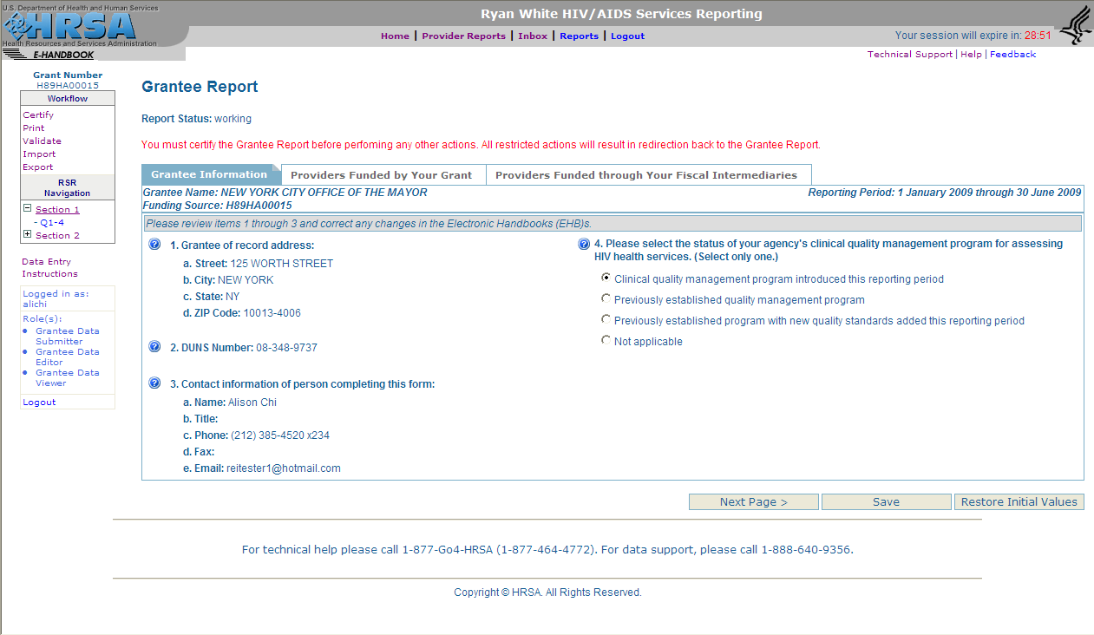

Once you’ve updated, entered, and/or verified the data on the Grantee Information page, click on “Next Page” to save the data and advance to the next page, “Providers Funded by Your Grant.”

------------------------------------------------------------------------------------------------------------------------------
NOTE: Navigation buttons appear at the bottom of each page of the online forms within the RSR system. Use the “Next Page” and “Previous Page” buttons to save any edits you have made in one or more fields and navigate through the report. The “Save” button will save your edits without changing the page. Use the “Restore Initial Values” button to undo any edits you have made since last saving the report.
------------------------------------------------------------------------------------------------------------------------------

How to complete the Grantee Report contract lists

To complete the Grantee Report, view, update, and verify a list of your service provider contracts that were active during the reporting period. For the purpose of the RSR, contracts include formal contracts, memoranda of understanding, or other agreements. A service provider contract that was active during the reporting period is a contract under which:

- Services were delivered by the service provider during the reporting period; and/or
- Any portion of the contract period falls within the reporting period.

All contracts with first-line providers, identified by their grantees as required to submit a Service Provider Report, should be listed on the “Providers Funded by Your Grant” contract list. If a grantee of record contracts with another agency to provide fiscal intermediary services (i.e., that use an administrative agent to award and/or monitor the use of its RWHAP funds), the grantee of record also is responsible for reporting the list of the contracts with second-line providers funded by its grant through its fiscal intermediary (FI) service provider (administrative agent).

How to Update the List of “Providers Funded by Your Grant”

Review the list of service provider contracts that were active during the given reporting period. If a contract is missing from the list, add the new provider contract using the ADD PROVIDER CONTRACT link beneath the table on the left side of the screen (see Figure 2). This link will open a second window with a search form you can use to locate and select a provider in the RWHAP provider directory. If the provider you have contracted with is not listed, contact Ryan White Data Support to have it added to the directory. To remove a provider contract, click the Remove icon (a trash can) next to the provider’s name.

Figure 2. RSR Grantee Report Online Form:
Screenshot of the “Providers Funded by Your Grant” Section
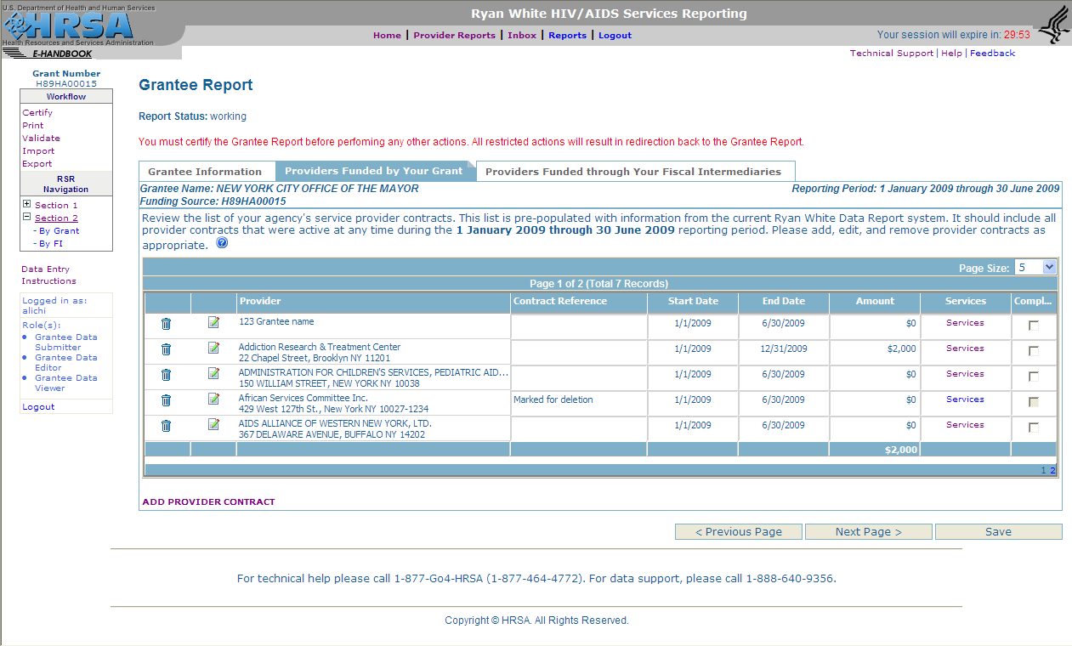

After reviewing and updating your provider contract list, verify the contact information for each of your providers. To edit a provider’s address, click on the Edit icon (a clipboard and pencil) to open another window where you can do so.

Next, verify your providers’ contract information by reviewing the data in the following fields, which you may edit at any time:

- Contract Reference (optional): You may want to use this if you have multiple contracts with one of your service providers under a single grant. You can assign a contract reference number (or name) for each to make it easier for you and your provider to identify each contract.
- Contract Start and End Date: Enter the actual dates for the contract. Keep in mind that the contract period may begin before and/or extend beyond the reporting period dates.
- Contract Amount: Enter the total amount of funding allocated for the selected contract.

For each contract, grantees are required to specify the services the provider is authorized to deliver. Select the “Services” link to open another screen (Figure 3). Select all services the agency has been contracted to provide under this agreement. (They are defined in the “Which services are reported in the RSR?” section of this manual.) After saving the information you enter on the Services Web pages, simply close the window to return to the “Providers Funded by Your Grant” page.

Figure 3. RSR Grantee Report Online Form: Screenshot of the Services List
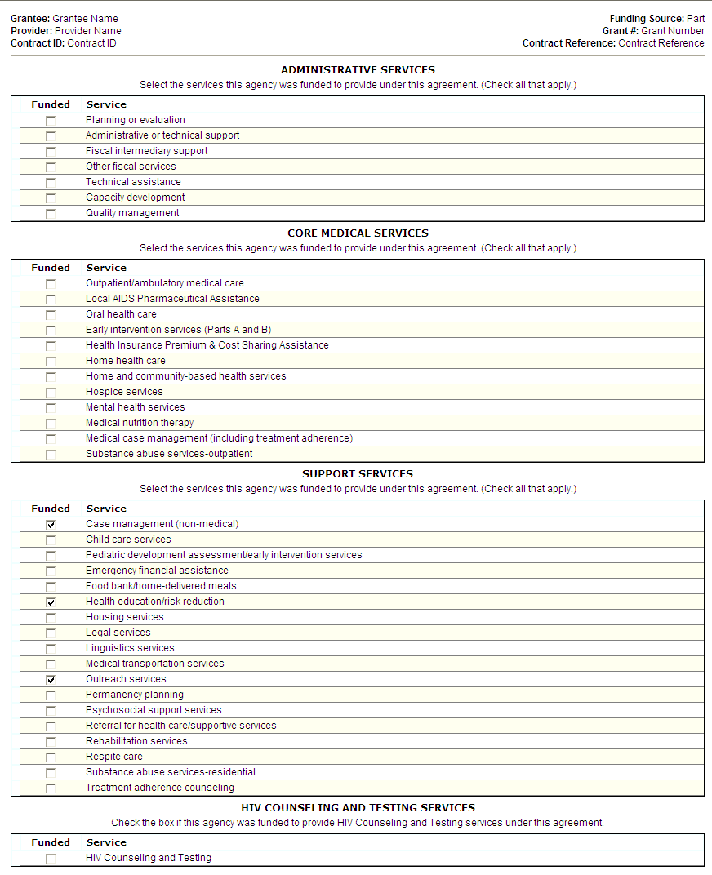

After reviewing and updating (if necessary) the information for each contract, check the box in the “Completed” column (Figure 2). Then click on “Next Page” to save the data and advance to the final page, “Providers Funded Through Your Fiscal Intermediaries.”

How to Update the List of “Providers Funded Through Your Fiscal Intermediaries”

Select a contract for fiscal intermediary services from the list box near the top of the page. A list of contracts funded by your grant through the selected FI service will be displayed.

If a contract is missing from the list, add the new provider contract using the ADD PROVIDER CONTRACT link beneath the table on the left of the screen (Figure 4). This link will open a second window with a search form you may use to locate and select a provider from the RWHAP directory. If the provider you have contracted with is not listed, contact Ryan White Data Support to have it added. To remove a provider contract, click the Remove icon next to the provider’s name.

After reviewing and updating your provider contract list, verify their contact information. To edit a provider’s address, click on the Edit icon to open another browser window where you can do so.

Figure 4. RSR Grantee Report Online Form:
Screenshot of the “Providers Funded through your Fiscal Intermediaries” Section
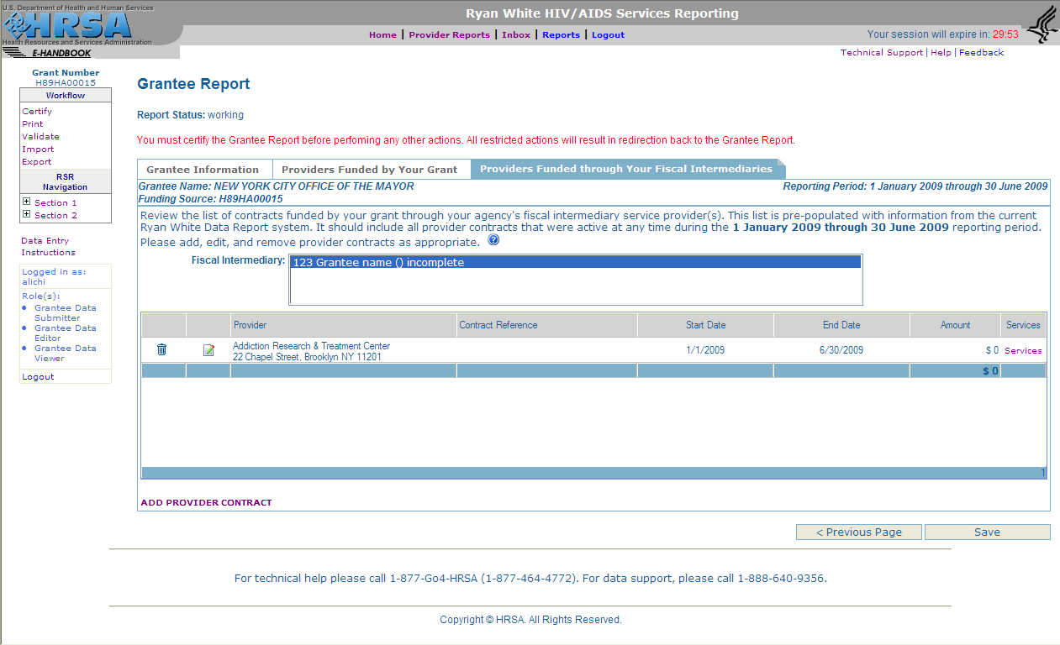

Next, verify your providers’ contract information by reviewing the data in the following fields, which you may edit at any time.

- Contract Reference (optional): You may want to use this if you have multiple contracts with one of your service providers under a single grant. You can assign a contract reference number (or name) for each to make it easier for you and your provider to identify a particular contract.
- Contract Start and End Date: Enter the actual dates of the selected contract. Keep in mind that the contract period may begin before and/or extend beyond the reporting period dates.
- Contract Amount: Enter the total amount of funding allocated for the selected contract.

For each contract, grantees are required to specify the services the provider is authorized to deliver. Select “Services” to open another window with the list of RWHAP-eligible services (Figure 3). They are defined in the “Which services are reported in the RSR?” section of this manual. Select all services the agency has been contracted to provide under this agreement. After saving the services pages, simply close the browser window to return to the “Providers Funded by Your Grant” page.

After reviewing and updating (if necessary) all information for each contract, check the box in the “Completed” column (Figure 4). Click on “Save” to save the data and then close the Grantee Report.

When you are satisfied that your report is complete and correct, indicate that you have completed data entry by clicking “Certify” in the RSR Administration menu (near the upper left-hand corner of the RSR Grantee Report Web pages) and then following the instructions on your screen.

------------------------------------------------------------------------------------------------------------------------------
NOTE: (1) The Grantee Report is automatically submitted to HAB after all of its contracted service providers have successfully submitted their Service Provider Reports and, if applicable, Client Reports. (2) Providers cannot submit their reports for grantee review until their grantee(s) have certified their Grantee Reports in the Ryan White Services Reporting System.
------------------------------------------------------------------------------------------------------------------------------

The Service Provider Report

All agencies that provide direct client services must complete one Service Provider Report online. Multiply-funded providers will include information from all program Parts under which the agency is funded. See the “Who is the Service Provider?” and the “RSR Reporting Requirements for Service Providers” sections of this manual for more information about service providers required to submit a Service Provider Report.

Providers may submit their data manually using the online form or may upload an XML file of the Service Provider Report into the RSR system. The report includes information from all program Parts under which an agency is funded. For more information about service provider reporting requirements, see the Grantee Report section “RSR Reporting Requirements for Service Providers.”

How to Complete the Service Provider Report Manually
------------------------------------------------------------------------------------------------------------------------------
NOTE: If the information is available to HAB, selected items will be prepopulated in the Service Provider Report. Items that are “display only” are prepopulated and cannot be modified directly within the Service Provider Report.
------------------------------------------------------------------------------------------------------------------------------

Provider Information

1. Provider Address (display only) (Figure 5). To edit this item, update your agency profile in the RSR System. If you are a grantee that also is a service provider, update your agency profile in both the EHBs and the RSR System. You may update the profile at any time during the year.

Figure 5. RSR Provider Report Online Form:
Screenshot of Provider Information Section (Questions 1–2)
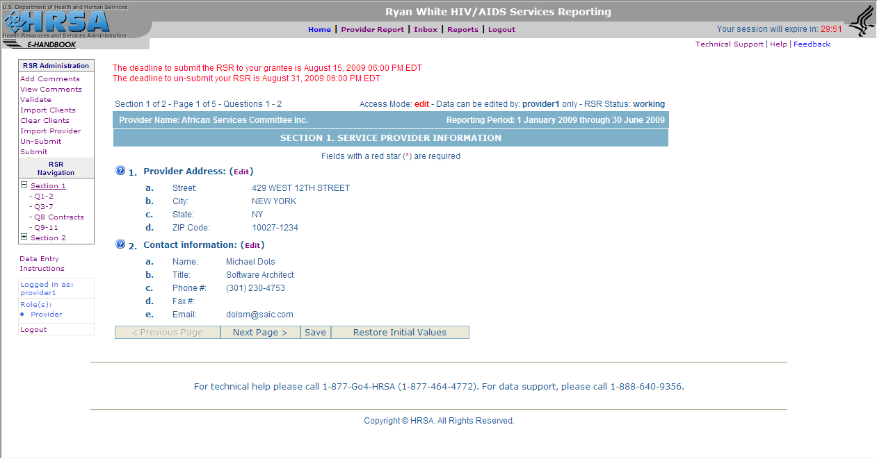

2. Contact information of person completing this form (display only). To edit this item, update your user profile in the RSR System. If you are a grantee that also is a service provider, update your user profile in both the EHBs and RSR System. The contact information for RSR System and EHBs users may be updated at any time during the year.

3. Provider Type (select only one): Select the provider type that best describes your agency. If you select “Other facility,” you must provide a description (Figure 6).

- Hospital or university-based clinic includes ambulatory/outpatient care departments or clinics, emergency rooms, rehabilitation facilities (physical, occupational, speech), hospice programs, substance abuse treatment programs, sexually transmitted diseases (STD) clinics, HIV/AIDS clinics, and inpatient case management service programs.

- Publicly funded community health center includes community health centers, migrant health centers, rural health centers, and homeless health centers.

- Publicly funded community mental health center is a community-based agency, funded by local, State, or Federal funds, that provides mental health services to low-income people.

- Other community-based service organization (CBO) includes non-hospital-based organizations; AIDS service and volunteer organizations; private, nonprofit social service and mental health organizations; hospice programs (home and residential); home health care agencies; rehabilitation programs; substance abuse treatment programs, case management agencies; and mental health-care providers.

- Health department includes State or local health departments.

- Substance abuse treatment center is an agency that focuses on the delivery of substance abuse treatment services.

- Solo/group private medical practice includes all health and health-related private practitioners and practice groups.

- Agency reporting for multiple fee-for-service providers is an agency that reports data for more than one fee-for-service provider (e.g., State operating a reimbursement pool).

- PLWHA coalition includes organizations of People Living with HIV/AIDS (PLWHA) that provide support services to individuals and families affected by HIV and AIDS.

- VA facility is a facility funded through the U.S. Department of Veterans Affairs.

Figure 6. RSR Provider Report Online Form:
Screenshot of Provider Information Section (Questions 3–7)
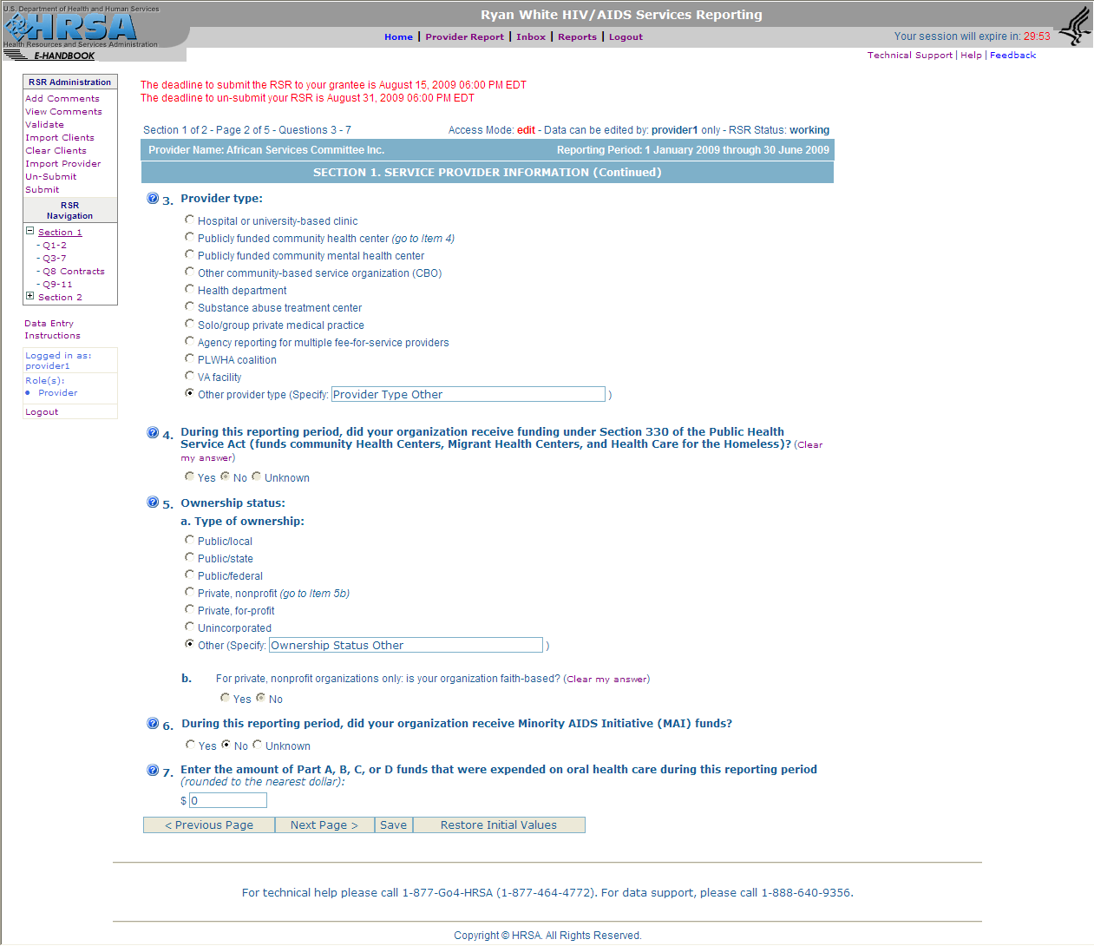

4. Did your organization receive funding under Section 330 of the Public Health Service Act (PHSA) (funds Community Health Centers, Migrant Health Centers, and Healthcare for the Homeless)?

Indicate (yes, no, unknown) if you received such funding during the reporting period. Section 330 of the PHSA supports the development and operation of community health centers that provide preventive and primary health care services, supplemental health and support services, and environmental health services to medically underserved areas/populations.

5. Ownership Status

a. Type of ownership (select only one): Select the category that best describes your agency’s ownership status:

- Public/local is an organization funded by a local government entity and operated by local government employees. Local health departments are examples of local publicly owned organizations.

- Public/state is an organization funded by a State government entity and operated by State government employees. A State health department is an example of a State publicly owned organization.

- Public/Federal is an organization funded by the Federal Government and operated by Federal Government employees. A VA hospital is an example of a Federal publicly owned organization.

- Private, nonprofit is an organization owned and operated by a private, not-for-profit entity, such as a nonprofit health clinic.

- Private, for-profit is an organization owned and operated by a private entity, even though it may receive government funding. A privately owned hospital is an example.

- Unincorporated is an agency that is not incorporated.

- Other is an agency other than those listed above.

b. For private, nonprofit organizations only: Is your organization faith-based?

If you selected “private, nonprofit,” indicate if your agency received funding as a faith-based organization (that is, one operated by a religiously affiliated entity, such as a Catholic hospital).

6. During this reporting period, did your organization receive Minority AIDS Initiative (MAI) funds?
Indicate (yes, no, unknown) whether your organization received MAI funds during the given period.

7. Enter the amount of RWHAP Part A, B, C, D, or F (MAI) funds expended on oral health care during the reporting period. Do not include Dental Reimbursement Program (DRP) or Community-Based Dental Partnership Program (CBDPP) funds.

8. Indicate the Ryan White services you delivered to clients during the reporting period.

Grantee/contract Information
The list of grantees/contracts is prepopulated with information already provided by your grantees in their Grantee Reports. If a contract is missing from this list, ask your grantee of record to add the missing contract to its grantee report (see Figure 7).

Contract reference
A contract reference is an optional feature and will only appear if your grantee has multiple contracts with your agency under the same grant number. If your grantee uses this feature, it will designate a contract reference number or name to help you track the separate contracts as you complete your Provider Report.

Figure 7. RSR Provider Report Online Form:
Screenshot of the Provider Information Section (Question 8)
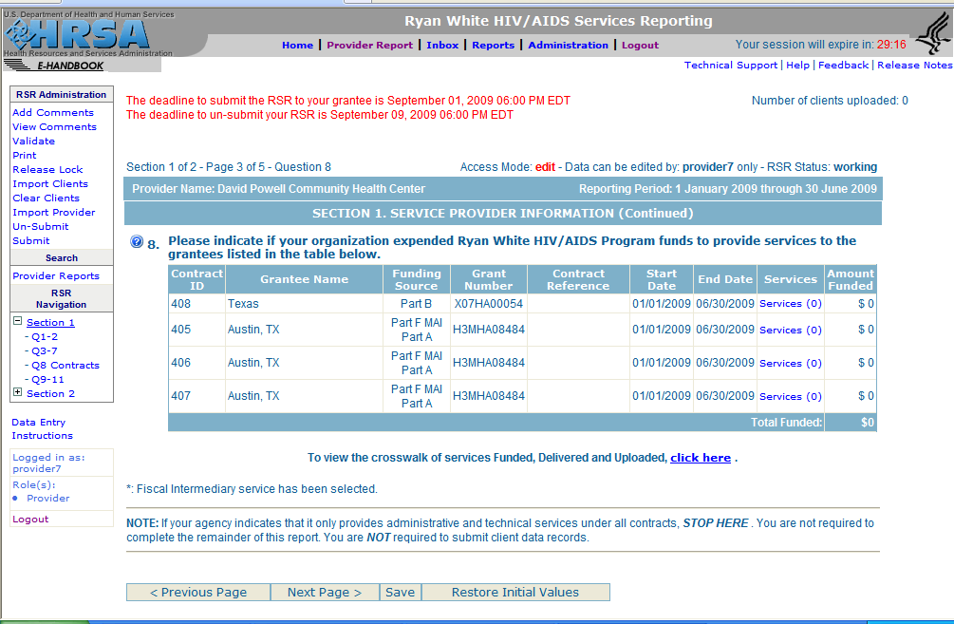

Services
For each of the contracts listed in Item 8, click on the “Services” link to open a new window to indicate the services your agency delivered with RWHAP funds. The window will show a series of four lists that display all RWHAP services under the four categories: Administrative and Technical, Core Medical, Support, and HIV Counseling & Testing (see Figure 8 for an example). For each list:

- Review the services authorized by your grantee; the box next to the service in the “Funded” column will be checked if your agency may provide the indicated service with RWHAP funds. If a service you were contracted to provide is missing from the list, ask your grantee of record to authorize the missing service category for the selected contract in its grantee report.
- Identify each service your agency provides with RWHAP funds under the selected contract. If you delivered a service to any clients during the reporting period using RWHAP funds, check the box beside it (this includes services paid entirely by a third party but delivered by an individual whose salary is paid for in part or in whole with RWHAP funds). If you did not deliver a service you were funded to provide to any clients during the reporting period, don’t check the box for that service. Click on “Next Page” at the bottom of the screen to advance through the lists.

Figure 8. RSR Provider Report Online Form: Screenshot of the Services List
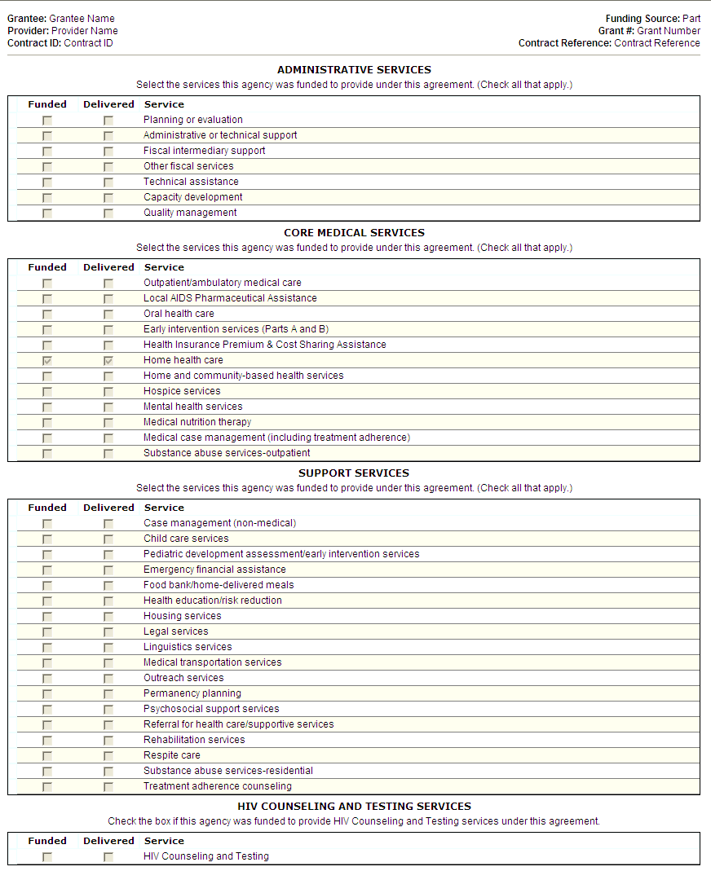

After saving the services page, simply close the window to return to the Service Provider Report.

After reviewing and updating (if necessary) the information for each contract, click “Save” to save the edited data and continue with the final three items in the Service Provider Information section (Figure 9) of the Provider Report.

------------------------------------------------------------------------------------------------------------------------------
NOTE: If your agency indicates that it only provides administrative and technical services under all contracts, STOP HERE. You are not required to complete the remainder of this report. You are NOT required to submit client data records.
------------------------------------------------------------------------------------------------------------------------------

Figure 9. RSR Provider Report Online Form:
Screenshot of the Provider Information Section (Questions 9–11)
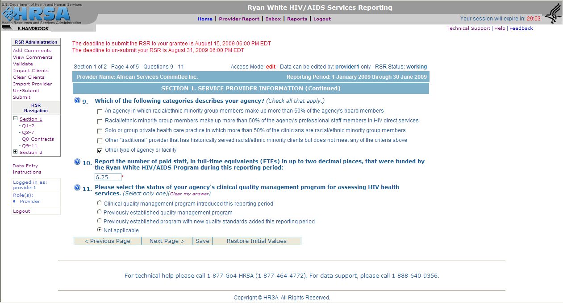

9. Which of the following categories describes your agency (select all that apply):

- Agency in which racial/ethnic minority group members make up more than 50% of the agency’s board members.
- Racial/ethnic minority group members make up more than 50% of the agency’s professional staff members in direct HIV services.
- Solo or group private health care practice in which more than 50% of the clinicians are racial/ethnic minority group members.
- Other provider that has historically served racial/ethnic minority clients but does not meet any of the criteria above.
- Other type of agency or facility.

------------------------------------------------------------------------------------------------------------------------------
NOTE: The fourth and fifth options in this list are mutually exclusive. Providers may select 1, 2, and/or 3, 4, OR 5.
------------------------------------------------------------------------------------------------------------------------------

10. Report the number of paid staff, in full-time equivalents (FTEs), who were funded by the Ryan White HIV/AIDS Program during the given reporting period. You may enter up to two decimal places. Enter a zero if there are no paid staff.

How to Calculate FTEs

Step 1: Count each staff member who works full time (at least 35–40 hours per week) on RWHAP as one FTE. Full-time employees who regularly work overtime should not be counted as more than one FTE. If a percentage of each staff member’s time is being funded by Parts A, B, C, D, and/or F (MAI), you can simply add the percentages to calculate the total. For example: Physician .50 FTE, Nurse Practitioner 1.0 FTE, Dentist .20 FTE, Case Manager .75 FTE, C&T 1.0 FTE = 3.45 FTEs.

Step 2: Identify the staff members who do not work full time on HIV/AIDS care (e.g., part-time employees or full-time employees who spend only a portion of their time in HIV/AIDS care) and sum the weekly hours they spend in HIV/AIDS care. Divide this number by your agency’s definition of full time (e.g., 35 or 40 hours per week).

Step 3: Add the FTEs calculated in steps 1 and 2. This sum is the number of FTEs you should report.

11. Select the status of your agency’s clinical quality management program for assessing HIV health services. (Select only one.) Every RWHAP is required to use such a program to assess the extent to which HIV health services that medical providers and/or medical case managers provide patients are consistent with the most recent Public Health Service guidelines for the treatment of HIV/AIDS. (For further information on quality management of the RWHAP, refer to the Technical Assistance Manual at http://hab.hrsa.gov/tools/QM/index.htm.)

Indicate whether your agency:

- has established a new program to manage the clinical quality of RWHAP services during the reporting period;
- has a previously established clinical quality management program; or
- has recently updated an existing program with new quality standards.

After reviewing and updating (if necessary) the information on this page of the Service Provider Report, click on “Next Page” to save the data and advance to the next page in the Service Provider Report, “HIV Counseling and Testing” (see Figure 10).

HIV Counseling and Testing

If your agency used Ryan White Program funding to provide HIV counseling and testing (HC&T) services during the given reporting period, you must complete this section. Report ALL individuals who received the service at your agency during the reporting period, regardless of funding source. Keep in mind that, because Ryan White funding may be used to test individuals anonymously, those you report in this section may include people who are not counted or reported as Ryan White Program clients in any of your other data reporting items.

12. Number of individuals tested for HIV: Indicate the number of people tested using an FDA-approved test during the reporting period.

13. Of those tested (Item 12), number that tested NEGATIVE? The number that tested NEGATIVE for HIV during the reporting period.

14. Number that tested NEGATIVE (Item 13) and received posttest counseling: Of the number indicated in Item 13, how many received HIV posttest counseling?

Figure 10. RSR Provider Report Online Form:
Screenshot of the HIV Counseling and Testing Section
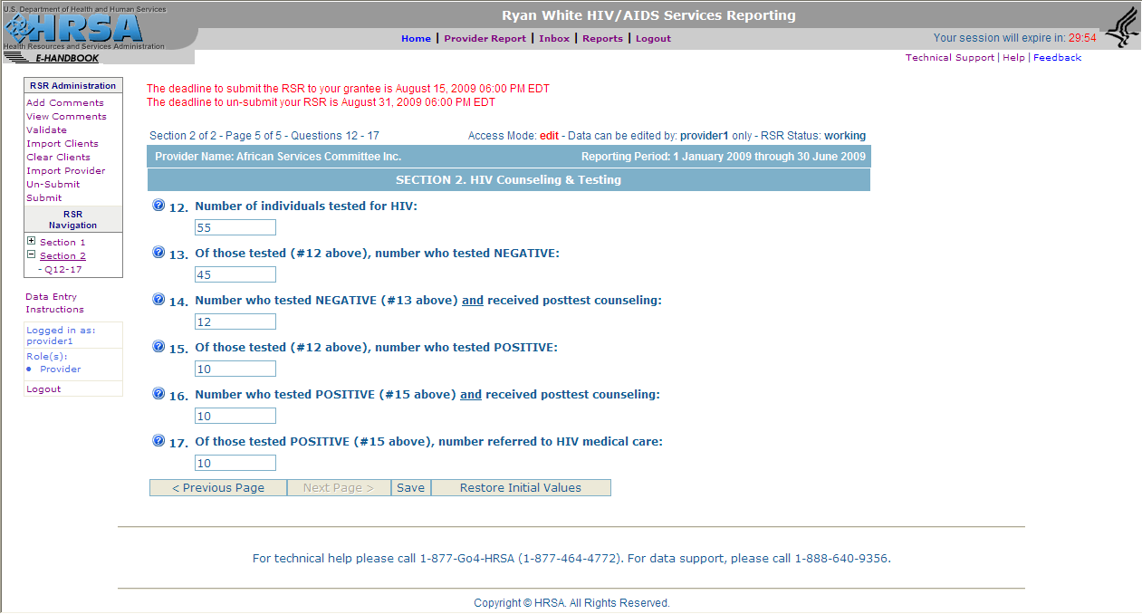

15. Of those tested (Item 12), number that tested POSITIVE? Of the total number tested, indicate how many tested positive for HIV during the reporting period.

16. The number that tested POSITIVE (Item 15) and received posttest counseling: Of the number specified in Item 15, indicate how many received HIV-posttest counseling immediately following the test or returned for counseling at a later date.

17. Of those tested POSITIVE (Item 15), number referred to HIV medical care: Of the total number that tested positive for HIV, indicate how many were referred to HIV medical care.

Importing the Client-Level Data XML File

The Service Provider Report cannot be submitted to the grantee by providers of core medical and support services until the Client Report is imported into the RSR System. The Client Report is a collection of RWHAP client records that can be submitted in a single XML (eXtensible Markup Language) Client File.

------------------------------------------------------------------------------------------------------------------------------
NOTE: Agencies that do not provide RWHAP-funded core medical and/or support services directly to RWHAP clients WILL NOT SUBMIT a Client Report.
------------------------------------------------------------------------------------------------------------------------------

To upload an XML Client File, click “Import Clients” in the RSR Administration menu (near the upper left-hand corner of the Provider Report Web pages) to open another window. Then, follow the on-screen instructions. Following upload, click “Save.”

When you are satisfied that your report is complete and correct, submit the Service Provider and Client Reports to your grantee for review by clicking on “Submit” in the RSR Administration menu and following the instructions on your screen.

How to complete the Service Provider Report via XML file upload

Agencies required to submit a Service Provider Report have the option of importing an XML Provider Report file into the RSR system as an alternative to manual data entry of the report. This file includes the data required to populate:

- Items 3–7 and 9–11: the provider’s organizational data;
- Item 8: the services provided with Ryan White funds under each agreement; and
- Items 12–17: HIV counseling and testing data.

To upload the Service Provider Report XML File, click on “Import Provider” in the RSR Administration menu (near the upper left-hand corner of the pages) to open another window, then follow the on-screen instructions. Be sure to review the data in the RSR system for accuracy after the upload is complete. If there are errors in the report, you may (1) correct the error manually or (2) upload a revised XML Provider File. Please note, however, that after the initial Service Provider Report XML file upload, all subsequent file uploads will overwrite the existing provider data in the RSR system.

Be sure to carefully review the data in Item 8 of the Service Provider Report for accuracy after uploading your XML Provider Report file. When the RSR system receives an XML file that either does not have a contract reference(s) or whose contract reference(s) does not match the contract reference entered by the grantee, the system will associate service data based on a set of predetermined rules:

- If a service reported as delivered in the uploaded XML matches a service authorized under one (and only one) contract in the RSR system, the system will associate the service with that contract;
- If a service reported as delivered in the uploaded XML matches a service authorized under more than one contract in the RSR system, the system will associate the service with all contracts under which it is authorized.

If the service reported as delivered does not match ANY service authorized by the provider’s grantee(s) under ANY contract, the provider will receive a data validation error. To resolve this error, you will need to either (1) modify the services reported as delivered in your Service Provider Report or (2) contact your grantee and ask them to “authorize” the service in the applicable contract.
After confirming the data in the Service Provider Report is accurate, upload the Client Report (see the section “Importing the XML Client File” above). Following upload of the XML Client File, select “Save” and close the Service Provider Report.

When you are satisfied that your report is complete and correct, submit the Service Provider and Client Reports to your grantee for review by clicking on “Submit” in the RSR Administration menu and following the instructions on your screen.

The Client Report

A Client Report must be submitted for all service providers that were funded by the RWHAP to provide core medical or support services directly to clients. Grantees may decide on a case-by-case basis whether to require the service provider to submit its own client data or if the grantee will submit the provider’s client data on behalf of the provider. (See more about grantee and provider reporting requirements in the section “Who is the Service Provider?”)

Reporting Client-Level Data

The client report should contain one record (“row” of data in a database) for each client who received an RWHAP-funded core medical service or support service during the reporting period. The data elements reported per client are determined by the specific RWHAP-funded service(s) the client received at your agency. HAB does not require or want grantees or providers to report a client’s service data for any services he/she received that were NOT paid for by the Ryan White HIV/AIDS Program. See the chart “Required Client-Level Data Elements for RWHAP Eligible Services” in Appendix A to determine the minimum client-level data elements that will be reported for a client based on the RWHAP-funded service(s) he or she received.

-------------------------------------------------------------------------------------------------------------------------------
Example: A service provider organization receives RWHAP funding to provide outpatient/ambulatory medical care services, medical case management services, and several support services including linguistic services, housing services, and medical transportation services.

Client 1 receives outpatient/ambulatory medical services, medical case management services, and medical transportation services. The record for client 1 will report:

- data for all demographic data elements
- data for all clinical services data elements
- the number of visits in each quarter for outpatient/ambulatory medical care services
- the number of visits in each quarter for medical case management services
- the client received medical transportation services during the applicable quarter(s)

Client 2 receives only housing services and linguistics services. The record for client 2 will report:

- data for selected demographic data elements (e.g., race, ethnicity, age, housing status)
- the client received housing services during the applicable quarter(s)
- the client received linguistics services during the applicable quarter(s)
-------------------------------------------------------------------------------------------------------------------------------

Submitting Client-Level Data to HAB

The Client Report (client-level data set) must be uploaded in the required XML format. XML (eXtensible Markup Language) is a standard, simple, and widely adopted method of formatting text and data so that it can be exchanged across all of the different computer platforms, languages, and applications.

Providers need to extract the client-level data elements from their systems and into the proper XML format before they can be uploaded to the HAB server. Several software applications for managing and monitoring HIV clinical and supportive care—including CAREWare, LabTracker, Aries, AIRS, and Casewatch Millennium—will be able to export the data in the required XML format. No special action will be required to generate the XML file. However, if your organization uses a custom-built data collection system, you will need to write a program that extracts the data from it and insert it into an XML file that conforms to the rules of the RSR XML schema. The schema can be obtained from HAB at http://hab.hrsa.gov/manage/CLD.htm.

------------------------------------------------------------------------------------------------------------------------------
NOTE: Technical support will be available to providers with custom systems through the HAB Web site and from HAB project officers.
------------------------------------------------------------------------------------------------------------------------------

Client-Level Data Fields

This section outlines the data fields that will be submitted in the client-level data XML file.

------------------------------------------------------------------------------------------------------------------------------
NOTE: The item numbers listed below correspond to the items listed in the “Data Element for Client-Level Data Export” document available at http://hab.hrsa.gov/manage/CLD.htm.
------------------------------------------------------------------------------------------------------------------------------

System Variables

The XML file will contain three system fields that are prepopulated in the XML file:

- SV1 Reporting Period

- January 1 through June 30 (interim report)
- January 1 through December 31 (annual report)

------------------------------------------------------------------------------------------------------------------------------
NOTES: (1) Information that is not available when the interim report is submitted may be included in the annual report. However, grantees and providers will not be able to amend data submitted in the annual report. (2) Beginning in 2011, Ryan White Program grantees will submit the RSR once each year for the previous calendar year. This report will include information on all clients served and services funded between January 1 and December 31 of the reporting year.
------------------------------------------------------------------------------------------------------------------------------

- SV2 Unique Provider ID

The Unique Provider ID is the provider’s organization identification number. It is automatically generated when the provider is entered in the RSR/RDR Web system provider directory.

- SV3 Unique Provider Registration Code

The Unique Provider Registration Code is automatically generated when the provider is entered into the RSR/RDR Web system provider directory. It is the same code that providers use when they create an account in the RSR/RDR Web system.

- SV4 Encrypted Unique Client ID

The Unique Client ID (UCI) is a unique 11-character alphanumeric code that distinguishes one Ryan White client from all others and is the same for the client across all provider settings. The UCI is derived from the first and third letters of a client’s first and last name, his or her date of birth (MM/DD/YY), and a code for gender (1=male, 2=female, 3=transgender, 9=unknown). A 12th character, “A” to “Z”, is added if a provider needs to distinguish between two clients with the same UCI.

Providers will use a program (provided by HAB) to encrypt the UCI at their site before sending HAB the encrypted UCI as part of the Client Report. ONLY the encrypted UCI gets reported in the uploaded client data, not the unencrypted UCI.

------------------------------------------------------------------------------------------------------------------------------
NOTES: Although the client’s date of birth, name, and gender are used to create the unique client ID, this information is encrypted before it is sent to HRSA. The method used to encrypt the UCI does not allow for decryption, thus securing the client’s privacy. HRSA will never actually see the information (the client’s full date of birth and name) that makes up the unique client identifier.
------------------------------------------------------------------------------------------------------------------------------

Guidelines for Collecting and Recording Client Names

Grantees should develop business rules/operating procedures outlining the method by which client names should be collected and recorded. For example:

- Enter the client’s entire name as it normally appears on documentation such as a driver’s license, birth certificate, passport, or social security card.
- Follow the naming patterns, practices, and customs of the local community, or region (i.e., for Hispanic clients living in Puerto Rico, record both surnames in the appropriate order).
- Avoid the use of nicknames (i.e., do not use Becca if the client’s full name is Rebecca).
- Avoid using initials.

Grantees should instruct providers and staff in the correct entry of client names. This is especially true when clients receive services from multiple providers in a network. Client names must be entered in the same manner in order to avoid false duplicates.

Client Demographics

1. Date of client’s first service visit at this provider’s agency

Indicate this date in the form MM/DD/YYYY. If only the month and year are collected, enter “01” as the day of the client’s first visit (i.e., MM/01/YYYY).

------------------------------------------------------------------------------------------------------------------------------
NOTES: (1) This visit may have occurred before the start of the reporting period. (2) This date may or may not be the date the client first received a Ryan White-funded service. (3) This date may or may not be for a HIV-related service visit. (4) This date may or may not be same date reported in Item 47, date of first outpatient/ambulatory care visit. (5) The date of first visit at a service provider agency does not change in subsequent reports. (6) You are not expected to resort to unreasonable measures to locate this information in your files. If you are unable to identify the first date of service, please report the earliest date available in your records.
------------------------------------------------------------------------------------------------------------------------------

2. What was the client’s vital/enrollment status at the end of the reporting period?

- Active—The client will be continuing in the program.

- Referred or Discharged—The client was referred to another program or agency and will not continue to receive services at this agency. Also select this category if the client was discharged from a program because he or she became self-sufficient and no longer needed Ryan White Program-funded services; the client voluntarily leaves your program; or the client refuses to participate.

- Removed—The client was removed from treatment due to violation of rules.

- Incarcerated—The client will not be continuing in the agency’s program because he or she is serving a criminal sentence in a Federal, State, or local penitentiary, prison, jail, reformatory, work farm, or similar correctional institution (whether operated by the government or a contractor).

- Relocated—The client has moved out of the agency’s service area and will not continue to receive RWHAP services at the agency’s location.

- Deceased

- Unknown—The client has been “lost to care.”

------------------------------------------------------------------------------------------------------------------------------
NOTE: Each agency must determine its own guidelines for classifying a client as “discharged” or “lost to care.”
------------------------------------------------------------------------------------------------------------------------------

3. If the client is reported as “deceased” in Item 2, indicate date of death (MM/DD/YYYY) if known.

4. Client’s year of birth

Indicate the client’s birth year in the form YYYY, if known.

------------------------------------------------------------------------------------------------------------------------------
NOTE: Even though only the year of birth will be reported to HAB, providers should collect the client’s full date of birth. The client’s birth month and day are used to generate the UCI.
------------------------------------------------------------------------------------------------------------------------------

Reporting Client Race and Ethnicity

Office of Management and Budget (OMB) Revisions to the Standards for the Classification of Federal Data on Race and Ethnicity provides a minimum standard for maintaining, collecting, and presenting data on race and ethnicity for all Federal reporting purposes. The standards were developed to provide a common language for uniformity and comparability in the collection and use of data on race and ethnicity by Federal agencies.

The standards have five categories for data on race: American Indian or Alaska Native, Asian, Black or African American, Native Hawaiian or Other Pacific Islander, and White. There are two categories for data on ethnicity: “Hispanic or Latino” and “Not Hispanic or Latino.” The racial category descriptions, defined in October 1997, are required for all Federal reporting, as mandated by the OMB. For more information, go to:

http://www.whitehouse.gov/omb/fedreg/1997standards.html

HAB is required to use the OMB reporting standard for race and ethnicity. However, service provider agencies should feel free to collect race and ethnicity data in greater detail. If the agency chooses to use a more detailed collection system, the data collected should be organized so that any new categories can be aggregated into the standard OMB breakdown.
------------------------------------------------------------------------------------------------------------------------------
NOTE: RWHAP providers are expected to make every effort to obtain and report race and ethnicity, based on each client’s self-report. Self-identification is the preferred means of obtaining this information. Providers should not establish criteria or qualifications to use to determine a particular individual's racial or ethnic classification, nor specify how someone should classify himself or herself.
------------------------------------------------------------------------------------------------------------------------------

5. Ethnicity

Indicate the client’s ethnicity based on his or her self-report.

- Hispanic or Latino—A person of Cuban, Mexican, Puerto Rican, South or Central American, or other Spanish culture or origin, regardless of race. The term “Spanish origin” can be synonymous with “Hispanic or Latino.”

- Not Hispanic or Latino—A person who does not identify his or her ethnicity as “Hispanic or Latino.”

- Unknown indicates the client’s ethnicity is unknown or was not reported.

6. Race (Select one or more)

Indicate the client’s race based on his or her self-report. NOTE: Multiracial clients should select all categories that apply.

- American Indian or Alaska Native—A person having origins in any of the original peoples of North and South America (including Central America), and who maintains tribal affiliation or community attachment.

- Asian—A person having origins in any of the original peoples of the Far East, Southeast Asia, or the Indian subcontinent including, for example, Cambodia, China, India, Japan, Korea, Malaysia, Pakistan, the Philippine Islands, Thailand, and Vietnam.

- Black or African American—A person having origins in any of the black racial groups of Africa.

- Native Hawaiian or Other Pacific Islander—A person having origins in any of the original peoples of Hawaii, Guam, Samoa, or other Pacific Islands.

- White—A person having origins in any of the original peoples of Europe, the Middle East, or North Africa.

- Unknown—Indicates the client’s racial category is unknown or was not reported.

7. Current Gender

Indicate the client’s gender (the socially and psychologically constructed, understood, and interpreted set of characteristics that describe the current sexual identity of an individual) based on his or her self-report.

- Male—An individual with strong and persistent identification with the male sex.

- Female—An individual with strong and persistent identification with the female sex.

- Transgender—An individual whose gender identity is not congruent with his or her biological gender, regardless of the status of surgical and hormonal gender reassignment processes. Sometimes the term is used as an umbrella term encompassing transsexuals, transvestites, cross-dressers, and others. The term transgender refers to a continuum of gender expressions, identities, and roles, which expand the current dominant cultural values of what it means to be male or female.

- Unknown—Indicates the client’s gender category is unknown or was not reported.

8. If the client is reported as “transgender” in Item 7, indicate the subgroup, if known:

- Male to Female
- Female to Male

9. Report the client’s income in terms of the percent of the Federal poverty measure at the end of the reporting period. (See “Appendix C: Calculating Client Income Percentage of the Federal Poverty Measure Using HHS Federal Poverty Guidelines” for additional information.)

- Equal to or below the Federal poverty measure
- 101–200% of the Federal poverty measure
- 201–300% of the Federal poverty measure
- More than 300% of the Federal poverty measure
- Unknown/unreported

If your organization collects this information early in the reporting period, it is not necessary to collect it again at the end of the reporting period (although changes should be documented). Report the latest information on file for each client.

------------------------------------------------------------------------------------------------------------------------------
NOTE: There are two slightly different versions of the Federal poverty measure—the poverty thresholds (updated annually by the U.S. Bureau of the Census) and the poverty guidelines (updated annually by the HHS.) If your agency already uses one of these measures, use that to report this data item. Otherwise, HAB recommends and prefers that your organization use the HHS poverty guidelines to collect and report it. For more information on poverty measures and to see the 2009 HHS Poverty Guidelines, go to http://aspe.hhs.gov/poverty/index.shtml.
------------------------------------------------------------------------------------------------------------------------------

10. Indicate the client’s housing status at the end of the reporting period.

Stable Permanent Housing includes:

- Renting and living in an unsubsidized room, house, or apartment
- Owning and living in an unsubsidized house or apartment
- Unsubsidized permanent placement with families or other self-sufficient arrangements
- Housing Opportunities for Persons with AIDS (HOPWA)-funded housing assistance, including Tenant-Based Rental Assistance (TBRA) or Facility-Based Housing Assistance, but not including the Short-Term Rent, Mortgage and Utility (STRMU) Assistance Program
- Subsidized, non-HOPWA, house or apartment, including Section 8, the HOME Investment Partnerships Program, and Public Housing
- Permanent housing for formerly homeless persons, including Shelter Plus Care, the Supportive Housing Program (SHP), and the Moderate Rehabilitation Program for SRO Dwellings (SRO Mod Rehab)
- Institutional setting with greater support and continued residence expected (psychiatric hospital or other psychiatric facility, foster care home or foster care group home, or other residence or long-term care facility)

Temporary Housing includes:

- Transitional housing for homeless people
- Temporary arrangement to stay or live with family or friends
- Other temporary arrangement such as a Ryan White Program housing subsidy
- Temporary placement in an institution (e.g., hospital, psychiatric hospital or other psychiatric facility, substance abuse treatment facility, or detoxification center)
- Hotel or motel paid for without emergency shelter voucher

Unstable Housing Arrangements include:

- Emergency shelter, a public or private place not designed for, or ordinarily used as, a regular sleeping accommodation for human beings, including a vehicle, an abandoned building, a bus/train/subway station/airport, or anywhere outside
- Jail, prison, or a juvenile detention facility
- Hotel or motel paid for with emergency shelter voucher

Unknown indicates the client’s housing status is unknown or was not reported.

Definitions are based on:

- Housing Opportunities for Persons With AIDS (HOPWA) Program, Annual Progress Report (APR), Measuring Performance Outcomes, form HUD-40110-C
- McKinney-Vento Act, Title 42 US Code, Sec. 11302, General definition of homeless individual

11. Indicate the geographic unit code of the client’s residence at the end of the reporting period.

The geographic unit code is the initial three digits of a U.S. Postal Service ZIP code. For example, “200” is the geographic unit code for a client living in an area represented by the five-digit ZIP code “20001.”

-------------------------------------------------------------------------------------------------------------------------------
NOTE: The privacy of RWHAP clients is of the utmost importance to HAB. To ensure that client information is protected, HAB has chosen to collect only the initial three digits of a U.S. Postal Service ZIP code. Should a client record report one of the low population geographic unit codes outlined in the latest release of the HIPAA Privacy Rule, the RSR System will automatically replace the reported geographic unit code with “000.”

The HIPPA Privacy Rule, as defined in 45CFR164.514(b)(2), requires the removal of all geographic subdivisions smaller than a State, including street address, city, county, precinct, ZIP code, and their equivalent geocodes, except for (1) the initial three digits of a ZIP code if the geographic unit formed by combining all ZIP codes with the same initial three digits contains more than 20,000 people, and (2) the initial three digits of a ZIP code for all geographic units containing 20,000 or fewer people is changed to 000. The Final Modification of the HIPAA Privacy Rule, which used 2000 Census data, identifies 17 restricted ZIP codes: 036, 059, 063, 102, 203, 556, 692, 790, 821, 823, 830, 831, 878, 879, 884, 890, and 893.
-------------------------------------------------------------------------------------------------------------------------------

If the client’s housing is “Unstable,” enter the geographic unit code of the place he or she considers his or her residence or “home base.” Home base for a person who is homeless or has an unstable living arrangement is the place where that person returns regularly and presently intends to remain, including an emergency shelter or a public or private place not designed for, or ordinarily used as, a regular sleeping accommodation for human beings, including a vehicle, abandoned building, bus/train/subway station/airport, or anywhere outside. It also can be a place the person returns to regularly where he or she can receive messages and be contacted.

12. Indicate the HIV/AIDS status of the client at the end of the reporting period.

- HIV-negative (affected)—Client has tested negative for HIV, is an affected partner or family member of an individual who is HIV-positive, and has received at least one RWHAP-funded support service during the reporting period.

- HIV-positive, not AIDS—Client has been diagnosed with HIV but has not advanced to AIDS.

- HIV-positive, AIDS status unknown—Client has been diagnosed with HIV. It is not known whether the client has advanced to AIDS.

- CDC-defined AIDS—Client is an HIV-infected individual who meets the CDC AIDS case definition for an adult or child. NOTE: Once a client has been diagnosed with AIDS, he or she always is counted in the CDC-defined AIDS category regardless of changes in CD4 counts. For additional information, see: http://www.cdc.gov/ncphi/disss/nndss/casedef/aidscurrent.htm

- HIV-indeterminate (infants only)—A child under the age of 2 whose HIV status is not yet determined but was born to an HIV-infected mother.

- Unknown—A client who is not an infant and whose HIV/AIDS status is unknown or was not reported.

13. If the response to Item 12 is “CDC-defined AIDS,” indicate the year (YYYY) of the client’s AIDS diagnosis, if known.

14. What is the client’s risk factor for HIV infection (select one or more):

- Men who have sex with men (MSM) cases include men who report sexual contact with other men (i.e., homosexual contact) and men who report sexual contact with both men and women (i.e., bisexual contact).

- Injection drug user (IDU) cases include clients who report use of drugs intravenously or through skin-popping.

- Hemophilia/coagulation disorder cases include clients with delayed clotting of the blood.

- Heterosexual contact cases include clients who report specific heterosexual contact with an individual with, or at increased risk for, HIV infection (e.g., an injection drug user).

- Receipt of transfusion of blood, blood components, or tissue cases include transmission through receipt of infected blood or tissue products given for medical care.

- Mother with/at risk for HIV infection (perinatal transmission) cases include transmission from mother to child during pregnancy. This category is exclusively for infants and children infected by mothers who are HIV-positive or at risk.

- Other indicates the client’s exposure category is known, but not listed above.

- Unknown indicates the client’s exposure category is unknown or was not reported.

15. Report all sources of health insurance the client had for any part of the reporting period. If the client did not have any health insurance of any kind throughout the entire reporting period, report “No insurance” (select one or more).

- Private means health insurance plans such as BlueCross/BlueShield, Kaiser Permanente, and Aetna.

- Medicare is a health insurance program for people 65 years of age and older, some disabled people under 65 years of age, and people with end-stage renal disease (permanent kidney failure treated with dialysis or a transplant).

- Medicaid is a jointly funded, Federal-State health insurance program for certain low-income and needy people.

- Other public means other Federal, State, and/or local government programs providing a broad set of benefits for eligible individuals. Examples include State-funded insurance plans, military health care (TRICARE), State Children’s Insurance Program (SCHIP), Indian Health Services, and Veterans Health Administration.

- No insurance means the client did not have insurance to cover the cost of services at any time during the reporting period, the client self-pays, or services are covered by RWHAP funds.

- Other insurance means client has an insurance type other than those listed above.

- Unknown means the primary source of medical insurance is unknown and not documented.

-------------------------------------------------------------------------------------------------------------------------------
NOTE: The No Insurance and Unknown options in this list are mutually exclusive. Providers may report the Private, Medicare, Medicaid, and/or Other public insurance options; the No Insurance option; OR the Unknown option.
-------------------------------------------------------------------------------------------------------------------------------

Core Services
Definitions for these services can be found in the “Which services are reported in the RSR?” section of this instruction manual.

For each RWHAP client, report the number of visits per quarter for each RWHAP-funded core medical service. If a Ryan White client received a core medical service that was not funded through your RWHAP contract, do not report on that service for the client. If a Ryan White client received a core medical service that your organization funds through multiple sources, including Ryan White and non-Ryan White funds, report the number of visits per quarter for that core medical service, unless your data system can discern that the client’s visits were paid for with non-Ryan White funds.
------------------------------------------------------------------------------------------------------------------------------
NOTE: For each day, only one service visit per category may be counted.
------------------------------------------------------------------------------------------------------------------------------

16. Indicate the number of Outpatient/ambulatory medical care service visits the client received per quarter during the reporting period.

17. Indicate the number of Oral health care service visits the client received per quarter during the reporting period.

18. Indicate the number of Early Intervention Services (Part A and B) service visits the client received per quarter during the reporting period.

19. Indicate the number of Home health care service visits the client received per quarter during the reporting period.

20. Indicate the number of Home and community-based health service visits the client received per quarter during the reporting period.

21. Indicate the number of Hospice service visits the client received per quarter during the reporting period.

22. Indicate the number of Mental health service visits the client received per quarter during the reporting period.

23. Indicate the number of Medical nutrition therapy service visits the client received per quarter during the reporting period.

24. Indicate the number of Medical case management (including treatment adherence) service visits the client received per quarter during the reporting period.

25. Indicate the number of Substance abuse service (outpatient) visits the client received per quarter during the reporting period.

26. Indicate (Yes/No/Unknown) if the client received Local AIDS Pharmaceutical Assistance (Not ADAP) at any time during each quarter.

27. Indicate (Yes/No/Unknown) if Health Insurance Premium funding was provided for the client at any time during each quarter.

Support Services

Definitions for these services can be found in the “Which services are reported in the RSR?” section of this manual.

For each Ryan White client, report on whether or not a support service was received for each Ryan White-funded support service. If a Ryan White client received a support service that was not funded through your RWHAP contract, do not report on that service for the client. If a Ryan White client received a support service that your organization funds through multiple sources, including Ryan White and non-Ryan White funds, report on whether or not the client received that support service, unless your data system can discern that the client’s receipt of service was paid for with non-Ryan White funds.

28. Indicate (Yes/No/Unknown) if the client received Case management (non-medical) services at any time during each quarter of the reporting period.

29. Indicate (Yes/No/Unknown) if the client received Child care services at any time during each quarter of the reporting period.

30. Indicate (Yes/No/Unknown) if the client received Developmental assessment/early intervention services at any time during each quarter of the reporting period. (Part D only.)

31. Indicate (Yes/No/Unknown) if the client received Emergency financial assistance services at any time during each quarter of the reporting period.

32. Indicate (Yes/No/Unknown) if the client received Food bank/home- delivered meals services at any time during each quarter of the reporting period.

33. Indicate (Yes/No/Unknown) if the client received Health education/ risk reduction services at any time during each quarter of the reporting period.

34. Indicate (Yes/No/Unknown) if the client received Housing services at any time during each quarter of the reporting period.

35. Indicate (Yes/No/Unknown) if the client received Legal services at any time during each quarter of the reporting period.

36. Indicate (Yes/No/Unknown) if the client received Linguistics services at any time during each quarter of the reporting period.

37. Indicate (Yes/No/Unknown) if the client received Transportation services at any time during each quarter of the reporting period.

38. Indicate (Yes/No/Unknown) if the client received Outreach services at any time during each quarter of the reporting period.

39. Indicate (Yes/No/Unknown) if the client received Permanency planning services at any time during each quarter of the reporting period.

40. Indicate (Yes/No/Unknown) if the client received Psychosocial support services at any time during each quarter of the reporting period.

41. Indicate (Yes/No/Unknown) if the client received a Referral for health care/ supportive services at any time during each quarter of the reporting period.

42. Indicate (Yes/No/Unknown) if the client received Rehabilitation services at any time during each quarter of the reporting period.

43. Indicate (Yes/No/Unknown) if the client received Respite care services at any time during each quarter of the reporting period.

44. Indicate (Yes/No/Unknown) if the client received Substance abuse services (residential) at any time during each quarter of the reporting period.

45. Indicate (Yes/No/Unknown) if the client received Treatment adherence counseling services at any time during each quarter of the reporting period.

Clinical Information

Only providers who received Ryan White HIV/AIDS Program funding to provide Outpatient/ambulatory health services are required to report the clinical information data elements. These providers will report all of the clinical information (Items 44–66) for each of their Ryan White HIV-positive or indeterminate clients who received outpatient/ambulatory health services, regardless of who paid for or delivered those clinical services. For example: An HIV-positive client receives two outpatient/ambulatory medical visits, one paid for in part with RWHAP funds. This provider will report all clinical activity for its RW client, including two outpatient/ambulatory care visits, in Item 48.

-------------------------------------------------------------------------------------------------------------------------------
NOTE: The reporting period for RSR purposes is the period of time for which data are submitted to HAB (e.g., January 1–December 31, 2010.) This should not be confused with clinical performance measurement periods. Though providers are required to report the applicable data elements with each report submission, they should not perform a clinical activity more frequently than required to meet the generally accepted standards of medical care for HIV-positive patients.
-------------------------------------------------------------------------------------------------------------------------------

Data provided in this section will help HAB prove that, nationally, the program is meeting patient care requirements as set forth in:

- The 2009 Ryan White HIV/AIDS program legislation;
- HAB’s Government Performance and Results Act (GPRA) measures;
- HAB’s Performance Assessment Rating Tool (PART) measures; and
- HAB’s HIV/AIDS Core Clinical Performance Measures for Adults & Adolescents.

Ultimately, information provided in this section will help HAB ensure that RW clients receive a consistent level of service across all provider settings.

46. HIV risk-reduction screening/counseling

Indicate (yes/no/unknown) if HIV risk-reduction screening and/or counseling was provided to the client during this reporting period. HIV risk-reduction screening and counseling refers to a short questionnaire administered by a clinician to identify patients at risk for HIV infection or re-infection and counseling patients about ways to reduce their risk.

47. First outpatient/ambulatory care visit

List the date of the client’s first outpatient/ambulatory care visit at this provider agency. If the full date is not available, report the month and year of the first visit and the day as”01” (i.e., MM/01/YYYY).

------------------------------------------------------------------------------------------------------------------------------
NOTES: (1) This visit may have occurred before the start of the reporting period. (2) This visit may or may not be an RWHAP-funded visit. (3) This date may or may not be same date reported in Item 1, date of client’s first service visit at this provider agency. (4) The date of first outpatient/ambulatory care visit does not change in subsequent reports. (5) You are not expected to resort to unreasonable measures to locate this information in your files. If you are unable to identify the first date of service, please report the earliest date available in your records.
------------------------------------------------------------------------------------------------------------------------------

48. Outpatient/ambulatory care visit dates

Report all dates (MM/DD/YYYY) of the client’s outpatient/ambulatory care visits in this provider’s HIV care setting with a clinical care provider during the reporting period. A clinical care provider is a physician, physician’s assistant, clinical nurse specialist, nurse practitioner or health care professional who is certified in his or her jurisdiction to prescribe antiretroviral (ARV) therapy.

49. CD4 Cell Counts

Report the value and test date for all CD4 count tests administered to the client during the reporting period. The CD4 cell count measures the number of T-helper lymphocytes per cubic millimeter of blood. It is a good predictor of immunity. As CD4 cell count declines, the risk of developing opportunistic infections increases. The test date is the date the client’s blood sample is taken.

50. Viral Load Counts

Report the value and test date for all viral load tests administered to the client during the reporting period. Viral load is the quantity of HIV RNA in the blood and is a predictor of disease progression. Test results are expressed as the number of copies per milliliter of blood plasma. The test date is the date the client’s blood sample is taken.

51. PCP Prophylaxis

- Yes
- No
- Not medically indicated
- No, client refused
- Unknown

PCP prophylaxis is drug treatment to prevent pneumocystis cariini pneumonia (PCP)—the most common infection in people with HIV and a major cause of mortality for persons with < 200 CD4 cells, yet almost entirely preventable and treatable. Indicate if clients were prescribed a PCP prophylaxis at any time during the reporting period. NOTE: Select “yes” if the client began or was continuing a prophylactic regimen during the reporting period.

For additional information about PCP prophylaxis, see:
http://hab.hrsa.gov/special/measure03.htm
http://www.hrsa.gov/performancereview/prophylaxis.htm
http://www.aidsinfo.nih.gov/Guidelines/Default.aspx?MenuItem=Guidelines

52. Was the client prescribed HAART at any time in this reporting period?

- Yes
- No, not medically indicated
- No, not ready (as determined by clinician)
- No, client refused
- No, intolerance, side effect, toxicity
- No, HAART payment assistance unavailable
- No, other reason
- Unknown

HAART is highly active antiretroviral therapy, an aggressive anti-HIV treatment including a combination of three or more drugs with activity against HIV whose purpose is to reduce viral load to undetectable levels. NOTE: Report “yes” if the client began or was continuing on HAART during the reporting period. For additional information about HAART, visit: http://www.aidsinfo.nih.gov/Guidelines/Default.aspx?MenuItem=Guidelines.

53. Indicate if the client was screened for tuberculosis (TB) during the reporting period.

- Yes
- No
- Not medically indicated
- Unknown

Tuberculosis screening is the use of physical examinations and tests (such as PPD skin tests, blood tests, X-rays, and sputum tests) to determine latent or active infection by mycobacterium tuberculosis bacteria. For additional information about tuberculosis, visit: http://www.aidsinfo.nih.gov/Guidelines/Default.aspx?MenuItem=Guidelines.

54. If the response to Item 53 is “no” or “not medically indicated,” indicate if the client has been screened for TB since his or her HIV diagnosis.

- Yes
- No
- Not medically indicated
- Unknown

55. Has the client been screened for syphilis during this reporting period?

- Yes
- No
- Not medically indicated
- Unknown

Syphilis is a sexually transmitted disease (STD) that can be diagnosed by examining material from a chancre (infectious sore) using a dark-field microscope or with a blood test. Additional information may be obtained at http://www.aidsinfo.nih.gov/Guidelines/Default.aspx?MenuItem=Guidelines.

56. Has the client been screened for hepatitis B during this reporting period?

- Yes
- No
- Not medically indicated
- Unknown

Hepatitis B is a serious infection caused by the hepatitis B virus (HBV). If it goes undiagnosed and untreated it can cause permanent liver damage. A screening blood test can determine a diagnosis. For additional information, please see: http://www.aidsinfo.nih.gov/Guidelines/Default.aspx?MenuItem=Guidelines.

57. If the response to Item 56 is ”no” or “not medically indicated,” indicate if the client has been screened for hepatitis B since his or her HIV diagnosis.

- Yes
- No
- Not medically indicated
- Unknown

58. Has the client completed the vaccine series for hepatitis B?

- Yes
- Not medically indicated
- No
- Unknown

The hepatitis B vaccine series is a sequence of shots that stimulate a person’s natural immune system to protect against HBV. If the client is in the process of completing a hepatitis B vaccination series, report “no” for the reporting period; you will indicate that the client has completed the series in subsequent reports.

59. Has the client been screened for hepatitis C during this reporting period?

- Yes
- No
- Not medically indicated
- Unknown

Hepatitis C screening is the use of physical examinations and tests—such as anti-HCV tests, HCV RIBA tests, HCV-RNA tests, and viral load or quantitative HCV tests—to detect the presence of the HCV virus and/or antibodies indicating exposure to the virus.

60. If the response to Item 59 is “no” or “not medically indicated,” indicate if the client has been screened for hepatitis C since his or her HIV diagnosis.

- Yes
- No
- Not medically indicated
- Unknown

61. Was the client screened for substance use (alcohol and drugs) during the reporting period?

- Yes
- No
- Not medically indicated
- Unknown

Substance use screening is a quick, simple way to identify clients who need further assessment or treatment for substance use disorders. Screening may include biomarkers (e.g., positive drug screen or liver disease) and client reports of consumption patterns.

62. Was a mental health screening conducted for the client during this reporting period?

- Yes
- No
- Not medically indicated
- Unknown

Mental health screenings include the use of brief structured instruments or commonly used questionnaires to assess potential mental health problems. Screenings are designed to determine whether the client presents signs or symptoms of a mental health problem and if the client should be referred to a mental health professional. Screens are not diagnostic tools and, although typically administered by a mental health professional, may be administered by trained health care professionals in other medical/clinical disciplines.

63. For HIV+ women only: Did the client receive a Pap smear during this reporting period?

- Yes
- No
- Not medically indicated
- Not applicable
- Unknown

A Pap smear or screening is a way to examine cells taken from a woman’s cervix. It can detect cell changes that may be pre-cancerous as well as hidden, small tumors that may lead to cervical cancer.

64. For HIV+ women only: Was the client pregnant during the reporting period?

- Yes
- No
- Not applicable
- Unknown

65. For HIV+ women only: If the response to Item 64 is “yes,” indicate when the client entered prenatal care.

- First trimester
- Second trimester
- Third trimester
- At time of delivery
- Not applicable
- Unknown

Women whose pregnancies did not result in a live birth should be reported in the “Not applicable” category.

66. For HIV+ women only: If the response to Item 64 is “yes,” indicate if the client was prescribed antiretroviral therapy to prevent maternal-to-child transmission (vertical) of HIV.

- Yes
- No
- Not applicable
- Unknown

Women whose pregnancies did not result in a live birth should be reported in the “Not applicable” category.

Appendix A: Required Client-Level Data Elements For RWHAP-Eligible Services

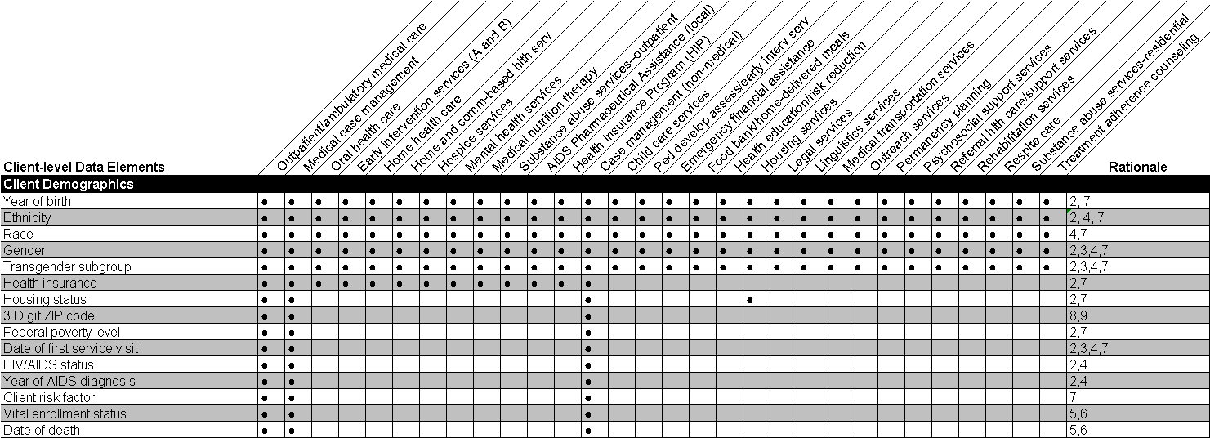

RATIONAL CODES

- Necessary for identifying new clients
- 2006 Ryan White Legislation requirement
- Necessary to assess RWHAP performance as required for GPRA
- Necessary to assess RWHAP performance as required for PART
- Necessary to track enrollment or vital status over the course of the reporting period
- Informs the denominator of other items
- Used to identify important population subgroups
- Used to measure and assess the extent of out-of-service area utilization.
- Used to determine areas of eligibility.
- Accountability, use of funds

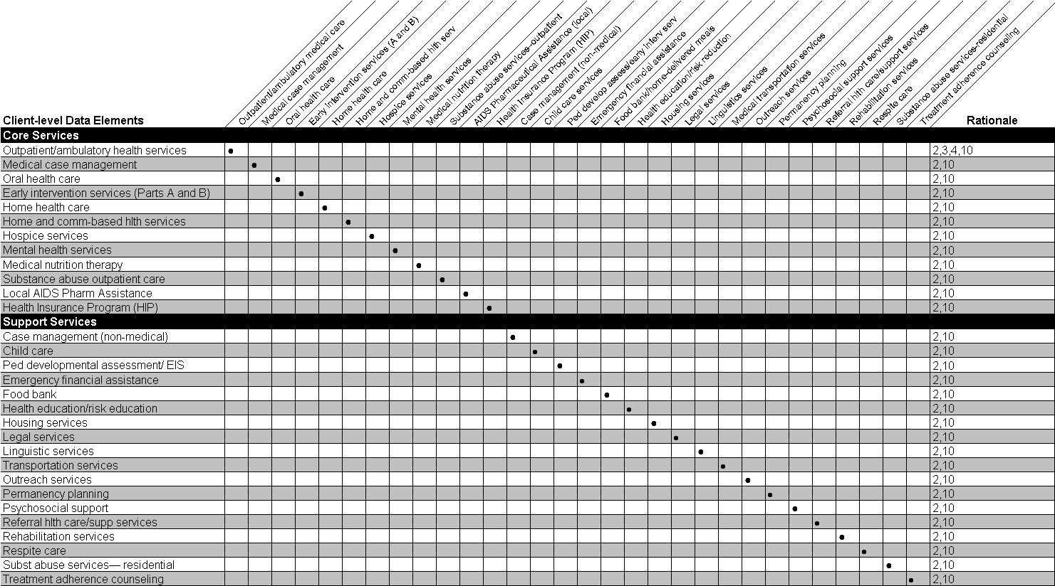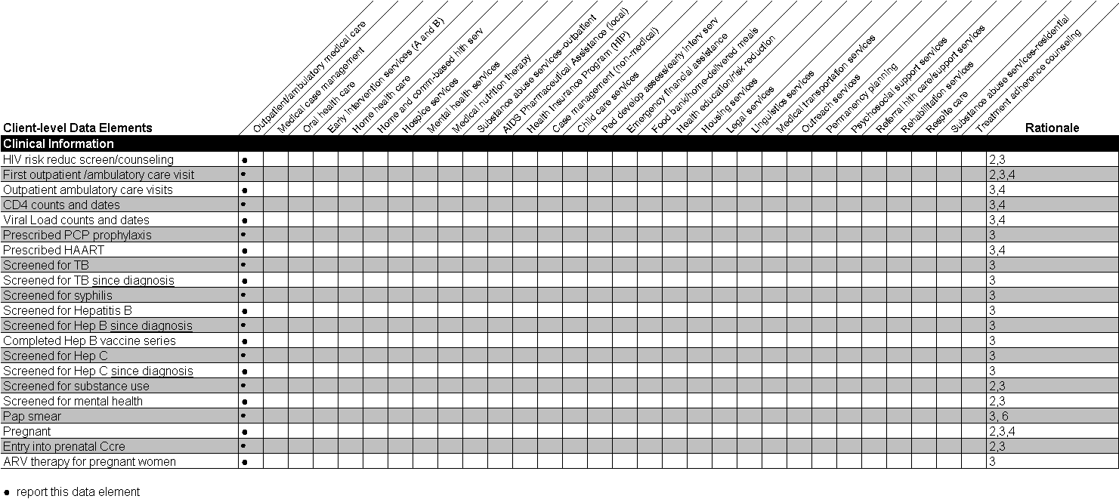

Appendix B: RSR Reporting Scenarios

RSR Submission Requirements

Each grantee of record will complete a separate Grantee Report for each RWHAP grant it receives from HRSA—Part A, Part B, Part C, Part D, and Part F (Part A MAI or Part B MAI). For example:
- An agency with only a Part C grant will complete one grantee form.
- An agency with a Part A and a Part F (Part A MAI) grant will complete two grantee forms—one for each grant.
- An agency with a Part C and a Part D grant will complete two grantee forms—one for each grant.

All agencies that provide Ryan White-funded services, including grantees that also provide services (grantee/providers), must complete one Service Provider Report online. The report includes information from all program Parts under which an agency is funded. See the “Who is the Service Provider” and the “RSR Reporting Requirements for Service Providers” sections of this manual for more information about service providers required to submit a Service Provider Report.

A Client Report must be submitted by every agency that provides outpatient/ambulatory medical care and/or case management services (medical or non-medical) with RWHAP funds. It must include one record for every client that receives an RWHAP-funded core or support services at the provider agency. The client-level data elements required in each record are determined by the RWHAP-funded service(s) the client receives at the agency.

------------------------------------------------------------------------------------------------------------------------------
NOTE: ALL providers of core and support services are required to submit client-level records. Only providers that deliver anonymous Outreach services exclusively are exempt from uploading client-level data.
------------------------------------------------------------------------------------------------------------------------------

RSR Submission Models

The scenarios below are meant to illustrate the many possible methods of meeting the RSR submission requirement. These scenarios:
- show the options available to grantees for setting up their contract lists in the RSR System;
- outline the required reports in the grantee’s RSR submission; and
- explain the client-level data that are expected from each provider based on the services its clients received.

Scenario 1: A grantee-provider

Variation A: A grantee-provider receiving funding from only one Program Part
- Part C Grantee, J. Warren Health Center, provides medical case management and outpatient/ambulatory medical care services at its clinic in Metroville, CA.

Variation B: A grantee/provider receiving funding from multiple Program Parts
- Part C Grantee, J. Warren Health Center, provides medical case management and outpatient/ambulatory medical care services at its clinic in Metroville, CA.
- J. Warren Health Center also receives funding from Part A Grantee, Metroville, and Part B Grantee, California.

How is the RSR submitted to HAB for these variations on scenario one?

In these scenarios, J. Warren Health Center will submit one Grantee Report, one Provider Report, and one Client Report.

Agency | Grantee Report | Provider Report | Client Report
J. Warren Health Center | ● | ● | ●

Scenario 2: A grantee with one provider
- Metroville is a Part A grantee that has one contract with one service provider, Total Care Clinic.
- Total Care Clinic provides outpatient/ambulatory medical care to HIV-positive patients.

How is the RSR submitted to HAB for this scenario?

- Metroville will submit one Grantee Report.
- Total Care Clinic will complete one Provider Report and upload client record data for all RWHAP-funded clients.

Agency | Grantee Report | Provider Report | Client Report
Metroville | ●
Total Care Clinic |  | ● | ●

When Metroville completes its Grantee Report, it will list one contract.

Provider Name | Contract Start | Contract End | Services
Total Care Clinic | 01/01/2010 | 12/31/2010 | Outpatient/ambulatory medical care

The data a provider will submit for each of its clients in its Client Report will depend upon the Ryan White-funded services received by the client.

Based on the reporting requirements and the Appendix A table:

Total Care Clinic will report the following for each of its clients who received a RW-funded outpatient/ambulatory health care service:
- All 15 client demographic data elements (Items 1–15).
- The number of outpatient/ambulatory medical care visits per quarter (Item 16).
- All clinical information data elements (Items 46–66).

Scenario 3: A grantee/provider with one provider
- Metroville is a Part A grantee that provides direct client services in a city-operated clinic. It also has one contract with one service provider, Total Care Clinic.
- Total Care Clinic provides outpatient/ambulatory medical care to HIV-positive patients.

How is the RSR submitted to HAB for this scenario?

- Metroville will submit one Grantee Report and one Provider Report, and upload client record data for all RWHAP-funded clients served in the city-operated clinic.
- Total Care Clinic will complete one Provider Report and upload client record data for all RWHAP-funded clients served at its location.

Agency | Grantee Report | Provider Report | Client Report
Metroville | ● | ● | ●
Total Care Clinic |  | ● | ●

When Metroville completes its Grantee Report, it will list two contracts, one with Total Care and one with itself.

Provider Name | Contract Start | Contract End | Services
Metroville | 01/01/2010 | 12/31/2010 | Outpatient/ambulatory medical care
Total Care Clinic | 01/01/2010 | 12/31/2010 | Outpatient/ambulatory medical care

The data a provider will submit for each of its clients in its Client Report will depend upon the Ryan White-funded services received by the client.

Based on the reporting requirements and the Appendix A table:

Metroville and Total Care Clinic will report the following for each of its clients who received a RW-funded outpatient/ambulatory health care service:
- All 15 client demographic data elements (Items 1–15).
- The number of outpatient/ambulatory medical care visits per quarter (Item 16).
- All clinical information data elements (Items 46–66).

Scenario 4: A grantee/provider with two providers.
- J. Warren Health Center is a Part C grantee that has one contract each with two service providers, Hearthstone Health and Friends Food Bank.
- Hearthstone Health provides home health care services to HIV-positive patients.
- Friends Food Bank provides home-delivered meals to HIV-positive clients.

How is the RSR submitted to HAB for this scenario?

- J Warren Health Center will submit one Grantee Report.
- Hearthstone Health will complete an online Provider Report and upload a Client Report.
- Friends Food Bank will complete an online Provider Report and upload a Client Report.

Agency | Grantee Report | Provider Report | Client Report
J. Warren Health Center | ●
Hearthstone Health |  | ● | ●
Friends Food Bank |  | ● | ●

When J. Warren Health Center completes its Grantee Report, it will list two contracts.

Provider Name | Contract Start | Contract End | Services
Hearthstone Health | 01/01/2010 | 12/31/2010 | Home health care
Friends Food Bank | 01/01/2010 | 12/31/2010 | Food bank/home delivered meals

The data that each provider will submit for each of its Ryan White clients in its Client Reports will depend upon the Ryan White-funded services received by the client.

Based on the reporting requirements and the Appendix A table:

Hearthstone Health will report the following for each of its clients who received RW-funded home health care:
- The five basic demographic data elements that capture age, race/ethnicity, and gender (Items 4–8)
- The health insurance data element (Item 15)
- The number of home health care visits per quarter (data element 19)

Friends Food Bank will report the following for each of its clients who received RW-funded home delivered meals:
- The five basic demographic data elements that capture age, race/ethnicity, and gender (Items 4–8)
- Whether (yes/no/unknown) the client received food bank/home-delivered meals during each quarter of the reporting period (Item 32)

Scenario 5: A grantee/provider with two providers exempt from reporting
- Part C Grantee, J. Warren Health Center, provides medical case management and outpatient/ambulatory medical care services at its clinic in Los Angeles.
- Acme Taxi provides medical transportation services only and submits vouchers monthly to J. Warren Health Center for payment.
- Community Dental Clinic provides oral health care services to eight clients from J. Warren Health Center on a fee-for-service basis.
- J. Warren Health Center decides to exempt both Acme Taxi and Community Dental Clinic.

How is the RSR submitted to HAB for this scenario?

J. Warren Health Center’s RSR submission will include one Grantee Report, one Service Provider Report, and one Client Report. J. Warren Health Center will report all of the services provided in-house, as well as the services provided by Acme Taxi and Community Dental Clinic, in the Provider Report.

In this scenario, when J. Warren Health Center completes its Grantee Report, it will list one contract under its name.

Provider Name | Contract Start | Contract End | Services
J. Warren Health Center | 01/01/2010 | 12/31/2010 | Outpatient/ambulatory Medical Care  Medical Case Management  Oral Health Care  Medical Transportation

The data that J. Warren Health Center will submit for each of its Ryan White clients in its Client Report will depend upon the Ryan White-funded services received by the client. For example (based on the reporting requirements and the Appendix A table):

J. Warren Health Center will report the following for each of its clients who received Ryan White-funded medical case management services only:
- All 15 client demographic data elements (Items 1–15)
- The number of medical case management visits per quarter (Item 24)

J. Warren Health Center will report the following for each of its clients who received Ryan White-funded medical case management, medical transportation, and oral health services:
- The five basic demographic data elements that capture age, race/ethnicity, and gender (Items 4–8)
- The health insurance data element (Item 15)
- The number of medical case management visits per quarter (Item 24)
- The number of oral health visits per quarter (Item 17)
- Whether (yes/no/unknown) the client received medical transportation during each quarter of the reporting period (Item 37)

J. Warren Health Center will report the following for each of its clients who received Ryan White-funded outpatient/ambulatory medical care, medical case management, medical transportation, and oral health services:
- All 15 client demographic data elements (Items 1–15)
- The number of outpatient/ambulatory medical care visits per quarter (Item 16)
- The number of medical case management visits per quarter (Item 24)
- The number of oral health visits per quarter (Item 17)
- Whether (yes/no/unknown) the client received medical transportation during each quarter of the reporting period (Item 37)
- All clinical information data elements (Items 46–66)

Scenario 6: A grantee that uses an administrative agent to coordinate its Ryan White HIV/AIDS Program
- State Department of Health is a Part B grantee that has one contract with one service provider, Integrated Methods Corporation.
- Integrated Methods Corporation provides fiscal intermediary services to the State Department of Health.
- Integrated Methods Corporation contracts with two providers, Allison B. Winthrop Hospital Center and Luminescent.
  - Allison B. Winthrop Hospital Center provides outpatient/ambulatory medical care services in the state’s largest city.
  - Luminescent provides medical case management and coordinates the provision of medical and support services to Ryan White clients in rural areas of the state. It uses Ryan White funds to pay for services—including outpatient/ambulatory medical Care, oral health care, and mental health services—provided through a number of agencies with which Luminescent has signed memorandums of agreement. These memoranda specify that the providers are strictly “fee-for-service” providers and establish a data use agreement between the providers and Luminescent.

How is the RSR submitted to HAB for this scenario?

- State Department of Health will submit one Grantee Report.
- Integrated Methods Corporation will complete an online Provider Report.
- Allison B. Winthrop Hospital Center will complete an online Provider Report and upload a Client Report.
- Luminescent will complete an online Provider Report and upload a Client Report.

------------------------------------------------------------------------------------------------------------------------------
NOTE: Integrated Methods Corporation will complete Items 1–8 only of the Provider Report. It will not complete a Client Report because it does not offer direct client services.
------------------------------------------------------------------------------------------------------------------------------

Agency | Grantee Report | Provider Report | Client Report
Part A Grantee | ●
Integrated Methods Corporation |  | ●
Allison B. Winthrop Hospital Center |  | ● | ●
Luminescent |  | ● | ●

In this scenario, the Part B grantee includes Integrated Methods Corporation on its “Providers Funded by Your Grant” contract list because it directly funds the organization to provide fiscal intermediary services.

Provider Name | Contract Start | Contract End | Services
Integrated Methods Corporation | 01/01/2010 | 12/31/2010 | Fiscal Intermediary Services

The Part B grantee also will list the organizations funded by Integrated Methods Corporation on its “Providers Funded Through Your Fiscal Intermediaries” contract list. Notice that Luminescent’s providers are excluded from the contract list. They are being given an exemption from reporting by the grantee because they are “fee-for-service” providers; Luminescent will submit one Service Provider Report in its own name and include the data for its providers.

Provider Name | Contract Start | Contract End | Services
Allison B. Winthrop Hospital Center | 01/01/2010 | 12/31/2010 | Outpatient/ambulatory Medical Care
Luminescent | 01/01/2010 | 12/31/2010 | Outpatient/ambulatory Medical Care  Oral Health Care  Mental Health Services

The data that each provider will submit for each of its Ryan White clients in its Client Report will depend on the Ryan White-funded services received by the client.

Based on the reporting requirements and the Appendix A table:

Allison B. Winthrop Hospital Center will report the following for each of its clients who received Ryan White-funded outpatient/ambulatory health care services:
- All 15 client demographic data elements (Items 1–15)
- The number of outpatient/ambulatory medical care visits per quarter (Item 16)
- All clinical information items (Items 46–66)

Because Luminescent provides medical case management services for all of its clients, it will report the following for all of its clients:
- All 15 client demographic items (Items 1–15)
- The number of medical case management visits per quarter (Item 24)

Additional items reported by Luminescent in each client’s record will depend on the services it provides for each client through its memorandums of agreement. For example, Luminescent will report the following for each of its clients who received Ryan White-funded outpatient/ambulatory medical care and oral health services:
- All 15 client demographic items (Items 1–15)
- The number of outpatient/ambulatory medical care visits per quarter (Item 16)
- The number of medical case management visits per quarter (Item 24)
- The number of oral health visits per quarter (Item 17)
- All clinical information Items (Items 46–66)

Appendix C: Calculating Client Income Percentage of the Federal Poverty Measure Using HHS Federal Poverty Guidelines
Calculation Steps

Here are five easy steps you can use to determine a client’s income percentage of the Federal poverty measure using the U.S. Department of Health and Human Services Federal poverty guidelines (FPG):

- Count the client’s family size.
- Add up the family income.
- Look up the FPG for the family size, year, and geographic location.
- Calculate the family income as a percent of the family FPG:

family income / guideline * 100 = % family FPG

- Use the percent of the family FPG to report the client percent of the Federal poverty measure for Item 9 of your RSR Client Report.
Background, Definitions, and Notes

To find the Poverty Guidelines and more information on poverty measurement, go to the HHS Poverty Guidelines, Research, and Measurement Web page at http://aspe.hhs.gov/POVERTY/.

The Federal poverty guidelines are dollar amounts that vary according to family size and are used to determine poverty status. HHS issues them each year in the Federal Register.

There are separate guidelines for the contiguous 48 states, Alaska, and Hawaii.

Family size is the number of family members who live together. An individual living alone (or with only non-relatives) counts as a family of one.

Family income is the sum of income of all family members who live together.

- It includes pre-tax money (or “cash”) income (earnings; unemployment compensation; Social Security; public assistance; veterans’ payments; survivor benefits; pension or retirement income; interest; dividends; rents; royalties; income from estates, trusts, educational assistance, alimony, child support, assistance from outside the household, and other miscellaneous sources)
- It excludes non-cash benefits (e.g., food stamps, housing subsidies) and capital gains (or losses)

All family members have the same poverty status; thus all family members have the same income percentage of the Federal poverty measure.

Glossary

Active client
An individual who was a client when the reporting period ended and is expected to continue in the program during the next reporting period.

ADAP
AIDS Drug Assistance Program. A State-administered program authorized under Part B of the Ryan White HIV/AIDS Program that provides FDA-approved medications to low-income individuals with HIV/AIDS disease who have limited or no coverage from private insurance, Medicaid, or Medicare.

Affected client
A family member or partner of an infected client who receives at least one Ryan White HIV/AIDS Program support service during the reporting period.

AIDS
Acquired immune deficiency syndrome. A disease caused by the human immunodeficiency virus.

ARV
Antiretroviral. A substance that fights against a retrovirus, such as the human immunodeficiency virus (HIV).

CDC
Centers for Disease Control and Prevention. The U.S. Department of Health and Human Services agency that administers HIV/AIDS prevention programs, including the HIV Prevention Community Planning process, among others. The CDC is responsible for monitoring and reporting infectious diseases, administers AIDS surveillance grants, and publishes epidemiologic reports such as the HIV/AIDS Surveillance Report.

Client
See infected client, affected client, active client, or indeterminate client.

Clinical Care Provider
A physician, physician’s assistant, clinical nurse specialist, nurse practitioner, or other health care professional who is certified in his or her jurisdiction to prescribe ARV therapy.

Combination therapy
Two or more drugs or treatments used together to achieve optimum results against HIV/AIDS. For more information on treatment guidelines, visit http://www.aidsinfo.nih.gov/guidelines.

Confidential information
Information such as name, gender, age, and HIV status, that is collected on the client and whose unauthorized disclosure could cause the client unwelcome exposure, discrimination, and/or abuse.

Consortium/HIV Care Consortium
An association of one or more public, and one or more nonprofit private, health care, and support service providers, people with HIV/AIDS, and community-based organizations operating within areas determined by the State to be most affected by HIV disease. The consortium agrees to use Part B grant assistance to plan, develop, and deliver (directly or through agreement with others) comprehensive outpatient health and support services for individuals with HIV disease. Agencies constituting the consortium are required to have a record of service to populations and subpopulations with HIV/AIDS.

Continuum of care
An approach that helps communities plan for, and provide, a full range of emergency and long-term service resources to address the various needs of people living with HIV/AIDS (PLWHA).

Contract
An agreement between two or more parties, especially one that is written and enforceable by law. For the purposes of the Ryan White Services Report, contracts include formal contracts, memoranda of understanding, or other agreements.

Core Medical Services
A set of essential, direct health care services provided to persons with HIV/AIDS and specified in the Ryan White HIV/AIDS Treatment Modernization Act.

DSP
Division of Science and Policy. The division within HRSA’s HIV/AIDS Bureau that serves as the principal source of program data collection and evaluation, the development of innovative models of care (Special Programs of National Significance, or SPNS), and the focal point for coordination of program performance activities and development of policy guidance.

EMA/TGA
Eligible Metropolitan Area/Transitional Grant Area—The geographic area eligible to receive Part A Ryan White HIV/AIDS Program funds. The boundaries of the EMA/TGA are defined by the Census Bureau. Eligibility is determined by AIDS cases reported to the CDC. Some EMAs include just one city and others are composed of several cities and/or counties. Some EMAs extend across more than one State.

Exposure category
See risk factor.

Family-centered
A model in which systems of care under Ryan White Part D are designed to address the needs of PLWHA and affected family members as a unit, by providing or arranging for a full range of services. The family structures may range from the traditional, biological family unit to nontraditional family units with partners, significant others, and unrelated caregivers.

Fee-for-service
The method of billing for health services whereby a physician or other health service provider charges the payer (whether it be the patient or his or her health insurance plan) separately for each patient encounter or service rendered.

GPRA
The Government Performance and Results Act. Enacted in 1993, the law requires Federal agencies to establish standards measuring their performance and effectiveness. HRSA has set both long-term and annual measures to assess the performance of Ryan White HIV/AIDS Program services.
http://www.whitehouse.gov/omb/mgmt-gpra/gplaw2m.html

Grantee of record
The official Ryan White HIV/AIDS Program grantee that receives Federal funding directly from the Federal Government (HRSA). A grantee also may be a provider if it provides direct services in addition to administering its grant.

HAART
Highly active antiretroviral therapy. An aggressive anti-HIV treatment including a combination of three or more drugs with activity against HIV whose purpose is to reduce viral load to undetectable levels.

HAB
HIV/AIDS Bureau. The Bureau within the Health Resources and Services Administration (HRSA) of the U.S. Department of Health and Human Services (HHS) that is responsible for administering the Ryan White HIV/AIDS Program. Within HAB, the Division of Service Systems administers Part A, Part B, and the AIDS Drug Assistance Program (ADAP); the Division of Community-Based Programs administers Part C, Part D, and the HIV/AIDS Dental Reimbursement Program; and the Division of Training and Technical Assistance administers the AIDS Education and Training Centers (AETC) Program. The Bureau’s Division of Science and Policy administers the SPNS Program, HIV/AIDS evaluation studies, and the Ryan White HIV/AIDS Program Data Report.

High-risk insurance pool
A State health insurance program that provides coverage for individuals who are denied coverage due to a preexisting condition or who have health conditions that would normally prevent them from purchasing coverage in the private market.

HIP
Health Insurance Program. A program of financial assistance for eligible individuals living with HIV to enable them to maintain continuity of health insurance or to receive medical benefits under a health insurance program. This includes premium payments, risk pools, co-payments, and deductibles.

HIV disease
Any signs, symptoms, or other adverse health effects due to the human immunodeficiency virus.

HOPWA
Housing Opportunities for People With AIDS. A program administered by the U.S. Department of Housing and Urban Development (HUD) that provides funding to support housing for PLWHA and their families.

HRSA
Health Resources and Services Administration. A Federal public health agency of the U.S. Department of Health and Human Services that is responsible for directing national health programs that improve the Nation’s health by assuring equitable access to comprehensive, quality health care for all. HRSA works to improve and extend life for people living with HIV/AIDS, provides primary health care to medically underserved people, serves women and children through State programs, and trains a health workforce that is both diverse and motivated to work in underserved communities. HRSA administers the Ryan White HIV/AIDS Program.

Indeterminate client
A child under the age of 2 whose HIV status is not yet determined but was born to an HIV-infected mother.

Infected client
An individual who is HIV-positive and receives at least one Ryan White HIV/AIDS Program-funded service during the reporting period.

Inpatient setting
This includes hospitals, emergency rooms and departments, and residential facilities where clients typically receive food and lodging as well as treatments.

Institution
This includes residential, health care, and correctional facilities.

- Residential facilities include supervised group homes and extended treatment programs for alcohol and other drug abuse or for mental illness.
- Health care facilities include hospitals, nursing homes, and hospices.
- Correctional facilities include jails, prisons, and correctional halfway houses.

MAI
Minority AIDS Initiative. See Part F MAI.

Not Medically Indicated
A determination made by a clinical care provider that a service, procedure, or treatment is not medically necessary. Medically necessary health care services are procedures used by a prudent medical care provider to diagnosis or treat an illness, injury, disease or its symptoms in a manner that is (a) in accordance with generally accepted standards of medical practice; or (b) clinically appropriate in terms of type, frequency, extent, site, and duration, and considered effective for a patient’s illness, injury, or disease; and (c) not primarily for the convenience of the patient or treating clinical care provider.

OI
Opportunistic infection. An infection or cancer that occurs in individuals with weak immune systems due to HIV, cancer, or immunosuppressive drugs such as corticosteroids or chemotherapy. Kaposi’s Sarcoma (KS), Pneumocystis cariini pneumonia (PCP), toxoplasmosis, and cytomegalovirus are all examples of such infections.

OMB
Office of Management and Budget. The office within the executive branch of the Federal Government that prepares the President’s annual budget, develops the Federal Government’s fiscal program, oversees administration of the budget, and reviews government regulations.

Outpatient setting
A hospital, clinic, medical office, or other place where clients receive health care services but do not stay overnight.

PART
Program Assessment Rating Tool. A diagnostic tool used to assess the performance and management of Federal programs. For the Ryan White HIV/AIDS Program, annual goals and outcome measures include, for example, improving access to health care by increasing the proportion of people living with HIV who receive medical care and treatment; and improving health outcomes by expanding health care to underserved, vulnerable, and special needs populations.
http://www.whitehouse.gov/omb/part/

Part A
The part of the Ryan White HIV/AIDS Program that provides direct financial assistance to designated EMAs/TGAs that have been the most severely affected by the HIV epidemic. The purpose of these funds is to deliver or enhance HIV-related core medical and support services to people living with HIV/AIDS and their affected partners and family members.

Part B
The part of the Ryan White HIV/AIDS Program that authorizes the distribution of Federal funds to States and territories to improve the quality, availability, and delivery of core medical and support services for individuals living with HIV/AIDS and their affected partners and family members. The Ryan White HIV/AIDS Program emphasizes that such care and support is part of a coordinated continuum of care designed to improve medical outcomes.

Part C
The part of the Ryan White HIV/AIDS Program that provides support for early intervention services, including preventive, diagnostic, and therapeutic services for people living with HIV/AIDS and their affected partners and family members. This support includes a comprehensive continuum of outpatient HIV primary care services including: HIV counseling, testing, and referral; medical evaluation and clinical care; other primary care services; and referrals to other health services.

Part D
The part of the Ryan White HIV/AIDS Program that supports coordinated family-centered outpatient care for women, infants, children, and youth with HIV/AIDS and their affected partners and family members. The Adolescent Initiative is a separate grant under the Part D program that is aimed at identifying adolescents who are HIV-positive and enrolling and retaining them in care.

Part F MAI
Minority AIDS Initiative. A national HHS initiative that provides special resources to reduce the spread of HIV/AIDS and improve health outcomes for people living with HIV disease within communities of color. This initiative was enacted to address the disproportionate impact of the disease in such communities. It was formerly referred to as the Congressional Black Caucus Initiative because of that body's leadership in its development. This is also known as Part A MAI and Part B MAI.

PHSA
Public Health Service Act.

PLWHA
People living with HIV/AIDS.

PLWHA coalition
Organizations of people living with HIV/AIDS that provide support services to individuals and families infected with and/or affected by HIV and AIDS.

Primary health care service
Any preventive, diagnostic, or therapeutic health service received on an outpatient basis by a client who is HIV-positive. Examples include medical, subspecialty care, dental, nutrition, mental health, or substance abuse treatment, medical case management, and pharmacy services; radiology, laboratory, and other tests used for diagnosis and treatment planning; and counseling and testing.

Provider agency/ service provider
The agency that provides direct services to clients (and their families). A provider agency may receive funds as a grantee (such as under Parts C and D) or through a contractual relationship with a grantee funded directly by HRSA’s Ryan White HIV/AIDS Program.

RDR
Ryan White HIV/AIDS Program Annual Data Report

Recipient
An organization receiving financial assistance directly from an HHS awarding agency to carry out a project or program. For the purposes of the Ryan White Services Report, a recipient is the grantee of record. See also “Grantee of record.”

Reporting period
A 6-month period, January 1 through June 30; or 12-month period, January 1 through December 31, of the calendar year.

Risk factor or risk behavior/exposure category
See also Transmission Category. Behavior or other factor that places an individual at risk for disease. For HIV/AIDS, this includes such factors as male-to-male sexual contact, injection drug use, and commercial sex work.

RSR
Ryan White HIV/AIDS Program Services Report

RWHAP
Ryan White HIV/AIDS Program

RWHAP-funded service
A service paid for with Ryan White HIV/AIDS Program funds.

The Ryan White HIV/AIDS Treatment Modernization Act of 2006
The Federal legislation created to address the health care and service needs of people living with HIV/AIDS (PLWHA) disease and their families in the United States and its territories. The law has changed how Ryan White funds can be used, with an emphasis on providing life-saving and life-extending services for people living with HIV/AIDS.

SPNS
Special Projects of National Significance. A health services demonstration, research, and evaluation program funded under Part F of the Ryan White HIV/AIDS Program. SPNS projects are awarded competitively.

Subrecipient
The legal entity to which a subaward is made and which is accountable to the recipient for the use of the funds provided. For the purposes of the Ryan White Services Report, a subrecipient is the service provider (contractor or subgrantee). See also “Provider agency/ service provider.”

Support services
A set of services needed to achieve medical outcomes that affect the HIV-related clinical status of a person living with HIV/AIDS.

Transmission category
A grouping of disease exposure and infection routes. In relation to HIV disease, exposure groupings include injection drug use, men who have sex with men, heterosexual contact, perinatal transmission, and so forth.

Unique Client Identifier UCI
A unique alphanumeric code that distinguishes one Ryan White client from all others and is the same for the client across all provider settings.

Index

AIDS Drug Assistance Program (ADAP), 12, 43, 62, 64
CD4 cell count, 46
Client Report (client-level data upload), 6, 17, 33–50
Clinical Information, 45–50
Core Services, 42–43
Reporting Requirements, 33, 54, 57
gender, 38
Geographic unit code, 40
Grantee Report, 5, 16, 18–23
Reporting Requirements, 7–10, 8, 18, 54
Grantee, definition of, 7
HAART, 47
health insurance, 42
Hepatitis B, 48
Hepatitis C, 48
HIV Counseling and Testing, 16, 30
HIV risk reduction screening/counseling, 45
Housing, types of
Stable Permanent Housing, 39
Temporary Housing, 39
Unstable Housing, 40
mental health screening, 49
Pap smear, 49
PCP, 46
Pregnancy, 50
Race and Ethnicity, Reporting of, 37
Ethnicity, 37
Race, 38
Reporting Period, 10, 34, 45
Reporting Requirements, 7–10
Risk factor, 41
Service Provider Report, 6, 16, 23–33
Reporting Requirements, 7–10, 54
Service Provider, definition of, 7
first line provider, 8
second line provider, 8
Services, 10–16
Administrative and Technical Services, 10–11
administrative or technical support, 10
capacity development services, 11
fiscal intermediary services, 11
other fiscal services, 11
planning or evaluation, 10
quality management, 11
technical assistance services, 11
Core Medical Services, 11–14
case management, medical, 13
Early Intervention Services (Parts A and B), 12
Early Intervention Services (Parts C and D), 12
Health Insurance Premium & Cost Sharing Assistance, 12
home and community-based health services, 13
home health care, 13
hospice, 13
Local AIDS Pharmaceutical Assistance, 12
mental health, 13
oral health care, 12
outpatient/ambulatory care, 45
outpatient/ambulatory medical care, 11
substance abuse services, outpatient, 14
HIV Counseling and Testing Services, 16
Support Services, 14–16
case management, non-medical, 14
child care, 14
emergency financial assistance, 14
food bank/home-delivered meals, 14
health education/risk reduction, 15
housing, 15
legal, 15
linguistics, 15
medical transportation, 15
outreach, 15
pediatric developmental assessment and early intervention services, 14
permanency planning, 15
psychosocial support, 15
referral for health care/supportive services, 15
rehabilitation, 16
respite care, 16
substance abuse services, residential, 16
treatment adherence counseling, 16
Substance use screening, 49
Syphilis, 47
Tuberculosis, 47
Unique Client ID, 35
Viral load count, 46
Vital enrollment status, 36

Contract. (n.d.). The American Heritage® Dictionary of the English Language, Fourth Edition. Accessed December 12, 2008, at Dictionary.com Web site: http://dictionary.reference.com/browse/contract

