January 19, 2010

MEMORANDUM FOR : Reviewer of 1220-0008

FROM : David Friedman, Assistant Commissioner
Division of Industrial Prices and Price Indexes

SUBJECT : New Internet Data Submission Option for the Producer Price Index Program

In May 2011, the Bureau of Labor Statistics (BLS) will begin offering a new option for respondents to submit price information for the Producer Price Index Program (PPI) through the BLS Internet Data Collection Facility (IDCF). This option has been introduced to ease the burden on respondents who find Internet data submission to be more convenient than the currently offered mail and fax options for reporting price information.

Respondents who choose to report via the Internet will be notified by e-mail message when it is time to submit their data each month. This message will include a hyperlink to the website of the BLS IDCF. Respondents will input an account number and password to access their survey information from this site.

The Internet survey instrument (Attachment I) uses a similar format to the paper PPI survey forms, with respondents providing information about the prices, characteristics, transaction terms, and discounts or surcharges for selected transactions each month. All relevant information about each priced transaction is presented in a single view in order to assist with accurate reporting and allow for quick navigation through the system. The BLS Office of Survey Methods Research was consulted on the design of the survey.

There is no change in burden for this collection option. The current OMB approval of the PPI survey is scheduled to expire on June 30, 2011.

If you have any questions about this request, please contact David Friedman at 202-691-6307 or by e-mail at Friedman.David@bls.gov.

Attachment I
Log-in Page

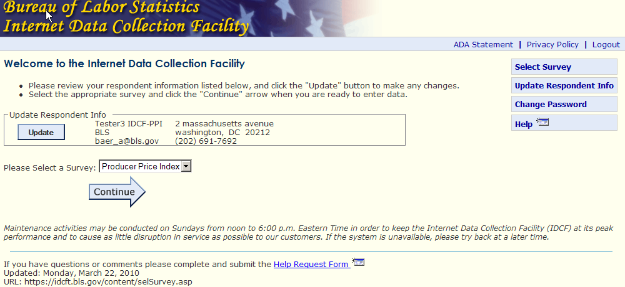

Welcome Page

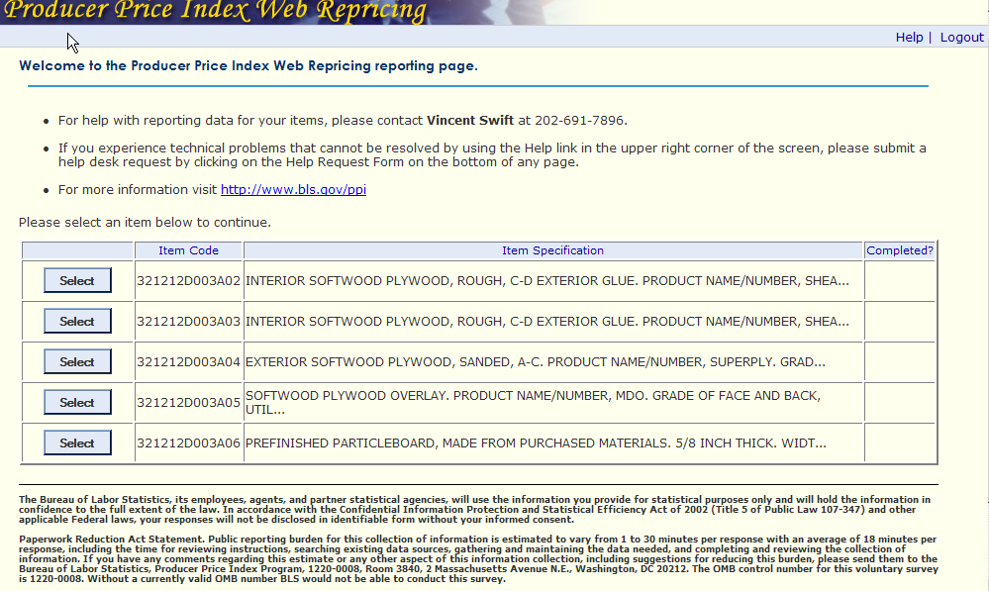
Item Detail Part 1: Item Description

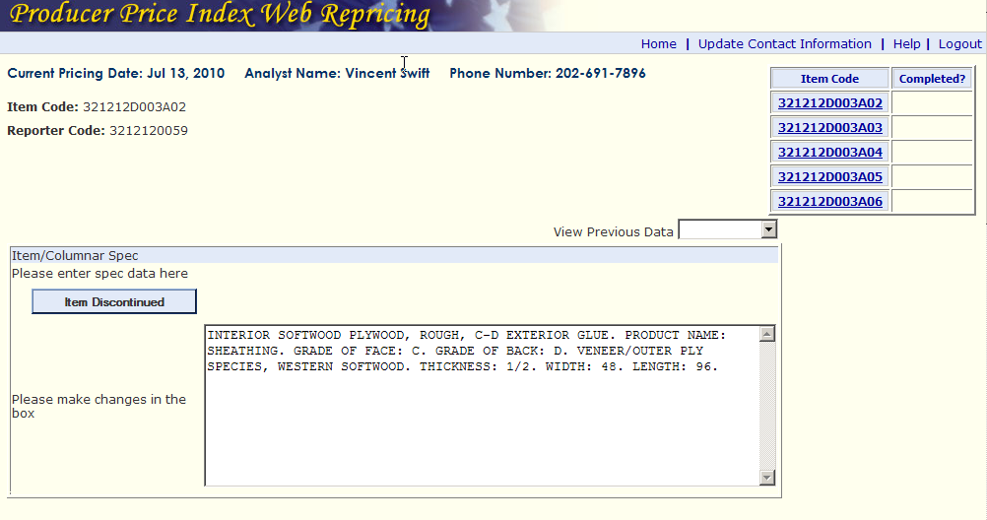

Item Detail Part 2: Terms of Transaction and Adjustments to Price

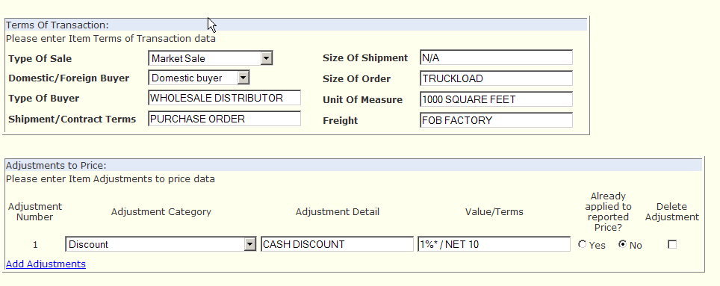

Item Detail Part 3: Price and Remarks

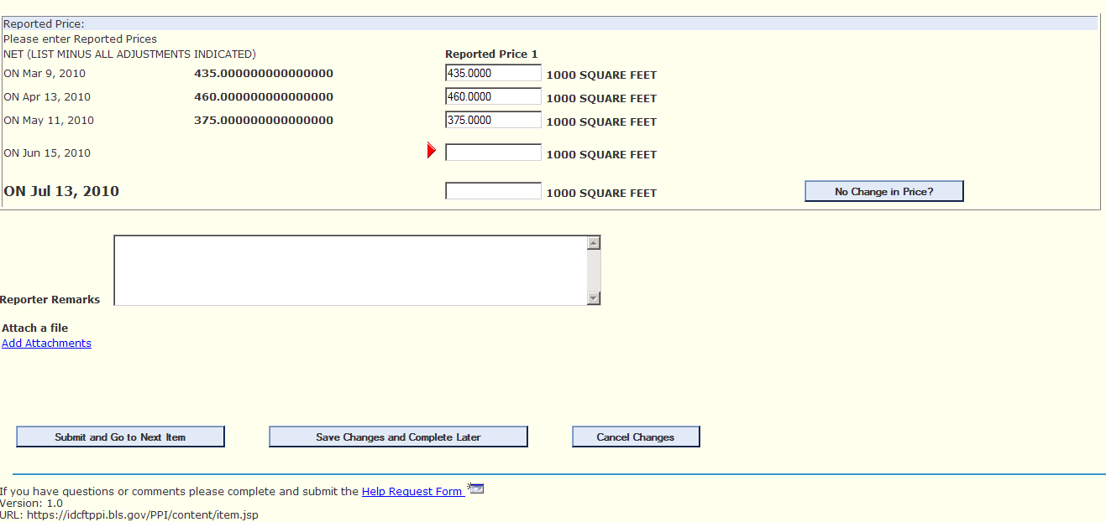

Exit Page

