State Survey Cover Letter

Dear (SEA Liaison):

Thank you for your participation in the U.S. Department of Education (ED) study, Charting the Progress of Education Reform: An Evaluation of the Recovery Act’s Role.

Information from the attached survey will be combined with data already submitted through Recovery.gov and other required reporting to provide a national picture of implementation and funding under the the American Recovery and Reinvestment Act (ARRA, or the Recovery Act). It is vitally important to ED that every state is represented; they have asked us to remind you that your State Education Agency (SEA) and the selected Local Education Agencies (LEAs) are federal grantees and therefore required to cooperate with this national evaluation.

We request that, as your SEA’s designated liaison for this study, you be responsible for identifying the appropriate staff to complete sections of the survey and for submitting the completed survey to Policy Studies Associates (PSA). Please complete and return the survey in the enclosed prepaid envelop no later than June 1, 2011. The first page of the survey includes a table that lists the different survey sections and asks for information about who was responsible for completing each section.

We look forward to receiving your completed survey. Feel free to contact Bruce Haslam of PSA, the evaluation’s Design Director, with questions or issues. He can be reached at mbhaslam@policystudies.com or 1-877-939-0460. Babette Gutmann, the evaluation’s Project Director, is also available to respond to any questions or issues. She can be reached at ARRASurvey@westat.com or at 1-888-855-1452. We welcome the opportunity to work with your agency over the next several years to make this study a success.

Sincerely,

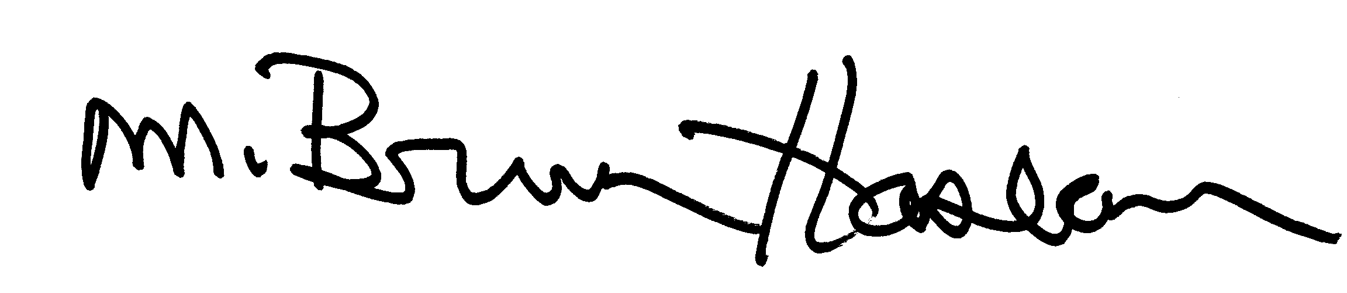

Babette Gutmann M. Bruce Haslam
Evaluation Project Director Evaluation Design Director
Charting the Progress of Education Reform Charting the Progress of Education Reform

Enclosure: Charting the Progress of Education Reform SEA Survey

Notice of Confidentiality
Information collected from the surveys comes under the confidentiality and data protection requirements of the Institute of Education Sciences (The Education Sciences Reform Act of 2002, Title I, Part E, Section 183). Information that could identify an individual or institution will be separated from the survey responses submitted, kept in secured locations, and be destroyed as soon as they are no longer required. Survey responses will be used only for research purposes. States may be identified but only in reporting composite measures of education reform. The reports prepared for the study will summarize survey findings across individuals and institutions and will not associate responses with a specific district, school, or person. We will not provide information that identifies state education agency, local education agency, or school respondents to anyone outside the study team, except as required by law.

Paperwork Reduction Act of 1995
According to the Paperwork Reduction Act of 1995, no persons are required to respond to a collection of information unless such collection displays a valid OMB control number. The valid OMB control number for this information collection is 1850-0877. The approximate time required to complete this data collection is estimated to be 75 minutes. If you have any comments concerning the accuracy of the time estimates or suggestions for improving this form, please write to: U.S. Department of Education, Washington, DC 20202-4651. If you have comments or concerns regarding the status of your individual submission of this form, write directly to the Institute of Education Sciences, U.S. Department of Education, 555 New Jersey Avenue, NW, Washington, DC 20208.

