These are the surveys and instructions given to subjects in the second of four sessions in one of our two conditions. This is the condition using single driver simulations
Session 2 tasks for single driver experiment are scheduled for 1 hour and 40 minutes. We used less than this in our pretests.

Welcome 5 minutes
3 drives 15 minutes
demographics 10 minutes
drive instructions 5 minutes
5 drives 25 minutes
5 drives 20 minutes
lottery 5 minutes
payment 5 minutes

sum 1 hour 30 minutes
break 10 minutes
Welcome
Thank you for returning for session two of the study. We are delighted to have you here.
We expect the session to last about two hours and you will have a chance to make some earnings through several tasks in addition to the participation fee of $____. Each task has specific instructions that you will be able to review and ask questions about before performing any tasks. We are here to help you so feel free to ask anything you like. At no time will you need to use any of your own money in the tasks. All tasks are designed so that you will be earning money.
You may skip specific questions and tasks. However, if you skip paid tasks you will not be paid for them. If you skip a large number of questions or tasks you may need to withdraw, in which case you will be paid for the tasks you have completed and $_____ of the participation fee as a compensation for your travel expenses .
We will again be using a driving simulator, that is a simulated driving exercise on a computer, and some individuals have a tendency to suffer from motion sickness. Do you easily suffer from motion sickness when riding amusement park rides or playing video games or going in cars or on boats? If you are pregnant you should not participate.
We need to first verify that you have a current Driver’s License and a current car insurance.
Before we begin the experiment, I will summarize the tasks you will be completing today. All the tasks in the driving simulator are similar so by the end of the session you will feel pretty comfortable with the driving.

HANDOUT: Overview of the Session

Station T1 download GPS data and calculate earnings
- Station C1 Simulator: 3 review drives
- Station T2 A few questions about you
- Station T2 Instructions 5 drives in simulator
- Station C2 Simulator: 5 drives for money

- Break

- Station C3 Simulator: 5 more drives for money
- Station T3 Lottery task for money
- Station T3 Field driving instructions
- Station T4 Payment and schedule next visit

The money you receive throughout the tasks is in addition to your show-up fee.

Station C1 Simulator: 3 Review Drives
(Less than 15 minutes was needed for this task in our pretests)
In this first review drive you are going to take 7th Ave to work. This is for practice only and you will earn no money based on this drive.
In this second review drive you are going to take 9th Ave to work. Do you have any questions?

How do you feel? Do you have any feeling of nausea at all?
Would you like to get up and move around, perhaps have some water?
Remember that sometimes when you take 9th Ave there will be a school bus pulling up from C Street. This bus stops at every intersection from C to F Street. If this happens, you and the other cars in front of you will have to also stop.
In this third review drive you will once again take 9th Ave and we will make sure that there is a school bus present so you can see what happens then.

Some Questions About You
In this survey most of the questions asked are descriptive. We will not be grading your answers. Please think carefully about each question and give your best answers.

1. How would you best describe your household?
[A household is an economic unit. It is defined as a group of persons who live in the same residence and each person contributes to general expenditures. Your household includes your spouse, children or parents who live with you, and all siblings, partners or room-mates with whom you share finances]
- Single under 30 years
- Single 30 – 59 years
- Single older than 59 years
- 2 adults, oldest person is under 30 years
- 2 adults, oldest person is 30 – 59 years
- 2 adults, oldest person is older than 59 years
- Single with children, oldest child 0 – 9 years
- Single with children, oldest child 10 – 17 years
- 2 adults with children, oldest child 0 – 9 years
- 2 adults with children, oldest child 10 – 17 years
- Household with at least 3 adults
2. How many people are there in your household (including your spouse, children or parents who live with you, and all siblings, partners or room-mates with whom you share finances)?

- 1 person
- 2 persons
- 3 persons
- 4 persons
- 5 or more persons

3. How many cars are there in your household (including those owned by your spouse, children or parents who live with you, and all siblings, partners or room-mates with whom you share finances)?
- 0
- 1
- 2
- 3
- 4
- 5+
4. How many cars in your household have a manual transmission (stick shift)?
- 0
- 1
- 2
- 3
- 4
- 5+

5. Are you employed (including self-employed)? Select the option which best applies to you.
- Full-time employed
- Full-time student without employment
- Part-time student without employment
- Part-time employed
- Unemployed
5b. (If yes to employed) Does your job involve driving during working hours? For instance delivering pizzas or other goods or cargo, driving to clients for onsite repairs like plumbing, electrical, etc...
- Yes, 3 or more days per week
- Yes, less than 3 but at least 1 day per week
- No

6. How many other adults in your household are employed at least part-time?
- 0
- 1
- 2
- 3
- 4+

7. What has been your primary occupation during the last 12 months?
[Primary occupation is defined as the type of occupation where you spend most of your working time.]
- Farmer
- Other self-employed
- Spouse assisting in family business
- Caring for spouse for medical reasons
- White collar worker
- Professional
- Skilled worker
- Unskilled worker
- Apprentice
- Student
- Retired
- Unemployed
- Stay at home spouse and/or mother
- Other: __________________
:
8. What type of residence do you live in?
- Owner-occupied house
- Owner-occupied apartment
- Owner-occupied mobile home
- Rented house
- Rented apartment
- Rented mobile home
- Multi-ownership of residence, cooperative
- Rented room
- Other: _________________

9. What is the zip code of your residence? __________

10. What is the square footage of your residence? __________
11. What was the highest level of formal education that your father (or male guardian) completed?
- Less than high school
- GED or High School Equivalency
- High school
- Vocational or trade school
- Two year college degree (AA degree)
- College or university
- Graduate degree

12. What was the highest level of education that your mother (or female guardian) completed?
- Less than high school
- GED or High School Equivalency
- High school
- Vocational or trade school
- Two year college degree (AA degree)
- College or university
- Graduate degree
13. Do you currently smoke cigarettes?
- No
- Yes
13A. If yes, how man cigarettes do you smoke in one day? _______ cigarettes

14. How often do you participate in extreme sports?
[Extreme sports include bungee-jumping, para-gliding, parachute jumping, gliding, rafting, diving and other dangerous sports.]
- Never
- A few times
- Occasionally
- Often
- Every chance I get
15. Have you ever played video games in which you can move around in a 3-dimensional world?
- Yes
- No
- I am not sure
16. Have you ever participated in online virtual worlds, such as Second Life?
- Yes
- No
- I am not sure

17. Have you ever played online video games, such as World of Warcraft?
- Yes
- No
- I am not sure
If “Yes”, name your favorite video games here:

18. How often do you play video or computer games or participate in online worlds?
- Never
- A few times
- Occasionally
- Often
- Every chance I get
- I am not sure

19. Do you regularly play video games that encourage the fast driving of vehicles in a virtual world, for example GTA?

- Yes I play such games frequently
- Yes but only on occasion
- No I never or infrequently play such games

Script: 5 Drives for Money

It is time again to drive in the simulator. It will be similar to the previous drives you did for money, but your earnings will be calculated differently.
For these paid drives, you will NOT know in advance whether there is a bus on 9th Ave or not. We have a deck of 100 cards here that contain a mix of cards with and without a bus. You will not know how many of these cards have a bus on them until you have finished all your drives today. The proportion of cards that have a bus is not at all the same as last time. There could be many more cards with a bus, or much fewer ones. After you are done with all the drives you may look at all the cards.
You will be allowed to draw ____ cards from the deck before we start so that you can get a feel for how many cards that may have a bus on them.
On 7th Ave. you will pay a toll that you select from our deck of Toll cards. This toll will stay the same for all your drives. Let us select the toll card now. You may review the cards before we shuffle them.
Your earnings in this part depend on you arriving to work on time. Of course, this depends on how long it takes to do the drive. Your wage today is $______. Any toll or charges for travel time will be deducted from this wage.
If you take ___minutes and ___ seconds or less to get to work, you will arrive on time and will receive your full $___ wage.
If you take longer than _ _minutes and ___ seconds, you will be late, and your wages will be reduced by ____.
The maximum charge you will incur will not exceed your wage of $__, so you will never incur any losses.
Please review the bullet handout for an overview. Do you have any questions?
I will now shuffle the bus cards.
You will now draw ____ cards (one at a time) from the deck with bus cards and look at them. You will return each card to the deck after viewing it. I will reshuffle the deck between each draw.
We record the outcome of your card draws on the record sheet.

Script Simulator: 5 Drives for Money

(Less than 25 minutes were needed for these 5 drives in our pretests)
Are you ready for your first drive? Do you know the toll?
Please draw a bus card and place it on the table face down without looking at it. When you are done with all your drives you may review all the cards that you drew.
Are you ready for your second drive? Do you know the toll? Draw the bus card from the second identical deck.
Are you ready for your third drive? Do you know the toll? Draw the bus card from the third deck.
Fourth drive.
Fifth drive.
You may now take a break to rest from the simulator, have some water and use the restroom. After your break you are going to station C3 where you will be doing your next 5 drives using the same toll and identical decks of bus cards. Let us walk over the C3 or C5 together and place your bus card deck there with the RA.

C2 bullets Handout

Draw a bus card without looking at it.

- Start at home
- Drive to work
- If you drive 7th Ave. you pay a toll
- If you drive 9th Ave. there is no toll
- Earnings:
  - Wage $__
  - Deduct $__ if drive takes longer than __ minutes and __ seconds
  - Pay a toll if you take 7th Ave.

Do this five times

Script Simulator: 5 More Drives for Money

(Less than 20 minutes were needed for these 5 drives in our pretests.)
The next five drives are exactly as the previous five. Please review your bullet handout.
After completing the 5 drives make sure to record the bus cards on the record sheets.

C3 bullets Handout

Draw a bus card without looking at it.
- Start at home
- Drive to work
- If you drive 7th Ave. you pay a toll
- If you drive 9th Ave. there is no toll
- Earnings:
  - Wage $__
  - Deduct $__ if the drive takes longer than __ minutes and __ seconds
  - Pay a toll if you take 7th Ave.

Do this five times
When done make sure to record the bus cards on the record sheets

Script: Lottery Choice Task for Money
(Less than 5 minutes was needed for this task in our pretests)
You will now be asked to make two more choices over pairs of lotteries, as you did last time. Recall that this is what the screen will look like for a typical choice, although the prizes and probabilities will be different. As an example we show here a lottery where there is a larger dark blue area than in the illustration we used earlier, corresponding to the higher prizes of $100 in the left and $1,000 in the right lottery.
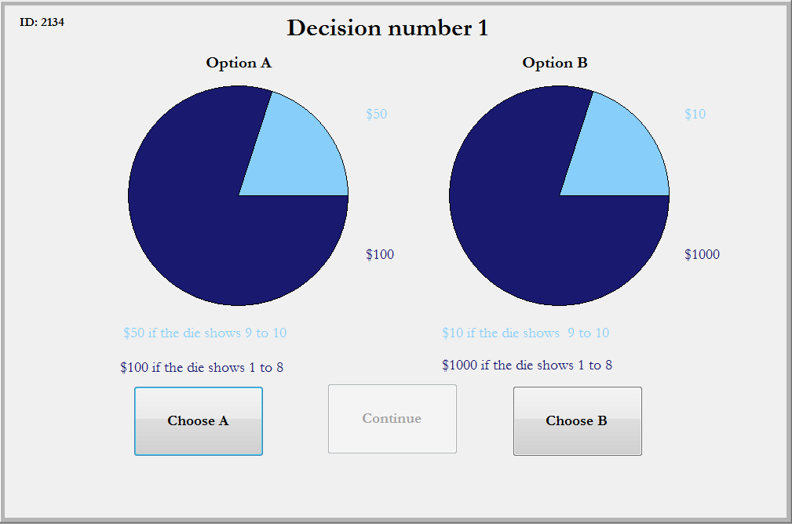
These choices will be made in the same manner as before, and we will be using a 10-sided die to play them out to see your earnings.

Payment and Scheduling
This is the end of today’s session. I hope you found it interesting and rewarding. We are going to accompany you to your car and help you place the GPS unit in a good spot.
Before we do that I will calculate your earnings across the tasks today and pay you. You will be paid over Paypal, unless you prefer a direct transfer to your bank account. We can only do a direct transfer if you have brought along a voided check.
We will instruct Paypal to send you the money right now online. Paypal then sends you an email right away with a link to their online site where you can either register as a Paypal user, or log in if you are already a Paypal user. The money will then be immediately available if you want to do online purchases, or you can request Paypal to send you a check with a few days delay, or you can transfer the money into your bank account. Paypal charges a small fee for sending you a check but transfers to your bank account are free.
The use of Paypal is offered as a courtesy to you so that you can be paid quickly and conveniently. Paypal is a private company. Neither Georgia State University nor the University of Central Florida has any authority to handle any disputes you may have with Paypal and cannot take any responsibility for your interactions with Paypal. Georgia State University and the University of Central Florida are also not responsible for any payment expenses required by Paypal.
Have you already signed up for a session in two weeks time? If not we can do so now as well.
Do you have any question about your driving task for the next two weeks?
Do you know how to contact us if you have any questions?
We will now accompany you to your car. Here is a card that you can keep in your car that summarizes your driving task.

