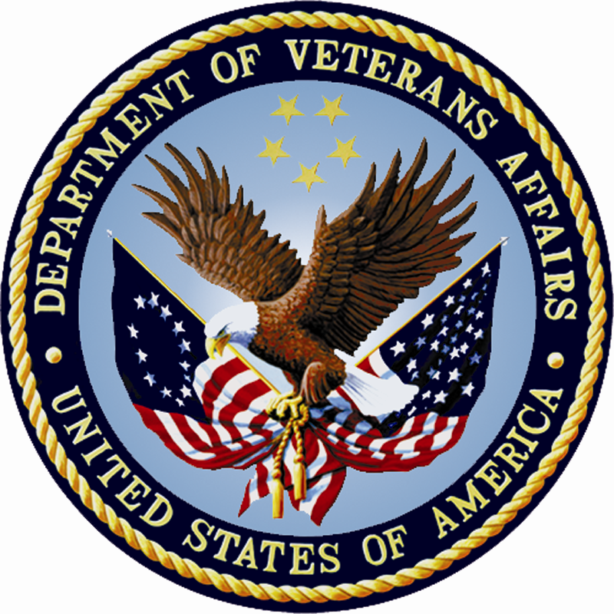

Nonprofit Program Office (NPPO)
Office of Research and Development
Veterans Health Administration

VA Affiliated Nonprofit Research and Education Corporations (NPCs)

Operations Oversight Questionnaire

PRA Statement: This information is collected in accordance with section 3507 of the Paperwork Reduction Act of 1995. Accordingly, we may not conduct or sponsor, and you are not required to respond to a collection of information unless it displays a valid OMB number. We anticipate that the time expended by all individuals who complete this assessment will average 90 minutes. This includes the time it will take to read instructions, gather the necessary facts and fill out the form. Disclosure of information is needed to meet specific legal oversight requirements, as well as, general oversight and management requirements. The obligation to respond is required. The approved NPC Oversight Plan includes reviews and audits of the NPCs. The information and recommendations developed from the questionnaire will strengthen the operations of the NPCs. It may also lead to improvements in the Nonprofit Oversight Board and Nonprofit Program Office (NPPO’s) own operations and/or those of the VHA Office of Research and Development and VHA itself. The questionnaire may also be used as a voluntary self-assessment by the NPCs.

Operations Oversight Questionnaire
for VA Affiliated Nonprofit Research and Education Corporations (NPCs)

Introduction and Instructions

This Operations Oversight Questionnaire is designed to be thought-provoking and helpful to the VA affiliated Nonprofit Research and Education Corporations (NPCs). Its primary objective is help the NPCs improve their operations so that there is a better likelihood that they will be self-sustaining and able to support VA research and education effectively for many years to come.

This questionnaire can be used in two ways: 1) as a voluntary self-assessment; or 2) as a mandatory NPPO oversight review or audit tool. If required by the NPPO, then the purpose will be to assess the NPC’s operations and to identify areas that need improvement. NPPO will make formal written recommendations for improvements to the NPC’s management, the related VA Medical Center Director, and the NPC’s board of directors where appropriate.

NPPO may also use what it has learned from responses to this questionnaire to improve its own operations and to make recommendations to the Office of Research and Development, VHA’s Nonprofit Oversight Board, or to VHA.

Normally, this questionnaire will be answered by the NPC’s Executive Director, Chief Executive Officer or other person with equivalent authority, ability and knowledge of the NPC’s operations.

If you are uncertain about how to answer any of the questions, then just skip over the question and go on to the next one. We will discuss the skipped questions with you either over the phone or in person and help you arrive at a suitable answer.

NPPO estimates that it will take a knowledgeable person an average of one and a half hours to answer this Operations Oversight Questionnaire. However, because of the huge size disparities in the NPCs and other factors peculiar to some of the NPCs, more or less time may actually be needed. If you would like to comment upon the estimated burden of answering this questionnaire, or have any questions or suggestions, then please contact Kimberly Collins, NPPO Administrator, at (816) 922-2043 or kimberly.collins@va.gov.

VA and NPPO cannot assure that the Operations Oversight Questionnaire answers will be kept confidential or private. However, NPPO will make a reasonable effort to confine the answers to those within VA who have a need to know about them.

This questionnaire does not contain any information that can reasonably be regarded as sensitive.

Under the Paperwork Reduction Act, VA may not conduct or sponsor, and you are not required to respond to a collection of information unless it displays a valid Office of Management and Budget (OMB) number, or is being collected from fewer than ten persons (entities) in a twelve month period. It is highly likely that NPPO will require answers to at least some of the questions in this questionnaire from ten or more of the NPCs annually.

This Operations Oversight Questionnaire will be made available to respondents electronically by email or for downloading from the NPPO Web site. Answered questionnaires can also be returned to NPPO electronically. There is no additional record keeping requirement for this questionnaire.

It is not only good business practice for NPCs to have sound, effective operations, it is also mandated by VA. Following are excerpts from the VA Office of Inspector General’s Report No. 07-00564-121 of May 5, 2008:

“The NPPO is responsible for providing oversight and guidance affecting operations… (of) each NPC …and ensuring deficiencies are corrected.”

The responses to this questionnaire will help NPPO fulfill its obligation to review NPC operations and to make recommendations for improvements where warranted.

NPC:
Prepared by: Date:

People, Programs, and Plans

- Who are your NPC’s key people? What are their backgrounds and roles in the organization? Do you have an adequate staff to support your current operations and your future growth and development?

- What major programs are especially important in your support of VA research and education? Are there any new programs that you plan to implement in the future? What have been some of your greatest accomplishments?

- What are your growth and development plans for the next three to five years? Do you have the resources and support you need to accomplish your plans? Are there any obstacles to your future growth and development?

Other Important Operating Matters

- What, if anything, can be done to increase your revenues?

- What, if anything, can be done to reduce your operating expenses?

- What, if anything, can be done to reduce your administrative expenses?

- How can your net worth be increased?

- Do you have an adequate administrative expense reserve fund?

- Has your NPC given consideration to becoming part of a Multi-NPC?

- What can VHA’s Office of Research and Development do to help your NPC be more effective and successful?

- What can the NPPO do to help your NPC be more effective and successful?

- Do you have any recommendations or suggestions for improving the nationwide NPC program?

