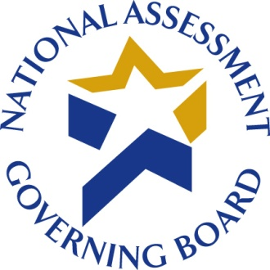

DATE

Dear President or Chancellor:

On behalf of the Governing Board of the National Assessment of Educational Progress (NAEP), I am asking for your institution’s participation in a pilot test of a survey on the tests used by postsecondary institutions to determine whether students are academically prepared or in need of developmental or remedial courses. This survey is part of a comprehensive research program on the preparedness of 12th grade students for postsecondary education and training.

This study has been endorsed by a number of national higher education organizations that encourage your participation (see overleaf).

The Federal Office of Management and Budget (OMB) has approved this survey (OMB No.: XXXX-XXXX). Westat, a research company in Rockville, Maryland, is contracted to conduct the survey.

Please forward the enclosed survey materials and a copy of this letter to the person or persons most knowledgeable about the evaluation of entering students to determine need for developmental or remedial courses in mathematics and reading. This may include individuals in offices of academic deans or academic departments, or offices that handle student services, new student orientation, or admissions. If more than one office or department is involved, please forward to the office or department with primary responsibility for evaluating entering students to determine need for developmental or remedial courses.

The survey is designed to be completed in 45 minutes or less. Participation in this survey is voluntary. Your institution’s participation is very important for the success of the study because the answers provided will be used to represent other institutions similar to yours. The information provided by your institution will be kept private to the extent permitted by law. Data for this study will be reported in aggregate form; the information provided by your institution will be combined with other participating institutions to produce statistical summaries and reports. Answers to frequently asked questions (FAQs) about the study can be found on page 7 of the enclosed survey questionnaire.

Institutions are encouraged to complete the survey online at www.nagb-survey.org. To login, use the User ID and Password printed on the label below.

If it is preferable, the enclosed paper questionnaire may be completed and returned either by mail using the enclosed postage-paid envelope or by toll-free fax at 1-800-254-0984 (Attn: Liam Ristow). The survey should be completed only once, using either the online or paper version.

We ask that the survey be completed within three weeks, and that a copy is kept for your files. If you have any questions about the survey, please contact Liam Ristow, the Westat survey manager, at 1-800-937-8281, ext. 2456 (toll-free) or 240-314-2456, or by e-mail at liamristow@westat.com. Thank you for your assistance.

Sincerely,
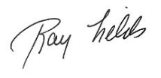
Ray Fields
Assistant Director for Policy and Research

Enclosures

800 NORTH CAPITOL STREET, NW, SUITE 825 ‌‌‌ WASHINGTON, DC 20002

The following organizations have endorsed this study and encourage your institution’s participation:

The American Association of Community Colleges

One Dupont Circle NW

Suite 410

Washington, DC 20036

The American Association of State Colleges and Universities

1307 New York Avenue NW

Washington, DC 20005

The American Council on Education

One Dupont Circle NW

Washington, DC 20036

The Association of Land-grant and Public Universities

1307 New York Avenue NW

Suite 400

Washington, DC 20005-4722

The State Higher Education Executive Officers

3035 Center Green Drive
Suite 100
Boulder, CO 80301-2205

‌

