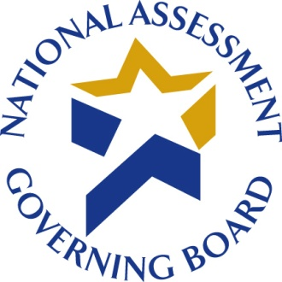

DATE

Dear President or Chancellor:

On behalf of the Governing Board of the National Assessment of Educational Progress (NAEP), I am asking for your institution’s participation in a pilot test of a survey on the tests used by postsecondary institutions to determine whether students are academically prepared or in need of developmental or remedial courses. This survey is part of a comprehensive research program on the preparedness of 12th grade students for postsecondary education and training. It has been endorsed by a number of national higher education organizations that encourage your participation (see overleaf). Answers to frequently asked questions (FAQs) about the study can be found on page 7 of the enclosed survey questionnaire.

The Federal Office of Management and Budget (OMB) has approved this survey (OMB No.: XXXX-XXXX). Westat, a research company in Rockville, Maryland, is contracted to conduct the survey.

Please forward the enclosed survey materials and a copy of this letter to the person or persons most knowledgeable about the evaluation of entering students to determine need for developmental or remedial courses in mathematics and reading. This may include individuals in offices of academic deans or academic departments, or offices that handle student services, new student orientation, or admissions. If more than one office or department is involved, please forward to the office or department with primary responsibility for evaluating entering students to determine need for developmental or remedial courses.

The survey is designed to be completed in 45 minutes or less. Participation in this survey is voluntary. Your institution’s participation is very important for the success of the study because the answers provided will be used to represent other institutions similar to yours. The information provided by your institution will be combined with other participating institutions to produce statistical summaries and reports. Your institution’s answers will be used only for statistical purposes and will not be disclosed, or used, in identifiable form for any other purpose.

Institutions are encouraged to complete the survey online at www.nagb-survey.org using the following information:
User ID: LOGIN
Password: PASSWORD

If it is preferable, the enclosed paper questionnaire may be completed and returned either by mail using the enclosed postage-paid envelope or by toll-free fax at 1-800-254-0984 (Attn: Liam Ristow). The survey should be completed only once, using either the online or paper version.

We ask that the survey be completed within three weeks, and that a copy is kept for your files. If you have any questions about the survey, please contact Liam Ristow, the Westat survey manager, at 1-800-937-8281, ext. 2456 (toll-free) or 240-314-2456, or by e-mail at liamristow@westat.com. Thank you for your assistance.

Sincerely,

Ray Fields
Assistant Director for Policy and Research
National Assessment Governing Board

Enclosures

WASHINGTON, D.C. 20006

