HASS AVOCADO BOARD  BOARD OF DIRECTORS ELECTION 20xx  OFFICIAL PRODUCER BALLOT | 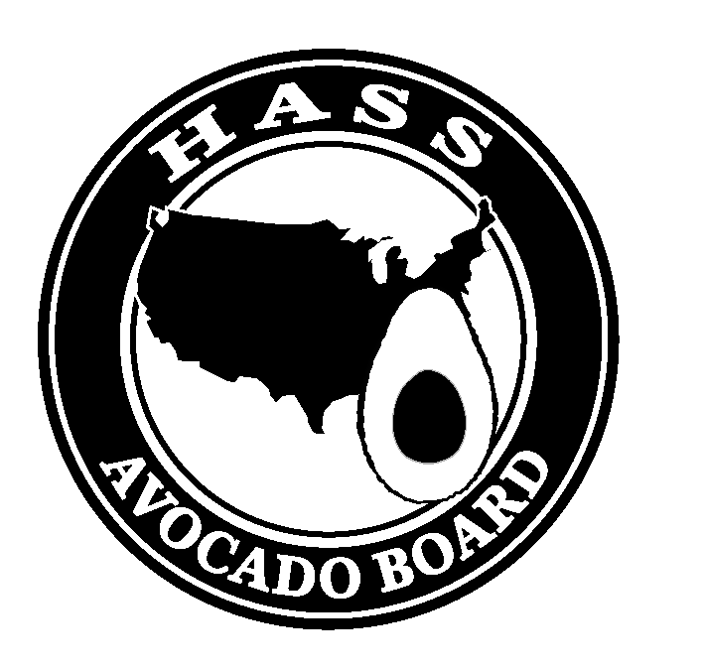

PLEASE FOLLOW THESE FOUR STEPS:
1. Determine your voting eligibility
2. Sign your ballot (required) DEADLINE TO RETURN YOUR BALLOT IS Month xx, 20xx
3. Check the appropriate voting boxes
4. Return ballot by Month xx, 20xx See reverse side for further information →
VOTER ELIGIBILITY, CERTIFICATION AND VOTING INSTRUCTIONS

STEP 1: In order to be eligible to vote, you must currently meet the definition of a Hass avocado producer: Under the Hass Avocado Promotion, Research and Information Order, 7 CFR Part 1219, a PRODUCER is defined as: Any person who is engaged in the business of producing Hass avocados in the United States for commercial use, who owns, or shares the ownership and risk of loss, of such Hass avocados.

If you DO NOT meet the criteria, check the box to the right, print and sign your name, and return your ballot without completing it.

Name:______________________________ Signature:____________________________ Date:______________

STEP 2: If you are an eligible Hass producer, complete the certification and voting sections below.

I hereby certify that I am a Hass avocado producer.

___________________________ ___________________ ______________________
Your legal or business entity name Signature Date

UNSIGNED BALLOTS ARE INVALID AND WILL NOT BE COUNTED

STEP 3: Vote for no more than xx (x) members and xx (x) alternates (including write-ins) by placing a check (√ ) in the left column next to your preference. If you vote for more than X members or X alternates, your ballot will be disqualified. If you wish to vote for a producer whose name is not on the ballot, you may write the name of the person on the write-in line and check the appropriate space. Candidate statements are included in this election package.

Vote √ | MEMBER NOMINEES |  | Vote √ | ALTERNATE NOMINEES
 |  |  |  | Write-in optional
 |  |  |  | Write-in optional
 | Write-in optional
 | Write-in optional

AVO-OPB (rev. 08/10) Destroy previous editions.

STEP 4: Mail this ballot to (audit firm) in the return envelope provided no later than Month xx, 20xx.

ADDITIONAL VOTING INSTRUCTIONS

XX producer member and xx producer alternate member seats will be open for the November 1, 20xx to October 31, 20xx (3-year) term.

Voters who are eligible as both a producer and an importer must declare in writing prior to each election whether they will be voting as a producer or an importer. Please complete the form included in your packet and fax to HAB at xxx-xxx-xxxx.

Please cast your ballot for the nominees, OR WRITE IN THE PRODUCER NAME(S) OF YOUR CHOICE. If you choose to write in a candidate name, you must include their full name and contact information. Each Hass avocado producer is entitled to submit one ballot. If more than one ballot is submitted by the same producer, that producer’s ballot will not be counted. An unsigned ballot or incomplete Certification Statement will disqualify the ballot.

Signed ballots must be returned to (audit firm) in the enclosed, prepaid, self-addressed envelope. Ballots must be received no later than close of business on Month xx, 20xx. Ballots received after that date will not be counted.

If you have any questions regarding the ballot, please contact HAB at xxx-xxx-xxxx.

According to the Paperwork Reduction Act of 1995, an agency may not conduct or sponsor, and a person is not required to respond to a collection of information unless it displays a valid OMB control number. The valid OMB control number for this information collection is 0581-0093. The time required to complete this information collection is estimated to average 15 minutes per response, including the time for reviewing instructions, searching existing data sources, gathering and maintaining the data needed, and completing and reviewing the collection of information.

The U.S. Department of Agriculture (USDA) prohibits discrimination in all its programs and activities on the basis of race, color, national origin, age, disability, and where applicable, sex, marital status, familial status, parental status, religion, sexual orientation, genetic information, political beliefs, reprisal, or because all or part of an individual’s income is derived from any public assistance program (Not all prohibited bases apply to all programs.) Persons with disabilities who require alternative means for communication of program information (Braille, large print, audiotape, etc.) should contact USDA’s TARGET Center at (202) 720-2600 (voice and TDD). To file a complaint of discrimination, write to USDA, Director, Office of Civil Rights, 1400 Independence Avenue, S.W., Washington, D.C. 20250-9410, or call (800) 795-3272 (voice) or (202) 720-6382 (TDD). USDA is an equal opportunity provider and employer.

AVO-OPB (rev. 08/10) Destroy previous editions.

IMPORTANT NOTICE

Voters who are eligible as both a producer and an importer must declare in writing prior to each election whether they will be voting as a producer or an importer.

If you represent both Producer and Importer, please complete the following and fax to HAB at xxx-xxx-xxxx.

I will be voting as: (check one)

- PRODUCER

- IMPORTER

Name: ____________________________________

Signature: _________________________________

If proper protocol is not followed, your vote could be disqualified.

AVO-OPB (rev. 08/10) Destroy previous editions.

