**Attachment 3:**

**Recruiting Flyer**

**NEEDED**

**VOLUNTEERS WITH INFLUENZA (THE FLU)**

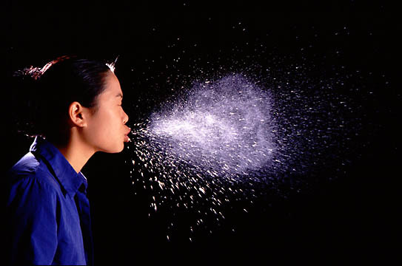

**Photo: Andrew Davidhazy, Rochester Institute of Technology**

West Virginia University and the National Institute for Occupational Safety and Health (NIOSH) are studying the droplets that people produce when they cough while they have the flu. We are recruiting **paid volunteers** to be test subjects.

**Who is eligible?**

You must:

* **Have influenza-like symptoms (fever, headache, fatigue, cough, sore throat, muscle aches) for less than three days.**
* Be a male or non-pregnant female, age 18 to 35.
* Be in otherwise good health with no underlying illnesses such as diabetes or heart disease.
* **Not** have another respiratory illness such as severe asthma, COPD or tuberculosis
* **Not** have a medical condition or illness that would make it difficult or uncomfortable for you to perform the test procedure
* **Not** have been vaccinated against influenza during the current season.

*(See other side for more information)*

**What do I have to do?**

First, the study will be explained to you. You will be asked to answer a short health questionnaire, including any history of respiratory problems. Your temperature will be taken, and three nasal swabs will be taken from you to test for the flu virus. Next, you will be asked to cough three times into a measurement system, waiting about 5 minutes between coughs. The test session will take about 30 minutes to complete.

**Payment**

You will receive a $40 gift card for participating in the study.

**Possible risks**

During the study, you will be asked several times to take a deep breath and cough hard. There is a slight possibility that this may cause you to become dizzy or faint. Other than this, you should not be at any risk or experience any discomfort during this study. This type of testing is similar to commonly-used medical procedures and has been done before at NIOSH.

**What if I am interested?**

Look for a test coordinator at Well WVU Student Health during flu season.