**Attachment H – Sample Reports  
Part 1 - Summary of evaluator needs**

Number of evaluators responding :

Overall level of experience in program evaluation

General knowledge assessment

|  |  |  |  |  |  |
| --- | --- | --- | --- | --- | --- |
|  | Not at all | General knowledge | Used or could use | Taught or could teach | Priority for training |
| Guiding principles | 1 | 2 | 5 | 0 |  |
| Joint Committee Program Standards | 2 | 3 | 3 | 0 |  |
| CDC Framework | 0 | 4 | 3 | 1 |  |
| Multiple approaches | 1 | 5 | 1 | 1 |  |

Common areas identified for requesting technical assistance

|  |  |  |
| --- | --- | --- |
| Technical assistance requested for | Percent requesting | Respondents that can teach this |
| Designing evaluations using mixed methods | 88% |  |
| Collecting observational data | 75% |  |
| Using logic models to guide questions | 75% |  |
| Budgeting for evaluation | 75% |  |
| Resolving conflicts | 75% |  |
| Synthesizing evaluation findings | 62% |  |
| Developing action plans | 62% | (respondent id) |
| Tailoring evaluation findings for community groups | 62% |  |

Common Organizational supports for evaluation

List of states with evaluators in strongly supportive organizations (>7 agree or strongly agree responses)

[respondents]

List of states with evaluators in non-supportive organizations

Organizational Availability of data and use of information

**Part 2 - Assessment of NACP Evaluation Technical Assistance**

Level of interaction with ETA over past year:

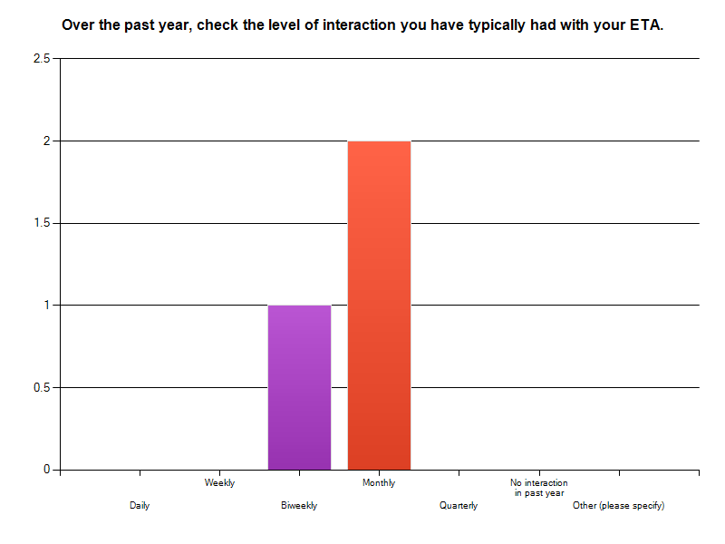

Satisfaction with level of interaction: 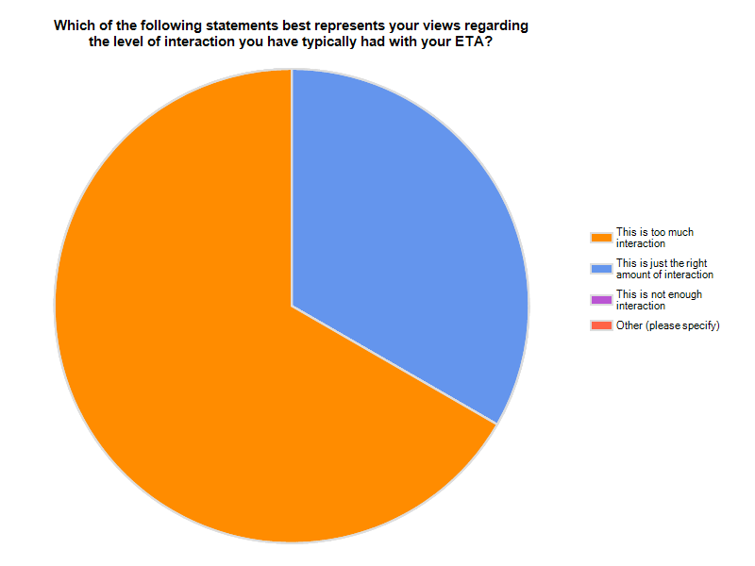

Ideal level of interaction: narrative responses compiled and reviewed for common themes.

Topics addressed and satisfaction with advice or resources provided:

|  | | | | |
| --- | --- | --- | --- | --- |
|  |  | | |  |
|  |  | | |  |
|  | **Adequate Advice/ Resources Provided** | **Inadequate Advice/ Resources Provided** | **Not Applicable (N/A)** | **Response Count** |
| **a. Evaluation Planning** | **100.0% (3)** | 0.0% (0) | 0.0% (0) | 3 |
| **b. Evaluation Implementation** | 0.0% (0) | 0.0% (0) | **100.0% (3)** | 3 |
| **c. General Problem Solving** | **100.0% (3)** | 0.0% (0) | 0.0% (0) | 3 |
| **d. Applying Evaluation Standards** | **33.3% (1)** | **33.3% (1)** | **33.3% (1)** | 3 |
| **e. Engaging Stakeholders** | **66.7% (2)** | 33.3% (1) | 0.0% (0) | 3 |
| **f. Describing the Program** | **33.3% (1)** | **33.3% (1)** | **33.3% (1)** | 3 |
| **g. Focusing the Design** | **66.7% (2)** | 0.0% (0) | 33.3% (1) | 3 |
| **h. Gathering Credible Evidence** | **66.7% (2)** | 0.0% (0) | 33.3% (1) | 3 |
| **i. Interpreting Findings/Justifying Conclusions** | 0.0% (0) | 0.0% (0) | **100.0% (3)** | 3 |
| **j. Ensuring Use/Disseminating Findings** | 33.3% (1) | 0.0% (0) | **66.7% (2)** | 3 |

Overall quality of interaction with ETA:

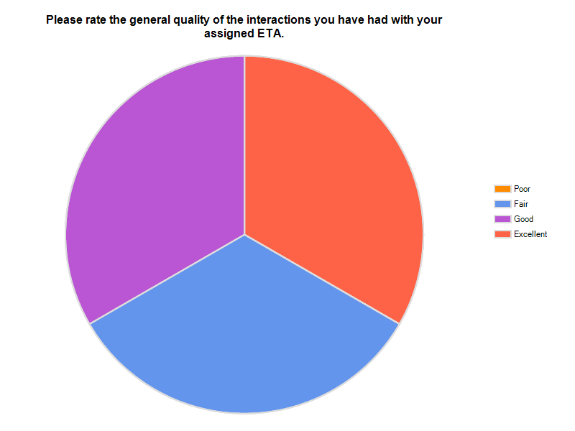

How ETA has helped:

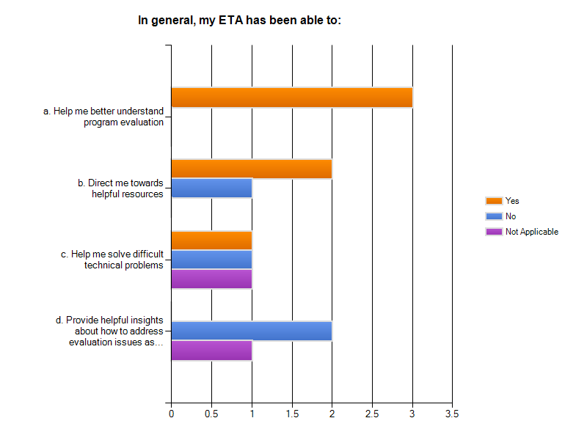

Use of resources:

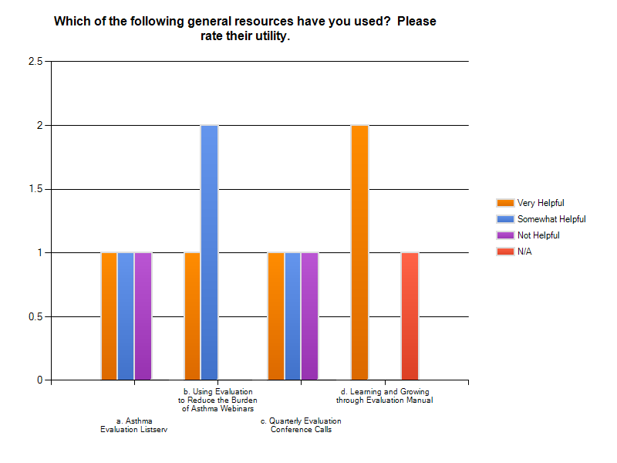

How can we improve evaluation TA? This is a narrative response and we will analyze for common themes, utilizing atlas-ti software, as appropriate. Atlas-ti is a commonly used software package used to for qualitative data analyses.