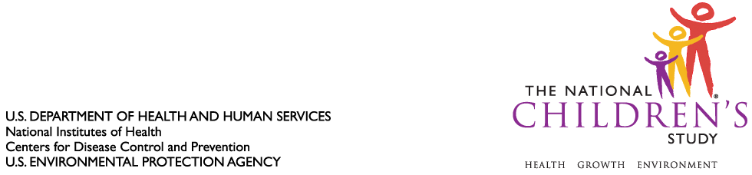

DATE: January 25, 2010

TO: Dr. Margo Schwab
Office of Management and Budget
Office of Information and Regulatory Affairs

FROM: Dr. Jennifer Park

THROUGH: Dr. Steven Hirschfeld

SUBJECT: Request for Non-Substantive Change to National Children’s Study, Vanguard (Pilot) Study (OMB Control #0925-0593, Expiration July 13, 2013) – Low-intensity to High-intensity Invitation Script and Validation Instrument

CC: Dr. Sarah Glavin, Ms. Jamelle Banks, Ms. Mikia Currie

We request non-substantive change to the National Children’s Study Vanguard (Pilot) Study protocol approved as revised by the Office of Information and Regulatory Affairs (OIRA) on September 22, 2008.

We request the addition of a Low-intensity to High-intensity Invitation Script of the National Children’s Study for implementation in the Vanguard (Pilot) Study protocol among the ten Vanguard Study Centers using the Two-Tier recruitment approach. This script invites Study participants who are enrolled in the Low-Intensity arm of the Two-Tier recruitment approach to join the High-Intensity arm of the same recruitment approach.

We also request the addition of a Validation Instrument of the National Children’s Study for implementation in the Vanguard (Pilot) Study protocol among the seven Initial Vanguard Study Centers.

Please see attached the referenced instrumentation for your consideration.

Attachments (2):

- Low-intensity Invitation to High-intensity Script
- Validation Instrument

