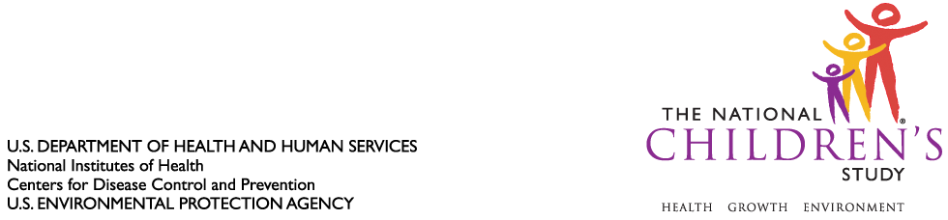

DATE: January 28, 2010

TO: Dr. Julie Wise
Dr. Margo Schwab
Office of Information and Regulatory Affairs

FROM: Dr. Jennifer Park

THROUGH: Dr. Steven Hirschfeld

SUBJECT: Request for Additional Hours for National Children’s Study Formative Generic Clearance (OMB Control #0925-0590, Expiration June 30, 2011)

CC: Dr. Sarah Glavin, Ms. Jamelle Banks, Ms. Mikia Currie

We request 32,026 additional hours for National Children’s Study Formative Generic Clearance that were approved by the Office of Information and Regulatory Affairs (OIRA) on June 12, 2008. The additional hours will enable the Study to conduct formative research projects in several fundamental research areas that will inform the development of the Main Study, which aims to launch in 2012.

For your consideration, please see the attached burden table, which summarizes 69 of these formative research projects that we have determined are ready for submission to OIRA during the clearance period. This listing includes the project name, participating institution, number of responses, and burden hours.

Please let us know if you have any questions.

Attachment (1):

- Burden Table for National Children’s Study Formative Generic Clearance

