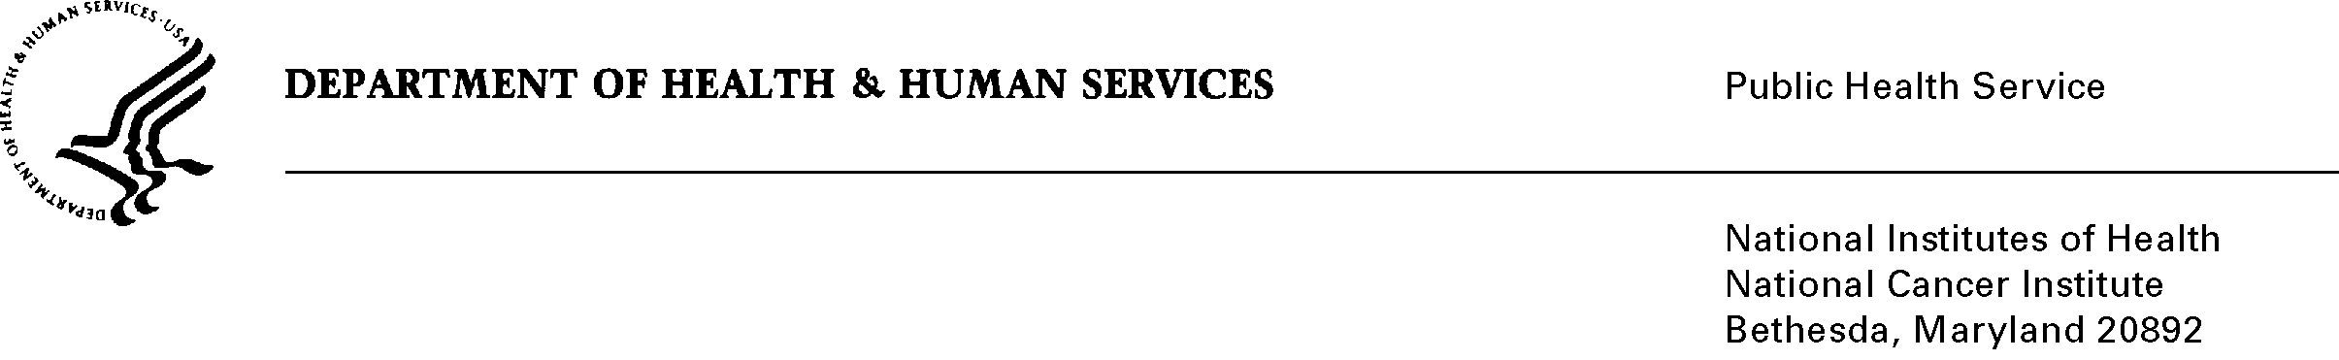
Date: December 17, 2010

To: Office of Management and Budget (OMB)

Through: Seleda Perryman, Report Clearance Officer, HHS
Mikia Currie, Program Analyst, Project Clearance Branch, OPERA, NIH
Vivian Horovitch-Kelley, OMB Project Clearance Liaison, OMAA, NCI

From: Nancy Breen, Ph.D.
National Cancer Institute/NIH

Subject: Revision for California Health Interview Survey Cancer Control Module
(CHIS-CCM) 2011, OMB No. 0925-0598, Expiry Date 2/28/2011.

This is a request for OMB to approve the revision of the, “California Health Interview Survey Cancer Control Module (CHIS-CCM) 2011.” for three years.

The NCI has sponsored five Cancer Control Modules in the California Health Interview Survey (CHIS), and will be sponsoring a sixth to be administered in 2011. CHIS is a telephone survey that collects population-based, standardized health-related data to assess California’s progress in meeting Healthy People 2010 objectives for the nation and the state. The CHIS sample is designed to provide statistically reliable estimates statewide, for California counties, and for California’s ethnically and racially diverse population.

The purpose of CHIS-CCM is to collect data to allow NCI to examine patterns and trends in cancer screening and follow-up, as well as to study other cancer-related topics such as diet and physical activity, by collecting data on health- and disease-related topics such as patterns and trends in cancer screening, disease risk factors, disease outcomes, and family history of disease. Additionally, CHIS is designed to be comparable to the National Health Interview Survey (NHIS) data in order to conduct comparative analyses. CHIS provides enhanced estimates for cancer risk factors and screening among racial/ethnic minority populations.

This revised submission proposals continual data collection and includes three new modules on health topics such as human papillomavirus, epilepsy, and medical home communication/care. In addition to a variety of collaborations and funding sources from federal, state and local agencies, the 2011 questionnaire will conduct an oversampling for American Indian and Alaska Natives which will provide data to support research studies on, for example, premature aging (a collaboration with the Indian Health Service and NCI).

A mission of the Division of Cancer Control and Population Sciences at the NCI is to establish and support programs for the prevention and treatment of cancer. The California Health Interview Survey Cancer Control Module 2011 is an important instrument that supports our ability to further examine patterns and trends in cancer screening and follow-up.

